Android is an operating system for smartphones Based on Linux
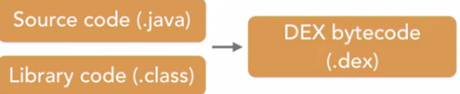
Android Software Stack:
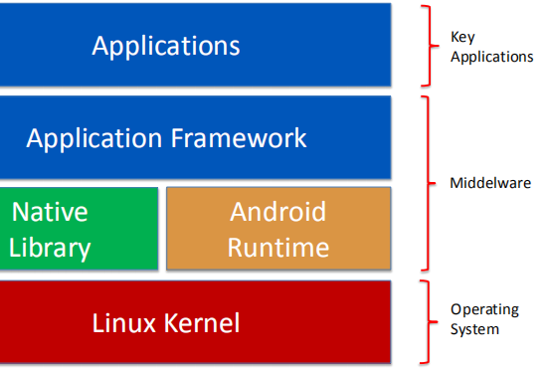

Android Studio is based on IntelliJ IDEA Community Edition
Android Studio also come with Android Studio IDE, Android SDK tools, Android Platform and emulator system images.

SDK Platform Android SDK Platform 29 Samples for SDK 29

Android Virtual Device (AVD)

Android App Architecture: Activity, Service, Broadcast Receiver, Content Provider, Intent
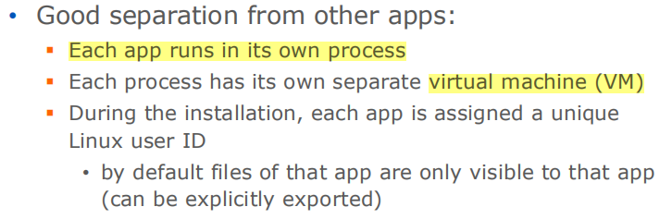
Activity :
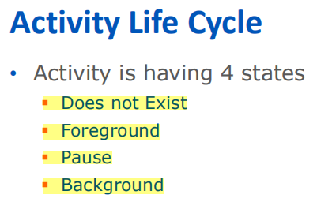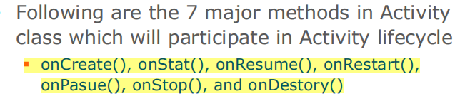
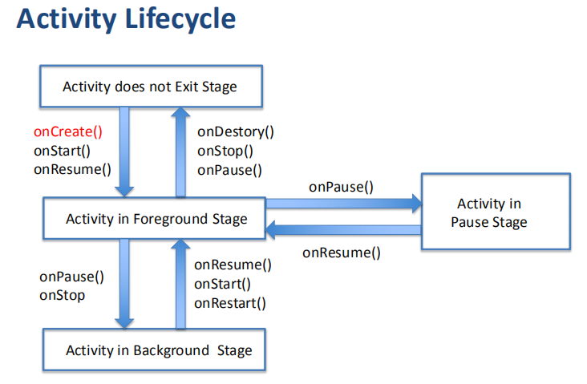
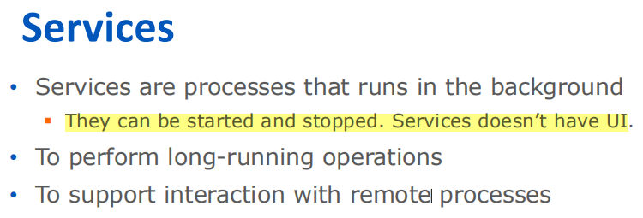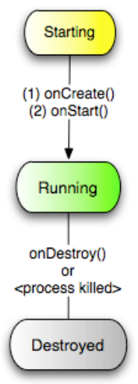

Broadcast Receiver
• Broadcast Receivers are registered for system announcements

Content Providers
• Content Provider is used to share the data between multiple apps.

Intents
• An intent is an Intent object with a message content.
• Intents represent events or actions.
• Intents can be implicit or explicit

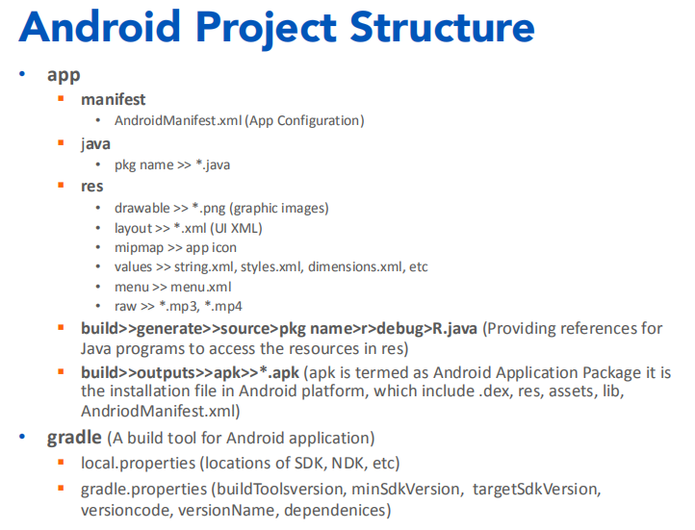
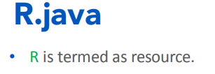
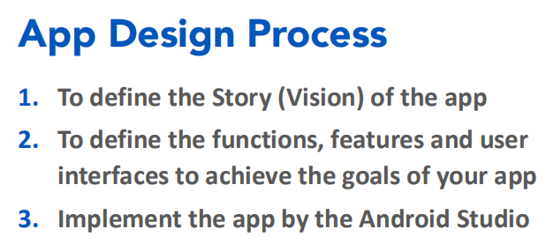

XML :
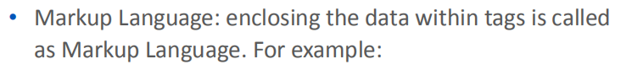
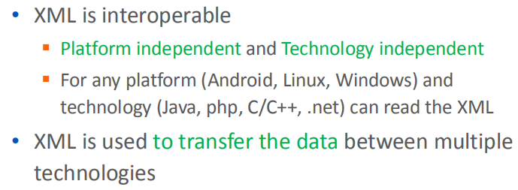
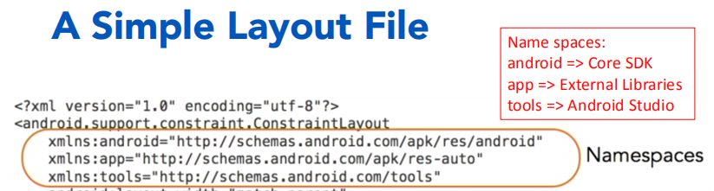

ViewGroup -> { LinearLayout, ConstraintLayout, RelativeLayout } -> TextView -> View

UI Elements Button (Image Button, EditText, Checkbox, Radio button, Toggle button, Rating Bar)

Device-Independent Pixels (dp) px = dp * (dpi / 160)
Scale-Independent Pixels (sp) • Similar to dp but used to specify font size
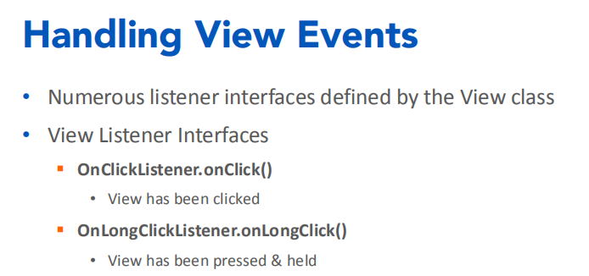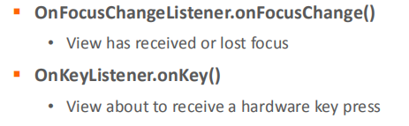
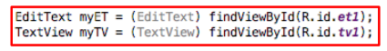
The UI Thread (main thread)
• Applications have a main thread (the UI thread)
• Application components in the same process use the same UI thread
• User interaction, system callbacks & lifecycle methods handled in the UI thread

