Software Analysis and Design | SWE5006 Team 1 — Lumen

UC1 Identity — Module Design and API
Sign up, sign in and manage the account
Item | Detail
Assessment | Software Analysis and Design; Software Design Patterns (SWE5006 Project Proposal - Lumen.docx §6.3)
Use case realised | UC1 — sign up, sign in and manage the account (proposal §6.1)
Slice owner | LU YI. Pages 02 Sign in / sign up and 05 Settings: Account; back-end modules identity and email
Design problem | “Four ways to become authenticated: GitHub, Google, email with password, and an existing session. Each exchange differs, all of them must end in one session, and a fifth must not change the session code.” (proposal §6.4)
Chosen pattern | Strategy with Template Method
Requirements sources | SWE5006 Project Proposal - Lumen.docx; docs/ARCHITECTURE.md, docs/SLICES.md, docs/ONBOARDING.md, docs/CODING_STANDARDS.md, CODEOWNERS
Notation references | 03a AM.pdf — «boundary» / «control» / «entity», attributes on entity classes only; 04a DM.pdf — transition strategies and design activities
Deliverables | Seven figures and thirteen tables across four sections: the overview, the module design, the API, and the effort estimate
Submitted by | LU YI
Date | 8 September 2026
Declaration on the Use of AI Tools
I used Claude (Opus) to render the UML figures from the model I specified and to draft the accompanying explanatory text. I reviewed and revised the models against the SWE5006 Project Proposal and the repository’s own documents (ARCHITECTURE.md, SLICES.md, ONBOARDING.md, CODING_STANDARDS.md, CODEOWNERS), and I am responsible for the content and quality of the submitted work.
Contents
Section | What it holds
§1 Overview | What this document delivers, the overall module design of UC1 (Figure 1), and every open item
§2 Module design | Each module taken apart: identity in §2.1–§2.5 (Figures 2–7), email in §2.6
§3 API | The HTTP interface those modules expose: conventions, four groups of endpoints, and the closed set of failures
§4 Effort estimate | The 10 person-days, by proposal task and by sprint

Figure | Diagram | Section
1 | Module structure of UC1 inside the monolith | §1.2
2 | Analysis class diagram — UC1 Identity | §2.1
3 | Analysis sequence diagram — sign in with email and password | §2.1
4 | Analysis sequence diagram — sign in with an OAuth provider | §2.1
5 | Design class diagram — Strategy with Template Method | §2.4
6 | Design sequence diagram — password login | §2.4
7 | Design sequence diagram — GitHub OAuth login | §2.4
Every figure is drawn by diagrams/gen_diagrams.py beside this document and exists twice: as the 240 dpi .png embedded here, and as an .svg that zooms without loss.

1. Overview

1.1 What this document delivers
This document designs UC1 — sign up, sign in and manage the account. It starts from the overall module structure of the slice (§1.2), takes each module apart in turn (§2), states the HTTP interface those modules expose (§3), and ends with the effort estimate (§4).
Two things it deliberately does not do. It does not design the email module’s internals, which have no owner decided yet (§2.6). And it produces no code: this round is documents only, and apps/server/src/modules/identity/ still holds only its README and an empty index.ts.

1.2 Overall module design
UC1 is one vertical slice holding two modules. Both live inside apps/server/src/modules/identity/, in one process against one Postgres database, calling each other in-process rather than over a network.
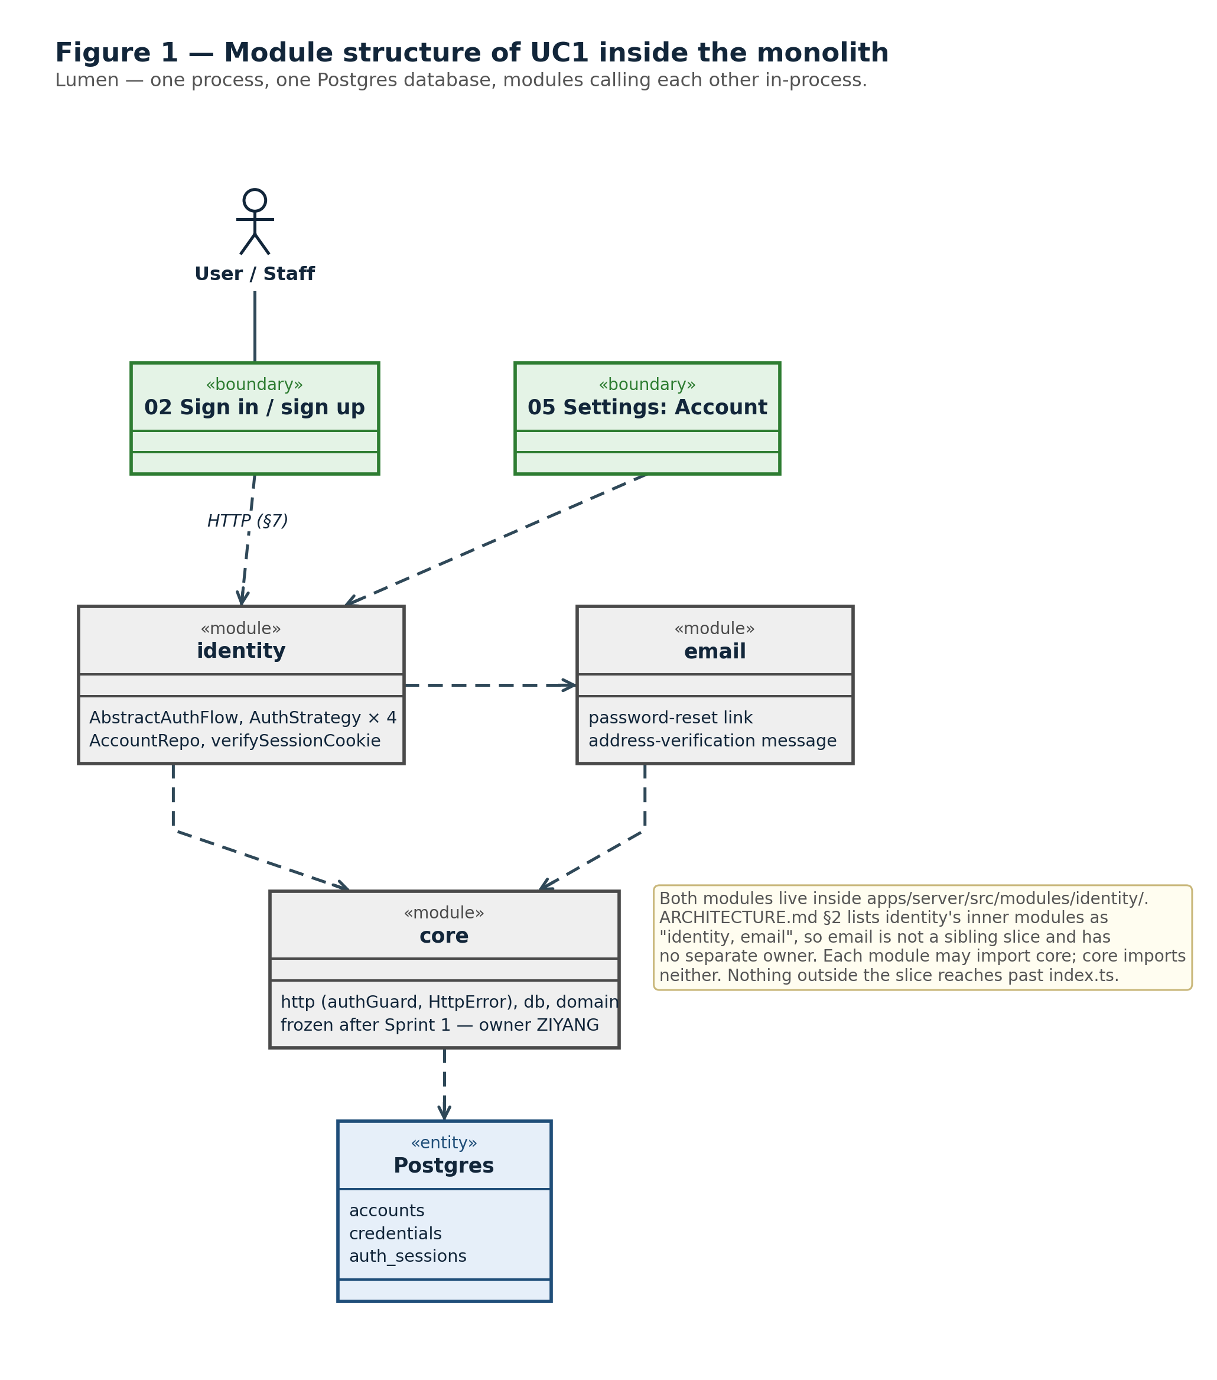
Figure 1 — Module structure of UC1 inside the monolith
Module | What it owns | May import | Taken apart in
identity | Authentication by all four routes (password, existing session, GitHub, Google), account records, and login sessions. Exposes verifySessionCookie so that the auth guard in core can resolve a request to a Principal without importing this slice. | core only | §2.1–§2.5
email | Outbound mail for the identity flows: the password-reset link and the address-verification message. Called in-process by identity; it publishes no HTTP endpoints of its own and owns no tables in this round. | core only; called by identity | §2.6
Table 1 — the two modules of UC1 and what each owns.
Three things the figure and the table fix:
- email is not a sibling slice. ARCHITECTURE.md §2’s module table lists identity’s inner modules as “identity, email”, so both live under the one slice directory. There is no modules/email directory and no second owner.
- The boundary rule holds for both. Each module may import core; core imports neither; nothing outside the slice reaches past identity/index.ts (CODING_STANDARDS.md). The third transition strategy in §2.2 is what makes real session verification reach core without breaking that rule.
- Only identity has a design problem. Its four authentication routes are what the pattern in §2.3 exists to solve.
Exactly two things cross the slice boundary outwards: the HTTP surface in §3, and the single exported function verifySessionCookie described in §2.5. Nothing else.

1.3 Sources, assumptions and open items
Two documents govern this slice, and they do not fully agree.
- The official Project Proposal (SWE5006 Project Proposal - Lumen.docx) — binding for grading. It fixes UC1’s scope, its back-end modules, the effort (10 person-days per member, 50 in total), and the required deliverable shape.
- The repository’s own documents (ARCHITECTURE.md, ONBOARDING.md, SLICES.md, CODEOWNERS), written by ZIYANG when scaffolding — what the team works against day to day.
Everything this design decided for itself, and every question it cannot answer alone, is collected below rather than left as remarks scattered through the later sections. The first four are decisions; the last six need someone else.
Decisions taken here
- auth_sessions, not sessions. core/db/schema.sql already has a sessions table meaning an agent session (UC3, tied to a project_id). The 2026-09-07 contract rewrite renamed that table, but the concept collision stands, so this slice’s login sessions get a distinctly named table (§2.5) and the analysis model names the class LoginSession (§2.1).
- One failure code for two failures. invalid_credentials covers both “no such account” and “wrong password” deliberately; distinguishing them would let an unauthenticated caller enumerate registered addresses. The same reasoning makes POST /api/auth/password/forgot answer 204 unconditionally.
- Staff routing is a client concern. There is no separate admin login. Every AuthStrategy and AbstractAuthFlow stays role-agnostic; the client reads Principal.role and redirects (§2.1).
- Other sessions survive a password change. POST /api/account/password revokes nothing else. Session revocation is a security feature UC1 does not claim, and inventing it here would put an unreviewed promise in the contract.
Open — needs someone else
- The two source documents disagree on the email module. The proposal’s use-case table (§6.1) lists UC1’s back-end modules as “identity, email”, while the repository scaffolds only modules/identity. Settled since, by ARCHITECTURE.md §2, which lists identity’s inner modules as “identity, email” — so email lives inside the identity folder with no separate owner, as §1.2 records. What remains open is that nobody has scaffolded it, so the password-reset endpoints of §3.5 are designed but not yet implementable.
- The two source documents disagree on the sprint calendar. The proposal’s §8.1 runs Sprint 1 from 1–14 September and Sprint 4 to 3 November; ONBOARDING.md compresses the same four sprints into 9-2→9-12, 9-15→9-26, 9-29→10-10, 10-13→10-24, and adds a 10-26 defence and an 11-10 final report that the proposal does not mention. §4.2 uses ONBOARDING.md’s dates because that is the calendar the team is actually operating on, but ZIYANG needs to pick one.
- The error shape does not match what core is building. The accepted core implementation — branch core/http-fastify, PR #5, not yet merged into main — defines a single HttpError class with four factories (badRequest(), unauthorized(), forbidden(), notFound(), for 400/401/403/404) and serialises every failure as { error: string }, where error carries the human-readable message. There is no machine-readable code field, and no 409 or 500 factory. Either §3.1 folds onto the single field core already has, or core/http/httpError.ts — frozen core — takes a reviewed edit. Undecided; it needs ZIYANG.
- core must accept the session-verifier port. The third transition strategy in §2.2 and its consequence in §2.5 need a small change to core/http/authGuard.ts, which CODEOWNERS assigns to ZIYANG and which is frozen after Sprint 1. Nothing in this slice can proceed to real authentication until that change is reviewed.
- Settings → Account has an ownership gap. SLICES.md lists “05 Settings → Account” as part of UC1, but CODEOWNERS gives the whole apps/web/src/pages/settings/ directory — currently one Settings.tsx — to HE RONG for billing. Proposed fix, for the team to confirm: split Settings.tsx into an owner-neutral shell plus per-tab components (AccountTab.tsx to identity, WalletTab.tsx and KeysTab.tsx to billing) and update CODEOWNERS to match.
- Two failure codes are proposed, not agreed. Every other code in Table 11 comes from a flow described in the proposal or the repository documents. invalid_body and oauth_not_configured were added so that the Failures column is complete, and they need whoever owns the shared error contract to accept them.

2. Module Design
§1.2 gave the two modules and how they call each other. This section takes each one apart. identity carries all of the behaviour, so it gets five subsections — its analysis model, the transition strategies that turn that model into a design, the design problem it owns and the pattern chosen for it, the resulting design model, and where all of it lands in the repository (§2.1–§2.5). email has one job and no internal variation, so it needs no pattern and gets one (§2.6).

2.1 The identity module — analysis model
The module in conceptual terms, before any TypeScript exists: boundary, control and entity only, with no pattern names — those belong to §2.3 and §2.4.
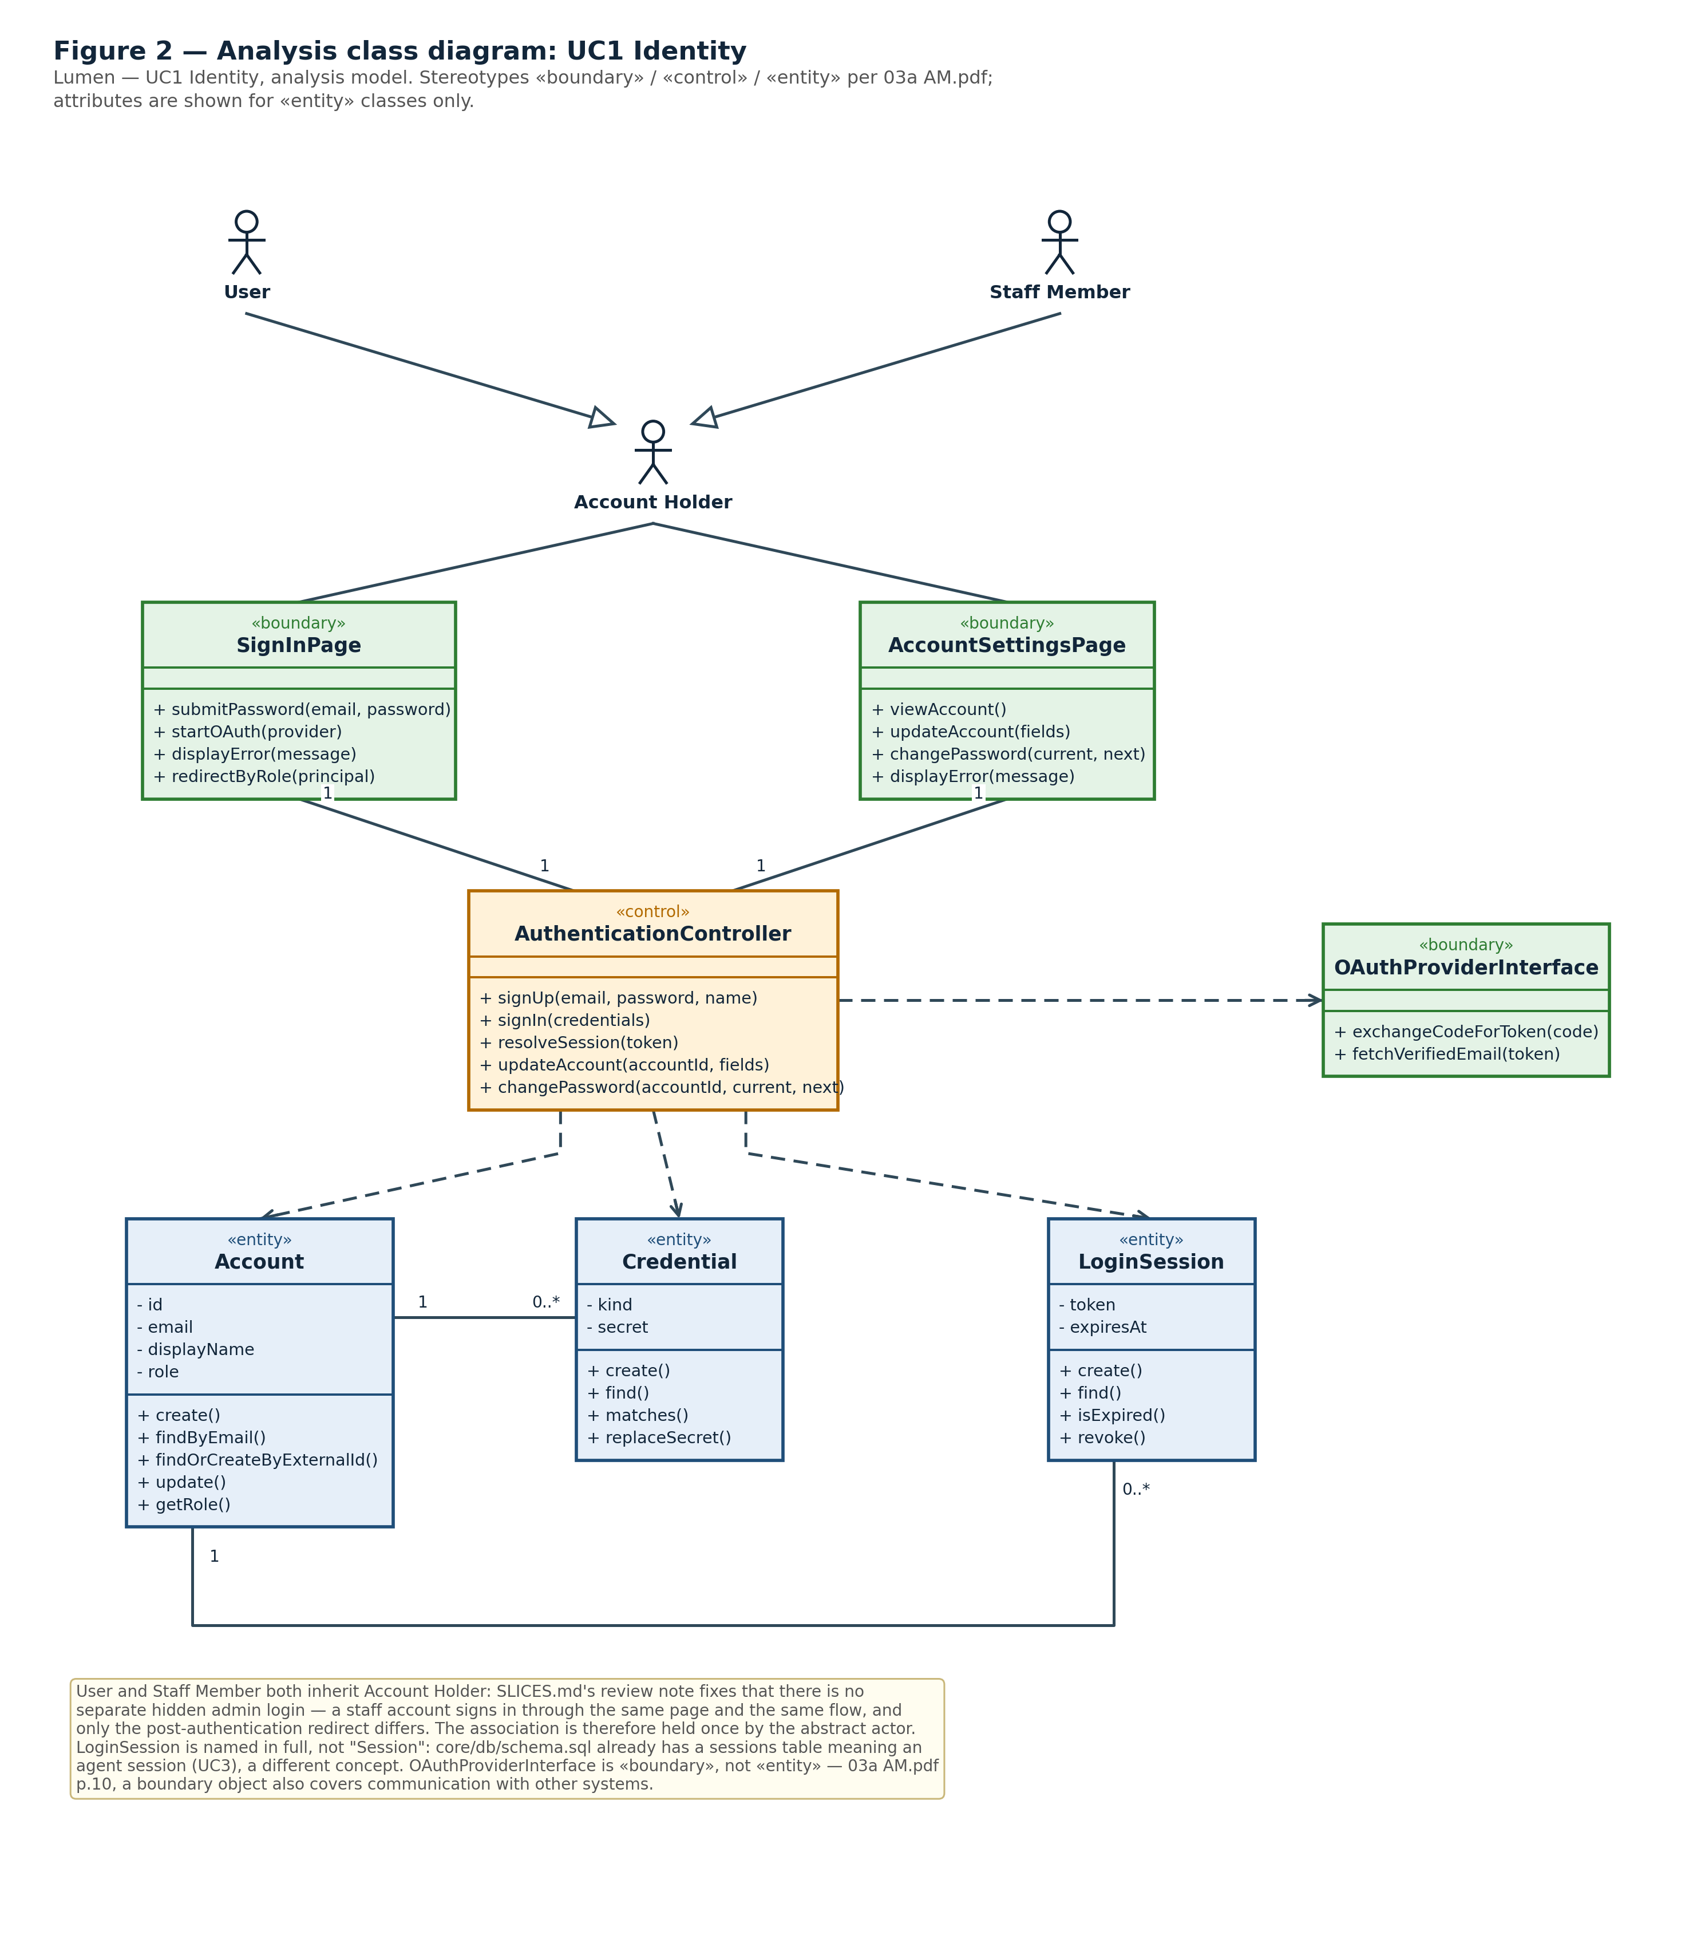
Figure 2 — Analysis class diagram: UC1 Identity
Class | Stereotype | Responsibility | Why it is here
SignInPage | «boundary» | Takes an email and password, or starts an OAuth exchange; redirects by role once a principal comes back | Page 02 in SLICES.md
AccountSettingsPage | «boundary» | Views and updates the account, and changes the password | Page 05, Account tab
AuthenticationController | «control» | The one control class for UC1: sign up, sign in, resolve an existing session, update the account | One control class per use case, 03a AM.pdf p.21
OAuthProviderInterface | «boundary» | Exchanges an authorisation code for a token, then for a verified email address | An external system is a boundary object, not an entity — 03a AM.pdf p.10
Account | «entity» | The person: identity, display name and role | accounts already exists in core/db/schema.sql
Credential | «entity» | One way one account can prove itself — a password hash, or a link to an external provider account | An account may hold several; adding a fifth kind must not disturb the others
LoginSession | «entity» | A live login, its opaque token and its expiry | See the naming decision in §1.3
Table 2 — analysis classes. Attributes are shown for «entity» classes only, per 03a AM.pdf; operations are derived from the messages each class receives in Figures 3 and 4.
Two modelling decisions worth defending, both visible in Figure 2:
- User and Staff Member both inherit the abstract actor Account Holder. SLICES.md’s review note is explicit that there is no separate hidden admin login: a staff account signs in through the same page and the same flow, and only the post-authentication redirect differs. Holding the association once, on the abstract actor, is what says that in the model.
- LoginSession is named in full, not Session. core/db/schema.sql already has a sessions table, and it means an agent session (UC3, tied to a project_id) — a different concept from a login session. §1.3 records the collision; §2.5 names the table auth_sessions to avoid it.

Sign in with email and password
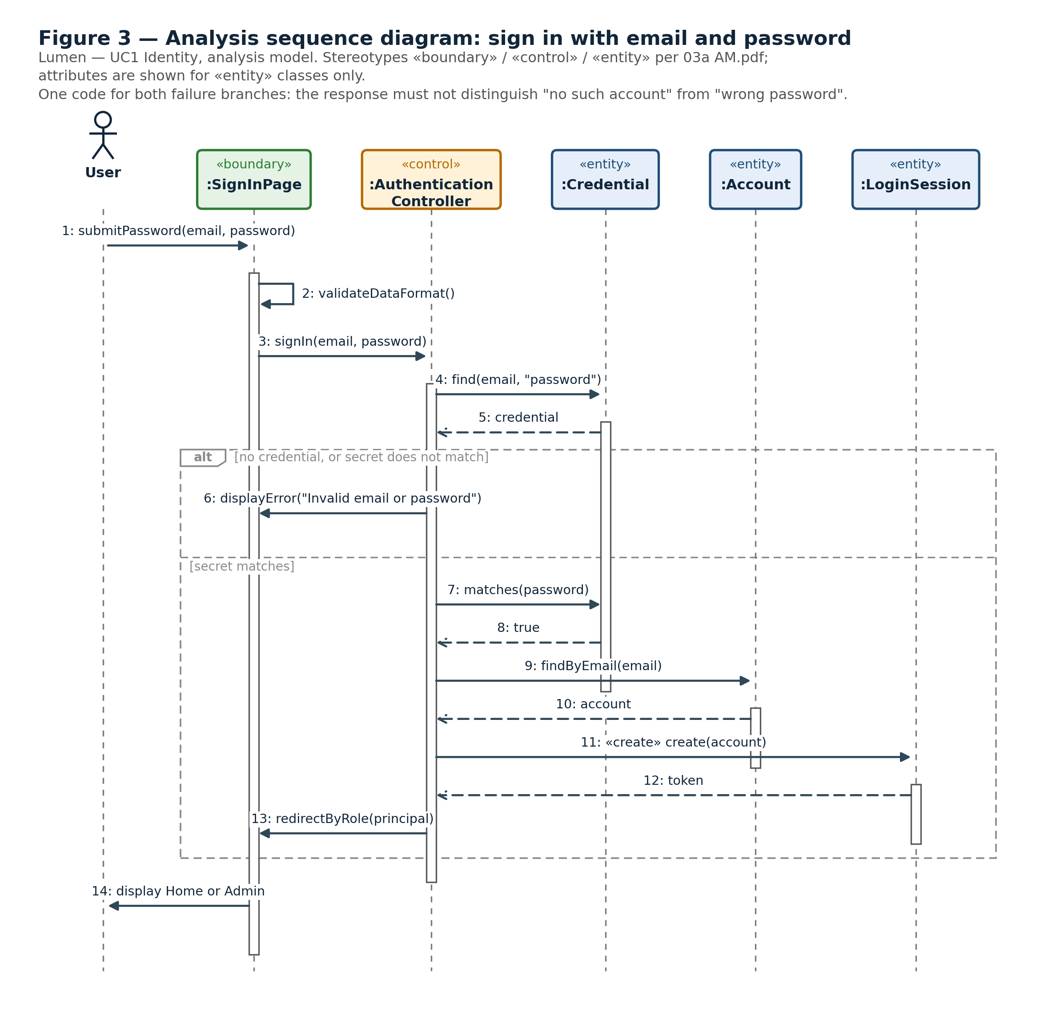
Figure 3 — Analysis sequence diagram: sign in with email and password
Both failure branches — no such credential, and a secret that does not match — collapse into one message. The response must not let a caller distinguish “no such account” from “wrong password”; §3.6 carries the same rule into the HTTP contract as a single invalid_credentials code.

Sign in with an OAuth provider
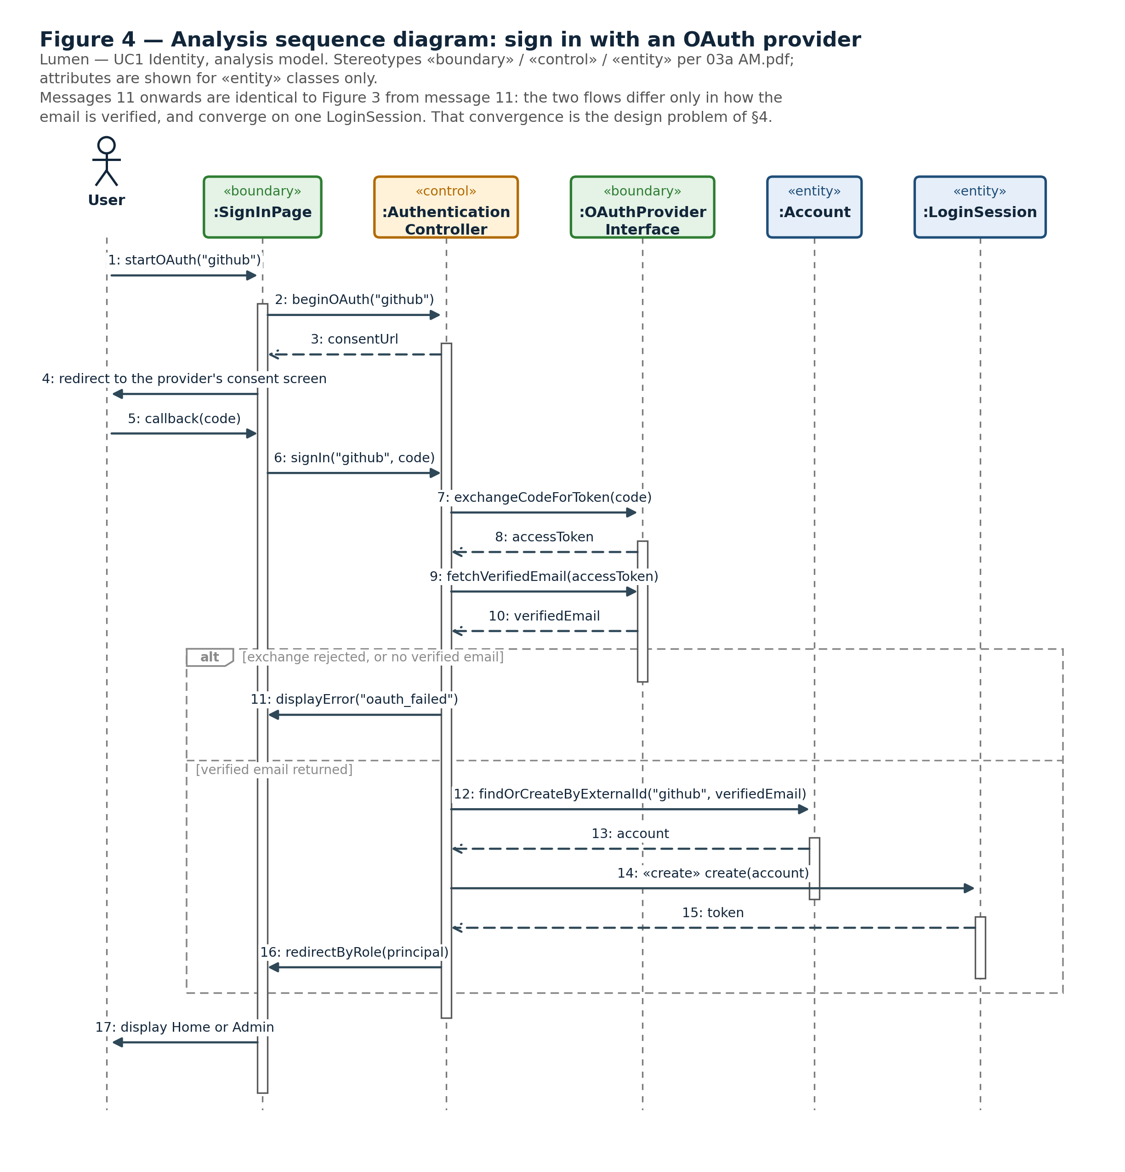
Figure 4 — Analysis sequence diagram: sign in with an OAuth provider
Figure 4 is the alternative flow of the same use case, and comparing it with Figure 3 states the design problem in one line: the two flows differ only in how the email address is verified, and from LoginSession.create onward they are identical. GitHub and Google differ from each other only in which endpoints are called. That convergence — four different beginnings, one shared ending — is what §2.3 has to solve.

2.2 The identity module — transition strategies
04a DM.pdf p.36 defines a transition strategy as a decision about one design concern, usually driven by a non-functional requirement, that constrains how a use case moves from analysis to design; a collection of them is what makes the resulting design uniform. p.37 fixes the shape each one is written in, and the three below follow it. They come before §2.4 because the design model is their consequence.

Programming language and standard library
Design concern | Which language, libraries and conventions the analysis objects become
Non-functional requirement | Maintainability — “the domain layer has no dependency on the agent library, the web framework or the database driver”; Security — password secrets must not be comparable in variable time
Impacted analysis objects | Credential, and the matches() operation on it
Impacted use cases | UC1, password sign-in and password change
Impacted static structure | One entity operation, Credential.matches()
Impacted dynamic interactions | Message 7 of Figure 3
Resulting design objects | PasswordStrategy, holding a private scryptCompare()
Resulting static structure | Strict TypeScript; operations carry parameter and return types, and every asynchronous operation returns Promise<T>. Hashing uses Node’s built-in crypto.scrypt — no new dependency enters the slice. Email lookups are normalised before comparison
Resulting dynamic interactions | Messages 3–8 of Figure 6
Justification | crypto.scrypt ships with the runtime the project already requires (Node 22), so the “no dependency on a third-party library” clause is satisfied by not adding one. crypto.timingSafeEqual under scryptCompare() keeps the comparison constant-time, so a failed sign-in leaks nothing about how nearly it succeeded

Persistence
Design concern | How analysis entities become rows, and which class is allowed to know that
Non-functional requirement | Maintainability — the domain layer has no dependency on the database driver
Impacted analysis objects | Account, Credential, LoginSession
Impacted use cases | UC1 in full
Impacted static structure | All three entity classes and their create() / find() operations
Impacted dynamic interactions | Every message in Figures 3 and 4 that reaches an entity
Resulting design objects | One repository class, AccountRepo, plus the tables credentials and auth_sessions (§2.5)
Resulting static structure | The entity operations of the analysis model collapse into AccountRepo, which is the only class in the slice that issues SQL. The strategies and the flow depend on it and never on the driver. accounts already exists in core/db/schema.sql; this slice adds the other two
Resulting dynamic interactions | In Figures 6 and 7 every database access is a message to :AccountRepo, which then talks to :Postgres. No other lifeline touches the database
Justification | One repository is what makes the “no dependency on the database driver” clause checkable by reading imports, and it is what lets PasswordStrategy be unit-tested against a stub repository rather than a live Postgres. The token is stored as token_hash, never in clear, so a database dump does not yield usable session cookies

Layering and the slice boundary
Design concern | How the shared HTTP layer authenticates a request without importing this slice
Non-functional requirement | Maintainability and Extensibility — CODING_STANDARDS.md: core may never import a slice; Security — every request must pass real verification once it exists
Impacted analysis objects | AuthenticationController.resolveSession(), LoginSession
Impacted use cases | UC1, and every other use case, because every request passes the guard
Impacted static structure | core/http/authGuard.ts, which today trusts a stub header through principalFromHeader
Impacted dynamic interactions | The resolve-session flow, and the first step of every other request in the system
Resulting design objects | SessionStrategy and the function verifySessionCookie it backs
Resulting static structure | authGuard.ts gains a module-level port, registerSessionVerifier(verify), and calls the registered verifier instead of the stub. identity/index.ts exports verifySessionCookie. apps/server/src/main.ts — the composition root, which already imports every slice — adds one line at bootstrap. Neither core nor identity imports the other. The three lines this costs are in §2.5
Resulting dynamic interactions | Unchanged for callers: the guard still returns a Principal or null. Only the implementation behind it moves
Justification | Inverting the dependency is the only way to satisfy both rules at once, and it is what ONBOARDING.md describes when it says 「陆一的真登录上线之前，大家先用桩账号开发；他一上线，全员切过去」 — before LU YI’s real login ships everyone develops against stub accounts, and the moment it ships everyone switches over. A port makes that switch one line in the composition root instead of an edit to every caller. It does need a small reviewed change to core, which is frozen after Sprint 1 — see §1.3

2.3 The identity module — design problem and pattern
The design problem this slice owns, quoted from the Project Proposal §6.4:
Four ways to become authenticated: GitHub, Google, email with password, and an existing session. Each exchange differs, all of them must end in one session, and a fifth must not change the session code.
The problem statement contains its own solution shape. It names one thing that varies — the exchange — and two that must not: the session that every route ends in, and the code that issues it. A pattern that fixes the algorithm once and lets only the varying step be substituted is exactly what is being asked for.
Chosen: Strategy with Template Method.
- AbstractAuthFlow.authenticate() is the template method. It fixes the three-step algorithm exactly once — find the strategy whose kind matches, call verify(), call onAuthenticated() — and no subclass overrides it.
- AuthStrategy is the strategy interface. Each concrete strategy supplies only verify(), the one step that actually differs between the four routes. PasswordStrategy compares a scrypt hash; SessionStrategy looks up a token; GithubStrategy and GoogleStrategy exchange an authorisation code for a verified email.
Three consequences, each answering a clause of the problem statement:
The problem says | The pattern answers
“each exchange differs” | Each exchange is one verify() in one class, and nothing else in the module needs to know which one ran
“all of them must end in one session” | onAuthenticated() runs from a single place inside the template method, for every route. It is structurally impossible for a route to skip it
“a fifth must not change the session code” | A fifth way in is one new class realising AuthStrategy, registered in strategies(). authenticate() and onAuthenticated() are untouched
Table 3 — how the chosen pattern answers the design problem.
Considered and rejected. The proposal’s §6.4 names candidate patterns as a hypothesis, not a conclusion, so the three nearest alternatives are compared here rather than assumed away.
- Strategy alone, without the template method. Each of the four strategies implements the whole flow. The varying step is isolated, but nothing then guarantees that “all of them must end in one session”: every strategy has to remember to call onAuthenticated(), and one that forgets is a login route issuing no session. The fifth way in has to remember it too. The second clause of the problem statement asks for exactly that guarantee, so Strategy on its own does not answer it.
- A factory. It produces the right handler for a kind, but it answers only which one, never what stays fixed once one is chosen. The lookup in strategies() already answers which one, so a factory above it adds no constraint that the problem statement asks for.
- Chain of responsibility. Four handlers try in turn until one claims the request. It would run, but the semantics are wrong: kind is stated by the caller, so nothing needs probing. It also makes “wrong password” hard to separate from “no such kind”, which contradicts §3.6, where invalid_credentials and unsupported_kind are deliberately distinct codes.
A fourth consequence is not in the problem statement but matters for the Definition of Done: each verify() is a unit that can be tested on its own against a stub AccountRepo, rather than through the whole login path.

2.4 The identity module — design model
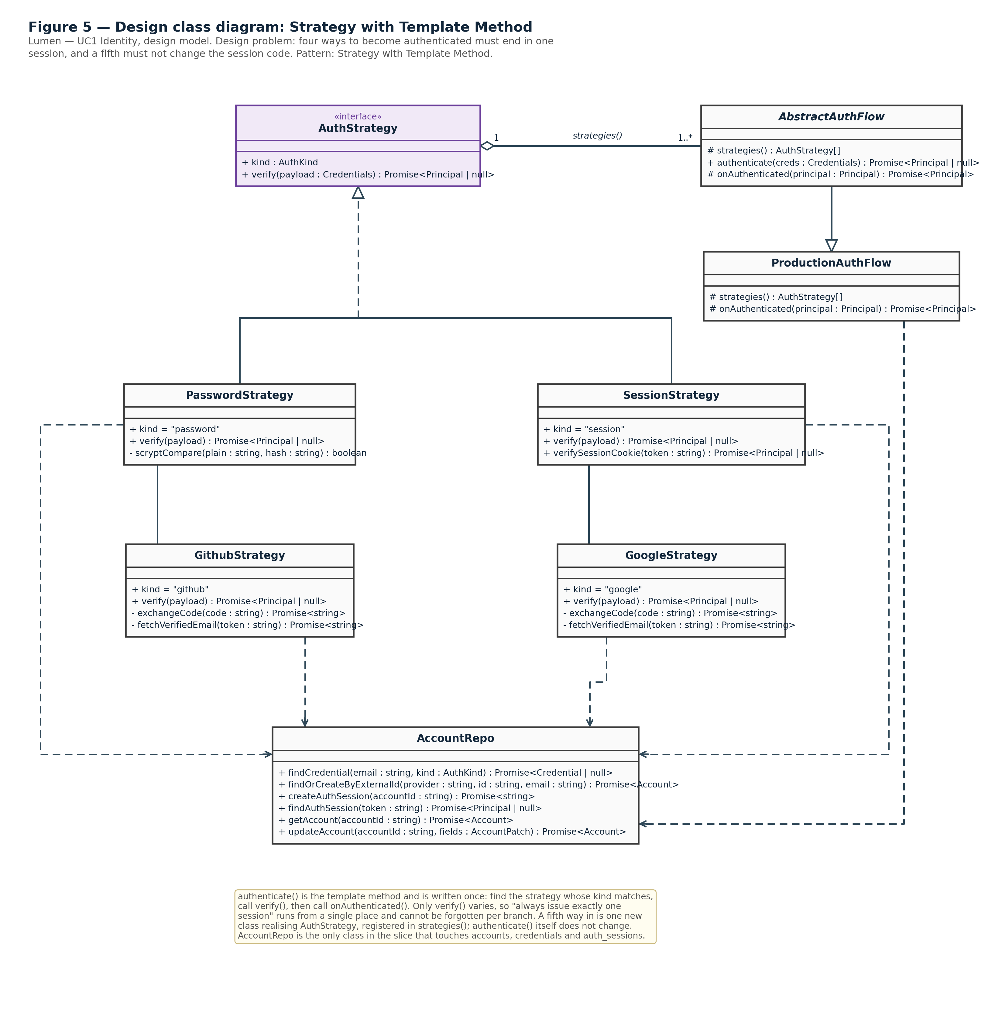
Figure 5 — Design class diagram: Strategy with Template Method
Read together with §2.2, the table below is the audit trail from Figure 2 to Figure 5: every analysis class is accounted for, and no design class appears without a reason for existing.
Analysis (Figure 2) | Design (Figure 5) | What moved it
AuthenticationController | AbstractAuthFlow + ProductionAuthFlow | The pattern, §2.3 — the control class splits into a fixed algorithm and the concrete flow that supplies the strategy list
Credential.matches() | PasswordStrategy.verify() with a private scryptCompare() | Programming language, §2.2
OAuthProviderInterface | GithubStrategy and GoogleStrategy, each with exchangeCode() and fetchVerifiedEmail() | Programming language, §2.2; and the pattern, §2.3
LoginSession | AccountRepo.createAuthSession() / findAuthSession() over the auth_sessions table | Persistence, §2.2
Account, Credential | AccountRepo, the only class issuing SQL | Persistence, §2.2
AuthenticationController.resolveSession() | SessionStrategy, reused as verifySessionCookie behind the guard’s port | Layering, §2.2
Table 4 — the analysis model mapped onto the design model.

Password login
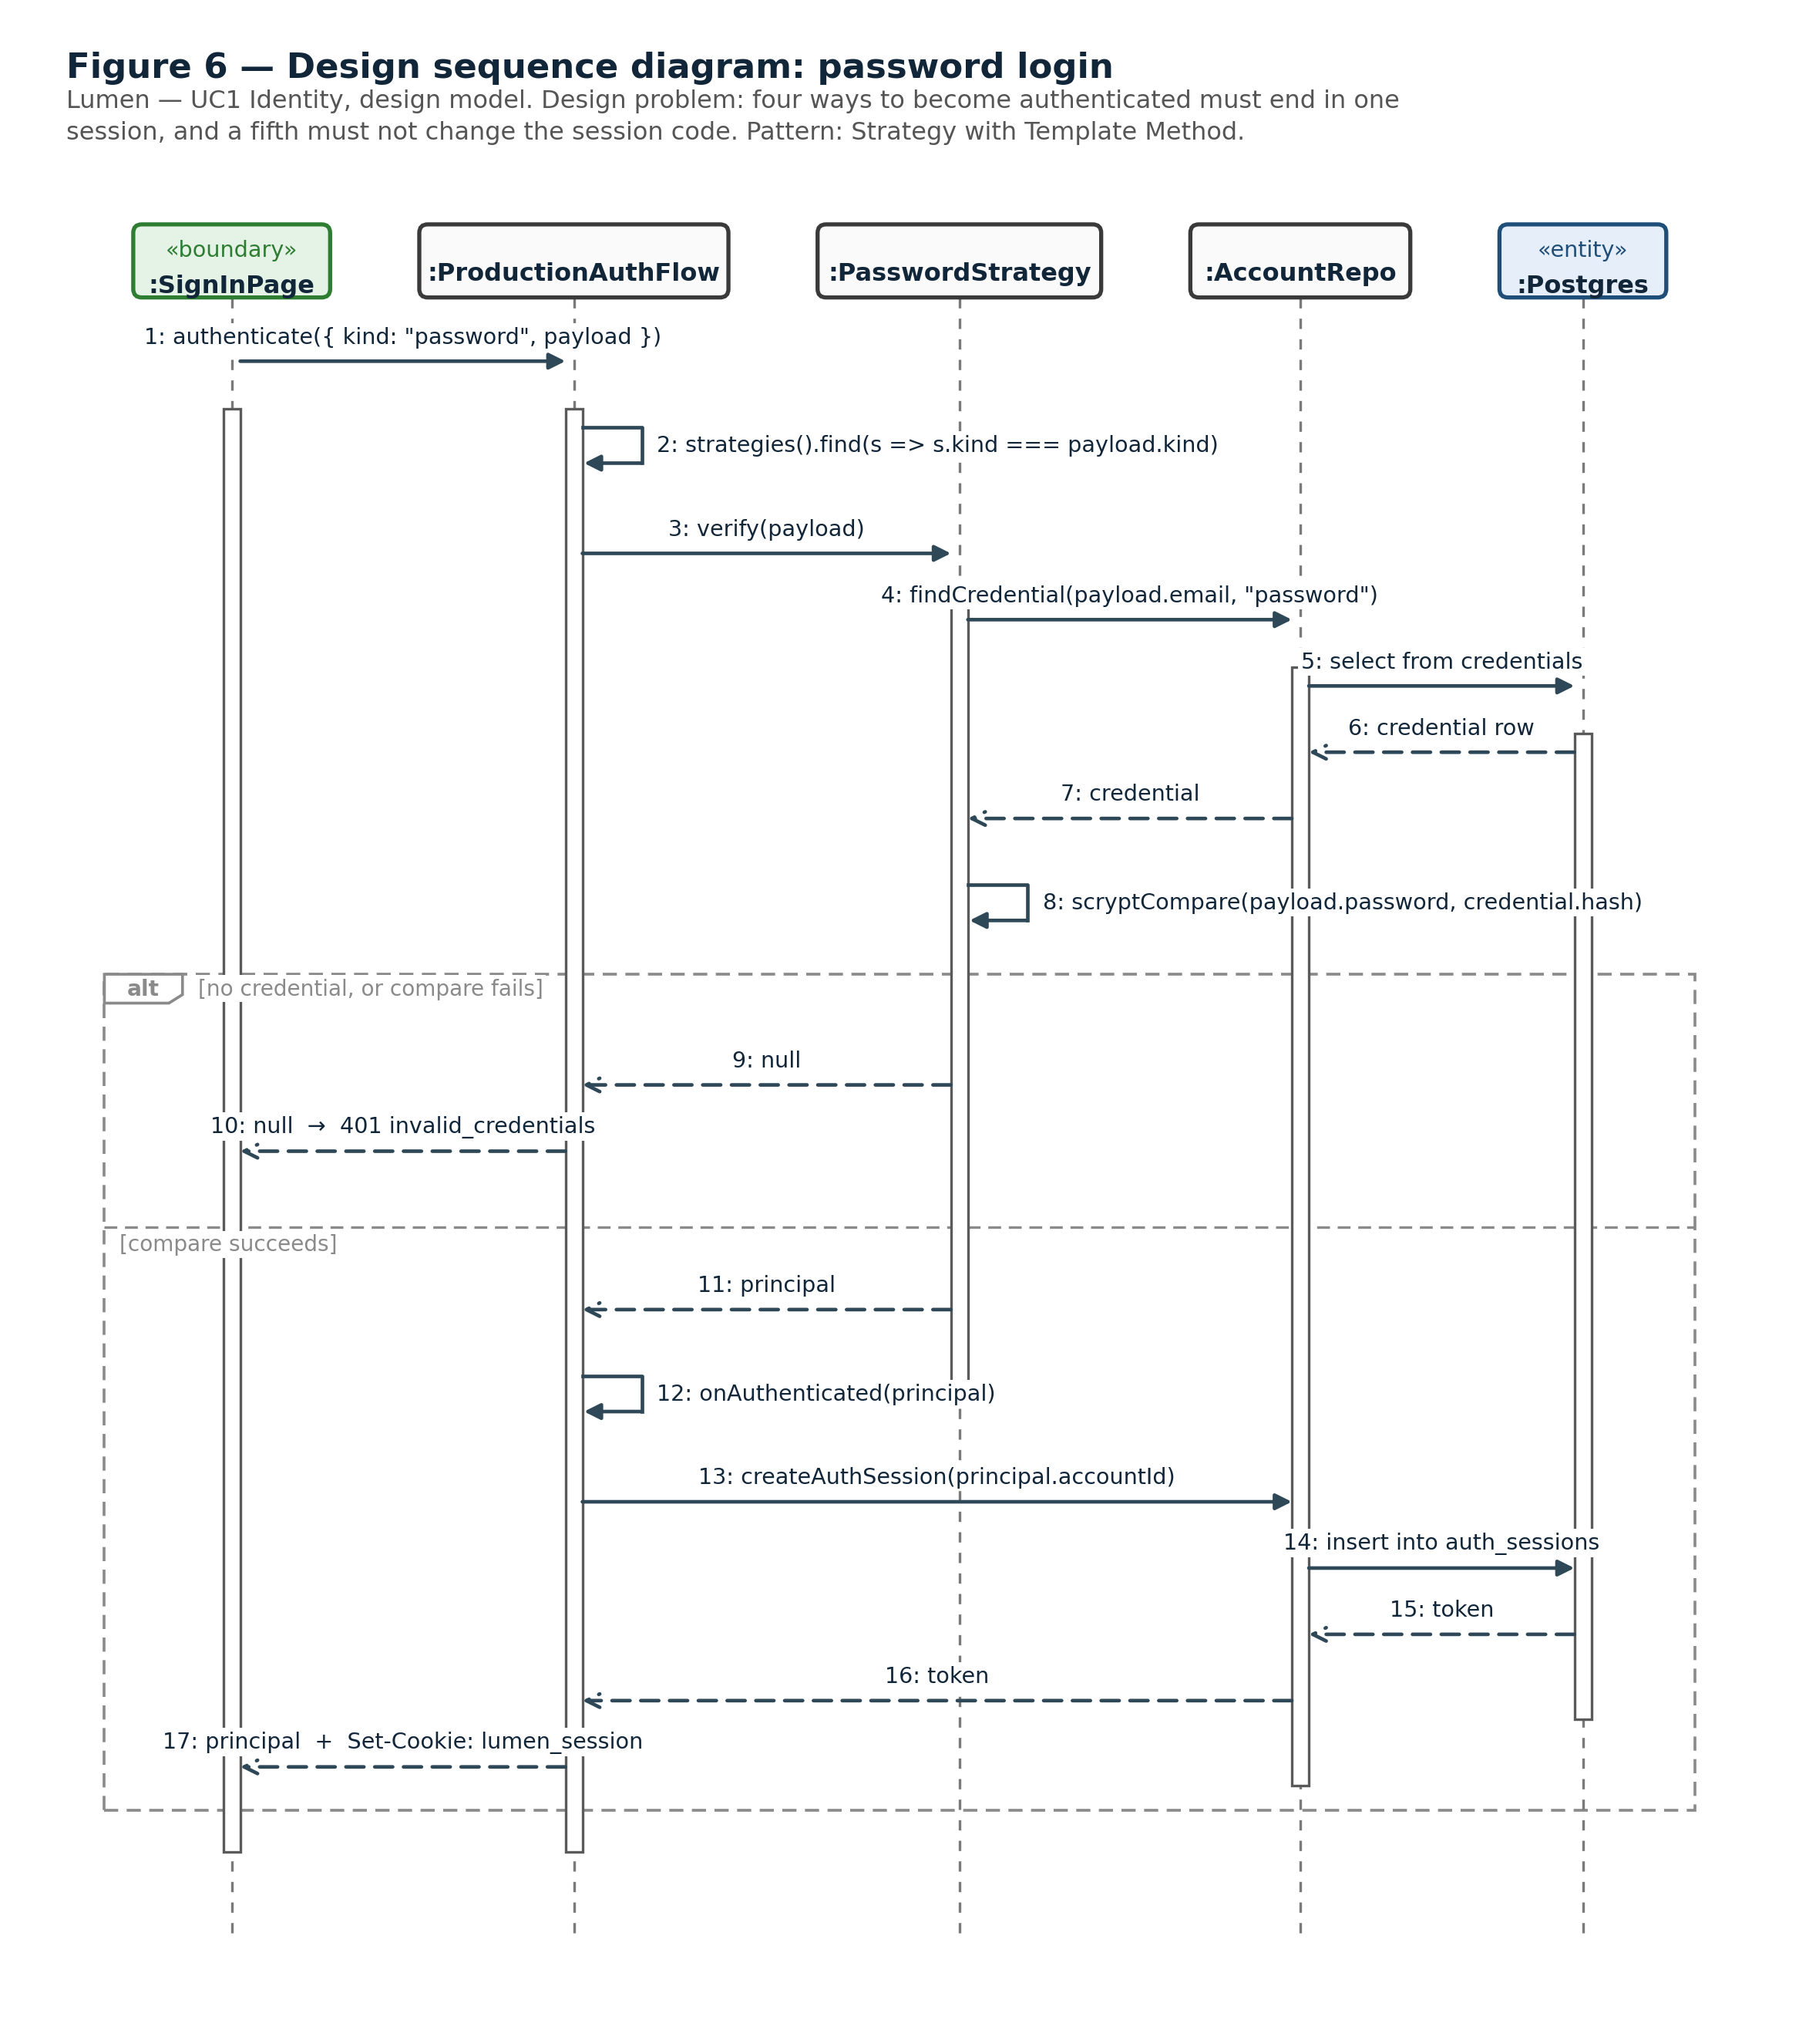
Figure 6 — Design sequence diagram: password login

GitHub OAuth login
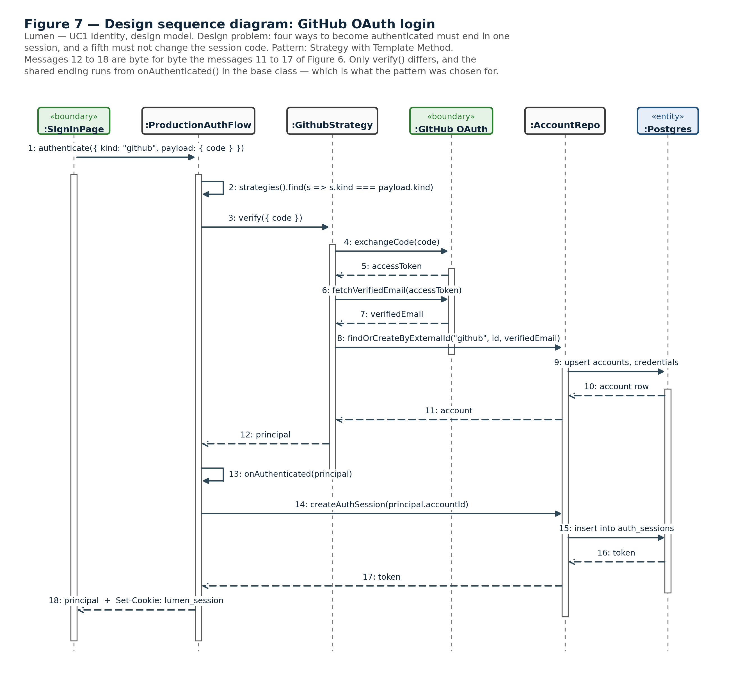
Figure 7 — Design sequence diagram: GitHub OAuth login
Messages 12 to 18 of Figure 7 are, message for message, messages 11 to 17 of Figure 6. Only verify() differs. The shared ending runs from onAuthenticated() in the base class, which is the whole point of the pattern and the reason Figure 7 is worth printing next to Figure 6 rather than described in a sentence.
Google login and the session check are the same two diagrams again with GoogleStrategy or SessionStrategy substituted, so they are not repeated.

2.5 The identity module — files, storage and wiring
Where the design model of §2.4 lands in the repository. Everything is inside apps/server/src/modules/identity/ except the schema migration and the one line in the composition root, both of which touch core-owned files and therefore need ZIYANG’s review.

Files
The folder currently holds a README and an empty index.ts — the 2026-09-07 contract rewrite removed the earlier scaffolding — so every file below is new.
File | Responsibility | Sprint
authStrategy.ts | The AuthStrategy interface, the Credentials type and AbstractAuthFlow | 1
passwordStrategy.ts | PasswordStrategy. Hashing via Node’s built-in crypto.scrypt (§2.2) — normalised email lookup, timing-safe compare | 1
sessionStrategy.ts | SessionStrategy. Looks up auth_sessions by opaque token and rejects it if expired. Used both as an AuthStrategy (kind: 'session') and directly by verifySessionCookie | 1
accountRepo.ts | The only file in the slice touching accounts, credentials and auth_sessions (§2.2) | 1
productionAuthFlow.ts | The concrete AbstractAuthFlow. strategies() returns password and session from Sprint 1, plus github and google once Sprint 3 lands — the template method does not change either way. onAuthenticated persists an auth_sessions row | 1
githubStrategy.ts | GithubStrategy. Exchanges an OAuth code for an access token, fetches the verified primary email, calls accountRepo.findOrCreateByExternalId | 3
googleStrategy.ts | The same shape against Google’s OAuth/OpenID endpoints | 3
identity.test.ts | Unit tests written against Figure 5: each verify() alone, AccountRepo against a test database, and authenticate() against stub strategies | 1 and 3
index.ts | The public index. Adds verifySessionCookie, ProductionAuthFlow, and whatever the sign-in page needs at the HTTP layer | 1
Table 5 — file-by-file plan. Nothing outside modules/identity imports any of these except through index.ts (CODING_STANDARDS.md).

Storage
A change to the core-owned apps/server/src/core/db/schema.sql, so per CODEOWNERS it goes through ZIYANG’s review even though the tables hold this slice’s data.
-- identity slice — LU YI. Adds credential storage and login sessions.
-- Named auth_sessions, not sessions: the existing `sessions` table is an
-- agent/project session (UC3), a different concept from a login session.
create table if not exists credentials (
id uuid primary key default gen_random_uuid(),
account_id uuid not null references accounts(id),
kind text not null check (kind in ('password', 'github', 'google')),
password_hash text,
external_provider text,
external_id text,
created_at timestamptz not null default now(),
unique (kind, external_provider, external_id)
);
create table if not exists auth_sessions (
id uuid primary key default gen_random_uuid(),
account_id uuid not null references accounts(id),
token_hash text not null unique,
created_at timestamptz not null default now(),
expires_at timestamptz not null
);

Wiring real session verification into core
The third transition strategy of §2.2 costs exactly three lines.
- core/http/authGuard.ts gains registerSessionVerifier(verify: (token: string) => Promise<Principal | null>) and calls the registered verifier in front of the Sprint 1 stub principalFromHeader.
- identity/index.ts exports verifySessionCookie, a thin wrapper around SessionStrategy.verify.
- apps/server/src/main.ts adds registerSessionVerifier(verifySessionCookie) at bootstrap.
main.ts is the composition root and already imports every slice directly, so it is allowed to import both sides; it is not itself core and not a slice.

2.6 The email module
Responsibility | Two outbound messages, both triggered by identity and by nothing else: the password-reset link, and the address-verification message sent after signup
Callers | identity only, in-process. POST /api/auth/password/forgot (§3.5) hands it an address; signup hands it a new account’s address
Interface | Called through the slice’s own public index, not over HTTP. It publishes no endpoints
Data | None. It owns no tables this round; the reset token lives in identity’s own storage, and the module is handed the address and the token to send
Design problem | None. There is one way to send a message and no variation to absorb, so no pattern applies
Status | Not designed this round. Nobody has scaffolded the module and no owner has been assigned — see §1.3. The two endpoints that call it are designed in §3.5 and become implementable the moment it exists
Table 6 — the email module.
Designing its internals now would mean guessing at a mail transport, a template mechanism and a retry policy that nobody has agreed, and then handing the eventual owner a design they did not write. What this document does commit to is the boundary: email is called in-process by identity, imports only core, and publishes nothing of its own.

3. API
The HTTP interface the two modules of §1.2 expose to the rest of the system. identity publishes all of it; email publishes none, and appears here only as what stands behind §3.5.
JSON over HTTP. The server framework is not chosen on main yet, and the other four slices have not published their own contracts, so this section is written as this slice’s own commitment: the endpoints identity will expose, complete enough for the sign-in page and the Settings → Account tab to be built against them, and for another owner to read without asking. Wiring waits on whatever core exposes (§1.3), but the contract does not.

3.1 Conventions
Session cookie. lumen_session — httpOnly, Secure, SameSite=Lax, an opaque token that maps to auth_sessions.token_hash. Set on a successful login or signup, refreshed on a successful session check, cleared on logout.
Error shape. The shape proposed for packages/contracts, which is frozen and so needs the PM’s sign-off:
interface ApiError {
readonly error: string; // machine-readable, e.g. "invalid_credentials"
readonly message: string; // human-readable
}
This does not match what core will actually provide, and the mismatch is unresolved — see §1.3. The status codes below are unaffected either way; only the body shape is in question.
Reading the endpoint tables. §3.2 to §3.5 take one group of endpoints each and give, per endpoint, how it is called, what a successful call returns, and every failure it can produce. The failure codes are defined once in §3.6; Principal is §3.7.

3.2 Authentication endpoints
Method and path | How it is called | Success | Failures
POST  /api/auth/signup | Body { email, password, displayName }. No cookie required. | 201  { principal: Principal }  + Set-Cookie: lumen_session | 409 email_taken  400 invalid_body
POST  /api/auth/login  (password) | Body { kind: 'password', email, password }. Calls ProductionAuthFlow.authenticate({ kind, payload }). | 200  { principal: Principal }  + Set-Cookie: lumen_session (refreshed) | 401 invalid_credentials  400 invalid_body  400 unsupported_kind (for kind: 'github' / 'google')
POST  /api/auth/login  (session) | Body { kind: 'session' } plus the lumen_session cookie. Resolved by SessionStrategy. | 200  { principal: Principal }  + Set-Cookie: lumen_session (refreshed) | 401 invalid_credentials — cookie missing, unknown, or past expires_at
POST  /api/auth/logout | Empty body, lumen_session cookie. | 204, no body. Clears the cookie and deletes its auth_sessions row. | None. Logging out without a valid session still returns 204 — the call is idempotent.
GET  /api/auth/me | No body, lumen_session cookie. What the client calls on page load, and what the role-based /admin redirect reads. | 200  { principal: Principal } | 401 not_authenticated
Table 7 — authentication endpoints. All five run through ProductionAuthFlow.authenticate() (Figure 6).

3.3 OAuth endpoints (Sprint 3)
OAuth needs a browser redirect rather than a JSON round trip, which is why kind: 'github' and kind: 'google' are rejected at POST /api/auth/login and get this start/callback pair instead. Both callbacks answer with a redirect, so their failures arrive as a query parameter on /signin, not as a JSON error body.
Method and path | How it is called | Success | Failures
GET  /api/auth/oauth/  github/start | Browser navigation. No body, no cookie. | 302 to GitHub’s consent screen. GITHUB_OAUTH_CLIENT_ID from .env, scope: verified email only. | 500 oauth_not_configured — client id or secret missing from .env
GET  /api/auth/oauth/  github/callback?code=… | GitHub redirects the browser here with code. Calls authenticate({ kind: 'github', payload: { code } }). | 302 to / or /admin by role  + Set-Cookie: lumen_session | 302 to /signin?error=oauth_failed — code exchange rejected, or no verified email on the provider account
GET /api/auth/oauth/  google/start  GET /api/auth/oauth/  google/callback?code=… | The same shape as the GitHub pair, against Google’s OAuth/OpenID endpoints and GOOGLE_OAUTH_CLIENT_ID / GOOGLE_OAUTH_CLIENT_SECRET. | Same as GitHub. | Same as GitHub.
Table 8 — OAuth endpoints. Both providers run the same authenticate() shape with a different AuthStrategy (Figure 7).

3.4 Account endpoints
All three require a valid lumen_session cookie and all three return 401 not_authenticated without one, so that row is not repeated per endpoint.
Method and path | How it is called | Success | Failures
GET  /api/account | No body, lumen_session cookie. | 200  { accountId, email, displayName, role }, role being 'user' or 'staff' | 401 not_authenticated
PATCH  /api/account | Body { displayName?, email? } — both optional, at least one required. | 200  { accountId, email, displayName, role }, the updated record | 401 not_authenticated  409 email_taken (the new address is already in use)  400 invalid_body (empty patch, or malformed address)
POST  /api/account/password | Body { currentPassword, newPassword }, lumen_session cookie. | 204, no body. Other login sessions are deliberately left alive — revoking them is outside UC1’s scope. | 401 invalid_credentials (wrong currentPassword)  401 not_authenticated  400 invalid_body (new password fails the length rule)
Table 9 — account endpoints, behind Settings → Account. The ownership caveat on that page is in §1.3.

3.5 Password-reset endpoints
Both endpoints hand work to the email module (§2.6), which is why both are designed here but neither is implementable yet.
Method and path | How it is called | Success | Failures
POST  /api/auth/  password/forgot | Body { email }. No cookie. Hands the address to the email module, which sends the reset link. | 204 always, whether or not the address exists — the response must not reveal which addresses are registered. | 400 invalid_body only (missing or malformed address). A rate limit belongs here but is not designed this round.
POST  /api/auth/  password/reset | Body { token, newPassword }. No cookie — the token is the proof. | 204, no body. | 400 invalid_or_expired_token (unknown, already used, or past expiry)  400 invalid_body
Table 10 — password-reset endpoints.

3.6 Failure codes
Every failure the endpoints above can return, in one place, so the client pages can be written against a closed set.
Code | Status | When | Returned by
invalid_body | 400 | A required field is missing, or a field fails its format or length rule. Raised before any strategy runs. | signup, both login shapes, PATCH /api/account, POST /api/account/password, both password/* endpoints
invalid_credentials | 401 | Password sign-in failed, the session cookie is absent, unknown or expired, or currentPassword is wrong. One code covers all of these on purpose — the response must not distinguish “no such account” from “wrong password” (§2.1) | POST /api/auth/login, POST /api/account/password
not_authenticated | 401 | The endpoint needs a signed-in caller and there is no valid session | GET /api/auth/me, GET/PATCH /api/account, POST /api/account/password
unsupported_kind | 400 | Called with kind: 'github' or 'google', which go through the OAuth start/callback pair instead | POST /api/auth/login
email_taken | 409 | The address already belongs to another account | POST /api/auth/signup, PATCH /api/account
invalid_or_expired_token | 400 | The reset token is unknown, already used, or past its expiry | POST /api/auth/password/reset
oauth_failed | 302 | The provider rejected the code exchange, or the account has no verified email. Not a JSON body — it arrives as /signin?error=oauth_failed | both OAuth callbacks
oauth_not_configured | 500 | The provider’s client id or secret is missing from .env | both OAuth start endpoints
Table 11 — the closed set of identity failures.
Two absences worth stating. There is no 403: role never gates an identity endpoint, because a staff account signs in through exactly the same flow as anyone else and /admin routing is a client-side read of Principal.role (§2.1). And there is no 404: unknown paths are core’s router concern, not this module’s.

3.7 Principal
The one type every endpoint above returns. Already defined in core/http/authGuard.ts, which is core-owned:
interface Principal {
readonly accountId: string;
readonly role: 'user' | 'staff';
}

4. Effort Estimate

4.1 By proposal task
The proposal fixes this precisely in §8: five members at ten person-days each, fifty in total, split into seven tasks. For LU YI, the 10-day budget lands as:
Category (proposal task) | Days | This slice’s work
Common: requirements, backlog, sprint plans, shared contract, schema and pipeline (tasks 1–2, split five ways) | 1.6 | The same for every member — no identity-specific content
Analysis and design of UC1 (task 3) | 2.0 | Figures 1–7 and the transition strategies in §2.2
Design problem: Strategy with Template Method (task 4) | 1.4 | §2.3 — the problem, the chosen pattern and its justification
Build the identity vertical slice (task 5) | 3.4 | The nine files in Table 5, the sign-in page and the Settings → Account tab. Not started: this round is documents only
Pipeline jobs for identity (task 6) | 0.8 | CI already runs SCA and CodeQL generically; the identity-specific concerns are OAuth secret handling and login-endpoint coverage once DAST has a target (Sprint 2 onward, per DOD.md)
Integration, hardening, report, presentation (task 7, split five ways) | 0.8 | The same for every member
Total | 10.0
Table 12 — effort by proposal task. The 10.0-day category total is the number the proposal grades against.

4.2 By sprint
Mapped onto ONBOARDING.md’s calendar — see the date caveat in §1.3.
Sprint | Dates | Identity work | Days
1 | 9-2 – 9-12 | Shared-contract share (0.8) + this design document (2.0) + start of build: password and session strategies, AccountRepo, the migration and the registerSessionVerifier wiring (2.2 of the 3.4 build days) | ~5.0
2 | 9-15 – 9-26 | Rest of build: the sign-in page, the Settings → Account tab (pending the ownership item in §1.3) and the account endpoints (1.2 of the 3.4 build days) | ~1.2
3 | 9-29 – 10-10 | The design-problem write-up (1.4) and the GitHub / Google OAuth build | ~1.4
4 | 10-13 – 10-24 | Pipeline jobs (0.8) and the shared integration and report (0.8) | ~1.6
Total |  |  | ~10.0
Table 13 — the weekly shape is illustrative; the fixed number the proposal grades against is the 10.0-day category total in Table 12.

