**配置yarn核心组件**

1. **配置以下的核心配置文件**

yarn-env.sh

|  |
| --- |
| export JAVA_HOME=/usr/java/jdk1.8.0_181-amd64 |

yarn-site.xml

|  |
| --- |
| <configuration>  <!-- Site specific YARN configuration properties -->  <!-- reducer获取数据的方式 -->  <property>  <name>yarn.nodemanager.aux-services</name>  <value>mapreduce_shuffle</value>  </property>  <!-- 指定YARN的ResourceManager的地址 -->  <property>  <name>yarn.resourcemanager.hostname</name>  <value>Hadoop-002</value>  </property>  </configuration> |

mapred-env.sh

|  |
| --- |
| export JAVA_HOME=/usr/java/jdk1.8.0_181-amd64 |

mapred-site.xml

注意首先要以mapred-site-template.xml为模版复制一个新建文件，命名为mapred-site.xml

cp -a etc/hadoop/mapred-site-template.xml etc/hadoop/mapred-site.xml

|  |
| --- |
| <configuration>  <!-- 指定mr运行在yarn上 -->  <property>  <name>mapreduce.framework.name</name>  <value>yarn</value>  </property>  </configuration> |

1. **分发配置文件到另外二台主机**
   1. 分发到hadoop-002

scp -r ~/bigdatasoftware/hadoop-2.7.2/etc/hadoop/* hadoop@hadoop-003:/home/hadoop/bigdatasoftware/hadoop-2.7.2/etc/hadoop/

* 1. 分发到hadoop-003

scp -r ~/bigdatasoftware/hadoop-2.7.2/etc/hadoop/* hadoop@hadoop-003:/home/hadoop/bigdatasoftware/hadoop-2.7.2/etc/hadoop/

1. **分发配置环境变量文件** 
   1. 分发到hadoop-002

scp -r ~/.bash_profile hadoop@hadoop-002:/home/hadoop/

* 1. 分发到hadoop-003

scp -r ~/.bash_profile hadoop@hadoop-003:/home/hadoop/

1. **执行环境变量文件**
   1. source ~/. bash_profile（另外两台主机也要执行）
2. **启动yarn组件**
   1. **在第二台主机(hadoop-002)：**

start-yarn.sh

1. **观察3台主机的进程**
   1. **Hadoop-001**

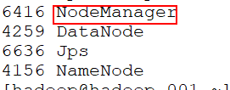

* 1. **Hadoop-002**

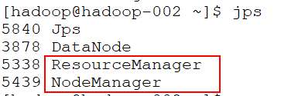

* 1. **Hadoop-003**

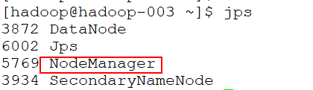

1. **打开浏览器，访问以下地址：**[http://hadoop-002:8088](http://hadoop-002:8088/)

