Tracy Kong
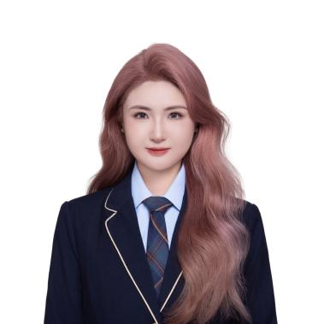

Phone: 029 0250 2691
Email: jkon419@aucklanduni.ac.nz
Date of Birth: 26/09/1996

SELF-INTRODUCTION
Media professional with over seven years of experience in creative planning and content production, contributing to more than 20 variety shows and short-form projects. Skilled at turning creative ideas into practical production plans, I am able to independently manage the full process from concept development and scriptwriting to filming and post-production, combining creative judgment with reliable execution. After completing my Master’s degree in Media (Screen Studies) at the University of Auckland, I am currently working as a part-time Video Editor at Channel 33, a Chinese-language television station in New Zealand. I contribute to program and news production, taking responsibility for planning, filming, and editing. Proficient in Mandarin, English, and Korean, with the ability to collaborate effectively within diverse teams and deliver consistent, high-quality content support.

EDUCATION

The University of Auckland Auckland, New Zealand
Master of Media and Screen Studies

Jilin College of the arts Jilin, China
Bachelor of Radio and Television Directing

SKILLS & COMPTENCIES

Languages: Mandarin, English, Korean
Technical Skills: Final Cut Pro, Adobe Premiere Pro, CapCut (Jianying), Adobe After Effects (basic), Adobe Photoshop (basic), DSLR cameras, Gimbals/Stabilizers, Vmix，Microsoft Word, Excel, PowerPoint
Core Competencies: Creative vision, Scriptwriting & storytelling, Project management, Team leadership, Post-production expertise, Problem-solving, Communication & collaboration, Attention to detail, Knowledge of industry trends

WORK EXPERIENCE

Channel33 Auckland, New Zealand
Post-production and Content Creator August 2025 – Present
- Plan, shoot, and edit television programs and short-form videos for Channel 33, a Chinese-language television station in New Zealand.
- Serve as program director (live directing) using Vmix, managing live broadcasts and multi-camera productions.
- Conduct on-site news and feature reporting, including shooting, interviewing, and editing.
- Collaborate with production teams on concept development, scriptwriting, and post-production workflows.
- Manage content distribution across digital platforms, including YouTube, WeChat Video, and Douyin, ensuring audience engagement and broadcast quality.

Danik Bathroom Auckland, New Zealand
Sales Associate (Part-time) October 2024 – June 2025
- Greet customers, introduce bathroom products, provide purchase recommendations, and achieve sales targets.
- Familiarize yourself with product features and industry trends to enhance sales expertise.
Maintain customer relationships, follow up on orders and after-sales services, and ensure customer satisfaction.
- Manage product display and store environment, and assist in executing promotional activities.

Tomorrow Advancing Life Beijing, China
Short Video Director(Full-time) November 2021 – October 2023
- Developed creative concepts and engaging scripts tailored to target audiences, ensuring alignment with project goals and brand messaging.
- Oversaw the preparation process, including location scouting, talent casting, budgeting, and scheduling to ensure smooth execution of the project.
- Led and managed the shooting process, directing actors, crew, and camera operators to capture the desired scenes and emotions while maintaining time and quality control.
- Collaborated with editors, sound designers, and visual effects artists during the editing phase to ensure that the final cut met creative and technical standards.
- Liaised with clients and stakeholders, presenting creative ideas, updates, and final deliverables while maintaining clear communication throughout the project lifecycle.

Beijing Yuanchun Media Beijing, China
Variety Show Director(Full-time) September 2019 – October 2021
- Lead the overall creative direction and production of variety shows, ensuring alignment with the project's vision and target audience.
- Develop original concepts, scripts, and show formats, collaborating closely with writers, producers, and other creative teams.
- Direct on-site filming, managing the technical crew, performers, and production staff to achieve high-quality results under tight deadlines.
- Supervise post-production processes, including editing, sound design, and visual effects, to deliver polished final products.
- Coordinate with marketing and distribution teams to align show content with promotional strategies.
- Continuously analyze audience feedback and ratings to refine future productions and enhance show appeal.

Youku Beijing,China
Variety Show Director(Full-time) July 2017 – August 2019
- Conducted topic exploration and completed pre-show planning in alignment with the show's positioning and objectives.
- Oversaw the entire production process to ensure high-quality program delivery.
- Collected and organized program materials, maintained consistent program style, and led the scriptwriting team in developing compelling scripts.
- Coordinated and supervised post-production efforts, ensuring smooth collaboration and maintaining production standards.
- Continuously monitored the production workflow to guarantee the program met quality expectations.

