Computer Vision hw2

B05902050

黃子源

I use PIL to complete the homework.

For task 3, I used 4-conneected neighborhood detection.

In my program, I use function getpixel() and putpixel() to get the value of every pixel, and use ImageDraw to draw the bounding box.

1. A binary image (threshold at 128)  
   I read all the pixels of lena.bmp, and create a new image img2 with mode 1. If the value of pixel in lena.bmp is smaller than 128, then putpixel 0 in lena2.bmp, and put 1 in lena2.bmp when it’s larger than 128. After that, we save img2 as lena2.bmp.

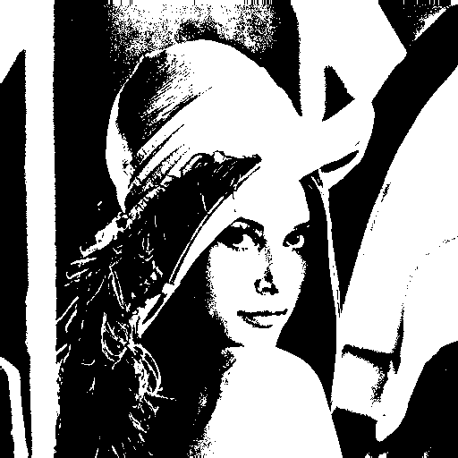

1. A histogram  
   I use matplotlib to generate the histogram, we can get the histogram by summarize the values of all pixels.

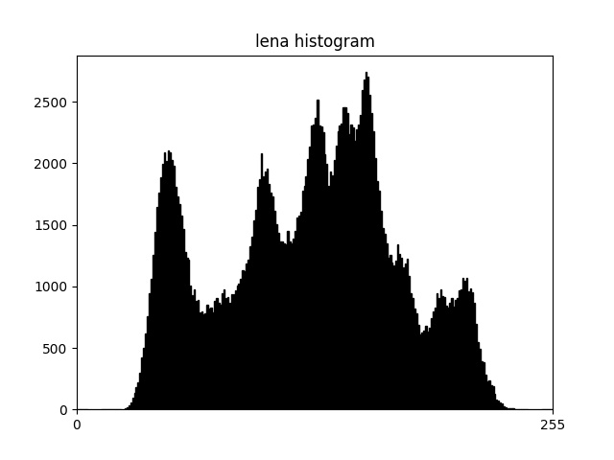

The principal code fragment of task 1, 2:

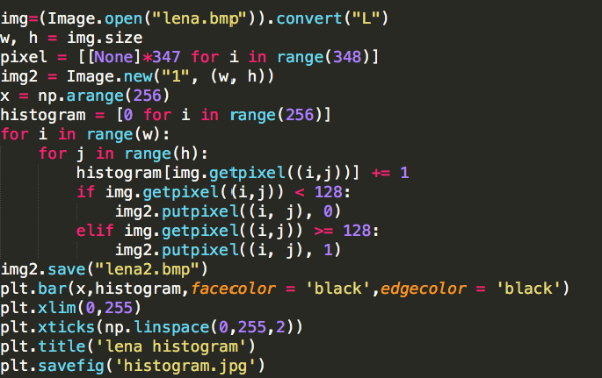

1. Connected components (bounding box)

I use Local Table Method to find the connected components. The algorithm is mostly similar with the pseudo code in class ppt, but I calculate the area and range of all the connected component. Then, for all the components which is larger than 500, I use ImageDraw to draw the bounding box of them and save the image as lena3.bmp.

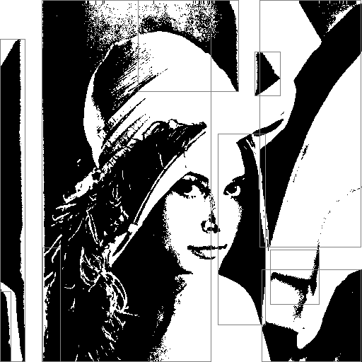

The principal code fragment of task 3:

