PBX3：12571-1-AP
scRNA-Seq Reveals New Enteric Nervous System Roles for GDNF, NRTN, and TBX3 - Cellular and Molecular Gastroenterology and Hepatology (cmghjournal.org)
Bowel stored at –20°C in 50% glycerol/50% PBS was rinsed in PBS, blocked (2 hours, PBS + 0.5% Triton X-100 (Sigma-Aldrich; Cat. #T8787) with 5% normal donkey serum (NDS) (Jackson ImmunoResearch Laboratory, West Grove, PA; RRID: AB_2337258), incubated in primary antibody (Table 9) with gentle rocking (4°C, 2 days), except for ANNA-1, which was incubated overnight (4°C). After washing (3 × 5 minutes, 0.5% PBS + 0.5% Triton X-100) and secondary antibody (Table 9) incubation in blocking solution with gentle rocking (1 hour, RT), tissue was washed (3 × 5 minutes, PBS) and mounted in 50% glycerol/50% PBS.
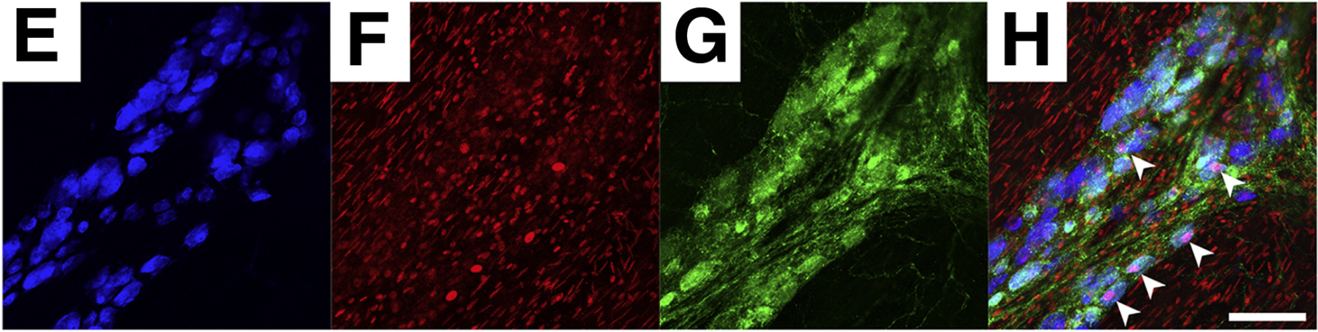
Rabbit anti-PBX3 | 1:100
二抗：1：400 RT1h

石蜡荧光：

Meis2 抗体 (H-10): sc-515470：
The transcription factor Tfap2e/AP-2ε plays a pivotal role in maintaining the identity of basal vomeronasal sensory neurons - ScienceDirect
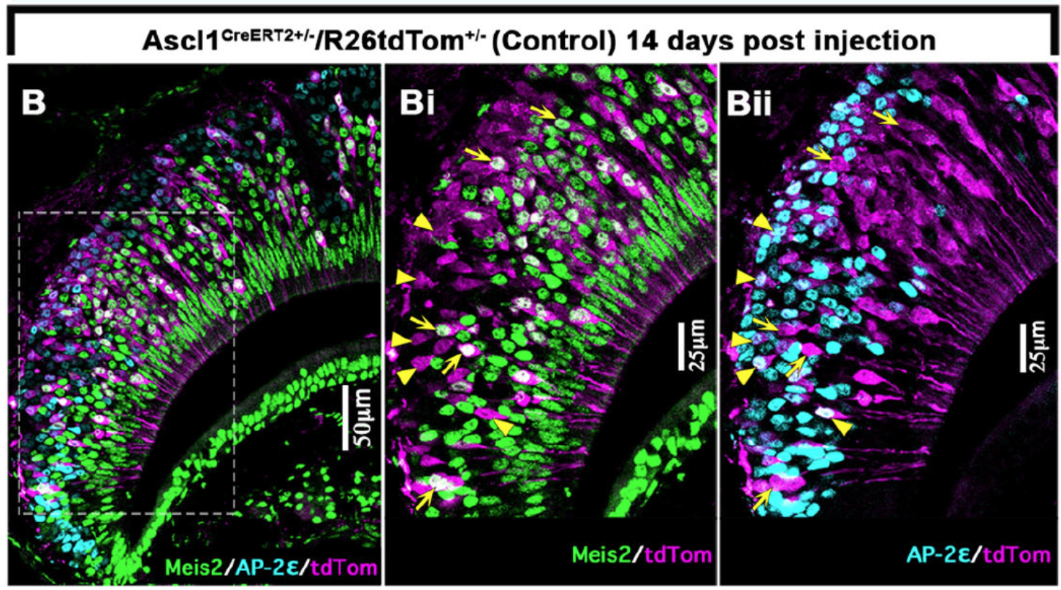
Citrate buffer (pH 6) microwave antigen retrieval
Mouse anti-Meis2 (1:500, sc-515470, Santa Cruz),

