
FACULTY OF INFORMATION COMMUNICATION TECHNOLOGY
COMP 102 – INTRODUCTION TO DATABASE
Title: DESIGN AND IMPLEMENTATION OF A PUBLIC SERVICE DATABASE SYSTEM USING MYSQL
Lecturer/Supervisor: MR SHEIK UMAR KANU
Class: BSEM 1201F
Semester/Year: SEMESTER 2 of 1
Date: 14/06/2026
STUDENT NAME | ID NUMBER | SIGNATURE
ABDUL AZIZ SESAY | 905005987
SHARON KOROMA | 905006201
GIBRIL BANGURA | 905005708

Academic Honesty Policy Statement
I/We, hereby attest that contents of this attachment are my own work. Referenced works, articles, art, programs, papers or parts thereof are acknowledged at the end of this paper. This includes data excerpted from CD-ROMs, the Internet, other private networks, and other people’s disk of the computer system.

LECTURER’S COMMMENTS/GRADE: | for office use only upon receive  Remark  DATE :  TIME :  RECEIVER’S NAME :

Table of Contents
1. Introduction 1
2. Refined Physical Data Model 2
3. Design Decisions 3
4. SQL Implementation 4
4.1 Database Creation 4
4.2 Table Creation 5
4.3 Query Execution 7
7. Conclusion 8
8. Reference 9

1. Introduction
The Market Stall Allocation System is a database solution developed to improve the management and allocation of market stalls to traders. In many local markets, stall allocation and registration processes are often handled manually, making it difficult to track trader information, stall occupancy, and payment records efficiently.
The objective of this project is to design and implement a relational database using MySQL that supports trader registration, stall management, allocation tracking, and payment monitoring. The system was developed based on the Physical Data Model created in Assignment 1 and further refined to improve data integrity and functionality.
The implementation demonstrates the use of primary keys, foreign keys, constraints, data manipulation operations, and SQL queries to manage and retrieve information effectively.

2. Refined Physical Data Model
The Physical Data Model was refined from the initial design by introducing additional constraints and attributes to improve data quality and support real-world operations. New attributes such as email, monthly_fee, and payment_date were added, while NOT NULL and UNIQUE constraints were applied where appropriate. The final model consists of four related tables: Trader, Stall, Allocation, and Registration.
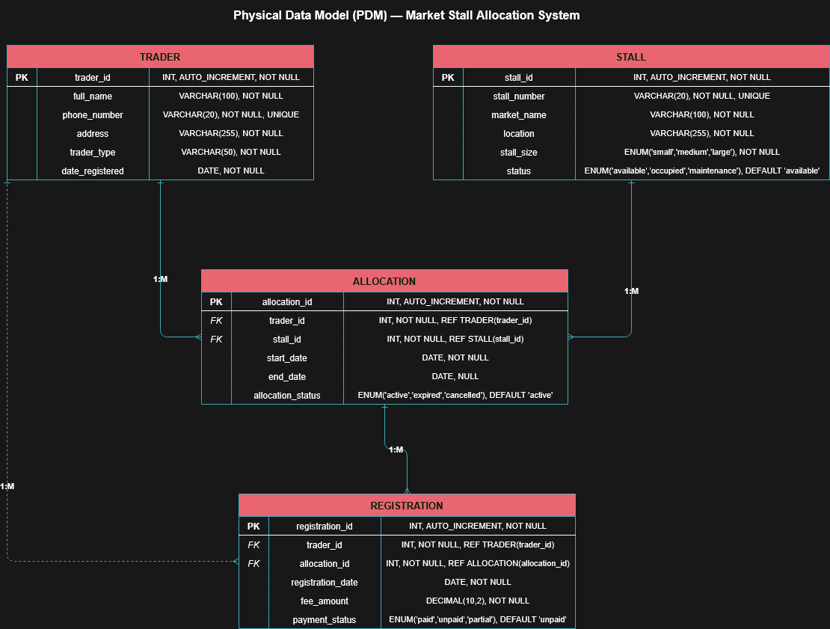

3. Design Decisions
The Trader table was created to store trader information such as name, contact details, and registration date. The trader_id attribute was selected as the Primary Key to uniquely identify each trader.
The Stall table stores information about available market stalls. A unique stall_number was used to prevent duplicate stall records. The monthly_fee attribute was included to support rental fee tracking.
The Allocation table was introduced to link traders and stalls. This design prevents data duplication and allows allocation history to be recorded separately from trader and stall information.
The Registration table stores registration and payment information. Separating registration records from allocation records improves database normalization and allows payment information to be managed independently.
Data types were selected based on the nature of the data being stored. VARCHAR was used for textual information, DATE was used for dates, and DECIMAL was used for monetary values such as monthly fees and registration fees.

4. SQL Implementation

4.1 Database Creation
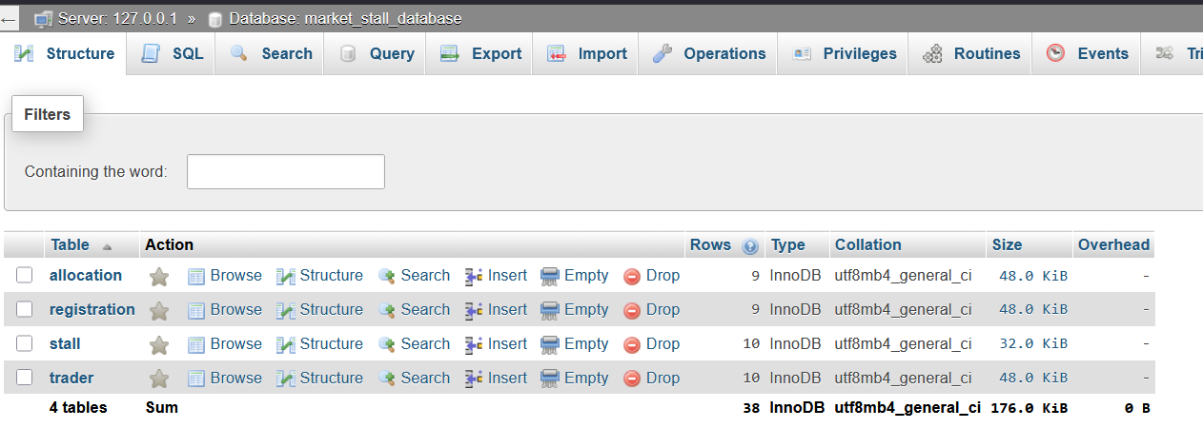
Figure 1: Database Creation

4.2 Table Creation
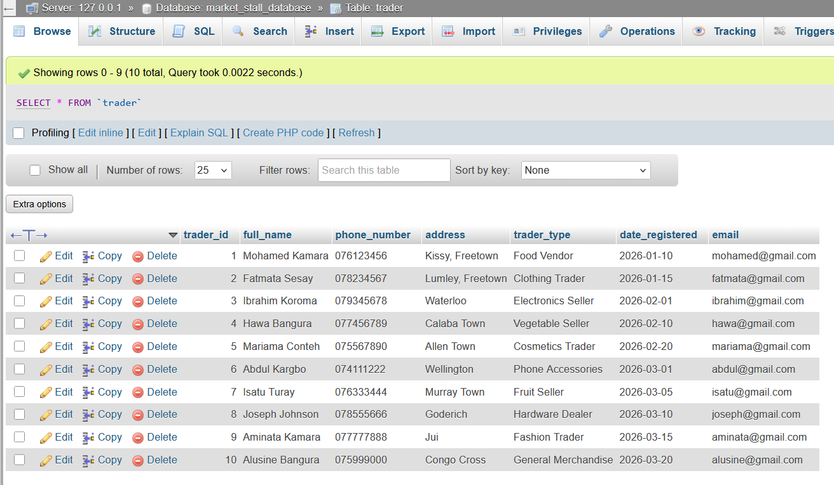
Figure 2:Trade Table Structure
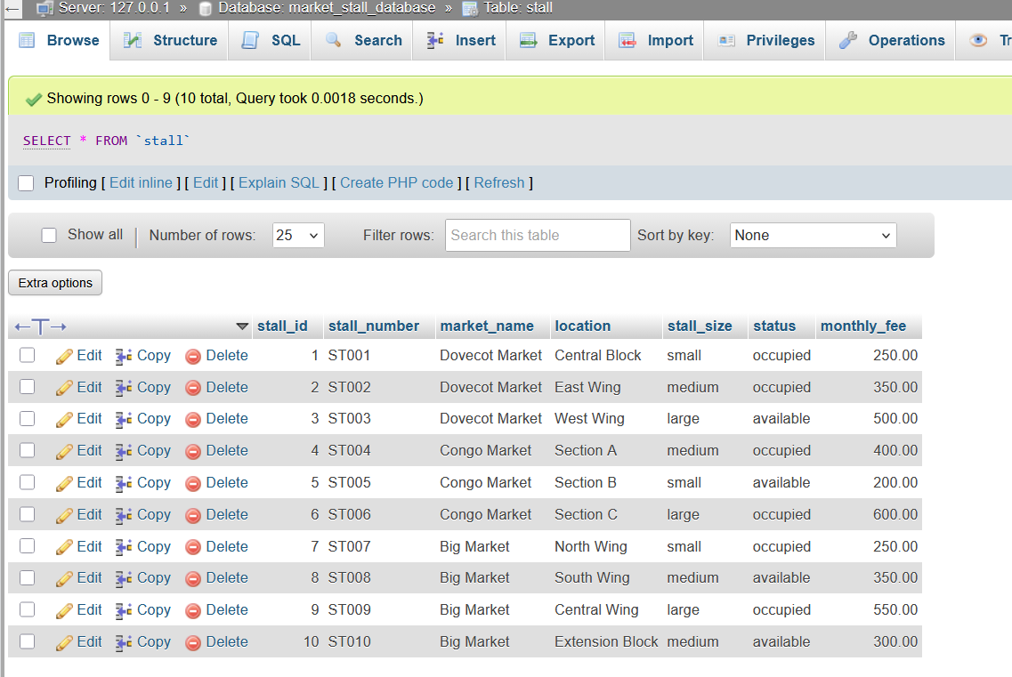
Figure 3: Stall Table Structure

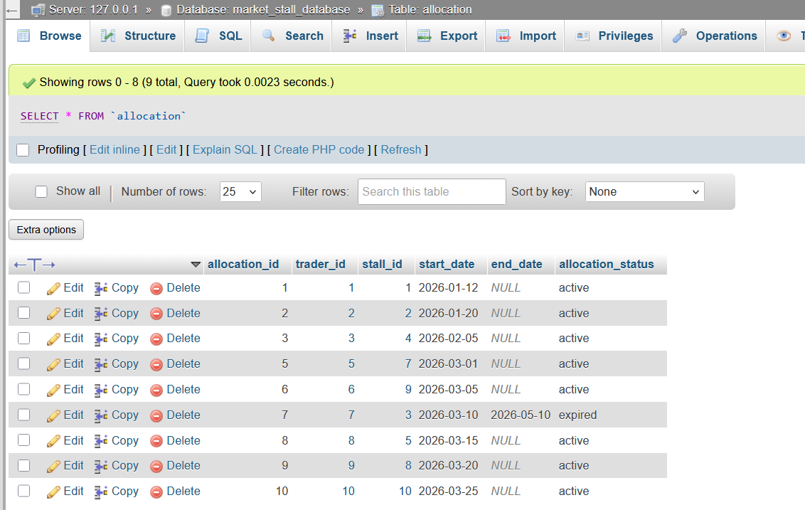
Figure 4: Allocation Table Structure
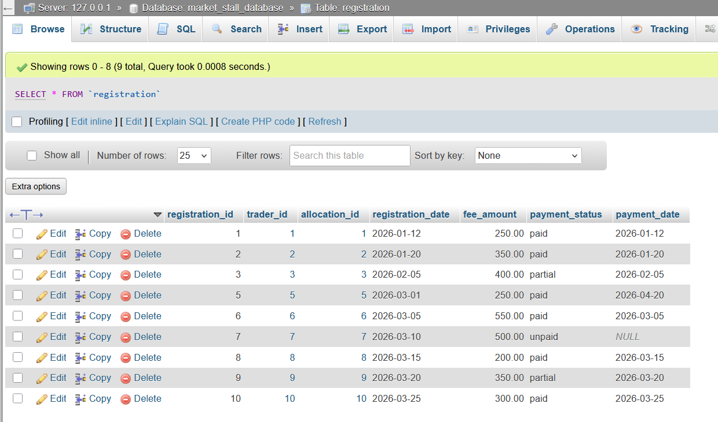
Figure 5: Registration Table Structure

4.3 Query Execution
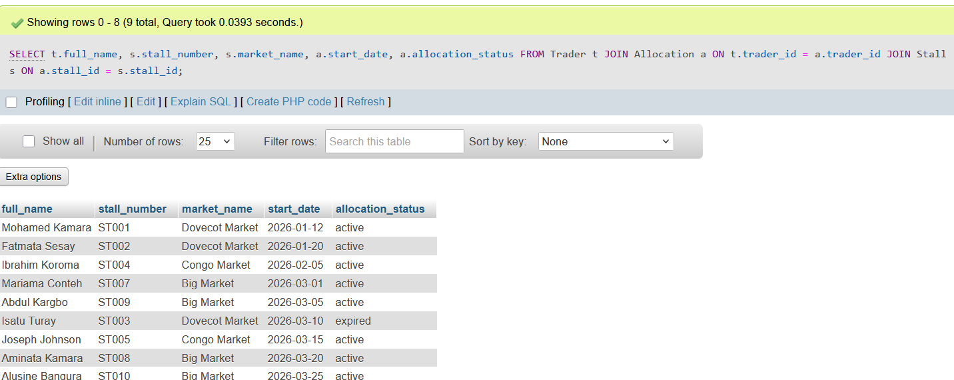
Figure 6: Query Result
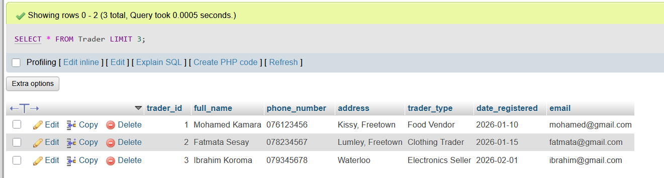
Figure 7: Limit Query

7. Conclusion
The Market Stall Allocation System was successfully implemented using MySQL. The project demonstrated the creation of a relational database capable of managing trader records, stall allocations, and payment information. Through the use of primary keys, foreign keys, constraints, and SQL queries, the database maintains data integrity and supports efficient information retrieval.
The completed system provides a structured approach to market management and demonstrates practical application of database design and implementation concepts covered in the course.

8. Reference
- Coronel, C. and Morris, S., 2019. Database Systems: Design, Implementation, & Management. 13th ed. Boston: Cengage Learning.
- Elmasri, R. and Navathe, S.B., 2016. Fundamentals of Database Systems. 7th ed. Boston: Pearson.
- MySQL, 2025. MySQL 8.0 Reference Manual. [online] Available at: <https://dev.mysql.com/doc/> [Accessed 14 June 2026].
- Oracle Corporation, 2025. MySQL Documentation. [online] Available at: <https://www.mysql.com/> [Accessed 14 June 2026].
- phpMyAdmin Developers, 2025. phpMyAdmin Documentation. [online] Available at: <https://www.phpmyadmin.net/docs/> [Accessed 14 June 2026].

