# Name

Zizhun GUO

# Result

Running Trained Program: (output result)

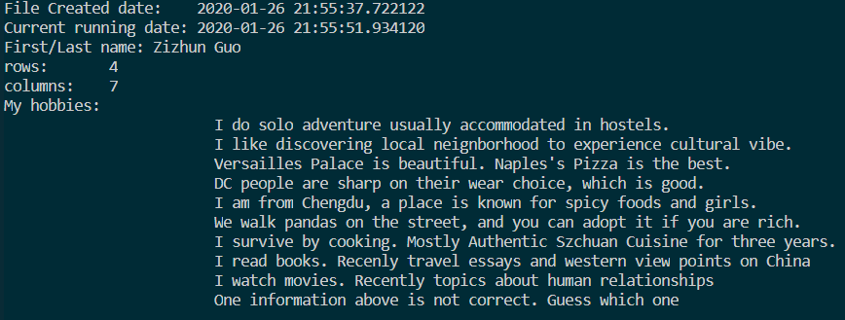

# What I learned

* Writing a mentor program that can produce a trained program in designed format.
  + Multi-line strings with """ """, printing multiple objects, the backslash "\" as the escape character, '\t', '\n', '\r', and '\\'.
  + String Interpolation / f-Strings (which is read-friendly to insert variables in a single string)
* APIs for data mining:
  + - Pandas’ read_csv() method that converting csv file data into dataframe datatype.
    - Using dataframe.shape() can get size for each axes, plus one if included the headers row
    - While preparing this homework, I quickly went over the numpy tutorial as its array data structure, and pandas tutorial as its Series and DataFrame data structure. I also tested some most used attributes and methods for warming up the later homework.
* Other things:
  + Review configuration: using VSCode as new IDE to edit and compile the python code
  + Still use Shell repl for real-time testing
  + Figured out the way for each homework, virtual environment can be created with useful APIs installed.