ㅣ
학번: 2023105225 이름:김지현

기말고사 코드 반영 본인의 Github 주소:
https://github.com/ziziccc/2026-1st-final_test

문제1 – CNN

SOURCE CODE
수정한 부분만 추가하였습니다.

class MyLeNet5_2(nn.Module):
def __init__(self):
super(MyLeNet5_2, self).__init__()

# TODO ①-A : conv_1 → Conv2d(1, 32, kernel_size=5, padding=2)
self.conv_1 = nn.Conv2d(1, 32, kernel_size=5, padding=2)

# TODO ①-B : maxpool_1 → MaxPool2d(kernel_size=(2,2), stride=2)
self.maxpool_1 = nn.MaxPool2d(kernel_size=(2, 2), stride=2)

# TODO ①-C : conv_2 → Conv2d(32, 64, kernel_size=5)
self.conv_2 = nn.Conv2d(32, 64, kernel_size=5)

# TODO ①-D : maxpool_2 → MaxPool2d(kernel_size=(2,2), stride=2)
self.maxpool_2 = nn.MaxPool2d(kernel_size=(2, 2), stride=2)

# TODO ①-E : conv_3 → Conv2d(64, 256, kernel_size=5)
self.conv_3 = nn.Conv2d(64, 256, kernel_size=5)

# TODO ①-F : relu → nn.ReLU()
self.relu = nn.ReLU()

# TODO ①-G : fc_1 → Linear(256, 128)
self.fc_1 = nn.Linear(256, 128)

# TODO ①-H : fc_2 → Linear(128, 10)
self.fc_2 = nn.Linear(128, 10)

def forward(self, x):

x = self.conv_1(x)
x = self.relu(x)
x = self.maxpool_1(x)

x = self.conv_2(x)
x = self.relu(x)
x = self.maxpool_2(x)

x = self.conv_3(x)

x = x.view(-1, 256)

x = self.fc_1(x)
x = self.relu(x)

res = self.fc_2(x)

return res

# ===== 수정 금지 =====
model_test = MyLeNet5_2()
print(model_test)
total_params = sum(p.numel() for p in model_test.parameters())
print(f"파라미터 수: {total_params:,}개")
# ===== 수정 금지 끝 =====

# TODO ③ : epochs 수정
epochs = 3
learning_rate = 0.01

# TODO ④ : 학번/이름 (필수)
STUDENT_ID = "2023105225" #e.g., 20201111111
STUDENT_NAME = "Kim Ji Hyun" #e.g., Hong Gil Dong

# ===== 수정 금지 =====
model = MyLeNet5_2().to(device)
optimizer = optim.Adadelta(model.parameters(), lr=learning_rate)
scheduler = optim.lr_scheduler.StepLR(optimizer, step_size=1, gamma=0.1)
loss_function = nn.CrossEntropyLoss()

print(f"학번: {STUDENT_ID} 이름: {STUDENT_NAME}")
print(f"epochs={epochs} lr={learning_rate} optimizer=Adadelta")
# ===== 수정 금지 끝 =====

OUTPUT (Screen Shots)
#1 | [제출 결과]
Train Epoch: 0 [0/60000 (0%)] Loss: 2.295961
Train Epoch: 0 [16000/60000 (27%)] Loss: 0.525226
Train Epoch: 0 [32000/60000 (53%)] Loss: 0.180265
Train Epoch: 0 [48000/60000 (80%)] Loss: 0.189560

Test set: Average loss: 0.0105, Accuracy: 9491/10000 (94.91%)

Train Epoch: 1 [0/60000 (0%)] Loss: 0.284714
Train Epoch: 1 [16000/60000 (27%)] Loss: 0.053404
Train Epoch: 1 [32000/60000 (53%)] Loss: 0.101557
Train Epoch: 1 [48000/60000 (80%)] Loss: 0.130780

Test set: Average loss: 0.0092, Accuracy: 9559/10000 (95.59%)

Train Epoch: 2 [0/60000 (0%)] Loss: 0.234648
Train Epoch: 2 [16000/60000 (27%)] Loss: 0.653797
Train Epoch: 2 [32000/60000 (53%)] Loss: 0.076103
Train Epoch: 2 [48000/60000 (80%)] Loss: 0.102049

Test set: Average loss: 0.0091, Accuracy: 9569/10000 (95.69%)

==================================================
학번: 2023105225 이름: Kim Ji Hyun
최종 Test Accuracy: 95.69%
==================================================
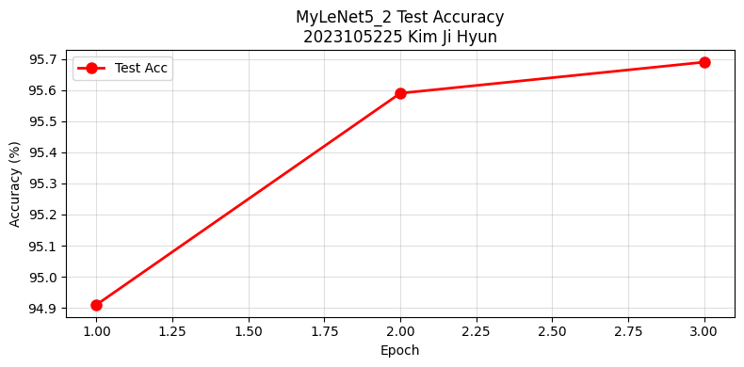
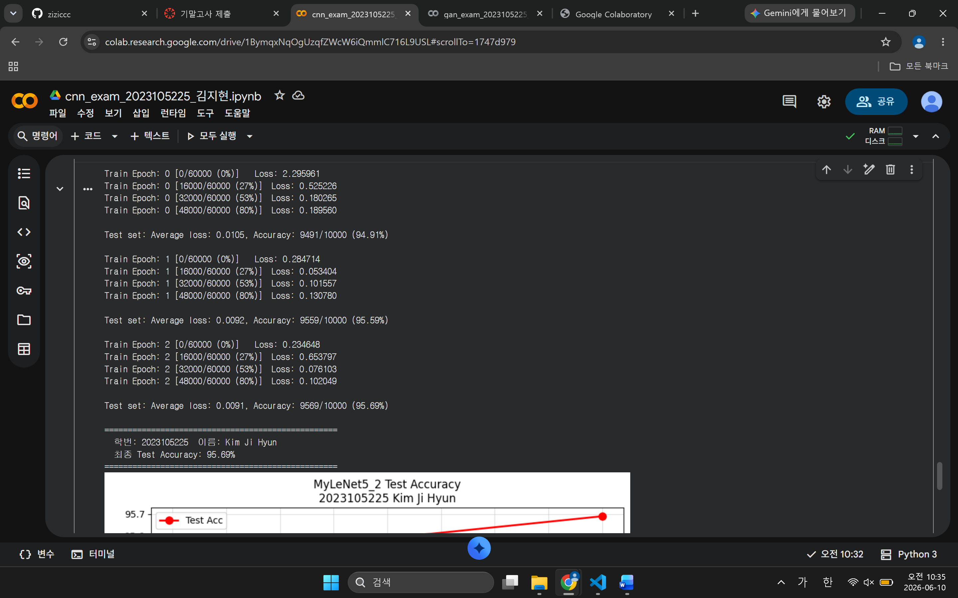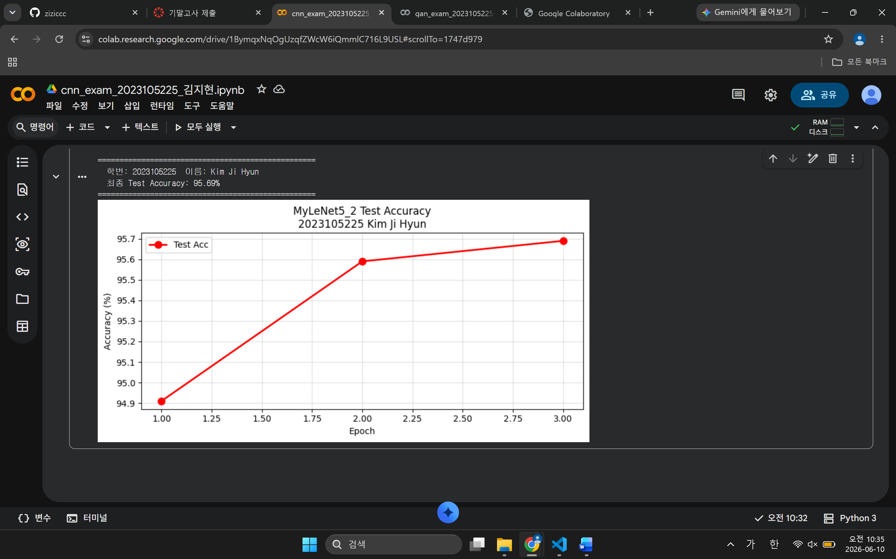

Github (Screen Shots)
#1 | 본인 Github에 Commit내용 또는 PR 내용을 제출 시간과 함께 제출
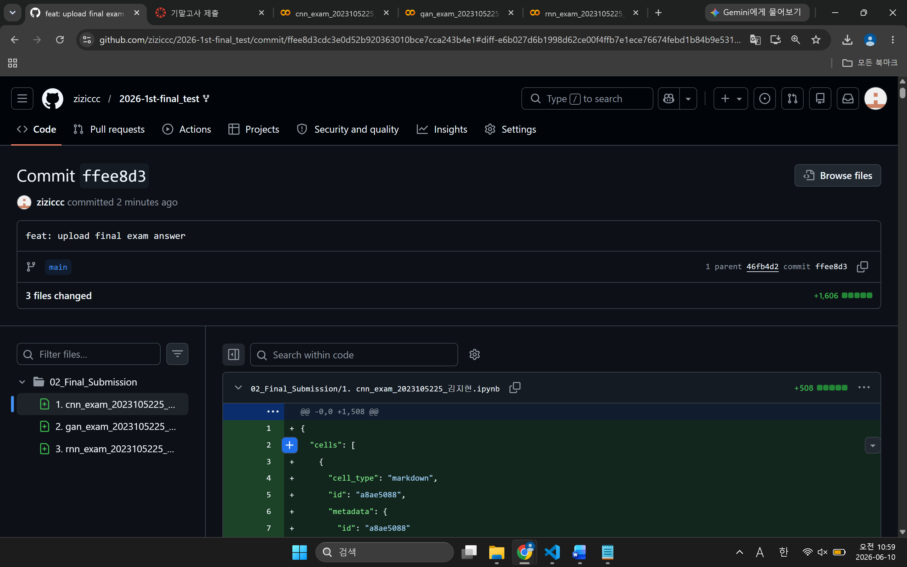

문제2 – GAN

SOURCE CODE
# TODO ① : 하이퍼파라미터 (변경표 참고)
latent_size = 64 # 수정 금지
num_epochs = 20 # ← 수정 대상
batch_size = 128 # ← 수정 대상
image_size = 784 # 수정 금지

# TODO ④ : 학번/이름 (필수)
STUDENT_ID = "2023105225" # (e.g., 20000000000)
STUDENT_NAME = "Kim Ji Hyun" # (e.g., Hong Gil Dong)

# ===== 수정 금지 =====
print(f"latent_size={latent_size} batch_size={batch_size} num_epochs={num_epochs}")
print(f"학번: {STUDENT_ID} 이름: {STUDENT_NAME}")
# ===== 수정 금지 끝 =====

# TODO ② : 수정된 Discriminator D
# 784 → 512 → 256 → 128 → 64 → 1
D = nn.Sequential(
nn.Linear(image_size, 512),
nn.LeakyReLU(0.2),
nn.Linear(512, 256),
nn.LeakyReLU(0.2),
nn.Linear(256, 128),
nn.LeakyReLU(0.2),
nn.Linear(128, 64),
nn.LeakyReLU(0.2),
nn.Linear(64, 1),
nn.Sigmoid() # 0~1 범위로 변환 (확률로 해석)
)

# TODO ③ : 수정된 Generator G
# 64 → 256 → 512 → 256 → 128 → 784
G = nn.Sequential(
nn.Linear(latent_size, 256),
nn.ReLU(),
nn.Linear(256, 512),
nn.ReLU(),
nn.Linear(512, 256),
nn.ReLU(),
nn.Linear(256, 128),
nn.ReLU(),
nn.Linear(128, 784),
nn.Tanh()
)
# ===== 수정 금지 =====
D = D.to(device)
G = G.to(device)

criterion = nn.BCELoss()
d_optimizer = torch.optim.Adam(D.parameters(), lr=0.0002)
g_optimizer = torch.optim.Adam(G.parameters(), lr=0.0002)

print("D 파라미터:", sum(p.numel() for p in D.parameters()), "개")
print("G 파라미터:", sum(p.numel() for p in G.parameters()), "개")
print("D:", D)
print("G:", G)
# ===== 수정 금지 끝 =====

OUTPUT (Screen Shots)
#2 | [제출 결과]
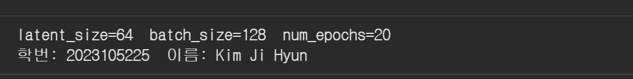

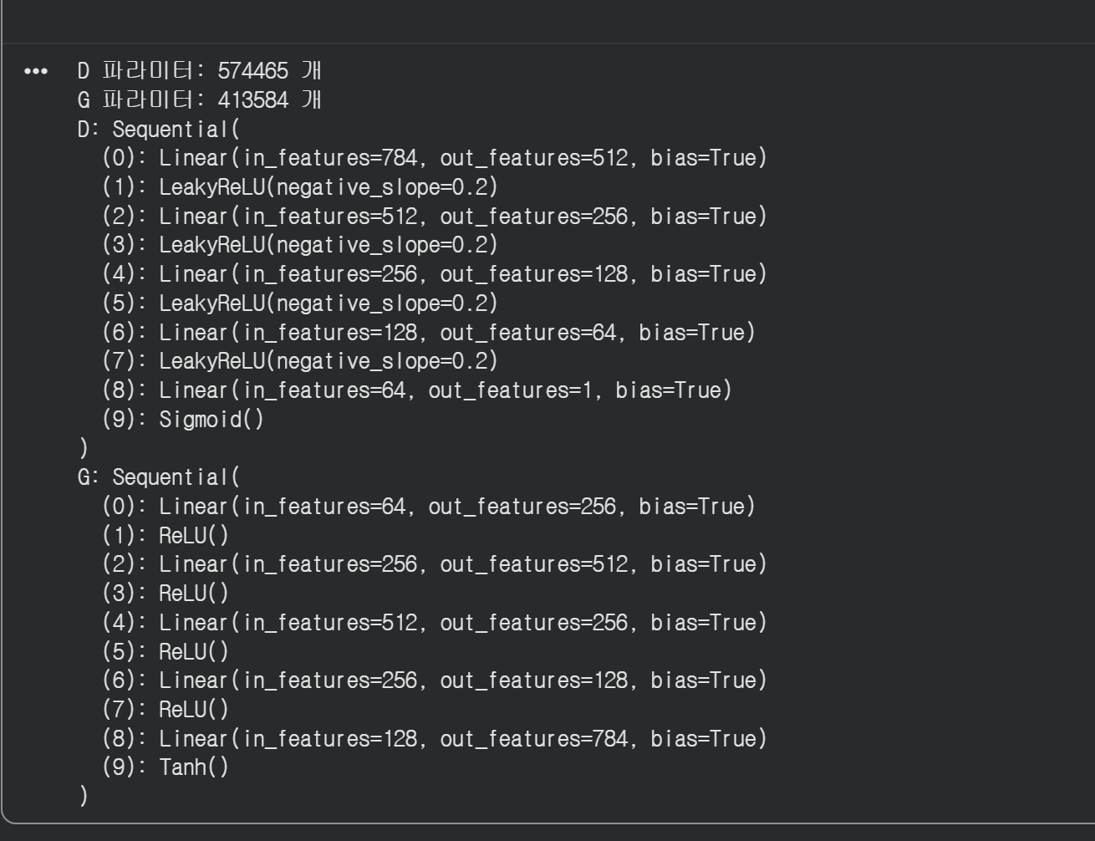
Epoch[1/20] Step[200/469] d:0.0484 g:5.8658 D(x):1.00 D(G):0.05
Epoch[1/20] Step[400/469] d:0.0227 g:8.4550 D(x):1.00 D(G):0.02
Epoch[2/20] Step[200/469] d:0.5451 g:11.7932 D(x):0.88 D(G):0.03
Epoch[2/20] Step[400/469] d:0.2984 g:9.0443 D(x):0.92 D(G):0.05
Epoch[3/20] Step[200/469] d:0.4382 g:4.0517 D(x):0.92 D(G):0.12
Epoch[3/20] Step[400/469] d:0.3357 g:4.3417 D(x):0.90 D(G):0.11
Epoch[4/20] Step[200/469] d:1.0689 g:4.1337 D(x):0.77 D(G):0.38
Epoch[4/20] Step[400/469] d:0.1606 g:3.2009 D(x):0.92 D(G):0.06
Epoch[5/20] Step[200/469] d:0.5664 g:2.0151 D(x):0.81 D(G):0.24
Epoch[5/20] Step[400/469] d:0.7094 g:2.8457 D(x):0.71 D(G):0.19
Epoch[6/20] Step[200/469] d:0.7131 g:1.9873 D(x):0.83 D(G):0.37
Epoch[6/20] Step[400/469] d:1.4993 g:1.7093 D(x):0.66 D(G):0.53
Epoch[7/20] Step[200/469] d:0.5120 g:2.5339 D(x):0.79 D(G):0.13
Epoch[7/20] Step[400/469] d:0.4245 g:3.5304 D(x):0.84 D(G):0.12
Epoch[8/20] Step[200/469] d:0.3486 g:3.6367 D(x):0.85 D(G):0.06
Epoch[8/20] Step[400/469] d:0.3155 g:4.0298 D(x):0.91 D(G):0.13
Epoch[9/20] Step[200/469] d:0.4362 g:4.7912 D(x):0.90 D(G):0.10
Epoch[9/20] Step[400/469] d:0.4225 g:4.3170 D(x):0.89 D(G):0.11
Epoch[10/20] Step[200/469] d:0.1677 g:4.3848 D(x):0.97 D(G):0.07
Epoch[10/20] Step[400/469] d:0.2214 g:5.0119 D(x):0.96 D(G):0.09
Epoch[11/20] Step[200/469] d:0.4004 g:5.4472 D(x):0.91 D(G):0.04
Epoch[11/20] Step[400/469] d:0.2320 g:4.7273 D(x):0.96 D(G):0.09
Epoch[12/20] Step[200/469] d:0.0767 g:5.3772 D(x):0.98 D(G):0.03
Epoch[12/20] Step[400/469] d:0.1878 g:3.8297 D(x):0.95 D(G):0.07
Epoch[13/20] Step[200/469] d:0.6792 g:3.6382 D(x):0.86 D(G):0.11
Epoch[13/20] Step[400/469] d:0.0629 g:3.9780 D(x):0.98 D(G):0.04
Epoch[14/20] Step[200/469] d:0.1115 g:4.7870 D(x):0.96 D(G):0.05
Epoch[14/20] Step[400/469] d:0.3753 g:5.6785 D(x):0.93 D(G):0.05
Epoch[15/20] Step[200/469] d:0.2862 g:4.2188 D(x):0.94 D(G):0.04
Epoch[15/20] Step[400/469] d:0.0770 g:4.2554 D(x):0.99 D(G):0.04
Epoch[16/20] Step[200/469] d:0.1228 g:4.4285 D(x):0.95 D(G):0.04
Epoch[16/20] Step[400/469] d:0.3587 g:3.8124 D(x):0.93 D(G):0.10
Epoch[17/20] Step[200/469] d:0.0186 g:6.7479 D(x):1.00 D(G):0.02
Epoch[17/20] Step[400/469] d:0.0071 g:6.1982 D(x):1.00 D(G):0.01
Epoch[18/20] Step[200/469] d:0.0275 g:5.5747 D(x):0.98 D(G):0.01
Epoch[18/20] Step[400/469] d:0.0019 g:6.2357 D(x):1.00 D(G):0.00
Epoch[19/20] Step[200/469] d:0.0323 g:2.2248 D(x):1.00 D(G):0.03
Epoch[19/20] Step[400/469] d:0.0222 g:7.0084 D(x):0.99 D(G):0.00
Epoch[20/20] Step[200/469] d:0.0051 g:7.5409 D(x):1.00 D(G):0.01
Epoch[20/20] Step[400/469] d:0.0006 g:7.7061 D(x):1.00 D(G):0.00

✅ 학습 완료!
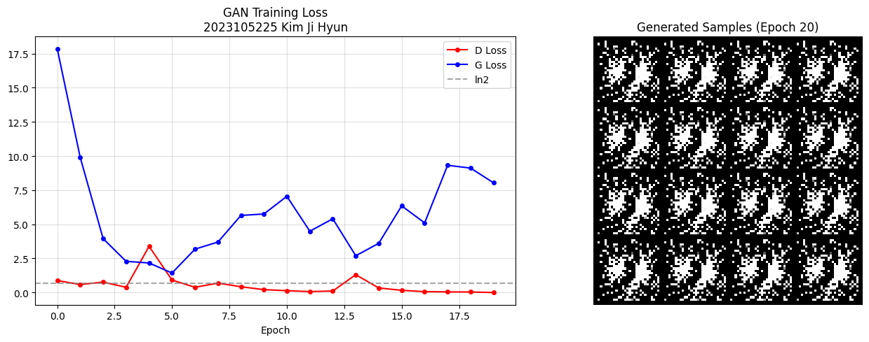

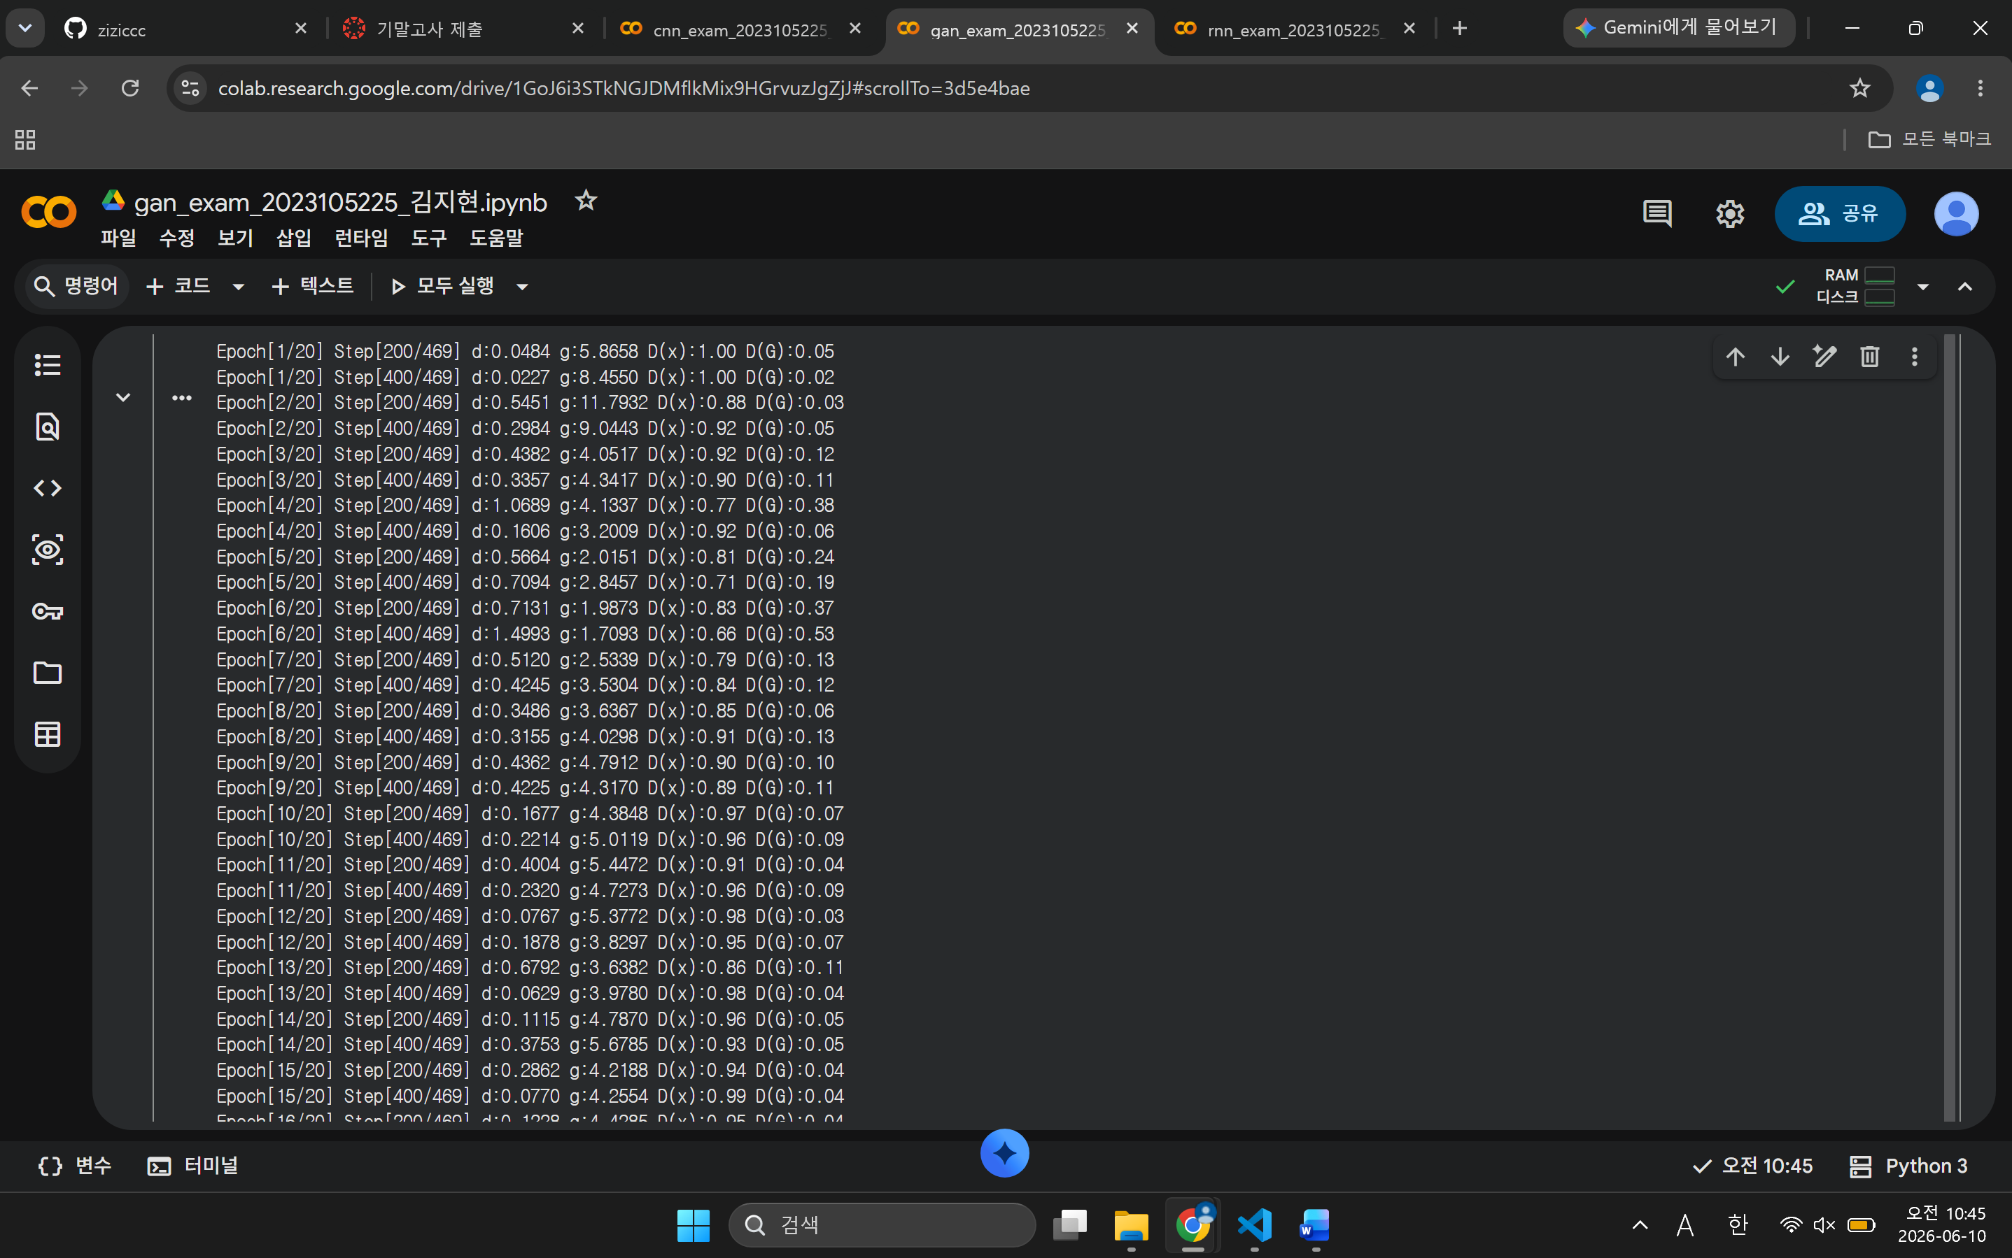
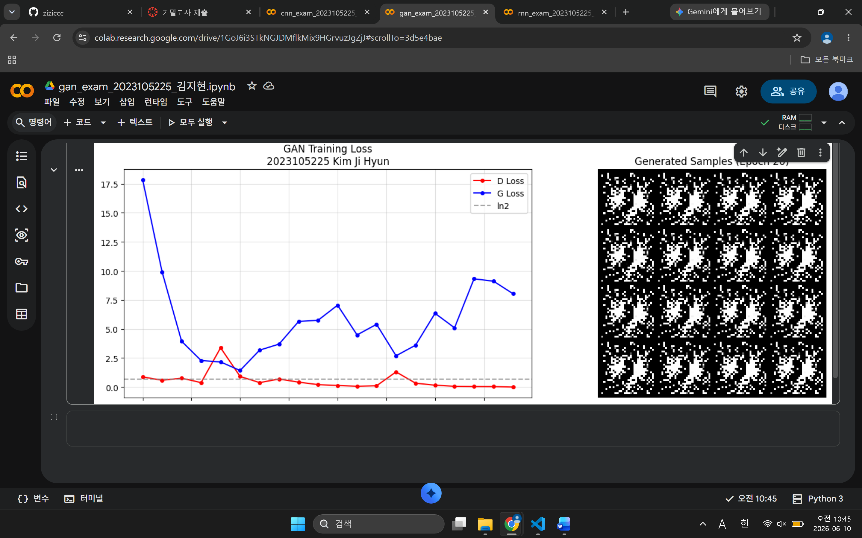

Github (Screen Shots)
#2 | 본인 Github에 Commit내용 또는 PR 내용을 제출 시간과 함께 제출
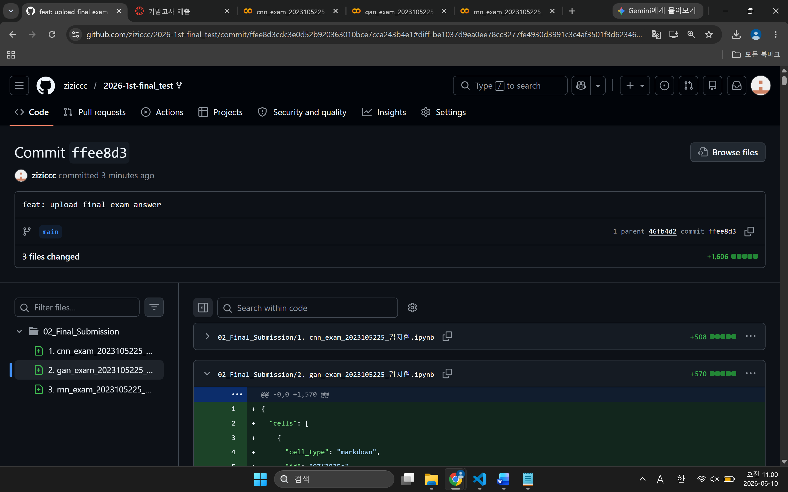

문제3 – rnn

SOURCE CODE
def word_to_onehot(string):
one_hot = np.array([]).reshape(0, n_letters)

for i in string:
idx = char_list.index(i)
zero = np.zeros(shape=n_letters, dtype=int)
zero[idx] = 1
one_hot = np.vstack([one_hot, zero])

return one_hot # shape: (len(string), 26)

def onehot_to_word(onehot_1):
onehot = torch.Tensor.numpy(onehot_1)
return char_list[onehot.argmax()]

# ===== 수정 금지 =====
test_oh = word_to_onehot('back')
print(f"word_to_onehot('back') shape: {test_oh.shape} (기대: (4, 26))")
test_tensor = torch.FloatTensor(test_oh[0])
print(f"onehot_to_word(back[0]) = '{onehot_to_word(test_tensor)}' (기대: 'b')")
# ===== 수정 금지 끝 =====

class myRNN(nn.Module):
def __init__(self, input_size, hidden_size, num_layer):
super(myRNN, self).__init__()
# ===== 수정 금지 =====
self.input_size = input_size
self.hidden_size = hidden_size
self.num_layer = num_layer
# ===== 수정 금지 끝 =====

# TODO ③ : RNN 레이어 정의
self.rnn = nn.RNN(input_size=input_size, hidden_size=hidden_size,
num_layers=num_layer)

def forward(self, x, hidden):
out, hidden = self.rnn(x, hidden)
return out, hidden

def init_hidden(self):
# ===== 수정 금지 (원본 코드 유지) =====
return torch.zeros(self.num_layer, 1, self.hidden_size)
# ===== 수정 금지 끝 =====

# ===== 수정 금지 =====
# TODO ④ : 학번/이름 (필수)
STUDENT_ID = "2023105225" # (e.g., 20000000000)
STUDENT_NAME = "Kim Ji Hyun" # (e.g., Hong Gil Dong)

test_model = myRNN(n_letters, 26, n_layers)
test_input = torch.randn(3, 1, 26)
test_hidden = test_model.init_hidden()
test_out, test_h = test_model(test_input, test_hidden)
print(f"학번: {STUDENT_ID} 이름: {STUDENT_NAME}")
print(f"output shape: {test_out.shape} (기대: [3, 1, 26])")
print(f"hidden shape: {test_h.shape} (기대: [1, 1, 26])")
# ===== 수정 금지 끝 =====

for i in range(epochs):
for j in range(n_four_words):
# ===== 수정 금지 =====
string = four_words[j]
one_hot = torch.from_numpy(word_to_onehot(string)).type_as(torch.FloatTensor())
hidden = model.init_hidden()
model.zero_grad()
# ===== 수정 금지 끝 =====

# TODO ⑤-A
input = one_hot[0:-1]

# ===== 수정 금지 =====
input = torch.unsqueeze(input, 1) # [3, 1, 26]
target = torch.tensor(np.argmax(one_hot[1:].numpy(), axis=1)) # [3]
# ===== 수정 금지 끝 =====

# TODO ⑤-B
output, hidden = model(input, hidden)

# ===== 수정 금지 =====
loss = loss_func(output.squeeze(1), target)
loss.backward()
optimizer.step()
# ===== 수정 금지 끝 =====

# ===== 수정 금지 =====
if i % 100 == 0:
print(f'epoch {i:4d} loss={loss.item():.6f}')
scheduler.step()
# ===== 수정 금지 끝 =====

OUTPUT (Screen Shots)
#3 | [제출 결과]
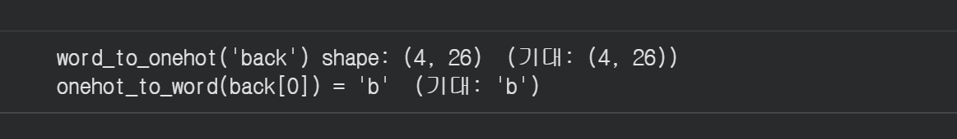

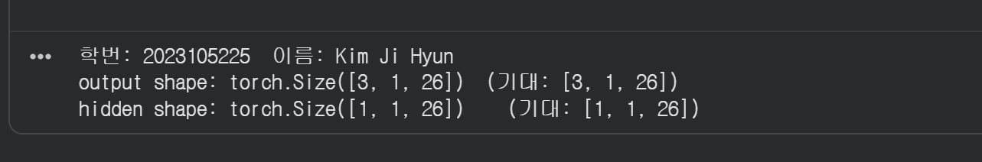

학번: 2023105225 이름: Kim Ji Hyun

[추론 결과]
1 GT: back OUT: barh
2 GT: ball OUT: barl
3 GT: band OUT: bark
4 GT: bank OUT: bark
5 GT: base OUT: barh
6 GT: bath OUT: barh
7 GT: bear OUT: baat
8 GT: beat OUT: baat
9 GT: bell OUT: baal
10 GT: best OUT: baat
11 GT: bird OUT: bare
12 GT: blow OUT: balw
13 GT: blue OUT: bale
14 GT: boat OUT: bart
15 GT: body OUT: bare
16 GT: bold OUT: bard
17 GT: bone OUT: bard
18 GT: book OUT: bard
19 GT: born OUT: bard
20 GT: burn OUT: bare
21 GT: call OUT: catl
22 GT: calm OUT: catl
23 GT: card OUT: cate
24 GT: care OUT: cate
25 GT: case OUT: cate
26 GT: cash OUT: cate
27 GT: cave OUT: cate
28 GT: cell OUT: caal
29 GT: chat OUT: caat
30 GT: chip OUT: caap
31 GT: city OUT: cary
32 GT: clay OUT: caly
33 GT: club OUT: cale
34 GT: coal OUT: caat
35 GT: coat OUT: caat
36 GT: code OUT: caae
37 GT: cold OUT: caal
38 GT: cool OUT: caad
39 GT: copy OUT: caay
40 GT: core OUT: caad
41 GT: dark OUT: dete
42 GT: data OUT: deta
43 GT: date OUT: deta
44 GT: dawn OUT: detn
45 GT: dead OUT: deat
46 GT: deal OUT: deat
47 GT: dear OUT: deat
48 GT: debt OUT: deat
49 GT: deed OUT: dead
50 GT: deep OUT: dead

마지막 글자 정확도: 26/50 (0.5200)
전체 글자 정확도 : 58/150 (0.3867)
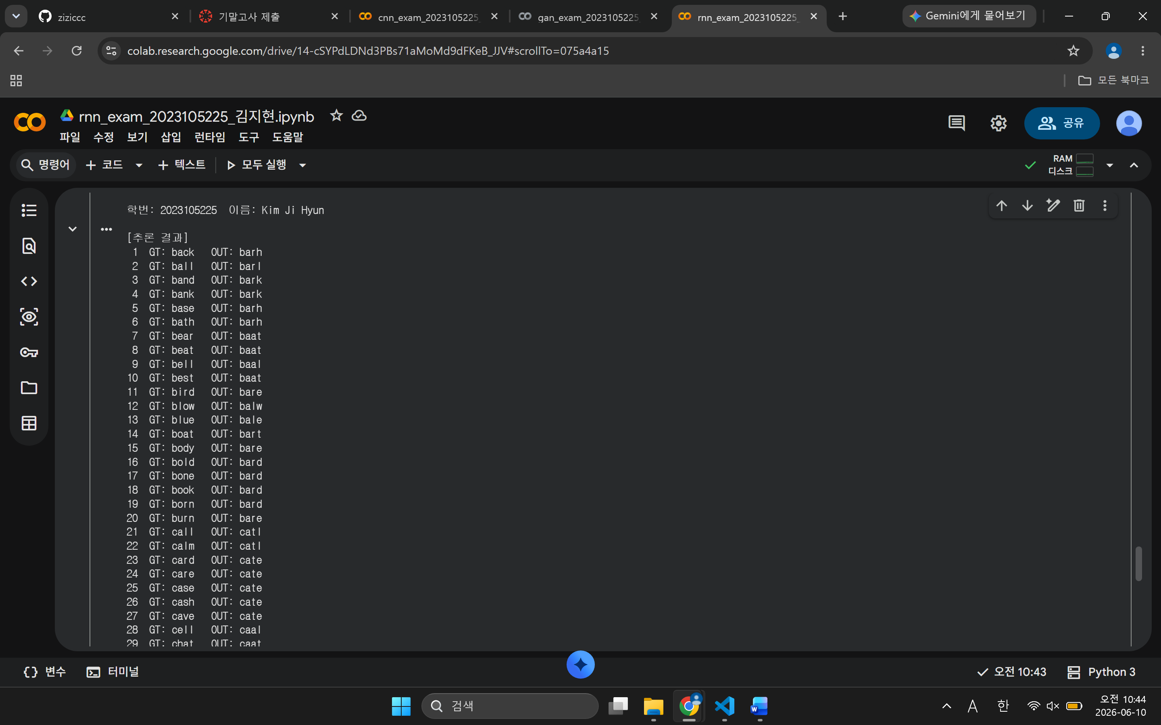

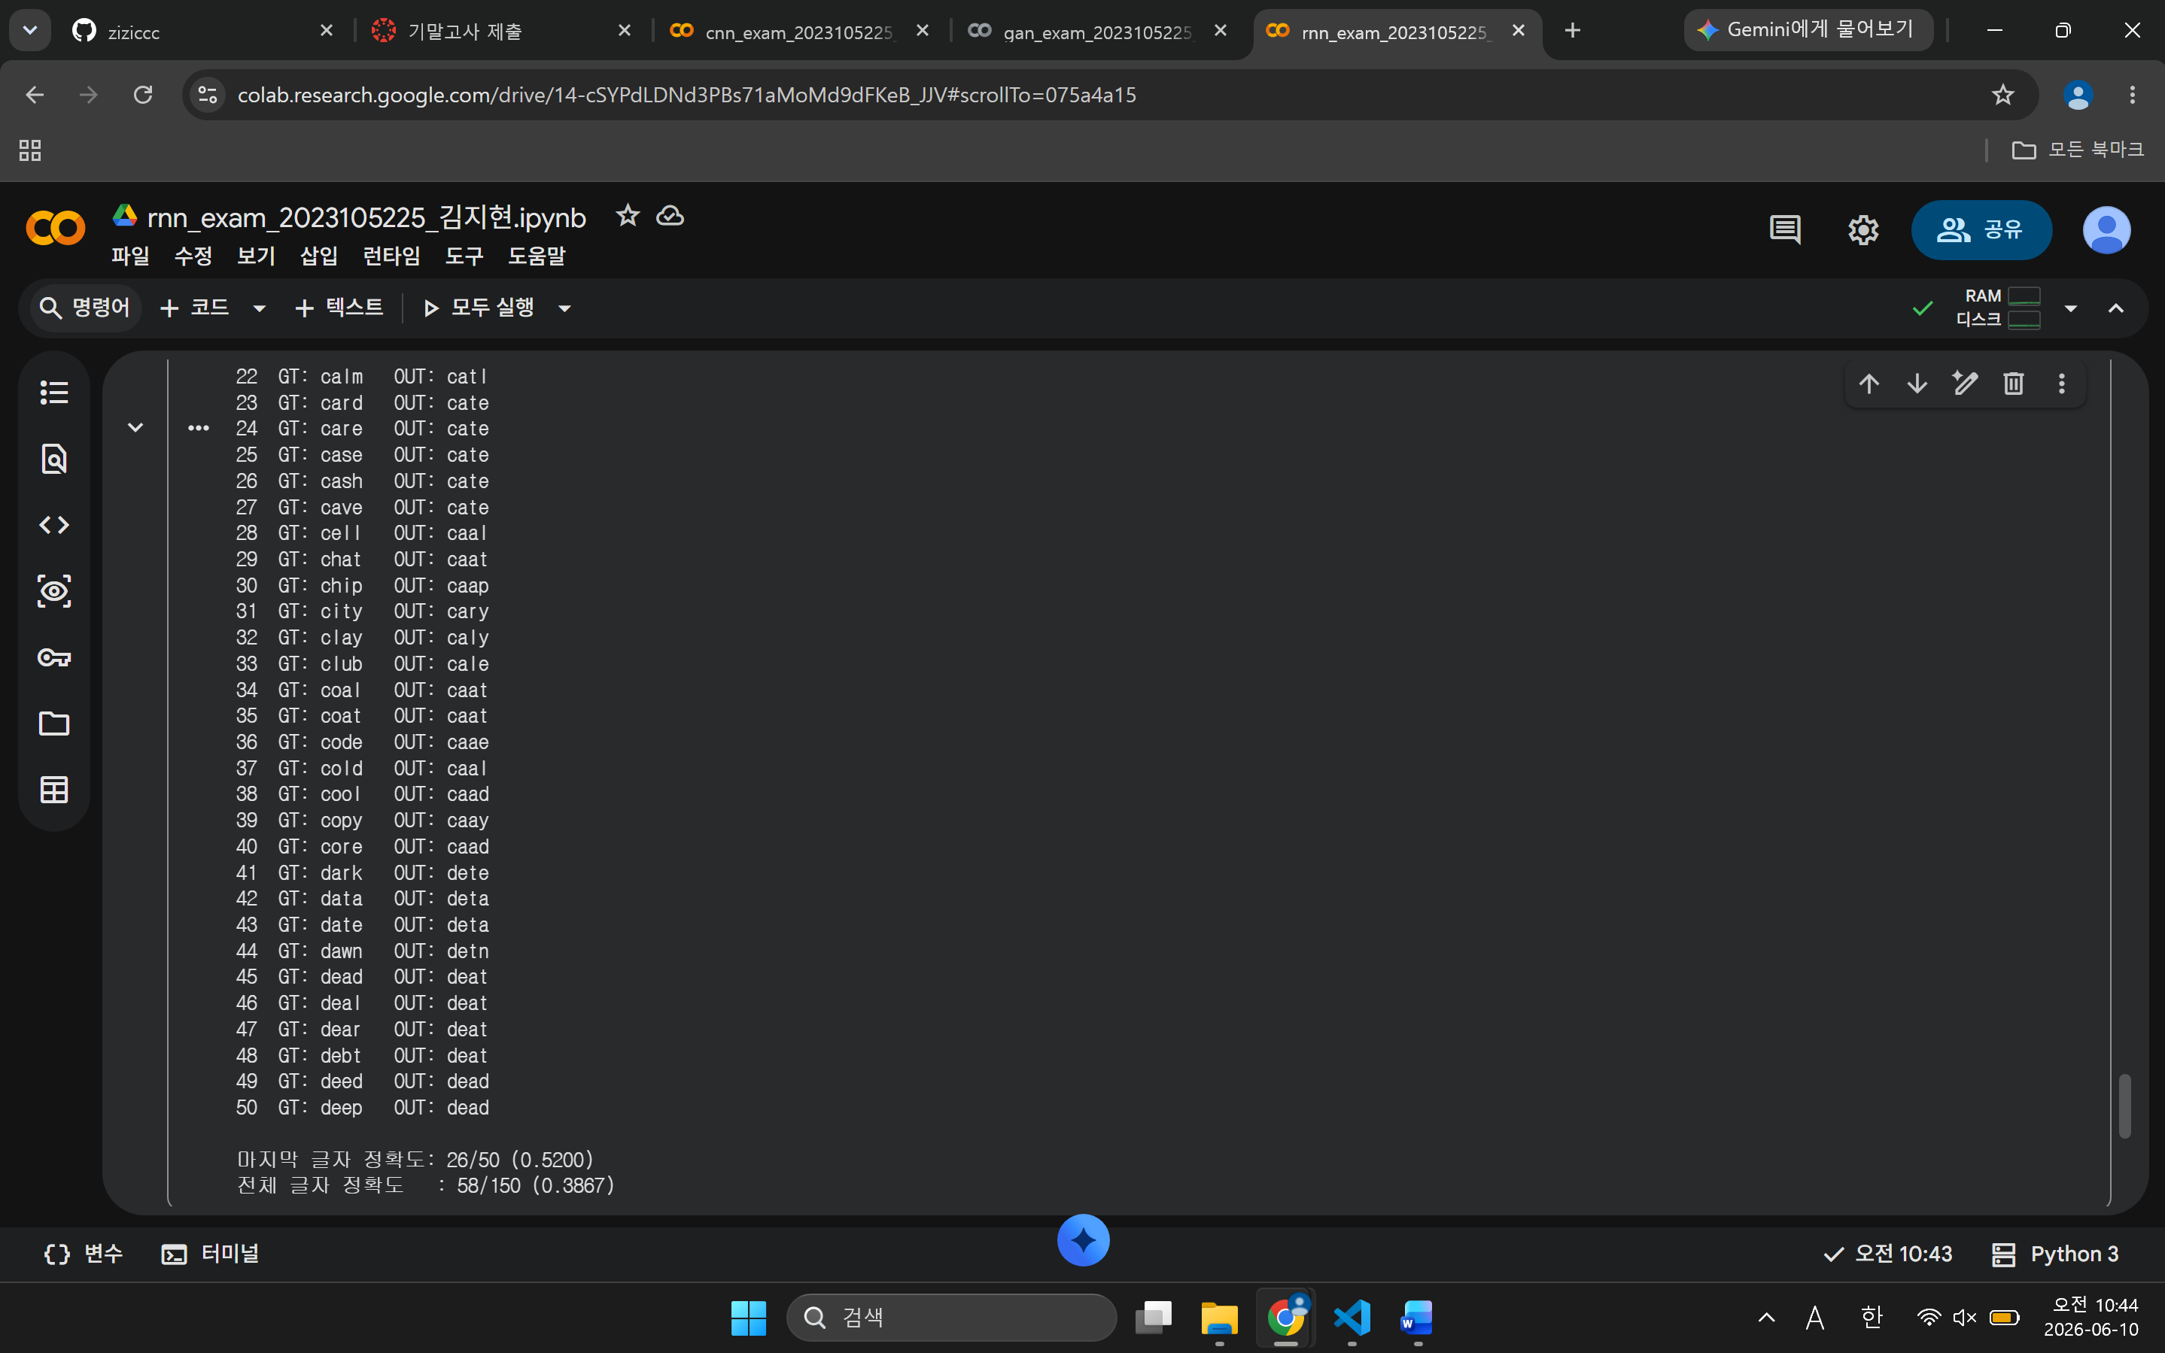

Github (Screen Shots)
#3 | 본인 Github에 Commit내용 또는 PR 내용을 제출 시간과 함께 제출
