1. **boot from spi flash or nand flash**
2. Short BOOT_DIS jumper to stop CPU booting from on-board boot device, then, CPU will run to SAM-BA mode.
3. Connect USB-A usb cable to PC
4. Identify the USB connection that is established, USB Serial Port should appear in Device Manager like following.

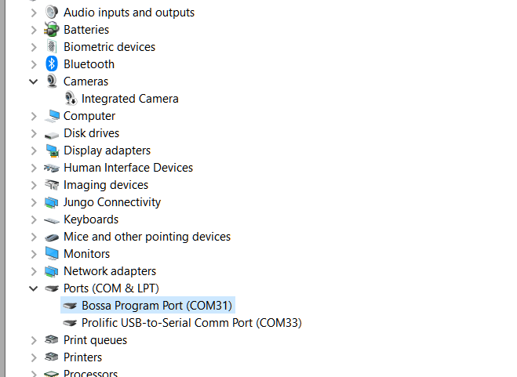

1. Install SAM-BA tools in PC

You can download it here: [SAM-BA 3.x release page](https://github.com/atmelcorp/sam-ba/releases)

unzip the file, and add the path to your environment path, like this:

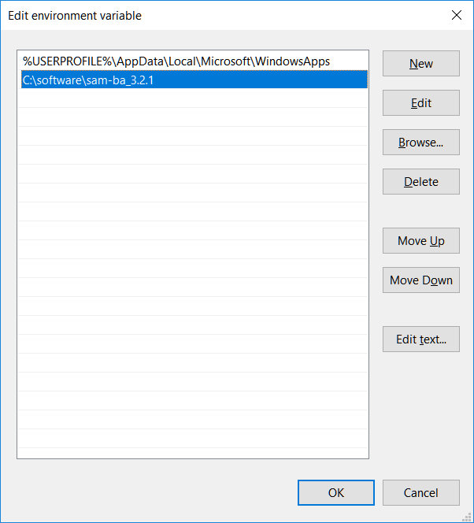

you can type sam-ba in dos windows, it should like this :

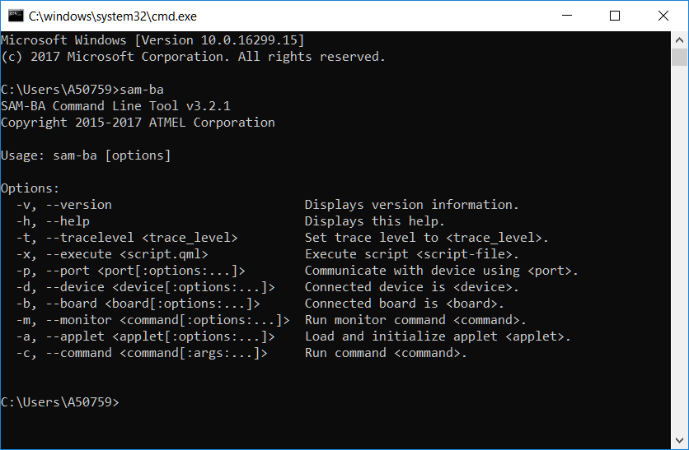

1. Download prebuild image from

<http://www.at91.com/linux4sam/bin/view/Linux4SAM>,

e.g ,on Sama5d2XplainedMainPage , we choose [linux4sam-poky-sama5d2_xplained_pda4-5.8.zip](ftp://www.at91.com/pub/demo/linux4sam_5.8/linux4sam-poky-sama5d2_xplained_pda4-5.8.zip)

1. Unzip the file, then open BOOT_DIS jumper, execute bat file, wait till a note file pop.

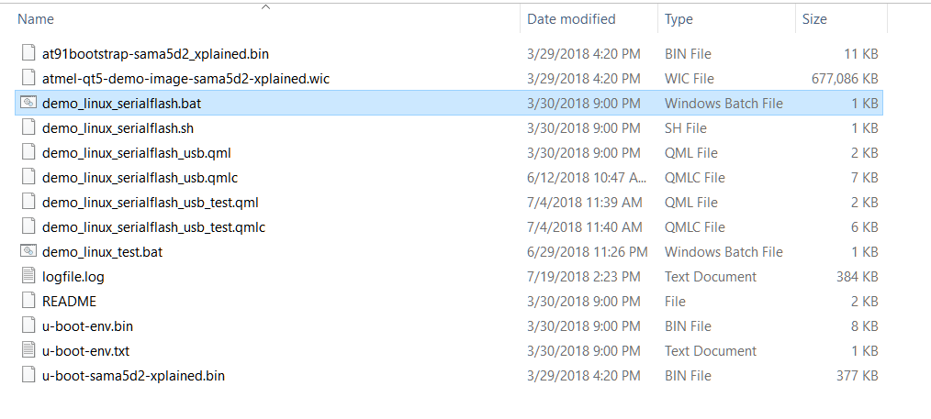

1. **Boot from external SD card**
2. e.g ,on Sama5d2XplainedMainPage , we choose [linux4sam-poky-sama5d2_xplained_pda4-5.8.img.bz2](ftp://www.at91.com/pub/demo/linux4sam_5.8/linux4sam-poky-sama5d2_xplained_pda4-5.8.img.bz2)

decompress the file ,you will get a xxxx.img file.

1. Install Win32DiskImager from <https://sourceforge.net/projects/win32diskimager/>
2. Prepare a 1GB( or more) SD card ,choose the image file on step 1,and start write,as below:

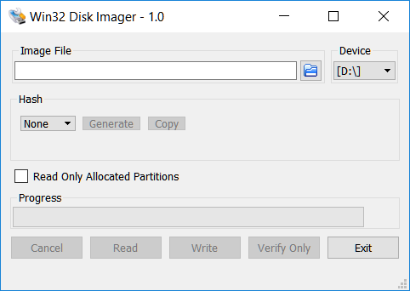

1. Insert sd card to board, boot th board.
2. **Access the console**

You have two ways to access the console,

1. EDBG USB port

Connect this port to PC,you will find a virtual series port in your devices manager,you can open it for console

1. CPU UART port

Connect directly to your uart device for console.

Following is a SAMA5D2 Xplain board overview, the two console ports shew in the red circle.

