Log and Graph Report

Single-instance

1.

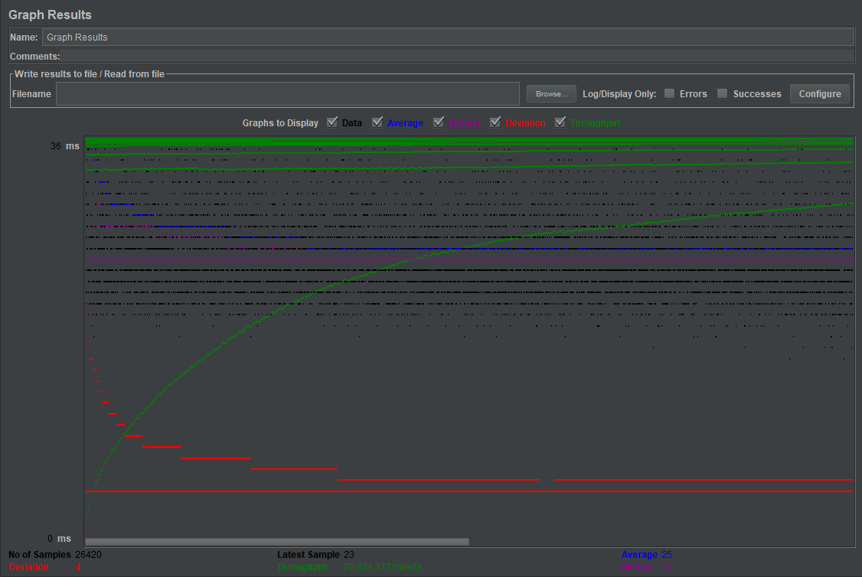

TJ avg : 122530.1048408463

TS avg : 2287178.147004277

2.

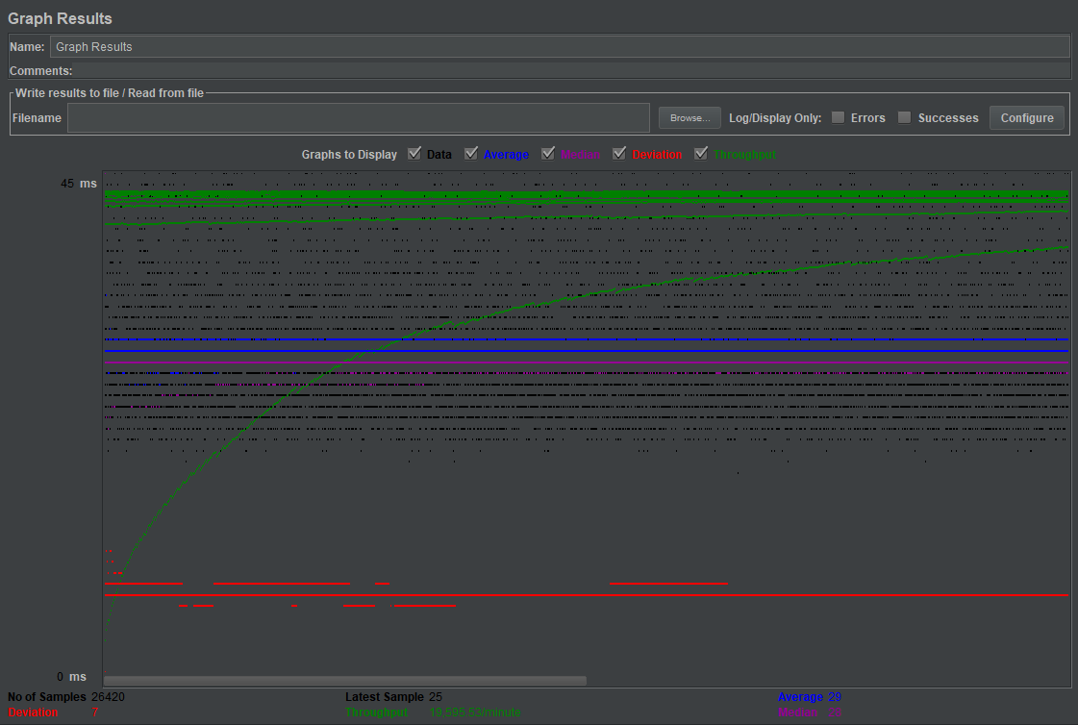

TJ avg : 213470.14439818318

TS avg : 6378932.462225587

3.

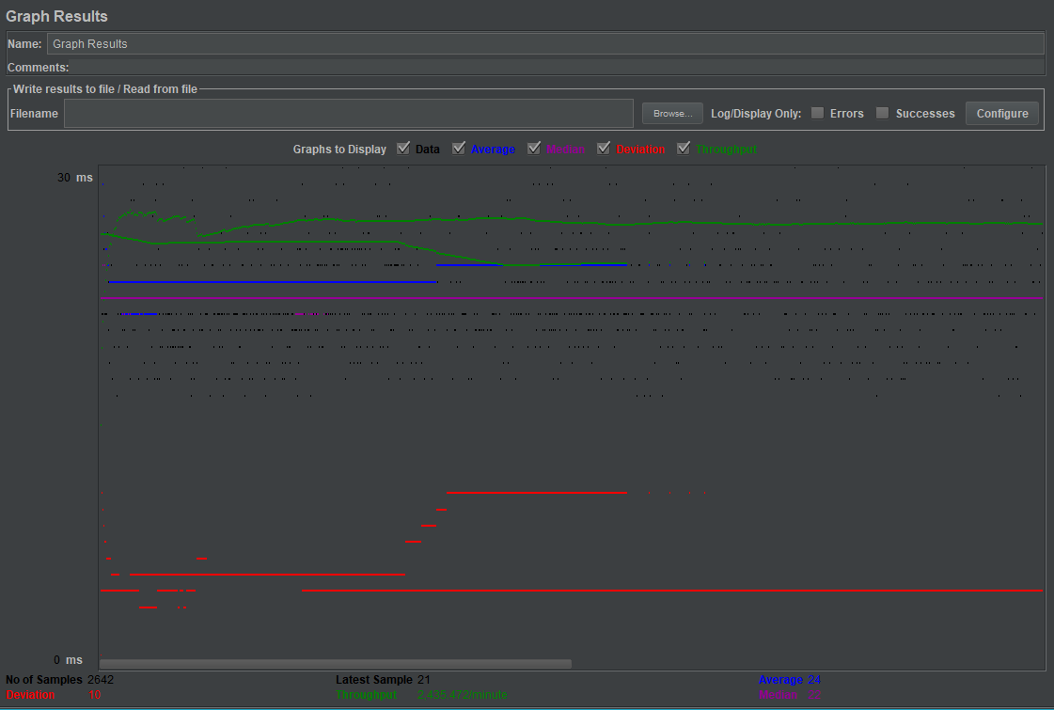

TJ avg : 90231.96707040121

TS avg : 1141736.4337623012

4.

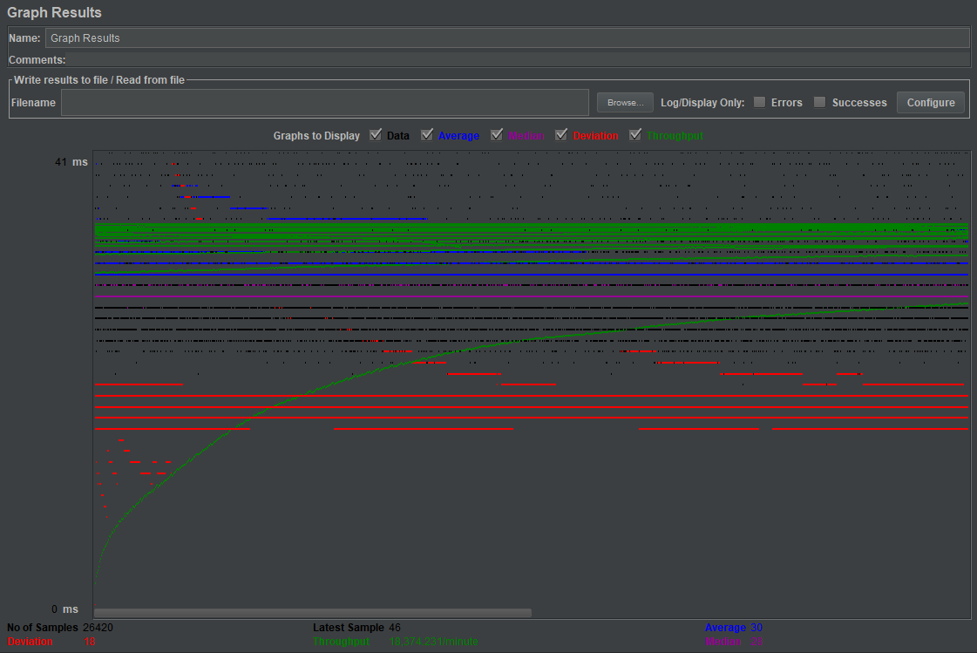

TJ avg : 108412.69473883422

TS avg : 1949459.4626040878

5.

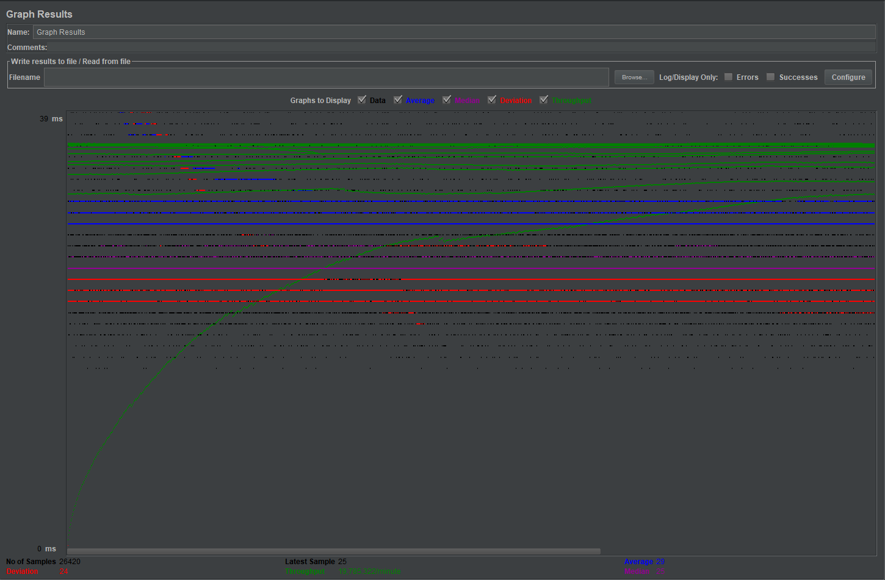

TJ avg : 147890.08626040877

TS avg : 2558404.6939061317

Scaled

1

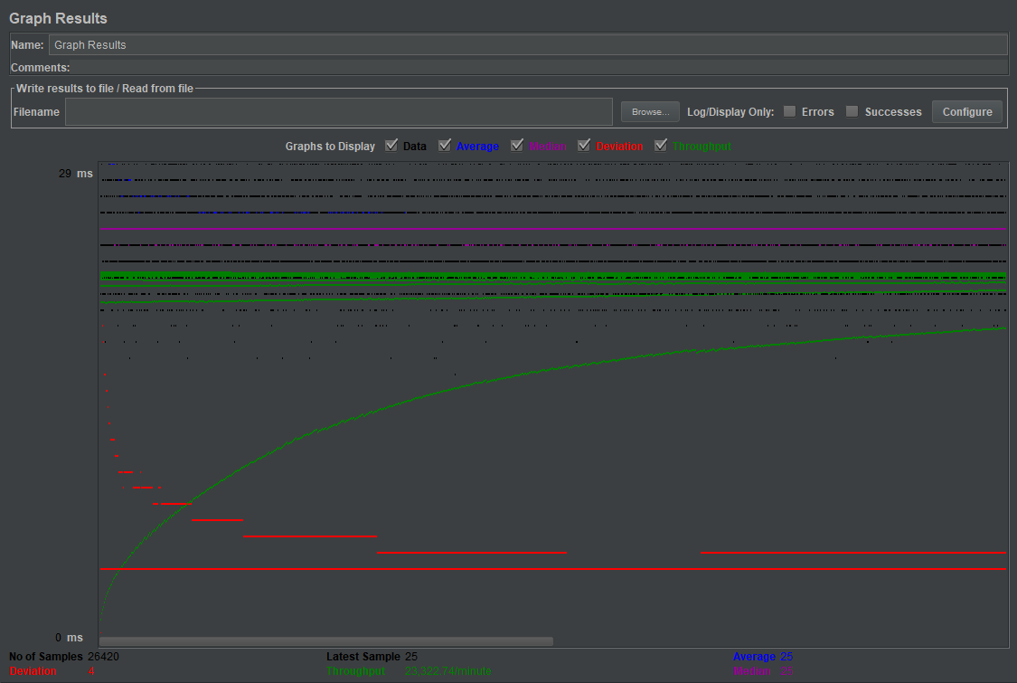

TJ avg : 97146.61261875024

TS avg : 1436138.054577798

2

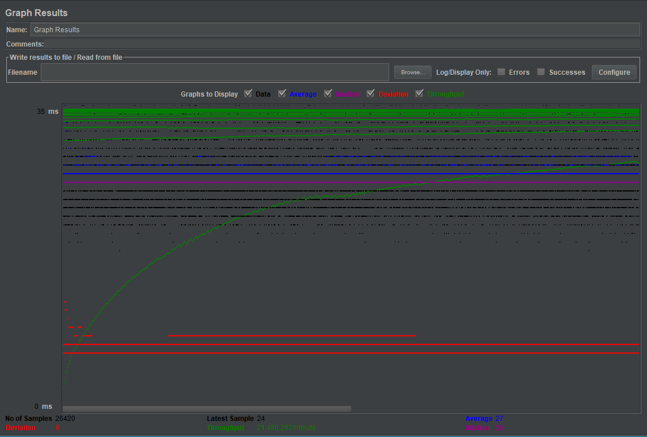

TJ avg : 113183.74761544284

TS avg : 3380212.158705526

3

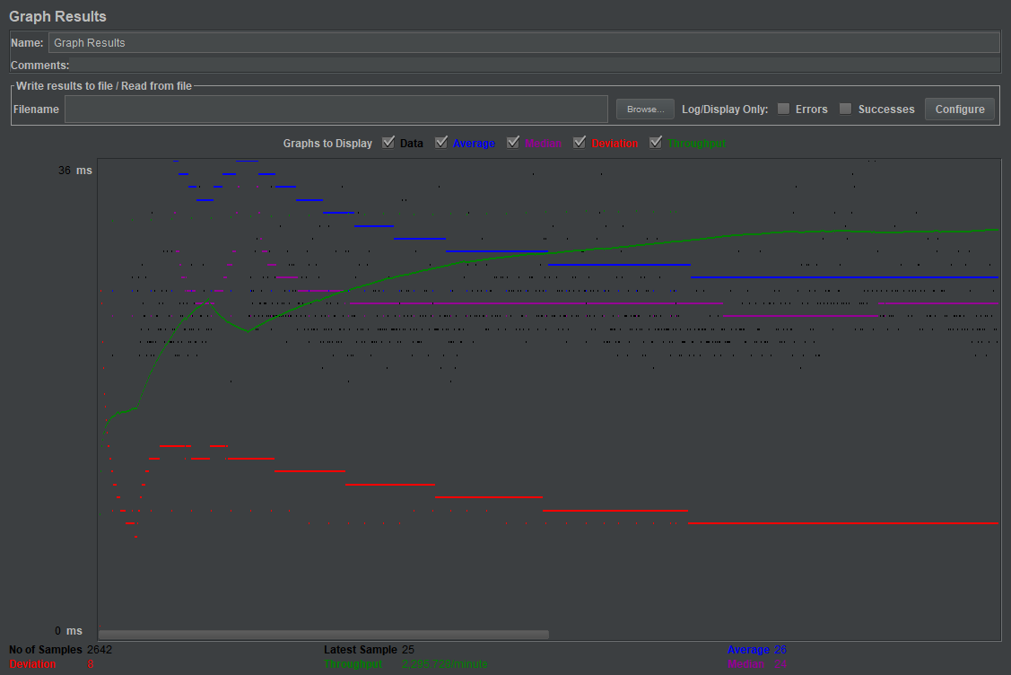

TJ avg : 103621.85881907646

TS avg : 1406249.8955336865

4

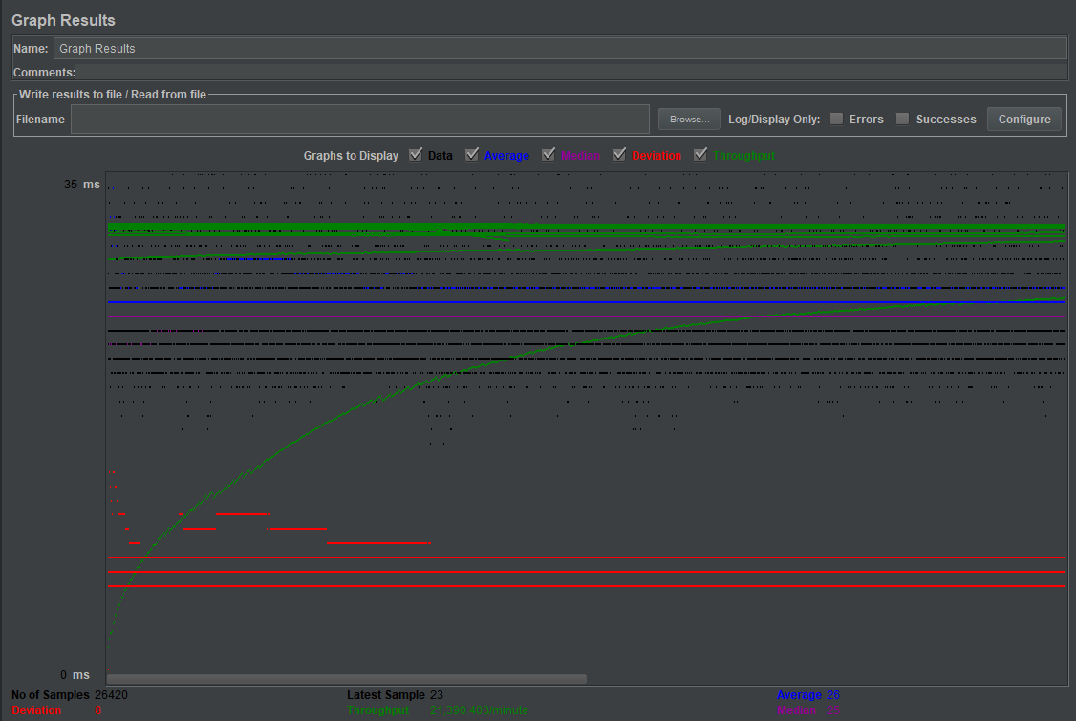

TJ avg : 93333.84394398183

TS avg : 1406429.0242619228