R Notebook

Exercise 3-1 #############

We have 2 continous variable from hicker smarthphone. dist -> Distance (in km) alti -> Altitude (in m)

1. Calculate the arithmetic mean and median for both distance and altitude

Mean, Median for Distance

dist<-c(12.5,29.9,14.8,18.7,7.6,16.2,16.5,27.4,12.1,17.5)  
mean(dist)

## [1] 17.32

median(dist)

## [1] 16.35

Mean, Median for Altitude

alti<-c(342,1245,502,555,398,670,796,912,238,466)  
mean(alti)

## [1] 612.4

median(alti)

## [1] 528.5

1. Determine the first and third quartiles for both distance and the altitude variables Discuss the shape of the distribution give the result of (a) and (b)

Quartiles for distance

quantile(dist,probs=c(0.25,0.75),type=2)

## 25% 75%   
## 12.5 18.7

To achieve correct quantile type 2 algorithm was used (default is 7).

Quartiles for distance

quantile(alti,probs=c(0.25,0.75),type=2)

## 25% 75%   
## 398 796

What does it means? Distance. Mean is higher than median and mean in higher range of 25% and 75% quantile. It means there were some trip(s) with longer length than others.

Altitude. Mean is in the middle of 25% and 75% range. Mean is much higher than average, so we have some trips with mich higher altitude move then others.

Interquartile range for distance

quantile(dist,probs=c(0.75),type=2) - quantile(dist,probs=c(0.25),type=2)

## 75%   
## 6.2

Interquartile range for distance

quantile(alti,probs=c(0.75),type=2) - quantile(alti,probs=c(0.25),type=2)

## 75%   
## 398

Absolute median deviation

1. For each observation do abs(x-mean). Output in vector t.
2. Sum all values in t.
3. Divide by len(t)

Distance.

dist<-c(12.5,29.9,14.8,18.7,7.6,16.2,16.5,27.4,12.1,17.5)  
m<-median(dist)  
dist = dist - m  
dist = abs(dist)  
sum(dist)/length(dist)

## [1] 4.68

1. Boxplots

Boxplot for distance

boxplot(dist,range=1.5)

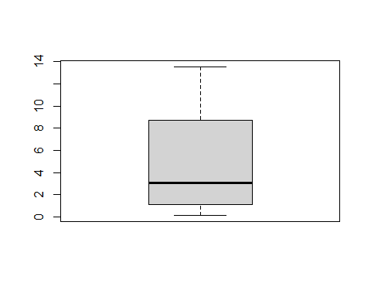

Boxplot for altitude

boxplot(alti,range=1.5)

