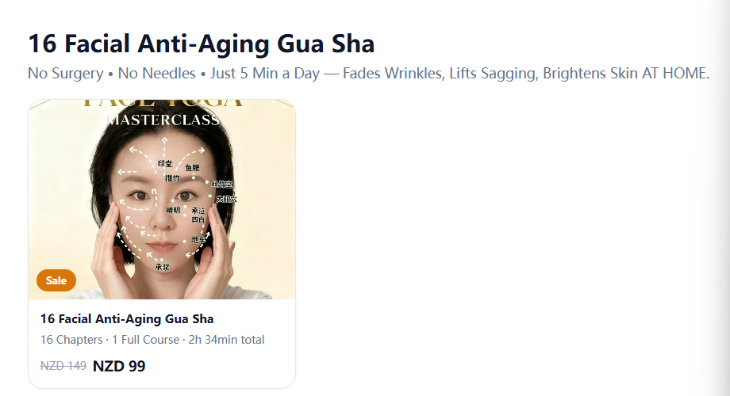主标题：Reverse Aging Without Surgery
副标题：5-Min Daily Gua Sha | Lift, Tighten & Brighten Your Face. No Needles, No Expensive Salon Visits.

课程页主标题 Youthful Glow Without The Effort
副标题 Beginner-Friendly Gua Sha Massage.
No Tools Expertise, No Pain, Just Natural Anti-Aging Results.

穴位板块

主标题英文
Natural Pain & Stress Relief Acupressure Care
副标题英文
No Pills, No Therapists.
Instant relief for headaches, body aches, anxiety & fatigue with 3 easy home points.
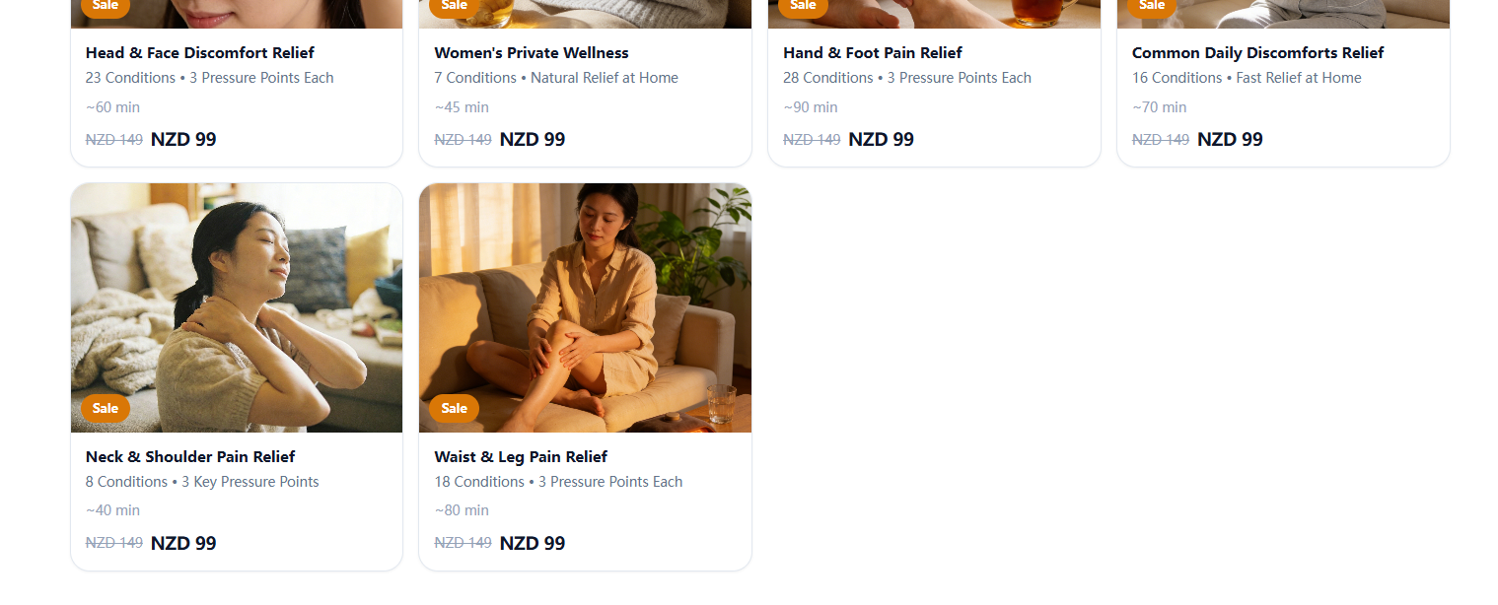
1111 Head & Face Discomfort Relief
Main Title：Stop Head Pain & Tension
Sub Title：Fix 23 Types of Aches | 3 Easy Moves, Instant Calm At Home

2222Women's Private Wellness
Main Title：Women’s Body Comfort & Relief
Sub Title：Ease 7 Common Female Issues | Gentle, Private Home Care

3333Hand & Foot Pain Relief
Main Title：Hand & Foot Aches Gone Fast
Sub Title：Relieve 28 Kinds Of Stiff Pain | Simple Daily Self Care

4444Common Daily Discomforts Relief
Main Title：Fix All Daily Body Aches
Sub Title：Fast Relief For 16 Everyday Pains | No Pills Needed

5555Neck & Shoulder Pain Relief
Main Title：Fix Stiff Neck & Shoulder Pain
Sub Title：Release 8 Types Of Tight Soreness | Quick 5-Min Routine

6666Waist & Leg Pain Relief
Main Title：Back & Leg Pain Relief
Sub Title：Ease 18 Kinds Of Body Discomfort | Simple All-Natural Method

太极板块

主标题
Fix Aches, Calm Anxiety & Sleep Deeply
副标题
Traditional Wudang Tai Chi. Gentle Daily Routine For All Ages & Fitness Levels.
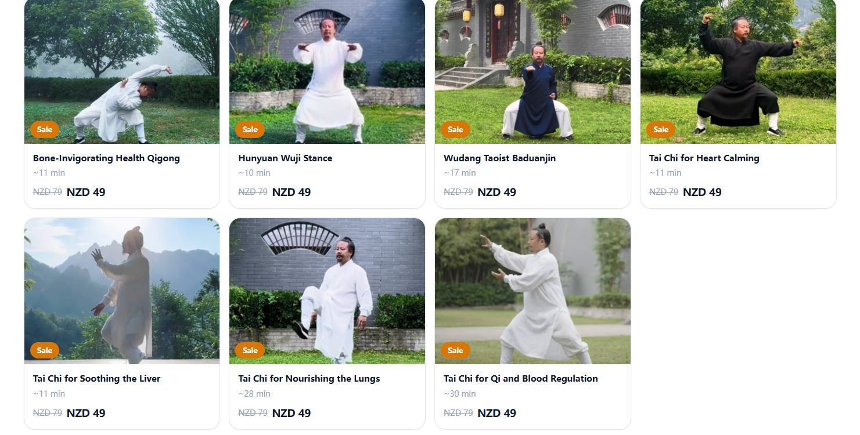
1｜Bone-Invigorating Health Qigong
Main Title: Bone & Joint Strength Qigong
Sub Title: Ease body stiffness, boost mobility & build deep physical strength

2｜Hunyuan Wuji Stance
Main Title: Hunyuan Wuji Stance for Inner Calm
Sub Title: Build stability, steady your mind & center your body’s energy

3｜Wudang Taoist Baduanjin
Main Title: Wudang Baduanjin for Full-Body Balance
Sub Title: Gentle daily movement to relax, refresh & restore whole-body wellness

4｜Tai Chi for Heart Calming
Main Title: Calm Mind & Relieve Restlessness
Sub Title: Soothe unease, steady mood & help you sleep more peacefully

5｜Tai Chi for Soothing the Liver
Main Title: Release Stress & Ease Irritability
Sub Title: Melt tension, clear frustration & relax tight body & mind

6｜Tai Chi for Nourishing the Lungs
Main Title: Deep Breathing & Vitality Boost
Sub Title: Breathe easier, build stamina & refresh your whole body

7｜Tai Chi for Qi and Blood Regulation
Main Title: Balance Qi & Blood for Full-Body Relaxation
Sub Title: Improve flow, ease stiffness & restore natural daily energy

咏春板块

Main Title：Wing Chun Practical Self-Defense Mastery
Sub Title：Learn simple, effective personal protection. Build confidence, strength & awareness daily
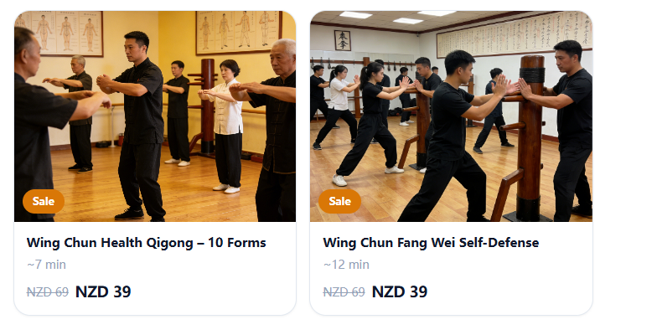
左侧主标题：Wing Chun 10 Health Qigong Forms
副标题：Gentle Daily Practice, Build Strength, Fix Posture & Boost All-Day Energy

右侧主标题：Wing Chun Practical Self-Defense
副标题：Simple Everyday Protection Skills, Gain Confidence & Feel Safe Anywhere

