Homework 3 — AI Report Validation System
Student name: _____________________ Date: _____________________

1. Written explanation (~500 words) — MUST be written by the student
Replace this paragraph with ~500 words in your own words. Cover: (a) purpose of the validation system; (b) how your custom rubric differs from the LAB Likert scales; (c) experimental design — three prompts (A/B/C), replicates per prompt, total N; (d) statistical results — copy F and p_anova from Section 4, name the winning prompt and Cohen's d; (e) design choices and challenges. Do NOT use an AI to write this section.

2. Git repository links
Validation runner (generation + AI reviewer): https://github.com/zj276-commits/Homework/blob/main/run_experiment.py
Statistical analysis (ANOVA + t-tests + plots): https://github.com/zj276-commits/Homework/blob/main/analyze_experiment.py
Custom rubric source / scenario fact pack: https://github.com/zj276-commits/Homework/blob/main/data/scenario_source.md
Example validation outputs: https://github.com/zj276-commits/Homework/blob/main/output/validation_results.csv
Per-dimension summary table: https://github.com/zj276-commits/Homework/blob/main/output/per_dimension_summary.csv
Full documentation: https://github.com/zj276-commits/Homework/blob/main/README.md
[Optional] If you reused Homework 1/2 reports as validator inputs (via --reports-dir), add links to those report files here as well.

3. Validation rubric (customized — not LAB Likert scales)
Dimension | Description | Scale | Contrast with LAB Likert (02_ai_quality_control.R)
scenario_fidelity_pct | Coverage of labeled facts F1–F10 without contradiction. | 0–100 % | LAB scores generic 'accuracy' on a 1–5 Likert; we tie it to a labeled fact pack.
decision_actionability_pct | Can a coordinator pick next-hour actions from the report alone? | 0–100 % | LAB has no 'usability' axis; this is operational, not literary.
briefing_structure_score | EOC-scannable layout (sections, no wall of text). | 0–10 integer | LAB measures 'clarity/formality' Likert; we score scannable structure directly.
traceability_pct | Explicit linkage of claims to fact IDs (F1, F2, …) or equivalent. | 0–100 % | LAB has no traceability dimension.
overreach_severity | False real-world escalation, fabricated URLs, contradicting drill scope. | 0–4 integer (penalty) | LAB uses one boolean 'accurate'; we encode degrees of drill breach.
Composite score: equal-weighted mean of the 4 normalized positive dimensions (briefing_structure_score is multiplied by 10 to share a 0–100 scale). overreach_severity is analyzed separately.

4. Statistical analysis (auto-embedded from output/)
Homework 3 — Statistical analysis of AI report validation experiment
========================================================================
Source CSV: output\validation_results.csv
N per prompt: {'A_minimal_paragraph': 6, 'B_structured_sections': 6, 'C_ICS_traceability': 6} (total N = 18)
=== PRIMARY ENDPOINT: composite_score (equal-weight mean of 4 normalized positive dims) ===
Means: A minimal paragraph=49.52, B structured sections=65.15, C ICS traceability=77.48
SD: A minimal paragraph=5.61, B structured sections=6.02, C ICS traceability=5.19
One-way ANOVA: F = 37.3250, p = 1.5016e-06
Pairwise Welch t-tests (two-sided) on composite_score:
A minimal paragraph vs B structured sections: t=-4.654, p=0.000915571, Cohen's d=-2.687
A minimal paragraph vs C ICS traceability: t=-8.961, p=4.4789e-06, Cohen's d=-5.174
B structured sections vs C ICS traceability: t=-3.796, p=0.00364284, Cohen's d=-2.192
Bonferroni-adjusted alpha: 0.05 / 3 = 0.01667
A minimal paragraph vs B structured sections: p_adj ≈ 0.00274671 (**significant**)
A minimal paragraph vs C ICS traceability: p_adj ≈ 1.34367e-05 (**significant**)
B structured sections vs C ICS traceability: p_adj ≈ 0.0109285 (**significant**)
=== Verdict ===
Reject H0 (p_anova = 1.502e-06 < 0.05). Highest mean composite score: **C ICS traceability** (77.48).
Significantly different pairs (after Bonferroni): A minimal paragraph ≠ B structured sections; A minimal paragraph ≠ C ICS traceability; B structured sections ≠ C ICS traceability
=== SECONDARY: per-dimension one-way ANOVA ===
dimension F p best (highest mean)
scenario_fidelity_pct 3.277 0.0659379 C ICS traceability
decision_actionability_pct 10.376 0.00148221 C ICS traceability
briefing_structure_score 17.113 0.00013464 C ICS traceability
traceability_pct 21.502 3.933e-05 C ICS traceability
overreach_severity 8.611 0.00323235 C ICS traceability (lowest mean = best)

4a. Per-dimension means and ANOVA
dimension | A_minimal_paragraph_mean | A_minimal_paragraph_sd | B_structured_sections_mean | B_structured_sections_sd | C_ICS_traceability_mean | C_ICS_traceability_sd | F | p_value
scenario_fidelity_pct | 58.443 | 11.812 | 72.563 | 9.366 | 74.28 | 13.694 | 3.277 | 0.0659378905636806
decision_actionability_pct | 55.708 | 11.718 | 72.75 | 5.938 | 74.293 | 3.456 | 10.376 | 0.0014822067160164
briefing_structure_score | 4.758 | 0.715 | 5.875 | 1.434 | 8.095 | 0.684 | 17.113 | 0.000134640001832
traceability_pct | 36.385 | 10.314 | 56.563 | 10.294 | 80.402 | 13.93 | 21.502 | 3.933004681541816e-05
overreach_severity | 1.167 | 0.408 | 0.333 | 0.516 | 0.167 | 0.408 | 8.611 | 0.0032323492502292
composite_score | 49.525 | 5.605 | 65.155 | 6.022 | 77.48 | 5.193 | 37.325 | 1.50160357372852e-06

5. Figures (auto-embedded)
Figure 1. Composite score by prompt (boxplot).
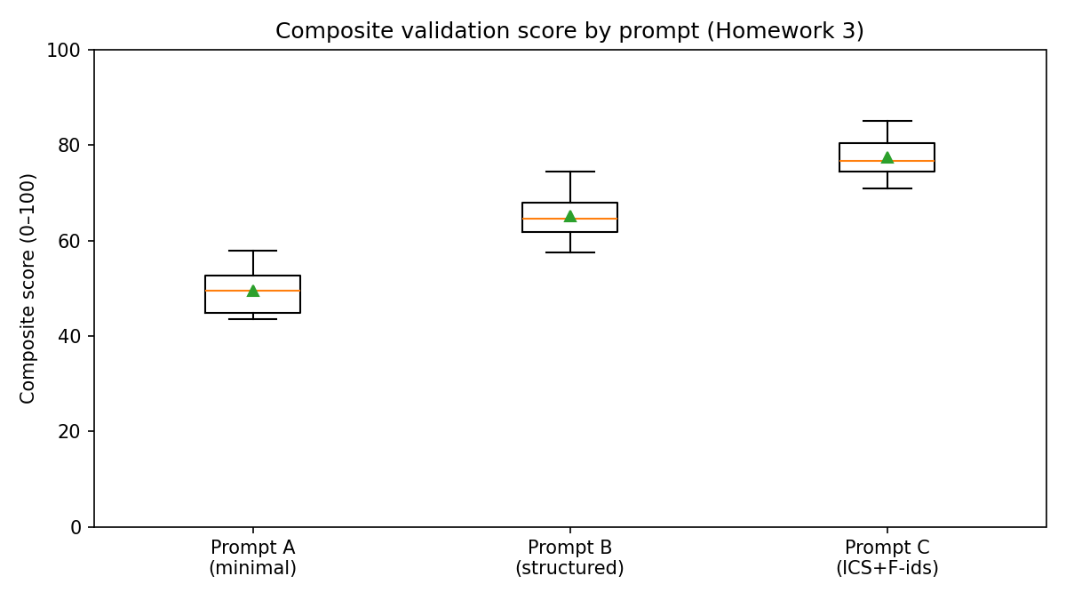
Figure 2. Per-dimension comparison across prompts.
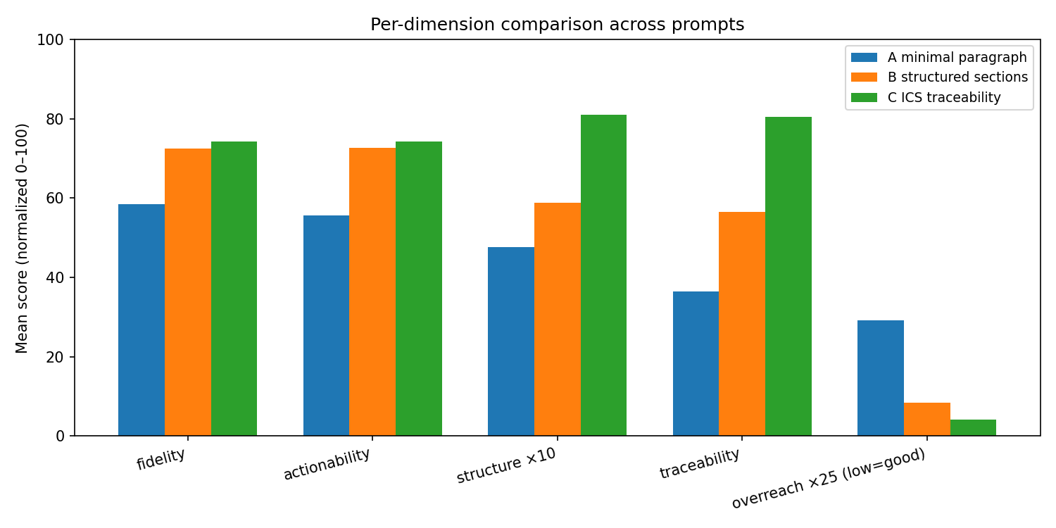

6. Sample inputs/outputs
Sample generated report (`MOCK_A_minimal_paragraph_r1.txt`):
[MOCK REPORT A_minimal_paragraph replicate 1]
Placeholder for offline testing.

Validation results — first rows of validation_results.csv
prompt_key | replicate | scenario_fidelity_pct | decision_actionability_pct | briefing_structure_score | traceability_pct | overreach_severity | composite_score | validator_notes
A_minimal_paragraph | 1 | 61.77 | 63.85 | 5.96 | 26.98 | 1 | 53.0379 | MOCK row — synthetic data for offline testing.
A_minimal_paragraph | 2 | 61.12 | 66.75 | 5.16 | 52.04 | 2 | 57.8763 | MOCK row — synthetic data for offline testing.
A_minimal_paragraph | 3 | 59.12 | 43.1 | 4.52 | 28.17 | 1 | 43.8991 | MOCK row — synthetic data for offline testing.
A_minimal_paragraph | 4 | 36.57 | 66.79 | 3.88 | 31.7 | 1 | 43.46 | MOCK row — synthetic data for offline testing.
A_minimal_paragraph | 5 | 72.56 | 41.37 | 4.48 | 46.3 | 1 | 51.2497 | MOCK row — synthetic data for offline testing.
A_minimal_paragraph | 6 | 59.52 | 52.39 | 4.55 | 33.12 | 1 | 47.6253 | MOCK row — synthetic data for offline testing.
B_structured_sections | 1 | 65.13 | 72.81 | 7.13 | 48.11 | 0 | 64.3316 | MOCK row — synthetic data for offline testing.
B_structured_sections | 2 | 71.5 | 71.56 | 6.86 | 64.01 | 0 | 68.9093 | MOCK row — synthetic data for offline testing.
B_structured_sections | 3 | 88.85 | 79.53 | 5.64 | 73.48 | 0 | 74.5628 | MOCK row — synthetic data for offline testing.
B_structured_sections | 4 | 66.29 | 75.72 | 7.01 | 47.23 | 0 | 64.8323 | MOCK row — synthetic data for offline testing.

7. Reproducibility & usage
Run metadata:
- mode: mock
- replicates_per_prompt: 6
- prompt_keys: ['A_minimal_paragraph', 'B_structured_sections', 'C_ICS_traceability']
- rubric_dimensions: ['scenario_fidelity_pct', 'decision_actionability_pct', 'briefing_structure_score', 'traceability_pct']
- composite_definition: equal-weighted mean of normalized positive dimensions (0-100)
- model_generator: MOCK
- model_validator: MOCK
- n_rows: 18
- generated_at_utc: 2026-05-10T23:26:20.285045+00:00
cd 11_decision_support/homework3
py -3.12 -m venv .venv
.venv\Scripts\pip install -r requirements.txt
copy .env.example .env (then set OLLAMA_API_KEY)
.venv\Scripts\python run_experiment.py
.venv\Scripts\python analyze_experiment.py
.venv\Scripts\python build_submission_docx.py

8. Screenshot checklist (paste yours below)
- Terminal showing run_experiment.py producing 18+ rows (or --mock)
- One generated report .txt open in editor
- validation_results.csv open in Excel / VS Code
- stats_summary.txt or terminal output of analyze_experiment.py
- boxplot_composite.png (already embedded above; you can also screenshot it)
- bar_per_dimension.png (already embedded above)

