Requirements

Junyan Fan:

|  |  |  |
| --- | --- | --- |
| Requirement | Requirement type  Functional | Use case |
| Description: the system should provide a GUI to let manager input a flight’s detail, like flight time, departure place, arrived place and price | | |
| Rationale:flight manger want to create a new rout, so he need set all detail | | |
| Source: flight manager | | |
| Fit criterion: a new rout will be apply | | |
| Dependencies:none | | |
| Rank of importance: Critical | | |
| Supporting materials: None | | |
| History create by Junyan Fan 27/03/2015 | | |

|  |  |  |
| --- | --- | --- |
| Requirement | Requirement type  Functional | Use case |
| Description: the system should provide a GUI to let manager check all rout and manager can select one and change detail about rout, the detail like like flight time, departure place, arrived place and price | | |
| Rationale: flight manager want to change any rout’s detail | | |
| Source flight manager | | |
| Fit criterion: new detail will be saved and apply | | |
| Dependencies： the data must be exist. | | |
| Rank of importance：Critical | | |
| Supporting materials：None | | |
| History create by Junyan Fan 27/03/2015 | | |

|  |  |  |
| --- | --- | --- |
| Requirement | Requirement type  Functional | Use case |
| Description: system have a button, when press it, will have a GUI to see all report  He can see some types about report. | | |
| Rationale: manager wants to know which report he got. These report can display the company’s state. | | |
| Source: all manager | | |
| Fit criterion: all report will be display | | |
| Dependencies: none | | |
| Rank of importance：Essential | | |
| Supporting materials：None | | |
| History create by Junyan Fan 27/03/2015 | | |

|  |  |  |
| --- | --- | --- |
| Requirement | Requirement type  Functional | Use case |
| Description: system should provide a page, this page just use for manger log in. | | |
| Rationale: manager need log in his page | | |
| Source all managers | | |
| Fit criterion: manager will log in successfully. | | |
| Dependencies: none | | |
| Rank of importance：Critical | | |
| Supporting materials：None | | |
| History create by Junyan Fan 27/03/2015 | | |

|  |  |  |
| --- | --- | --- |
| Requirement | Requirement type  Functional | Use case |
| Description: system should provide a GUI, which can display all plane’s state, manager can choose one, and display the detail about the plane. | | |
| Rationale: managers want to check every plane’s state they can do other operation later. | | |
| Source: manager | | |
| Fit criterion: all plant’s detail will display. | | |
| Dependencies: none | | |
| Rank of importance：Essential | | |
| Supporting materials：None | | |
| History create by Junyan Fan 27/03/2015 | | |

|  |  |  |
| --- | --- | --- |
| Requirement | Requirement type  Functional | Use case |
| Description: system should provide a GUI, which can have search function, manager can use this search other users, and see their information | | |
| Rationale: managers want to find some one and find his information do something | | |
| Source: manager | | |
| Fit criterion: the searched user will be display. | | |
| Dependencies: none | | |
| Rank of importance：Desirable | | |
| Supporting materials：None | | |
| History create by Junyan Fan 27/03/2015 | | |

|  |  |  |
| --- | --- | --- |
| Requirement | Requirement type  Functional | Use case |
| Description: System provide a GUI, which can let service manager choose some meal for the plane | | |
| Rationale: service manager need choose some meal for chosen plane | | |
| Source: service manager | | |
| Fit criterion: the plane will have meal can be chosen. | | |
| Dependencies: none | | |
| Rank of importance：Critical | | |
| Supporting materials：None | | |
| History create by Junyan Fan 27/03/2015 | | |

|  |  |  |
| --- | --- | --- |
| Requirement | Requirement type  Functional | Use case |
| Description: system provide a GUI, which can let service manager choose whether have headphone provide for chosen plane | | |
| Rationale: service manager want to decide this plane whether headphone provide. | | |
| Source: service manager | | |
| Fit criterion: chosen plane will be decision whether have headphone provide. | | |
| Dependencies: none | | |
| Rank of importance：Critical | | |
| Supporting materials：None | | |
| History create by Junyan Fan 27/03/2015 | | |

|  |  |  |
| --- | --- | --- |
| Requirement | Requirement type  Functional | Use case |
| Description: system provide a GUI, which can let service manager choose whether have blanket provide for chosen plane | | |
| Rationale: service manager want to decide this plane whether blanket provide. | | |
| Source: service manager | | |
| Fit criterion: chosen plane will be decision whether have blanket provide. | | |
| Dependencies: none | | |
| Rank of importance：Critical | | |
| Supporting materials：None | | |
| History create by Junyan Fan 18/04/2015 | | |

Ruixi He:

Staff side:

This session includes all functions that staff can use to interact with the flight management system.

|  |  |  |
| --- | --- | --- |
| Requirement: | Requirement Type:  Functional | Use Case: |
| Description: This system should provide a Staff with a GUI to book the flight ticket for the customer | | |
| Rationale: A staff assists the customer to book the flight ticket | | |
| Source: Staff | | |
| Fit Criterion: The ticket can be book successful and the record was saved. | | |
| Dependencies: None | | |
| Rank of importance: Critical | | |
| Supporting Materials: None | | |
| History: Created by Ruixi He 27/03/2015 | | |

|  |  |  |
| --- | --- | --- |
| Requirement: | Requirement Type:  Functional | Use Case: |
| Description: This system should provide a Staff with a GUI to search customer’s record. | | |
| Rationale: A staff wants to search for customer’s record | | |
| Source: Staff | | |
| Fit Criterion: A GUI form for customer’s record should be displayed. | | |
| Dependencies: None | | |
| Rank of importance: Critical | | |
| Supporting Materials: None | | |
| History: Created by Ruixi He 27/03/2015 | | |

|  |  |  |
| --- | --- | --- |
| Requirement: | Requirement Type:  Functional | Use Case: |
| Description: This system should provide a Staff with a GUI to search flight information. | | |
| Rationale: A staff wants to search for flight information. | | |
| Source: Staff | | |
| Fit Criterion: A GUI form for flight information should be displayed. | | |
| Dependencies: None | | |
| Rank of importance: Critical | | |
| Supporting Materials: None | | |
| History: Created by Ruixi He 27/03/2015 | | |

|  |  |  |
| --- | --- | --- |
| Requirement: | Requirement Type:  Functional | Use Case: |
| Description: This system should provide a Staff with a GUI to switch seat for two exist customers in one flight. | | |
| Rationale: A staff wants to switch the seat for two exist customers in a flight. | | |
| Source: Staff | | |
| Fit Criterion: The booking record of the customer should be updated. | | |
| Dependencies: None | | |
| Rank of importance: Critical | | |
| Supporting Materials: None | | |
| History: Created by Ruixi He 27/03/2015 | | |

Sandon:

|  |  |  |
| --- | --- | --- |
| **Requirement #:** F_ | **Requirement Type:** Functional | **Use Case #:** |
| **Description:** The system should allow the user to login | | |
| **Rationale:** Users can access needed information faster and change | | |
| **Source:** Member, Agent, Staff, Manager, Administrator | | |
| **Fit Criterion:** The user successfully logs in | | |
| **Dependencies:** None | | |
| **Rank of Importance:** Critical | | |
| **Supporting Materials:** None | | |
| **History:** Created by Sandon Joubert 1/4/2015 | | |

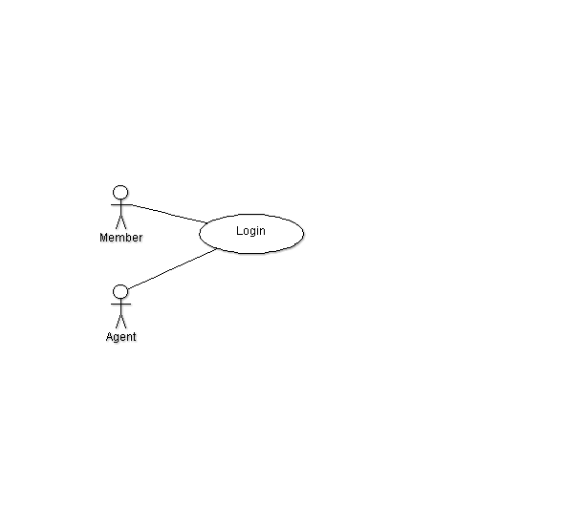

|  |  |  |
| --- | --- | --- |
| **Requirement #:** F_ | **Requirement Type:** Functional | **Use Case #:** |
| **Description:** A non-member should allow the user to become a new member | | |
| **Rationale:** Helps them keep track | | |
| **Source:** Non-member | | |
| **Fit Criterion:** The user successfully becomes a non-member | | |
| **Dependencies:** None | | |
| **Rank of Importance:** Critical | | |
| **Supporting Materials:** None | | |
| **History:** Created by Sandon Joubert 1/4/2015 | | |

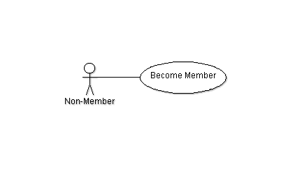

|  |  |  |
| --- | --- | --- |
| **Requirement #:** F_ | **Requirement Type:** Optional | **Use Case #:** |
| **Description:** The system should allow the user to change their password and other account information | | |
| **Rationale:** Sometimes users need to change information about themselves to better reflect changes in their life | | |
| **Source:** Member, Agent | | |
| **Fit Criterion:** The user successfully changes account information | | |
| **Dependencies:** Login F_ | | |
| **Rank of Importance:** Medium | | |
| **Supporting Materials:** None | | |
| **History:** Created by Sandon Joubert 1/4/2015 | | |

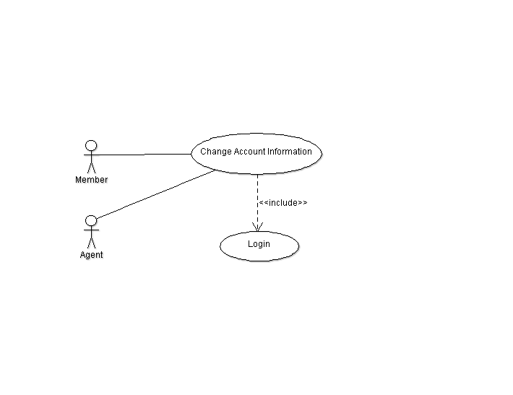

|  |  |  |
| --- | --- | --- |
| **Requirement #:** F_ | **Requirement Type:** Functional | **Use Case #:** |
| **Description:** Any customer should be able to search for a flight | | |
| **Rationale:** A customer must be able to have the liberty of finding the best flight for them | | |
| **Source:** Non-member, Member, Agent | | |
| **Fit Criterion:** The user successfully selects a flight | | |
| **Dependencies:** None | | |
| **Rank of Importance:** Critical | | |
| **Supporting Materials:** None | | |
| **History:** Created by Sandon Joubert 1/4/2015 | | |

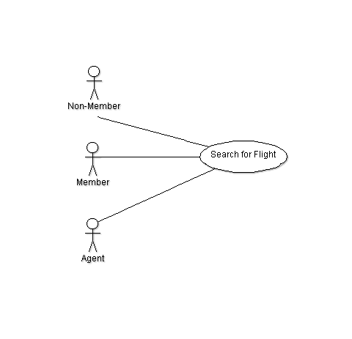

|  |  |  |
| --- | --- | --- |
| **Requirement #:** F_ | **Requirement Type:** Functional | **Use Case #:** |
| **Description:** Any customer should be able to book a flight | | |
| **Rationale:** It’s not a very good airline booking system if you can’t book a flight | | |
| **Source:** Non-member, Member, Agent | | |
| **Fit Criterion:** The user successfully books a flight | | |
| **Dependencies:** Login F_ | | |
| **Rank of Importance:** Critical | | |
| **Supporting Materials:** None | | |
| **History:** Created by Sandon Joubert 1/4/2015 | | |

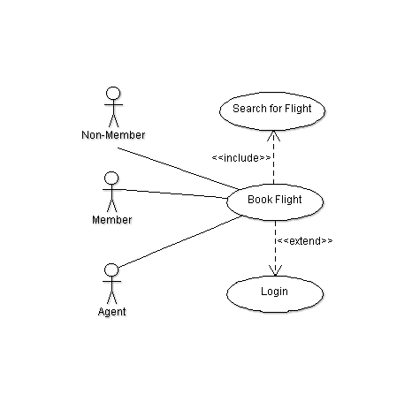

|  |  |  |
| --- | --- | --- |
| **Requirement #:** F_ | **Requirement Type:** Functional | **Use Case #:** |
| **Description:** Any customer should be able to change or add in-flight services | | |
| **Rationale:** A customer may of made a mistake or change of mind and wishes to change/add in-flight services after booking | | |
| **Source:** Non-member, Member, Agent | | |
| **Fit Criterion:** The user successfully changes / adds in-flight services | | |
| **Dependencies:** Login F_ | | |
| **Rank of Importance:** Critical | | |
| **Supporting Materials:** None | | |
| **History:** Created by Sandon Joubert 1/4/2015 | | |

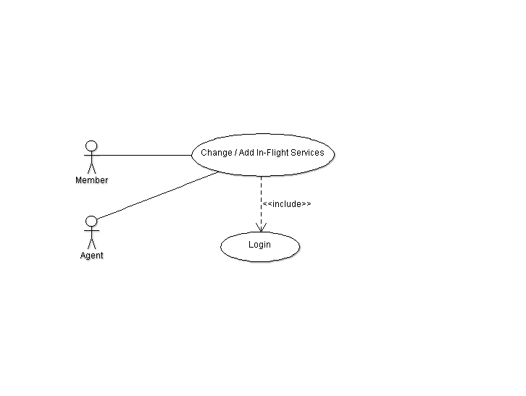

|  |  |  |
| --- | --- | --- |
| **Requirement #:** F_ | **Requirement Type:** Functional | **Use Case #:** |
| **Description:** Any customer should be able to change or cancel a booked flight | | |
| **Rationale:** A customer may of made a mistake or change of mind and wishes to change/cancel a flight after booking | | |
| **Source:** Non-member, Member, Agent | | |
| **Fit Criterion:** The user successfully changes / adds in-flight services | | |
| **Dependencies:** Login F_ | | |
| **Rank of Importance:** Critical | | |
| **Supporting Materials:** None | | |
| **History:** Created by Sandon Joubert 1/4/2015 | | |

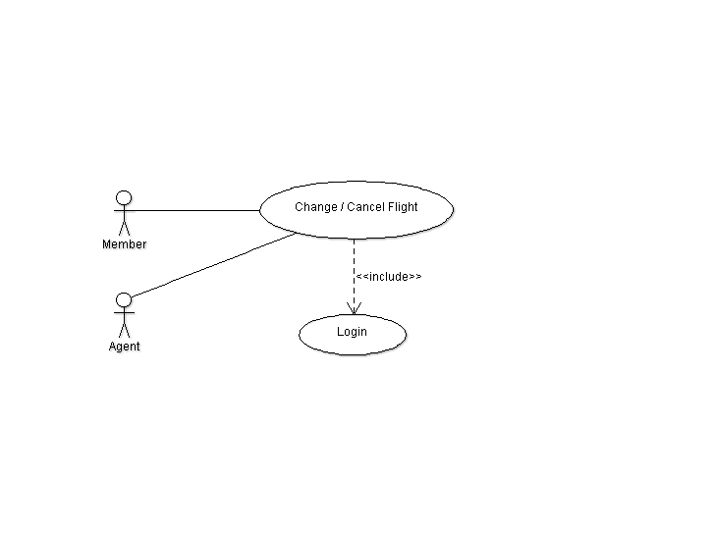

Zheli Jiang:

|  |  |  |
| --- | --- | --- |
| **Requirement #:** F_ | **Requirement Type:** Functional | **Use Case #:** |
| **Description:** Administrators should be provided with a GUI to create user groups. | | |
| **Rationale:** A administrator wants to create user groups. | | |
| **Source:** Administrator | | |
| **Fit Criterion:** User groups can be successfully created. | | |
| **Dependencies:** Login F_ | | |
| **Rank of Importance:** Critical | | |
| **Supporting Materials:** None | | |
| **History:** Created by Zheli Jiang 1/4/2015 | | |

|  |  |  |
| --- | --- | --- |
| **Requirement #:** F_ | **Requirement Type:** Functional | **Use Case #:** |
| **Description:** Administrators should be provided with a GUI to promote staff to manager. | | |
| **Rationale:** A administrator wants to promote staff to manager. | | |
| **Source:** Administrator | | |
| **Fit Criterion:** Staff can be successfully promoted to manager. | | |
| **Dependencies:** Login F_ | | |
| **Rank of Importance:** Critical | | |
| **Supporting Materials:** None | | |
| **History:** Created by Zheli Jiang 1/4/2015 | | |

|  |  |  |
| --- | --- | --- |
| **Requirement #:** F_ | **Requirement Type:** Functional | **Use Case #:** |
| **Description:** Administrators should be provided with a GUI to disable accounts. | | |
| **Rationale:** A administrator wants to disable accounts. | | |
| **Source:** Administrator | | |
| **Fit Criterion:** Accounts can be successfully disabled. | | |
| **Dependencies:** Login F_ | | |
| **Rank of Importance:** Critical | | |
| **Supporting Materials:** None | | |
| **History:** Created by Zheli Jiang 1/4/2015 | | |

|  |  |  |
| --- | --- | --- |
| **Requirement #:** F_ | **Requirement Type:** Functional | **Use Case #:** |
| **Description:** Administrators should be provided with a GUI to enable accounts. | | |
| **Rationale:** A administrator wants to enable accounts. | | |
| **Source:** Administrator | | |
| **Fit Criterion:** Accounts can be successfully enabled. | | |
| **Dependencies:** Login F_ | | |
| **Rank of Importance:** Critical | | |
| **Supporting Materials:** None | | |
| **History:** Created by Zheli Jiang 1/4/2015 | | |