Report
CSE Assignment 5

Name: Akshat Chhajer
Rno: 2018114008

Task 1:

waitx system call was added in proc.c

The definition:
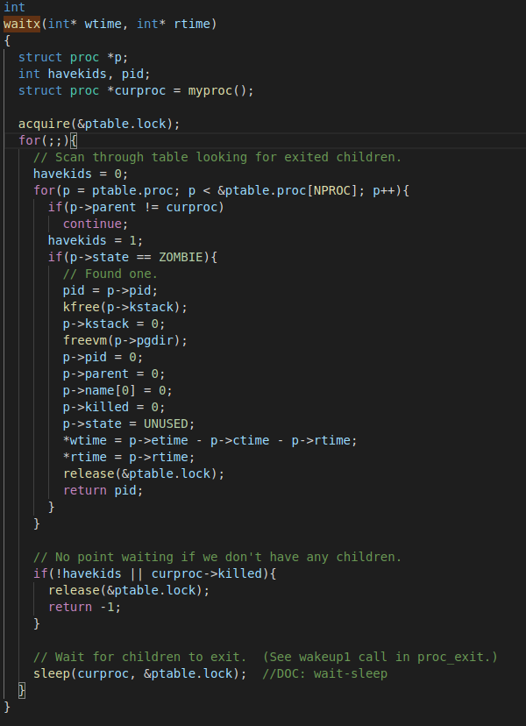

Task 2:

3 different types of scheduling was added to the xv6 OS.

- Round Robin (default)
- First Come First Serve
- Priority Based Scheduler
- Multilevel feedback queue

The workings of which can be found in the scheduler function in proc.c

To run:

$`make clean`
$`make qemu-nox SCHEDULER={scheduling policy}

Test Program

