### ***Idea Analysis & Marketing***

### **Price and Distribution Strategy**

### Our app will have two price strategies. First, the app will be free to download from the app store. There will be advertisements in the app that the users watch to gain more points to use for betting. The second option is you can pay a monthly subscription to remove the ads. With this option, the users will be given a monthly amount of points since there are no advertisements to gain points. Either option brings in revenue for us. The first option is a variable revenue strategy and the second one allows us to have fixed revenue coming in.

### The distribution strategy will heavily rely on our marketing strategy. Because we don’t have a product, we need to market our app so people know to go get the app on the app store. At first, a good way to distribute our app is by word of mouth. Telling everyone we know about it can quickly spread the information of the application. However, the marketing of the application will lead to more people downloading the app, and once people download it they will tell their friends to download it too. Ideally, when one person hears about WagerMe, they will tell their friends and our distribution will spread quickly. **Marketing Strategies**

### After analyzing our results from the survey and digging deeper into our market we concluded that the best ways to reach our target market is to go out on college campuses and market directly to students. On top of guerilla marketing we believe posting facebook ads would be very beneficial since social media is one of the best ways to target the 18-21 age group. In order to conduct these strategies, we will need funds to purchase both handouts and facebook advertisements. These costs are fairly cheap and will pay themselves off quickly.

### Guerilla Marketing

Guerilla marketing will be very effective with our target market since we are targeting the 18-21 year old age group. This age group is represented widely on college campuses, therefore getting out on college campuses and handing out flyers directly to students will be very effective and cheap. We plan to purchase flyers advertising the app and then having students go out on their campus and handing them out.

Social Media Advertisements

Between 85% and 99% of college students have a Facebook. This statistic proves that using facebook ads as a way to market wager me is a very important strategy. Targeting college students through social media allows for a very productive and easy way to reach these students. We will target the center of universities with a 5 mile radius to allow for multiple ads to be posted to students page a day. As a result, students will be accessed effectively and the return and spread of the application will increase dramatically.

**Description of the Industry**

WagerMe will be developed on mobile to capture the upward trend involving mobile usage overall and gambling specifically. Today, 91% of the US population owns a cell phone and two third of them are smartphones that the WagerMe application could be used on. This growth should keep going on in the next few years to reach overall 10 billion mobile internet devices in 2017/2018. The usage of applications is also soaring as shown by some forecasts according to which 268 billion apps downloads will be done in 2017 generating $77 billion worth of revenue for their owners. The type and frequency of this usage is also evolving. For instance, 60% of people who have downloaded an app recently are using apps on a daily basis. Moreover, social-oriented applications account for a large part of them. Indeed applications whose purpose is to connect people with each other are on the increase. As a result of all those elements, the average amount of points of contact with one’s smartphone reaches today 130.

However, this growing market implies a larger number of competitors in general and in the betting field in particular as described below. Among the apps currently used, a large majority is free which feed the habit of not paying for such services. Less than half of application users only have made at least one application purchase by the past. The revenue issued from them is however on the increase and should reach $277 billion in 2017 and should double within the next 5 years.

Mobile games represent the main category of mobile applications - representing 85% of their overall business revenue, equivalent to a total of $35 billion last year. The “Free to play” model is; however, preferred compared to other business models as illustrated by the chart.

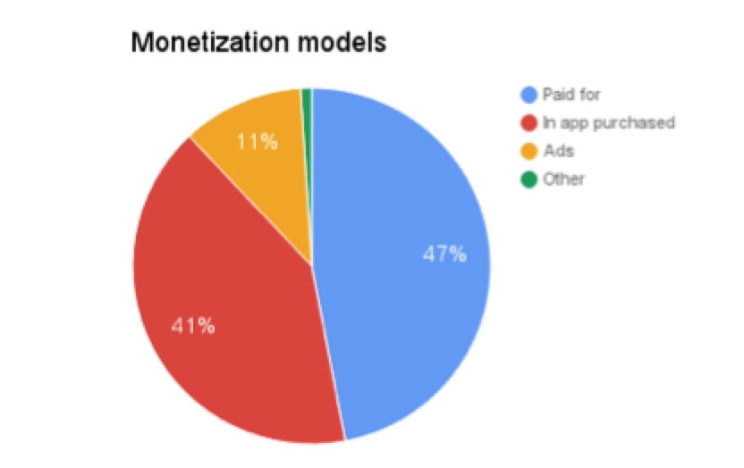

In addition to those trends and facts, 80% of American adults enjoy gambling of some sort on a yearly basis. The mobile sector seems to be the next main place for those activities. Even if it has been through a slow start, its growth is now exponential. Besides, mobile offers the conveniency players are looking for and the online desktop-based field is more and more saturated. Issues regarding regulation enforced by government and app stores however limit its growth. Mobile gambling is expected to keep increasing dramatically in the next few year while representing today 40% of the mobile users. An in 2018 it should represent $100 billion.

**Details of the Industry**

Current Size and Past Growth

The American Gambling Association estimates that 95 billion dollars will be bet on The NFL and College football this year, and only four percent of that money will be bet legally (Purdum, 2015). That does not even factor in the three other major sports leagues in the United States. There is no question that America loves to place bets, but they lack a legal and safe way to do that. WagerMe would solve that problem by allowing people to place bet legally, and without the fear of having to pay their losses. WagerMe also provides an additional layer of comfort in that bets can be placed against reliable friends.

Expected Growth

GamblingCompliance projects that in the future a fully developed legal American sports betting market would produce 12.4 billion dollars in annual revenue (Purdum, 2015). This illustrates the potential of the market in five to ten years, given sports betting is expected to be legalized by then. According to Statista, It is estimated that the sports betting industry will grow by 10 to 15 percent over the next 3 to 5 years. BusinessWire estimates that the gambling industry as a whole is expected to grow by around 6 percent by 2022.

Current and Future Industry Trends

More and more states are recognizing sports betting as a significant source of revenue. NBA Commissioner Adam Silver and many other high-ranking sports executives believe that the legalization of sports betting in all states is inevitable (Purdum & Rodenburg, 2016). Many in U.S. government believe gambling laws are out of date, especially Internet gambling laws (Purdum & Rodenburg, 2016). It is important that WagerMe gets out ahead of this trend, because a major feature of the app is the reward system. WagerMe’s reward system provides a competitive advantage, because most other peer-to-peer betting apps are illegal because they use actual currency. The legalization of betting would do away with this advantage. With the legalization of sport betting the industry would become a mobile/ online heavy industry, considering the lack of sport books in the United States. This is a positive for WagerMe because it is an application, but we need to get out ahead of the legalization of sport betting. Many believe that sport betting will be legal in five to ten years, which gives WagerMe plenty of time to capture the peer-to-peer betting market (Purdum & Rodenburg, 2016).

**Market Analysis**

Targeted Segment of Industry

We will be targeting any online or in-app segments of the Sports Betting industry. Americans bet over $95 Billion in 2015, and that number is expected to grow. The online market itself has yet to be established in the United States as new legislation is in order to decide how Sports Betting will become legalized. Once these laws have been created we will have a better understanding of the market.

Expected Market Growth

Over the next 3-5 years we expect the Sports Betting industry to increase by at least 5% annually. Though this seems like an astronomical number it really is not. According to Statista, a statistical research and analysis company, the market value of online gambling worldwide reached $35.52 billion in 2013. Now that number has surpassed $50 billion. At such a large annual increase it is hard to predict the exact percent increase per year, but we do know that the market is growing and growing very fast.

Current Market Trends

A current trend that is majorly affecting this segment is the involvement of online sportsbooks that don’t follow the federal laws. At the moment there are many online websites to place bets outside of the US, however, smaller websites are being created for consumers to place bets. These smaller websites skip any online money transfer and instead allow for individuals to figure out financials with whoever is in charge of that website. Many students here at IU do this already as to have their own bookmaking system. This trend is entirely illegal, nonetheless, it is taking much from the online legal sports betting market that we are attempting to enter.

Profile of Target Customer

Our target customers are males from 18-29 years of age. We chose this age group because people in this age group are more likely to use applications that have some sort of reward program. Males were our gender of choice because according to our primary research conducted in our surveys, men are more likely to bet regularly. The target market will also include those interested in sports, and those who are actively engaged in sports news. Those who are knowledgeable of what is going on in the different sports industries are going to be more likely to trust their money with it. We will focus on getting customers that we believe are going to actively involved, and the only way this can be done is by targeting those who actually *care* about sports. We need consumers like this otherwise we will not have a sustainable model.

**Survey Results**

Based on our survey results, our target market seems to be correct. While most of the people we surveyed were males, males also appeared to be more likely to bet regularly compared to females. Out of the 29 females, 21 of them said they “never” bet. Based on this information, males would make up the majority of our customer base. Since the surveys were conducted in Bloomington, almost everyone surveyed were within the usual college age range. Our target market is males between the ages of 18-29, and many of the people surveyed fall into this range. Since our research was limited to Bloomington, we were able to survey people within our target market. Less than a third of the people surveyed never bet, but over 40% of them makes a few bets a month, with the rest of the people surveyed betting more often than that. There is already many people betting on a regular basis. The WagerMe app will only provide more convenience for those who bet, and has the potential to attract those who do not. Just over half of those surveyed also preferred betting with actual money, while the rest preferred betting with virtual currency. For legal purposes, we will use virtual currency, which was found to still appeal to almost half of the people surveyed. About 75% liked the idea of having a Venmo style app experience for betting as well. This information will be helpful in designing the user interface of the app to be more appealing to our customer base. Over 75% wanted instantaneous credit when winning a bet, but for legal purposes, we believe a points and rewards system will be the better option. About 50% didn’t want a monthly subscription fee, but about 20% reported that they would be willing to pay a $5 monthly subscription fee, and 10% said they would pay as much as $10. We are considering different tiers user memberships based on this information to better accommodate those who bet more and more often. When asking about people’s opinion of the app, over 40% had positive opinions of the app, with less than 25% negative responses. The rest were neutral responses that did not take a stance either way. Almost 70% said they would recommend the app to a friend, which is important because that aligns with our marketing strategy.

**Competitor Analysis**

Competitors & Market Share

There are many competitors in the sports and peer-to-peer betting industries, but only a few names have stood out from the rest and no one business has taken majority share of the market. An article on GamblingJudge.com analyzes the top sports betting mobile applications and their positions in the relative industry. “William Hill”, “Ladbrokes”, “betfair”, “888sport”, and “Bet365” are listed as the highest-grossing, mobile betting companies with the most application downloads in the application store. With this market being very diversified, the WagerMe application has incredible opportunity to prove its superiority to competitors and capture a majority of the market share.

Differentiation from Competitors

The WagerMe application would utilize similar ideas to existing apps, but a multitude of features would differentiate our product and establish the WagerMe application as the top mobile, peer-to-peer betting platform. Similar applications on the market include “Youbetme,” “Favourit,” and “Bet365.” These applications are betting platforms, but they do not allow users to choose if they would like to create customized bets with peers or bet against the house. In addition, applications such as “Favourit” are illegal in the United States due to gambling with real money. Our application will also utilize a virtual currency and reward system which will allow users to bet points and later redeem them for prizes/valuables. We are also seeking to partner with large companies and vendors to supply these redeemable rewards while generating ad revenue as well. Lastly, our application will work to best suit the user’s needs, while making sure to enforce the betting laws in all states.

Works Cited:

BCG. "Global Online Gambling Industry Size 2009-2018." The Statistics Portal. Statista, n.d. Web. 08 Nov. 2016.

Purdum, D., & Rodenberg, R. (2016, October 28). Future of sports betting: the marketplace. In *ESPN.com*. Retrieved November

8, 2016.

Purdum, D. (2015, September). Research shows U.S. could dominate global legalized sports betting market. In *ESPN.com*.

Retrieved November 8, 2016.

"Top 10 Sports Betting Mobile Apps." *Gambling Judge*. N.p., 2 Feb. 2016. Web. 08 Nov. 2016. <http://www.gambling judge.com/tutorials-and-strategies/for-sports/top-10-sports-betting-mobile-apps/>.