# NIRS Data Collection

1. Connect cables to the NIRScout. Detector ports are on top. Detector ports and cables are labeled 1-4 or 5-8. Source cables should be plugged into the bottom, 1-4 on the left, 5-8 on the right (only 5-8 is labeled at the moment). Source cards on the right are for the LED cables.

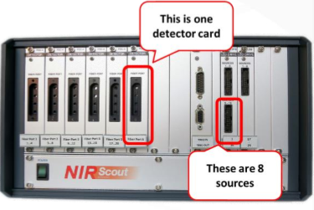

1. Don the cap on the participant.
2. Click NIRStar15-2

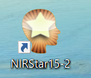

1. Click “configure hardware” at the top and ensure the correct montage is set up. We’re using motor for this example.

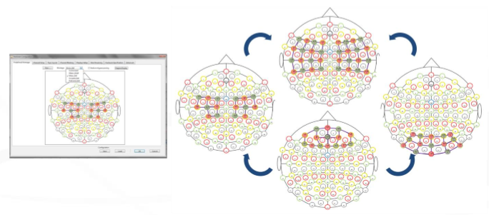

1. Return to the main screen and click calibrate. Adjust the sources and detectors for optimal gain settings. It may be difficult to achieve strong signal across all channels, so optimize until most are green/yellow.

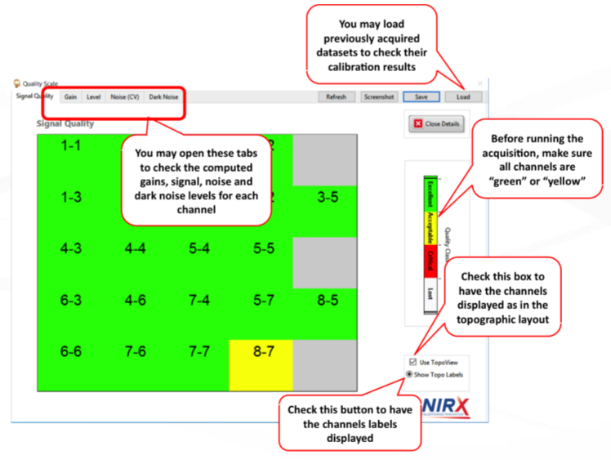

1. Open NIRStim

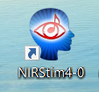

1. Click Load. Navigate to, and select “C:\NIRx\NIRStim\NIRStim04-0\examples\NIRx NIRStim Demo 01 - finger tapping.dex”

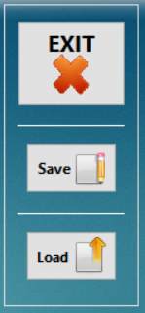

1. Switch back to NIRStar – hit record. Then enter the participants id at a minimum. Once recording has started, return to NIRStim and hit run.

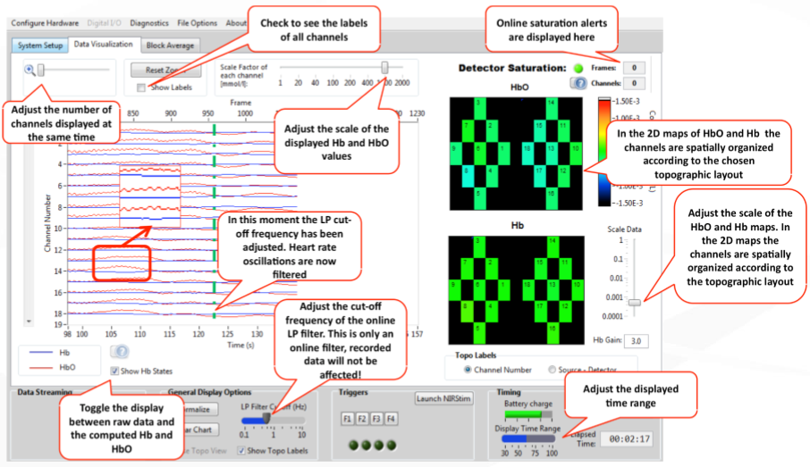

1. Once the stimulus is complete, switch to NIRStar and hit “stop”. Data will automatically be saved by the current date in “c:/NIRx/Data/”. If multiple scans are completed in one day, within the date folder, there will be incremental scans. Subject information will be in the .inf file.