gTheoryShiny: An Interactive, Bilingual Application for Generalizability-Theory Design Analysis
Author Name (placeholder)
Institution (placeholder)
Corresponding author: email (placeholder)

Manuscript prepared for Educational and Psychological Measurement
October 4, 2026

gTheoryShiny: An Interactive, Bilingual Application for Generalizability-Theory Design Analysis
Abstract
Generalizability theory (G-theory) provides a design-based framework for decomposing measurement variation and evaluating how reliability changes under alternative facet configurations, but applied users often face a gap between the model and the software workflow. We introduce gTheoryShiny, an open-source R/Shiny application that guides users from data import and wide-to-long transformation through facet-structure screening, linear mixed-effects estimation, G-study variance decomposition, D-study design comparison, and bootstrap uncertainty summaries. The application supports English and Simplified Chinese interfaces, validates common data and family constraints, protects fitted results when language changes, and preserves user-edited D-study settings when panels are reopened. We describe the implementation, a worked example, and an independent validation study using synthetic crossed designs. In a balanced one-facet design, restricted expected-mean-square calculations and restricted maximum-likelihood estimates differed by less than 5 × 10−7 variance units. In a two-facet worked example, the application returned a generalizability coefficient of .933 and a dependability coefficient of .913 for an 8-item × 4-rater design; increasing the item count to 16 raised the corresponding coefficients to .953 and .936. A 1,000-replicate parametric bootstrap completed without failed draws for the worked example, and a 400-condition Monte Carlo check showed near-zero implementation discrepancy between the application’s D-study calculations and independently coded formulas. The application is intended as an accessible analysis and teaching instrument, not as a substitute for design expertise or validity evidence.
Keywords: generalizability theory; G-study; D-study; reliability; performance assessment; linear mixed-effects model; Shiny; open science

Introduction
Measurement designs in education and psychology rarely differ only in the people being measured. Scores may vary with items, tasks, raters, occasions, or interactions among these facets. Generalizability theory (G-theory) formalizes this problem by treating observed-score variation as a combination of universe-score variation and multiple sources of relative or absolute error (Cronbach et al., 1963; Brennan, 2001). The design perspective is consequential: a G-study estimates variance components under an observed design, whereas a D-study uses those estimates to project reliability under alternative numbers of facet conditions.
The conceptual strength of G-theory creates a practical challenge. Users must align data structure, facet definitions, random-effects terms, variance-component interpretation, and D-study sample-size projections. Existing statistical software can estimate pieces of this workflow, but the transition from raw data to a defensible design decision still requires substantial programming and measurement knowledge. Reviews of G-theory applications emphasize the value of connecting variance decomposition to concrete assessment design decisions (Vispoel et al., 2018a, 2018b). R-based mixed-effects implementations further make G-theory accessible for complex and multivariate designs (Jiang, 2018; Jiang et al., 2020), while bootstrap work highlights the importance of uncertainty around variance components and coefficients (Tong & Brennan, 2007; Jiang et al., 2021).
gTheoryShiny addresses this workflow problem as an interactive instrument. The application combines guided data preparation, automatic facet-relationship screening, formula construction, mixed-effects estimation, D-study scenario analysis, and bilingual explanatory output in one reproducible interface. Its contribution is therefore operational rather than a new reliability coefficient: it makes a documented set of G-theory calculations inspectable, runnable, and teachable for users who may not write R code.

Purpose and Scope
This article has four aims. First, we document the design and implementation of gTheoryShiny. Second, we demonstrate a complete analysis from a crossed data table to G-study and D-study results. Third, we evaluate implementation accuracy using independent calculations, a parametric bootstrap, and a scoped Monte Carlo study. Fourth, we identify appropriate uses and limitations so that the application is not mistaken for evidence that a particular assessment is valid or sufficiently reliable.

Application Design

User workflow
The interface separates the analysis into Data Input, Data Structure, Data Analysis, and AI Assistant panels. Users may select a bundled example or upload a CSV file. Long-format data can be analyzed directly; wide-format data can be transformed by specifying the number of facet-label rows, facet prefixes, and facet names. The application then requests the unit of measurement, outcome, and facets, while showing the inferred nesting or crossing relationship for each pair of selected variables.
After the user confirms the structure, gTheoryShiny constructs a recommended random-effects formula. The univariate path uses lme4 for Gaussian and generalized linear mixed-effects models (Bates et al., 2015). Identity, logit, Poisson, and inverse-gamma links are exposed with outcome checks appropriate to each family. Non-estimable random terms are detected from replication patterns and omitted with a report to the user rather than silently forcing a singular model. The D-study panel allows users to change one or more facet sample sizes and displays the resulting generalizability and dependability coefficients.

Bilingual and state-preserving interaction
Language switching is implemented as a client-side dictionary layer backed by the same server-side language state. Labels, placeholders, option text, switch controls, and dynamically generated tables are translated without changing the values of analysis inputs. This distinction matters because a label update should not rerun or invalidate an already fitted model. The application also treats a changed upload as a changed data source: wide-format data must be transformed again after replacement, preventing a transformed table from being reused with a different file.

Uncertainty and interpretation
For univariate G-studies, the application provides a parametric bootstrap based on lme4::bootMer with optional parallel workers and percentile intervals for variance components and G-/D-study quantities. The interface reports singular-fit and convergence warnings, and it presents coefficient guidance in the selected language. These outputs are descriptive and decision-supporting. They do not replace examination of the design, missingness, score distributions, substantive construct representation, or external validity evidence.

Worked Example
The worked example used a newly generated crossed design with 80 persons, 8 items, and 4 raters. Scores were generated from independent person, item, rater, person-by-item, person-by-rater, item-by-rater, and residual components with target variances 1.00, .30, .15, .25, .10, .05, and .50, respectively. The data and generation script are included in the repository so that the example does not depend on person-level records from a proprietary assessment.
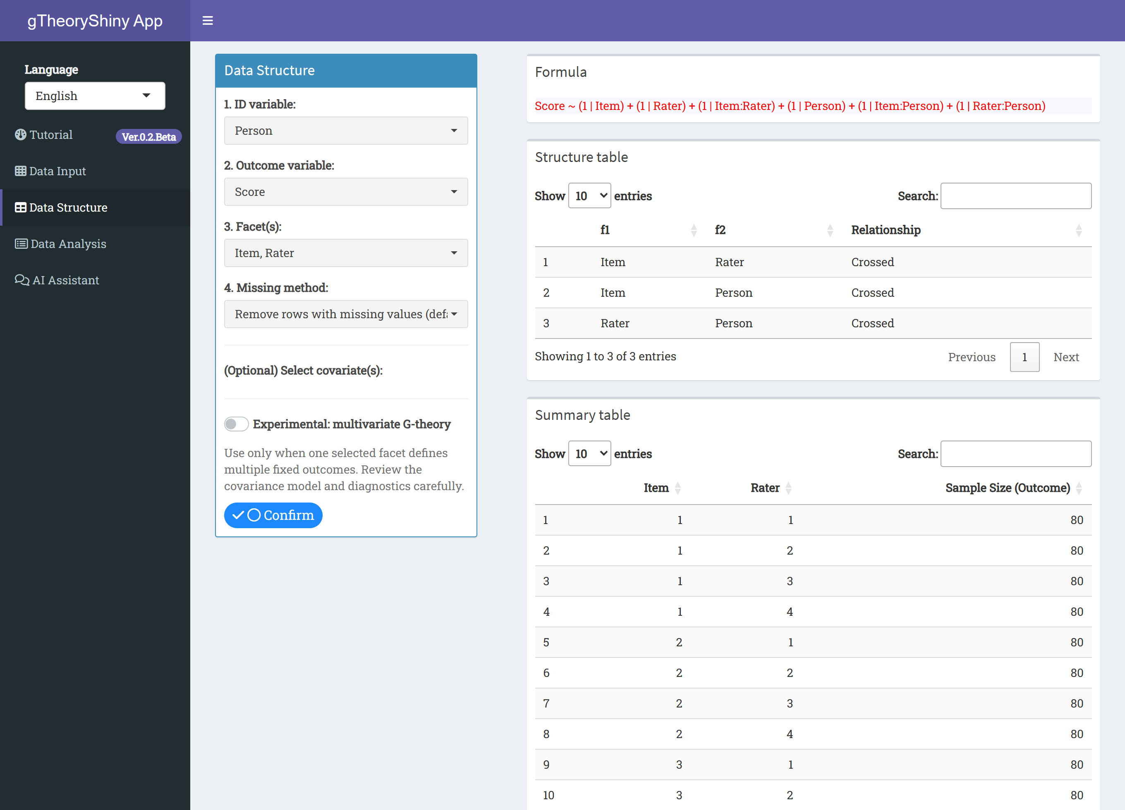
Figure 1. gTheoryShiny Data Structure panel after the worked example is uploaded. The panel displays variable selectors and the inferred facet structure.
For the observed 8-item × 4-rater design, the application estimated a person variance of 1.036, item variance of .050, rater variance of .063, person-by-item variance of .258, person-by-rater variance of .106, item-by-rater variance of .075, and residual variance of .511. The resulting G coefficient was .933 and the dependability coefficient was .913. The coefficients are design-specific: the D-study uses the estimated components to evaluate a different number of item and rater conditions.

Table 1
Items | Raters | Conditions/person | G coefficient | Dependability | Absolute error
4 | 2 | 8 | 0.851 | 0.815 | 0.235
8 | 2 | 16 | 0.898 | 0.867 | 0.160
12 | 2 | 24 | 0.915 | 0.885 | 0.135
16 | 2 | 32 | 0.924 | 0.895 | 0.122
4 | 4 | 16 | 0.894 | 0.869 | 0.156
8 | 4 | 32 | 0.933 | 0.913 | 0.099
12 | 4 | 48 | 0.946 | 0.928 | 0.080
16 | 4 | 64 | 0.953 | 0.936 | 0.071
4 | 6 | 24 | 0.909 | 0.889 | 0.130
8 | 6 | 48 | 0.945 | 0.929 | 0.079
12 | 6 | 72 | 0.957 | 0.944 | 0.062
16 | 6 | 96 | 0.964 | 0.951 | 0.054
Table 1. D-study projections from the worked two-facet example.
The scenario results show the expected design trade-off: increasing either facet improves reliability, while increasing both facets yields the largest reduction in error. The application makes this pattern visible without requiring users to rewrite a model or manually recompute denominators.

Validation Study

Independent variance-component benchmark
For a balanced one-facet dataset with 80 persons and 12 items, we independently computed the expected-mean-square variance estimates and compared them with the application’s restricted maximum-likelihood estimates. The absolute differences were 3.77 × 10−7 for the person component, 4.82 × 10−7 for the item component, and 4.34 × 10−8 for the residual component. These values are numerical agreement checks for the generated design; they are not a claim that REML and ANOVA estimates are interchangeable in unbalanced or non-Gaussian studies.

D-study formula verification
We implemented the D-study denominators independently from the application functions. Across 12 item-by-rater plans in the worked design and the one-facet design, the maximum absolute difference between independently calculated and application coefficients was below 2.3 × 10−16. The check was deliberately formula-based rather than a second call to the same function.

Bootstrap and Monte Carlo checks
A 1,000-draw parametric bootstrap for the one-facet worked example completed with 1,000 complete draws in 21.91 s on the analysis machine. The point estimates were .933 for G and .910 for dependability; percentile intervals were [.905, .951] and [.867, .938], respectively. Because bootstrap intervals can be sensitive to sample size, distributional assumptions, and model specification, these intervals are presented as an implementation demonstration rather than a universal recommendation (Jiang et al., 2021; Puth et al., 2015).
A scoped Monte Carlo check used four generated conditions—30 or 80 persons, 6 or 12 items for one-facet designs, and 3 or 4 raters for two-facet designs—with 100 replications per condition. All 400 fits completed. Absolute discrepancies between independent and application D-study formulas were at most 2.3 × 10−16. Mean coefficient bias ranged from −.010 to .005, with larger sampling error in the smaller two-facet condition. Nine of 100 small two-facet fits were flagged singular; this is reported as a property of the simulated sample and design, not hidden as a software failure.

Discussion
gTheoryShiny provides a practical bridge between G-theory concepts and a reproducible mixed-effects workflow. Its main value is integration: data checks, design structure, model specification, variance decomposition, D-study planning, uncertainty summaries, and explanatory text are connected in one interface. The bilingual layer is also part of the measurement workflow rather than cosmetic localization, because users can inspect the same fitted results while changing language and can teach or document the workflow for English- and Chinese-speaking users.
The application has important boundaries. It does not determine whether a facet should be fixed or random from substantive theory; the user must make that decision. Automatic nesting detection is based on observed combinations and can be misleading when a design is sparse or confounded. Singular fits, convergence warnings, and non-estimable terms require design review. The multivariate G-theory path is experimental and should be treated as a research feature requiring careful covariance and weight checks. Bootstrap results inherit the fitted model and should be accompanied by sensitivity analyses when decisions are consequential. Finally, coefficient thresholds such as .70 or .80 are contextual guidelines rather than validity standards.
The application is best used as an open, inspectable instrument for teaching, exploratory design analysis, and reproducible reporting. A publishable assessment study should still state the intended score interpretation, justify the universe and facets, report the design and missing-data decisions, examine model diagnostics, and provide evidence beyond a single coefficient (American Educational Research Association et al., 2014; Vispoel et al., 2018b).

Availability and Reproducibility
Source code, example data, regression tests, browser smoke tests, the validation script, generated validation tables, and the worked-example screenshots are available at https://github.com/zjiang4/gTheoryShiny. The repository is organized so that a user can install the listed R dependencies, run the application locally, and reproduce the analysis artifacts. The validation script records random seeds, package session information, bootstrap completion, and simulation conditions. The repository should be archived with a release DOI before submission so that the manuscript cites an immutable version.

References
American Educational Research Association, American Psychological Association, & National Council on Measurement in Education. (2014). Standards for educational and psychological testing. American Educational Research Association.
Bates, D., Mächler, M., Bolker, B., & Walker, S. (2015). Fitting linear mixed-effects models using lme4. Journal of Statistical Software, 67(1), 1–48. https://doi.org/10.18637/jss.v067.i01
Brennan, R. L. (2001). Generalizability theory. Springer. https://doi.org/10.1007/978-1-4757-3456-0
Brooks, M. E., Kristensen, K., van Benthem, K. J., Magnusson, A., Berg, C. W., Nielsen, A., Skaug, H. J., Mächler, M., & Bolker, B. M. (2017). glmmTMB balances speed and flexibility among packages for zero-inflated generalized linear mixed modeling. The R Journal, 9(2), 378–400. https://doi.org/10.32614/RJ-2017-066
Cronbach, L. J., Rajaratnam, N., & Gleser, G. C. (1963). Theory of generalizability: A liberalization of reliability theory. British Journal of Statistical Psychology, 16(2), 137–163. https://doi.org/10.1111/j.2044-8317.1963.tb00206.x
Jiang, Z. (2018). Using a linear mixed-effect model framework to estimate generalizability variance component in R: A lme4 package application. Methodology, 14(3), 133–142. https://doi.org/10.1027/1614-2241/a000149
Jiang, Z., Raymond, M., Shi, D., & DiStefano, C. (2020). Using a linear mixed-effect model framework to estimate multivariate generalizability theory parameters in R. Behavior Research Methods, 52(6), 2383–2393. https://doi.org/10.3758/s13428-020-01399-z
Jiang, Z., Raymond, M., DiStefano, C., Shi, D., Liu, R., & Sun, J. (2021). A Monte Carlo study of confidence interval methods for generalizability coefficient. Educational and Psychological Measurement, 82(4), 705–718. https://doi.org/10.1177/00131644211033899
Puth, M.-T., Neuhäuser, M., & Ruxton, G. D. (2015). On the variety of methods for calculating confidence intervals by bootstrapping. Journal of Animal Ecology, 84(4), 892–897.
Tong, Y., & Brennan, R. L. (2007). Bootstrap estimates of standard errors in generalizability theory. Educational and Psychological Measurement, 67(5), 804–817. https://doi.org/10.1177/0013164407301533
Vispoel, W. P., Morris, C. A., & Kilinc, M. (2018a). Applications of generalizability theory and their relations to classical test theory and structural equation modeling. Psychological Methods, 23(1), 1–26. https://doi.org/10.1037/met0000107
Vispoel, W. P., Morris, C. A., & Kilinc, M. (2018b). Practical applications of generalizability theory for designing, evaluating, and improving psychological assessments. Journal of Personality Assessment, 100(1), 53–67. https://doi.org/10.1080/00223891.2017.1296455
R Core Team. (2025). R: A language and environment for statistical computing. R Foundation for Statistical Computing. https://www.R-project.org/
Chang, W., Cheng, J., Allaire, J. J., Sievert, C., Schloerke, B., Aden-Buie, G., Xie, Y., Allen, J., McPherson, J., Dipert, A., & Borges, B. (2026). shiny: Web application framework for R (Version 1.14.0) [Computer software]. https://CRAN.R-project.org/package=shiny

