论文笔记2022/03/21-03/27

1. Noise2Context: Context-assisted learning 3D thin-layer for low-dose CT

<https://aapm.onlinelibrary.wiley.com/doi/epdf/10.1002/mp.15119?saml_referrer>

作者：Zhicheng Zhang，Lei Xing

期刊名：MP

LDCT无clean data

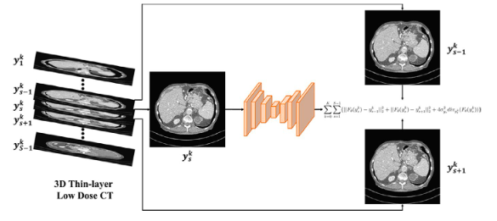

They use the adjacent two slices as the supervision. Under certain assumptions, the unsupervised problem is equivalent to having the ground truth as the supervision.

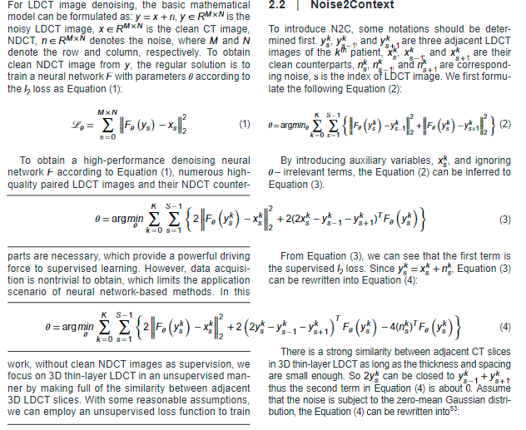 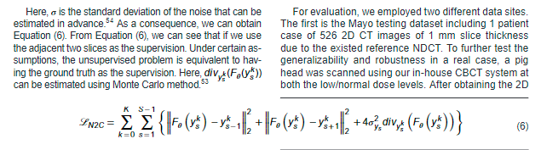

1. Low-dose CT reconstruction by self-supervised learning in the projection domain

<https://arxiv.org/pdf/2203.06824.pdf>

和上一篇方法类似，只是在投影域做

应该是要投MICCAI2022的

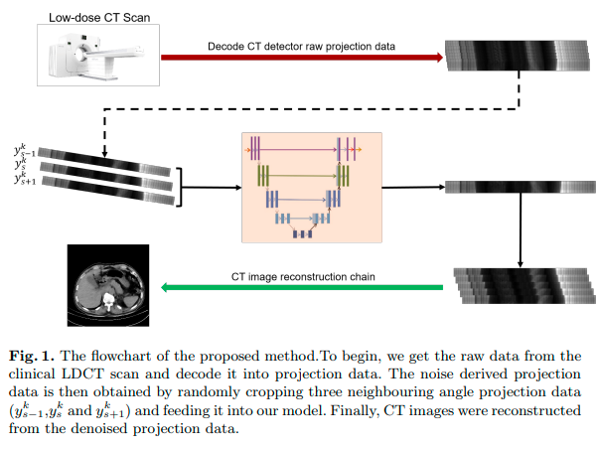

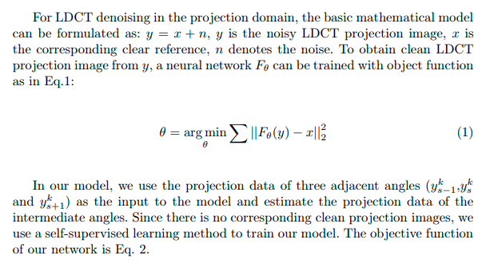

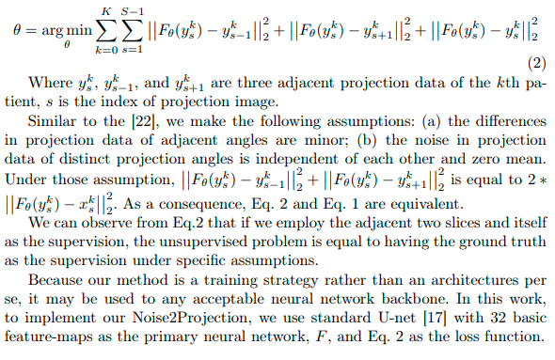

假设：

(a) the differences in projection data of adjacent angles are minor;

(b) the noise in projection data of distinct projection angles is independent of each other and zero mean.