**xx市xx工程xx桥**

**结**

**构**

**计**

**算**

**书**

编写：

校对：

福建省建筑工程质量检测中心有限公司

2019年1月

**目 录**

1. 工程概况 3

2. 检测依据 4

3. 结构分析模型 4

4. 桥梁静载试验 5

4.1. 试验概况 5

4.2. 测试结果 11

**xx市xx工程xx桥结构计算书**

# 工程概况

工程桩号里程范围为K0+460.434~K0+497.474，采用16×2m预应力混凝土简支空心板梁，桥总长37.04m。

上部结构：采用16m后张预应力混凝土空心板梁，梁中距1.25m，梁高0.80m。在0、2号桥台处设置一道D-40型的伸缩缝，在桥台处采用简易切缝处理；桥面横坡由盖梁形成；桥面铺装层采用4cm SMA-13+6cm AC-20+防水层+10cm厚防水混凝土桥面铺装。

下部结构：桥台采用纵横向两排Φ100cm钻孔灌注桩群桩基础，桩接承台，其上设肋板式台身及台帽。桥墩采用桩柱式桥墩，钻孔灌注桩基础。桩直径为Φ120cm，立柱直径为Φ100cm.

根据委托方提供的设计图纸，对现状桥梁跨度、主梁基本尺寸进行核查，结果与设计图纸相符。桥跨布置见x～x。

为了解该桥的实际工作状态，福建省龙岩市城市建设投资发展有限公司委托我公司对该桥进行静动载试验。



图 3-2 xx桥立面布置图（cm）



图 3-2 xx桥桥墩1/2断面布置图（cm）

# 检测依据

1.《公路桥梁荷载试验规程》（JTG/T J21-01-2015）

2.《混凝土结构现场检测技术标准》（GB/T 50784-2013）

3.《城市桥梁检测与评定技术规范》（CJJ/T 233-2015）

4.《城市桥梁设计规范》（CJJ 11-2011）

5.《城市桥梁养护技术标准》（CJJ 99-2017）

# 结构分析模型

采用有限元软件MIDAS/Civil建立桥梁上部结构梁格模型进行荷载试验分析，一共527个节点，716个梁单元，256个板单元，10cm厚C40桥面板参与受力计算，直梁格建模。设计荷载：城-A级，人群荷载4.0kN/m2，采用4车道进行计算。

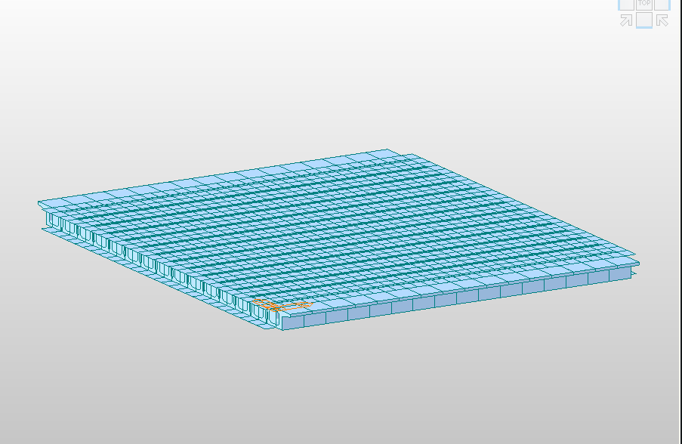

图3‑1 上部结构梁格模型-1

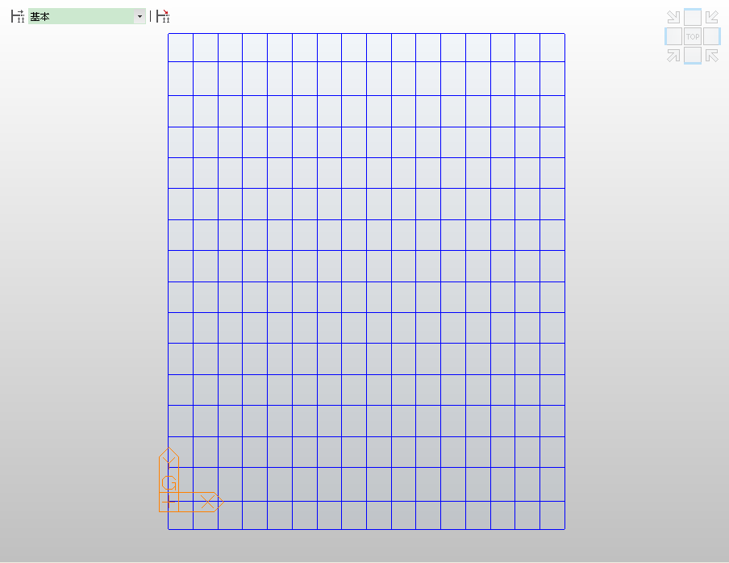

图3‑2 上部结构梁格模型-2

# 桥梁静载试验

## 试验概况

(1)加载工况及荷载效率

本次静载试验荷载效率为x.xx~x.xx，静载试验荷载效率满足规范要求。



图 4‑1 加载车辆平立面示意图

**表 4-1 加载车辆参数表**

|  |  |  |  |  |  |  |  |  |
| --- | --- | --- | --- | --- | --- | --- | --- | --- |
| **编号** | **车牌号** | **轴距(m)** | | **轮距(m)** | | **轴重(kN)** | | **总重(kN)** |
| **X1** | **X2** | **Y1** | **Y2** | **1轴** | **2、3轴** |
| 1# | 闽A M8588 | 3.65 | 1.40 | 2.10 | 1.90 | 78.6 | 353.9 | 432.5 |
| 2# | 闽A M8315 | 3.65 | 1.40 | 2.10 | 1.90 | 81.0 | 357.2 | 438.2 |
| 3# | 闽A M8232 | 3.65 | 1.40 | 2.10 | 1.90 | 91.3 | 340.3 | 431.6 |
| 4# | 闽A M8790 | 3.65 | 1.40 | 2.10 | 1.90 | 82.9 | 363.2 | 446.1 |

**表 4-2 各工况加载内容及试验荷载效率一览表**

|  |  |  |  |  |  |
| --- | --- | --- | --- | --- | --- |
| **工况**  **编号** | **试验工况内容** | **量测内容** | **设计理论值（kN*m）** | **试验理论值（kN*m）** | **荷载效率** |
|
| 工况一 | 左幅机动车道右侧偏载  跨中截面最大正弯矩 | 位移、应变 | 502.0 | 507.7 | 1.01 |
| 工况二 | 左幅机动车道居中加载  跨中截面最大正弯矩 | 位移、应变 | 318.6 | 324.6 | 1.02 |
| 工况三 | 右幅机动车道左侧偏载  跨中截面最大正弯矩 | 位移、应变 | 502.0 | 506.9 | 1.01 |
| 工况四 | 右幅机动车道居中加载  跨中截面最大正弯矩 | 位移、应变 | 318.6 | 320.7 | 1.01 |



图4‑2 试验内力控制截面图(cm)



图4‑3 工况1车辆布置图(cm)



图4‑4 工况2车辆布置图(cm)

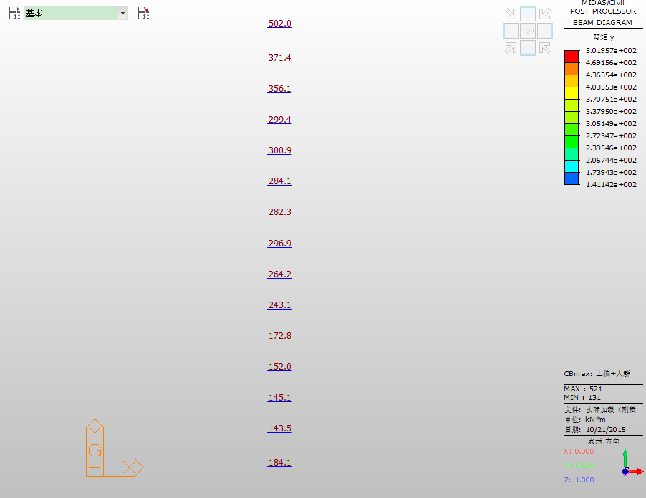

图4‑5 静载控制截面设计荷载-偏载作用下最大内力值(kN·m)

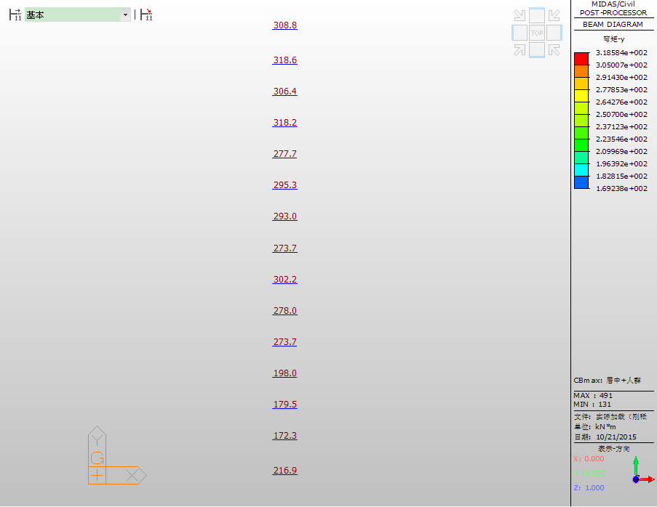

图4‑6 静载控制截面设计荷载-居中荷载作用下最大内力值(kN·m)

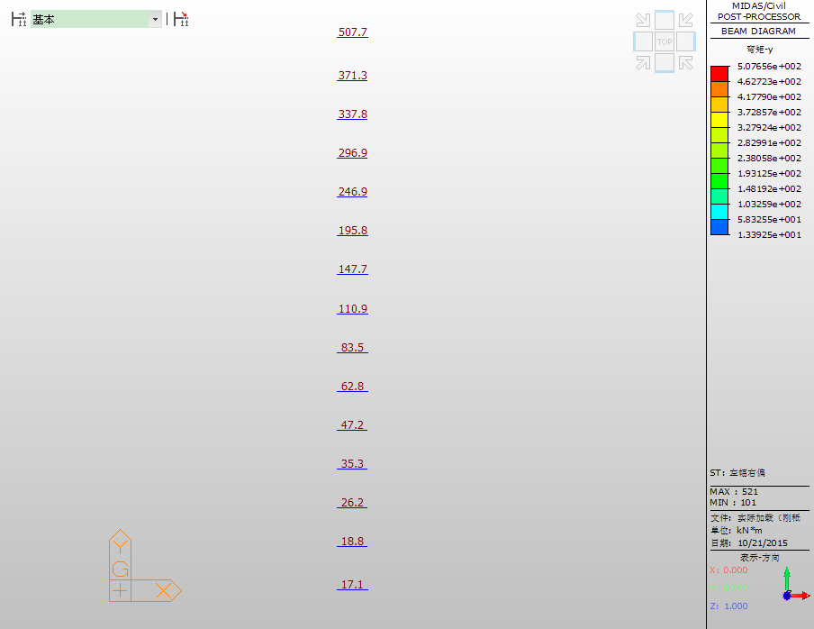

图4‑7 静载控制截面工况1满载内力值(kN·m，图中从上至下为L1~L15)

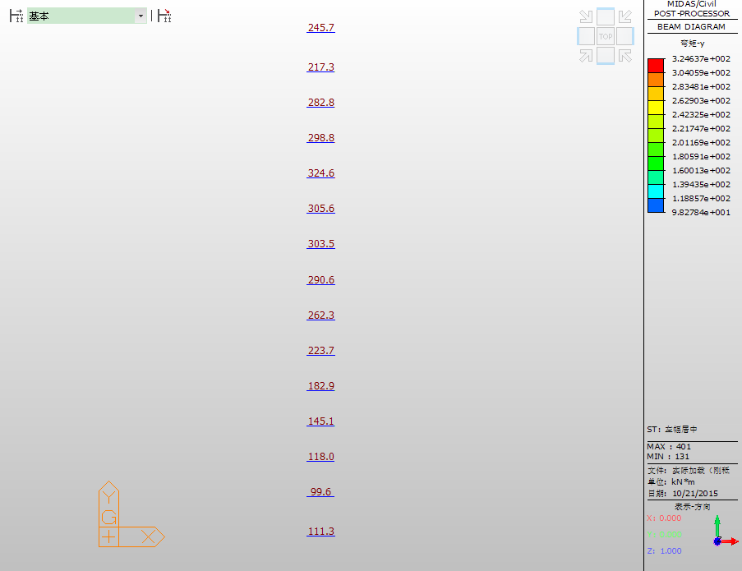

图4‑8 静载控制截面工况2满载内力值(kN·m，图中从上至下为L1~ L15)

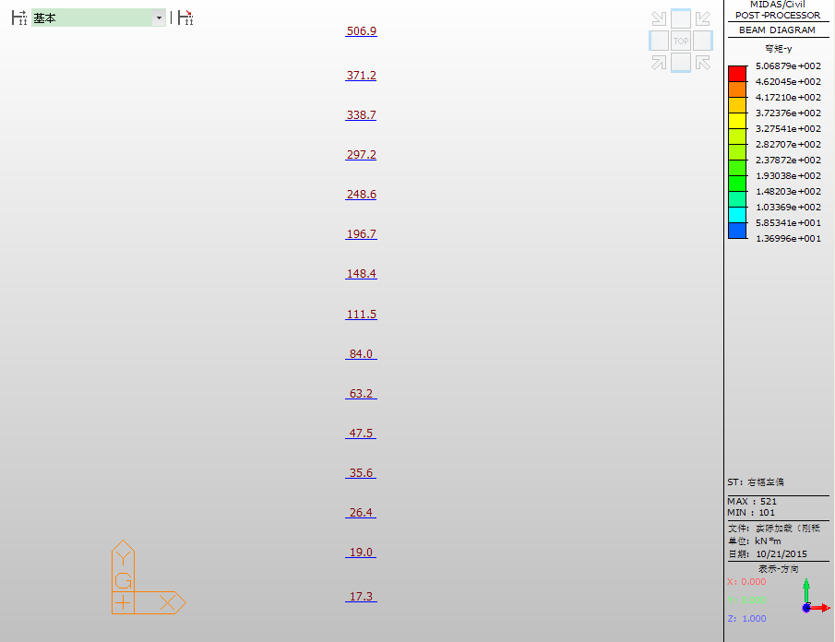

图4‑9 静载控制截面工况3满载内力值(kN·m，图中从上至下为R1~ R15)

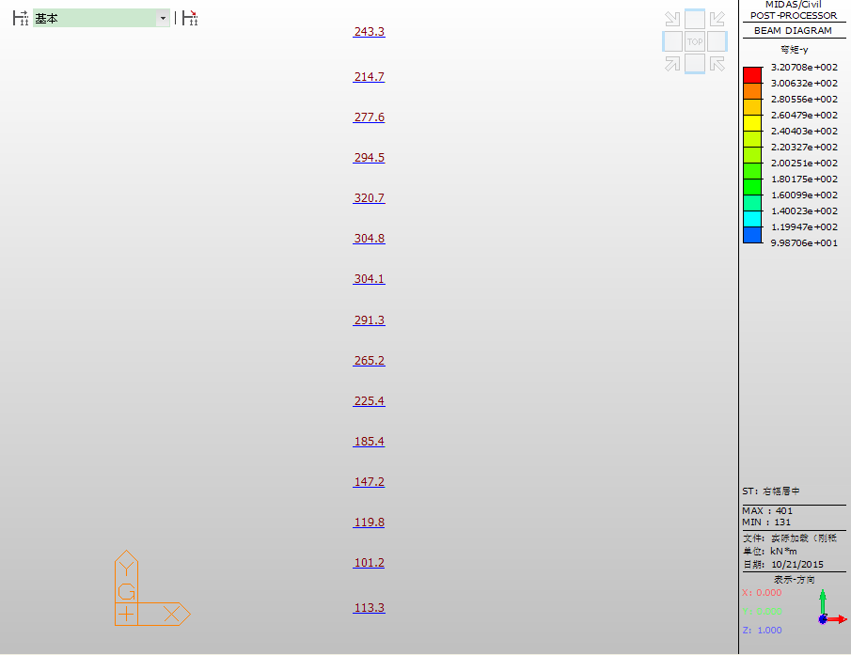

图4‑10 静载控制截面工况4满载内力值(kN·m，图中从上至下为R1~ R15)

(3)测点布置

①应变测点布置

主梁应变采集采用振弦式应变计，应变测点布置于试验跨控制截面梁底断面，测点编号见图4‑13所示。



图4‑11 应变测试截面测点布置图

②挠度测点布置

主梁挠度采集采用百分表，挠度测点布置于试验跨控制截面梁底断面，测点编号见图4‑14所示。



图4‑12 挠度测试截面测点布置图

## 测试结果

### 工况1测试结果

(1)应变检测结果

**表 4‑3工况1应变原始数据处理表**

|  |  |  |  |  |  |  |  |  |  |  |  |  |  |
| --- | --- | --- | --- | --- | --- | --- | --- | --- | --- | --- | --- | --- | --- |
| **测点** | **初始读数** | | **工况1** | | **退载** | | **工况1** | | | | | | |
| **模数R** | **温度T** | **模数R** | **温度T** | **模数R** | **温度T** | **加载** | | **退载** | | **总应变** | **弹性应变** | **残余应变** |
| **ΔR** | **ΔT** | **ΔR** | **ΔT** |
| L1 | 663.7 | 27.1 | 674.4 | 27.8 | 664.6 | 28.0 | 10.7 | 0.7 | 0.9 | 0.9 | 41.6 | 36.6 | 5.0 |
| L2 | 698.9 | 27.2 | 710.0 | 27.7 | 697.8 | 27.9 | 11.1 | 0.5 | -1.1 | 0.7 | 42.8 | 42.8 | 0.0 |
| L3 | 813.2 | 26.9 | 826.9 | 27.4 | 812.0 | 27.6 | 13.7 | 0.5 | -1.2 | 0.7 | 52.6 | 52.6 | 0.0 |
| L4 | 696.3 | 27.3 | 707.3 | 27.7 | 695.2 | 27.9 | 11.0 | 0.4 | -1.1 | 0.6 | 42.2 | 42.2 | 0.0 |
| L5 | 434.3 | 27.5 | 445.1 | 27.9 | 433.2 | 28.1 | 10.8 | 0.4 | -1.1 | 0.6 | 41.5 | 41.5 | 0.0 |
| L6 | 642.7 | 27.4 | 652.0 | 27.8 | 641.7 | 28.0 | 9.3 | 0.4 | -1.0 | 0.6 | 35.8 | 35.8 | 0.0 |
| L7 | 768.6 | 27.5 | 775.1 | 27.9 | 767.3 | 28.1 | 6.5 | 0.4 | -1.3 | 0.6 | 25.3 | 25.3 | 0.0 |
| L8 | 757.6 | 27.6 | 762.7 | 27.9 | 756.5 | 28.2 | 5.1 | 0.3 | -1.1 | 0.6 | 19.8 | 19.8 | 0.0 |
| L9 | 633.5 | 27.9 | 637.9 | 28.2 | 632.5 | 28.5 | 4.4 | 0.3 | -1.0 | 0.6 | 17.1 | 17.1 | 0.0 |
| L10 | 761.5 | 28.0 | 763.7 | 28.3 | 761.0 | 28.5 | 2.2 | 0.3 | -0.5 | 0.5 | 8.8 | 8.8 | 0.0 |
| L11 | 762.0 | 27.7 | 763.8 | 28.0 | 761.1 | 28.3 | 1.8 | 0.3 | -0.9 | 0.6 | 7.3 | 7.3 | 0.0 |
| L12 | 674.1 | 27.7 | 675.3 | 28.0 | 673.4 | 28.3 | 1.2 | 0.3 | -0.7 | 0.6 | 5.1 | 5.1 | 0.0 |
| L13 | 712.8 | 27.2 | 713.3 | 27.6 | 712.2 | 27.8 | 0.5 | 0.4 | -0.6 | 0.6 | 2.6 | 2.6 | 0.0 |
| L14 | 649.9 | 27.1 | 650.4 | 27.5 | 648.7 | 27.7 | 0.5 | 0.4 | -1.2 | 0.6 | 2.6 | 2.6 | 0.0 |
| L15 | 616.1 | 26.9 | 616.7 | 27.4 | 615.0 | 27.6 | 0.6 | 0.5 | -1.1 | 0.7 | 3.2 | 3.2 | 0.0 |
| 备注：应变换算值＝3.70×1.0200190×ΔR +1.80×ΔT | | | | | | | | | | | | | |

**表 4‑4工况1应变检测结果汇总表**

|  |  |  |  |  |  |  |  |
| --- | --- | --- | --- | --- | --- | --- | --- |
| **测点号** | **实测应变值(με)** | | | **满载应力 理论值(MPa)** | **满载理论应变值(με)** | **校验系数** | **相对残余 应变** |
| **总应变** | **弹性应变** | **残余应变** |
| L1 | 41.6 | 36.6 | 5.0 | 5.12 | 148.4 | 0.25 | 12.02% |
| L2 | 42.8 | 42.8 | 0.0 | 4.73 | 137.1 | 0.31 | 0.00% |
| L3 | 52.6 | 52.6 | 0.0 | 4.24 | 122.9 | 0.43 | 0.00% |
| L4 | 42.2 | 42.2 | 0.0 | 3.72 | 107.8 | 0.39 | 0.00% |
| L5 | 41.5 | 41.5 | 0.0 | 3.03 | 87.8 | 0.47 | 0.00% |
| L6 | 35.8 | 35.8 | 0.0 | 2.38 | 69.0 | 0.52 | 0.00% |
| L7 | 25.3 | 25.3 | 0.0 | 1.77 | 51.3 | 0.49 | 0.00% |
| L8 | 19.8 | 19.8 | 0.0 | 1.29 | 37.4 | 0.53 | 0.00% |
| L9 | 17.1 | 17.1 | 0.0 | 0.94 | 27.2 | 0.63 | 0.00% |
| L10 | 8.8 | 8.8 | 0.0 | 0.68 | 19.7 | 0.45 | 0.00% |
| L11 | 7.3 | 7.3 | 0.0 | 0.49 | 14.2 | 0.51 | 0.00% |
| L12 | 5.1 | 5.1 | 0.0 | 0.35 | 10.1 | 0.50 | 0.00% |
| L13 | 2.6 | 2.6 | 0.0 | 0.29 | 8.4 | 0.31 | 0.00% |
| L14 | 2.6 | 2.6 | 0.0 | 0.24 | 7.0 | 0.37 | 0.00% |
| L15 | 3.2 | 3.2 | 0.0 | 0.16 | 4.6 | 0.69 | 0.00% |
| 备注：应变ε(με)=σ(MPa)×100/3.45；拉应变为正 | | | | | | | |

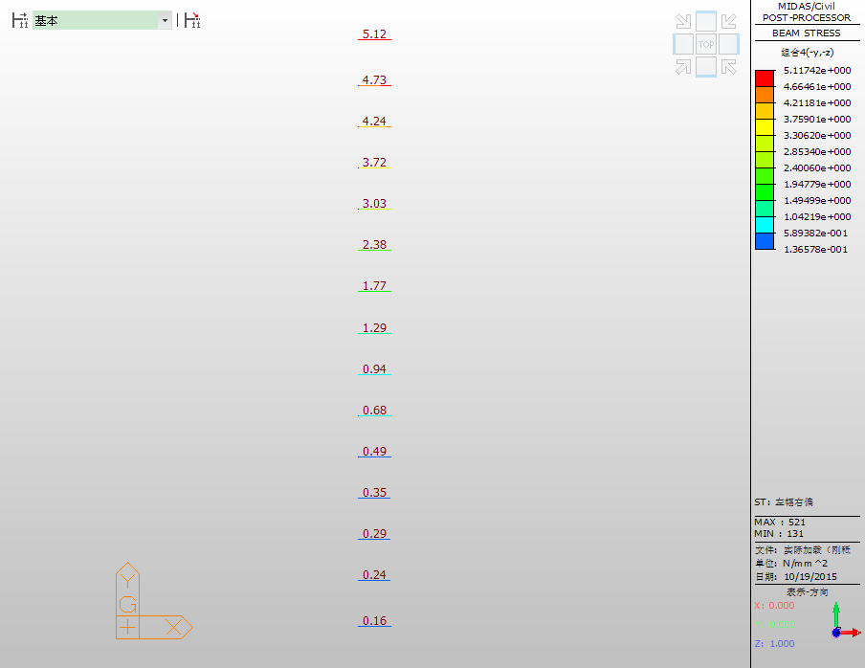

图 4‑13 工况1静载控制截面理论应力值(MPa，图中从上至下为L1~L15)



图4‑14 工况1应变实测值与理论计算值的关系曲线

(2)挠度检测结果

**表 4‑5 工况1挠度原始数据处理表**

|  |  |  |  |  |  |  |
| --- | --- | --- | --- | --- | --- | --- |
| **挠度值计算mm** | | | | | | |
| **测点** | **初始读数** | **工况1**  **满载** | **退载** | **总挠度** | **弹性挠度** | **残余变形** |
| L1 | 8.42 | 11.98 | 8.58 | 3.56 | 3.40 | 0.16 |
| L2 | 8.61 | 12.17 | 8.74 | 3.56 | 3.43 | 0.13 |
| L3 | 8.01 | 11.44 | 8.12 | 3.43 | 3.32 | 0.11 |
| L4 | 10.66 | 13.85 | 10.76 | 3.19 | 3.09 | 0.10 |
| L5 | 9.39 | 12.18 | 9.48 | 2.79 | 2.70 | 0.09 |
| L6 | 12.74 | 15.05 | 12.81 | 2.31 | 2.24 | 0.07 |
| L7 | 14.04 | 15.90 | 14.13 | 1.86 | 1.77 | 0.09 |
| L8 | 7.48 | 8.87 | 7.59 | 1.39 | 1.28 | 0.11 |
| L9 | 8.90 | 10.01 | 9.02 | 1.11 | 0.99 | 0.12 |
| L10 | 13.26 | 13.79 | 13.32 | 0.53 | 0.47 | 0.06 |
| L11 | 12.47 | 12.97 | 12.53 | 0.50 | 0.44 | 0.06 |
| L12 | 8.82 | 9.27 | 8.84 | 0.45 | 0.43 | 0.02 |
| L13 | 7.98 | 8.42 | 8.05 | 0.44 | 0.37 | 0.07 |
| L14 | 8.66 | 8.95 | 8.69 | 0.29 | 0.26 | 0.03 |
| L15 | 10.30 | 10.47 | 10.30 | 0.17 | 0.17 | 0.00 |
| 备注：总挠度=满载-初读；残余变形=退载-初读；弹性挠度=总挠度-残余变形 | | | | | | |

**表 4‑6 工况1挠度检测结果汇总表**

|  |  |  |  |  |  |  |
| --- | --- | --- | --- | --- | --- | --- |
| **测点号** | **实测值（mm）** | | | **满载理论值（mm）** | **校验系数** | **相对残**  **余变形** |
| **总变形** | **弹性变形** | **残余变形** |
| L1 | 3.56 | 3.40 | 0.16 | 8.21 | 0.41 | 4.49% |
| L2 | 3.56 | 3.43 | 0.13 | 7.58 | 0.45 | 3.65% |
| L3 | 3.43 | 3.32 | 0.11 | 7.01 | 0.47 | 3.21% |
| L4 | 3.19 | 3.09 | 0.10 | 6.01 | 0.51 | 3.13% |
| L5 | 2.79 | 2.70 | 0.09 | 5.1 | 0.53 | 3.23% |
| L6 | 2.31 | 2.24 | 0.07 | 3.82 | 0.59 | 3.03% |
| L7 | 1.86 | 1.77 | 0.09 | 2.88 | 0.61 | 4.84% |
| L8 | 1.39 | 1.28 | 0.11 | 2.17 | 0.59 | 7.91% |
| L9 | 1.11 | 0.99 | 0.12 | 1.64 | 0.60 | 10.81% |
| L10 | 0.53 | 0.47 | 0.06 | 1.23 | 0.38 | 11.32% |
| L11 | 0.50 | 0.44 | 0.06 | 0.92 | 0.48 | 12.00% |
| L12 | 0.45 | 0.43 | 0.02 | 0.68 | 0.63 | 4.44% |
| L13 | 0.44 | 0.37 | 0.07 | 0.5 | 0.74 | 15.91% |
| L14 | 0.29 | 0.26 | 0.03 | 0.35 | 0.74 | 10.34% |
| L15 | 0.17 | 0.17 | 0.00 | 0.23 | 0.74 | 0.00% |
| 备注：向下挠度为正 | | | | | | |



图 4‑15 工况1挠度实测值与理论计算值的关系曲线

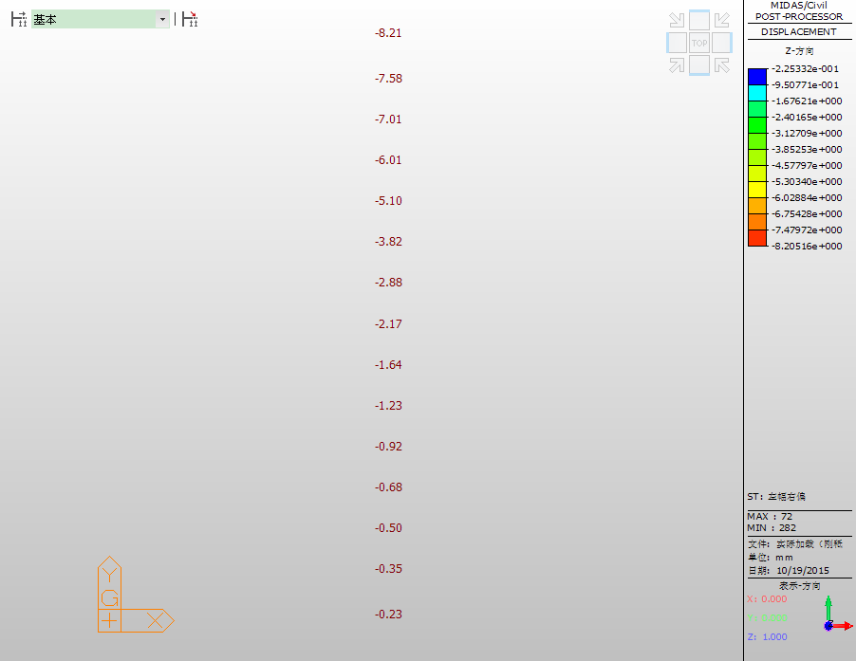

图 4‑16工况1静载控制截面理论挠度值(图中挠度向下为负，单位：mm，图中从上至下为L1~L15)

### 工况2测试结果

(1)应变检测结果

**表 4‑7工况2应变原始数据处理表**

|  |  |  |  |  |  |  |  |  |  |  |  |  |  |
| --- | --- | --- | --- | --- | --- | --- | --- | --- | --- | --- | --- | --- | --- |
| **测点** | **初始读数** | | **工况2** | | **退载** | | **工况2** | | | | | | |
| **模数R** | **温度T** | **模数R** | **温度T** | **模数R** | **温度T** | **加载** | | **退载** | | **总应变** | **弹性应变** | **残余应变** |
| **ΔR** | **ΔT** | **ΔR** | **ΔT** |
| L1 | 664.6 | 28.0 | 669.1 | 28.5 | 665.0 | 28.4 | 4.5 | 0.5 | 0.4 | 0.4 | 17.9 | 15.7 | 2.2 |
| L2 | 697.8 | 27.9 | 703.1 | 28.4 | 696.8 | 28.3 | 5.3 | 0.5 | -1.0 | 0.4 | 20.9 | 20.9 | 0.0 |
| L3 | 812.0 | 27.6 | 821.4 | 28.1 | 810.9 | 28.1 | 9.4 | 0.5 | -1.1 | 0.5 | 36.4 | 36.4 | 0.0 |
| L4 | 695.2 | 27.9 | 706.1 | 28.3 | 694.8 | 28.3 | 10.9 | 0.4 | -0.4 | 0.4 | 41.9 | 41.9 | 0.0 |
| L5 | 433.2 | 28.1 | 446.8 | 28.5 | 432.8 | 28.5 | 13.6 | 0.4 | -0.4 | 0.4 | 52.0 | 52.0 | 0.0 |
| L6 | 641.7 | 28.0 | 655.2 | 28.4 | 641.3 | 28.4 | 13.5 | 0.4 | -0.4 | 0.4 | 51.7 | 51.7 | 0.0 |
| L7 | 767.3 | 28.1 | 780.3 | 28.4 | 767.4 | 28.4 | 13.0 | 0.3 | 0.1 | 0.3 | 49.6 | 48.7 | 0.9 |
| L8 | 756.5 | 28.2 | 768.7 | 28.4 | 756.7 | 28.4 | 12.2 | 0.2 | 0.2 | 0.2 | 46.4 | 45.3 | 1.1 |
| L9 | 632.5 | 28.5 | 644.6 | 28.6 | 632.9 | 28.6 | 12.1 | 0.1 | 0.4 | 0.1 | 45.8 | 44.1 | 1.7 |
| L10 | 761.0 | 28.5 | 768.9 | 28.7 | 762.0 | 28.7 | 7.9 | 0.2 | 1.0 | 0.2 | 30.2 | 26.1 | 4.1 |
| L11 | 761.1 | 28.3 | 769.1 | 28.4 | 761.4 | 28.4 | 8.0 | 0.1 | 0.3 | 0.1 | 30.4 | 29.1 | 1.3 |
| L12 | 673.4 | 28.3 | 679.2 | 28.5 | 673.6 | 28.5 | 5.8 | 0.2 | 0.2 | 0.2 | 22.2 | 21.1 | 1.1 |
| L13 | 712.2 | 27.8 | 714.9 | 28.1 | 711.1 | 28.1 | 2.7 | 0.3 | -1.1 | 0.3 | 10.7 | 10.7 | 0.0 |
| L14 | 648.7 | 27.7 | 653.0 | 28.1 | 647.8 | 28.1 | 4.3 | 0.4 | -0.9 | 0.4 | 16.9 | 16.9 | 0.0 |
| L15 | 615.0 | 27.6 | 619.1 | 27.9 | 614.0 | 28.0 | 4.1 | 0.3 | -1.0 | 0.4 | 16.0 | 16.0 | 0.0 |
| 备注：应变换算值＝3.70×1.0200190×ΔR +1.80×ΔT | | | | | | | | | | | | | |

**表 4‑8工况2应变检测结果汇总表**

|  |  |  |  |  |  |  |  |
| --- | --- | --- | --- | --- | --- | --- | --- |
| **测点号** | **实测应变值(με)** | | | **满载应力 理论值(MPa)** | **满载理论应变值(με)** | **校验系数** | **相对残余 应变** |
| **总应变** | **弹性应变** | **残余应变** |
| L1 | 17.9 | 15.7 | 2.2 | 2.28 | 66.1 | 0.24 | 12.29% |
| L2 | 20.9 | 20.9 | 0.0 | 2.65 | 76.8 | 0.27 | 0.00% |
| L3 | 36.4 | 36.4 | 0.0 | 3.26 | 94.5 | 0.39 | 0.00% |
| L4 | 41.9 | 41.9 | 0.0 | 3.53 | 102.3 | 0.41 | 0.00% |
| L5 | 52.0 | 52.0 | 0.0 | 3.90 | 113.0 | 0.46 | 0.00% |
| L6 | 51.7 | 51.7 | 0.0 | 3.79 | 109.9 | 0.47 | 0.00% |
| L7 | 49.6 | 48.7 | 0.9 | 3.81 | 110.4 | 0.44 | 1.81% |
| L8 | 46.4 | 45.3 | 1.1 | 3.64 | 105.5 | 0.43 | 2.37% |
| L9 | 45.8 | 44.1 | 1.7 | 3.31 | 95.9 | 0.46 | 3.71% |
| L10 | 30.2 | 26.1 | 4.1 | 2.77 | 80.3 | 0.33 | 13.58% |
| L11 | 30.4 | 29.1 | 1.3 | 2.24 | 50.4 | 0.58 | 4.28% |
| L12 | 22.2 | 21.1 | 1.1 | 1.74 | 39.7 | 0.53 | 4.95% |
| L13 | 10.7 | 10.7 | 0.0 | 1.37 | 32.5 | 0.33 | 0.00% |
| L14 | 16.9 | 16.9 | 0.0 | 1.12 | 27.8 | 0.61 | 0.00% |
| L15 | 16.0 | 16.0 | 0.0 | 0.96 | 27.8 | 0.58 | 0.00% |
| 备注：应变ε(με)=σ(MPa)×100/3.45；拉应变为正 | | | | | | | |

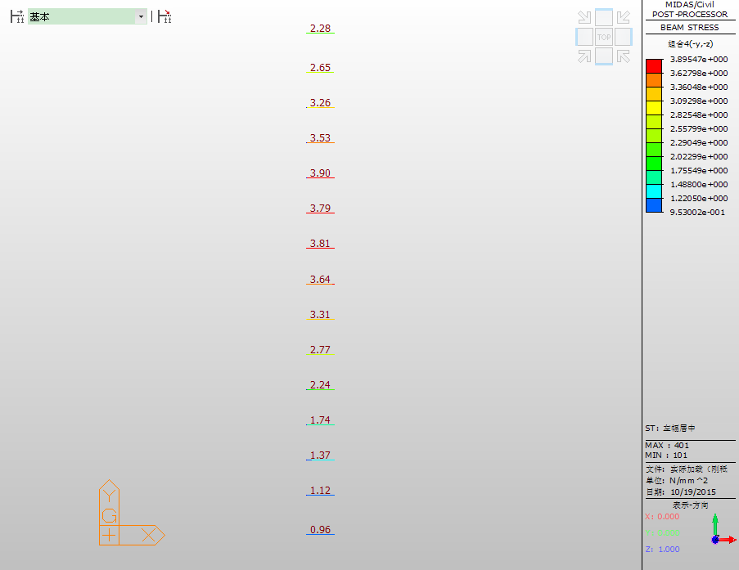

图 4‑17 工况2静载控制截面理论应力值(MPa，图中从上至下为L1~L15)



图4‑18 工况2应变实测值与理论计算值的关系曲线

(2)挠度检测结果

**表 4‑9 工况2挠度原始数据处理表**

|  |  |  |  |  |  |  |
| --- | --- | --- | --- | --- | --- | --- |
| **挠度值计算mm** | | | | | | |
| **测点** | **初始读数** | **工况2**  **满载** | **退载** | **总挠度** | **弹性挠度** | **残余变形** |
| L1 | 8.58 | 10.32 | 8.58 | 1.74 | 1.74 | 0.00 |
| L2 | 8.74 | 10.80 | 8.73 | 2.06 | 2.06 | 0.00 |
| L3 | 8.12 | 10.54 | 8.14 | 2.42 | 2.40 | 0.02 |
| L4 | 10.76 | 13.43 | 10.78 | 2.67 | 2.65 | 0.02 |
| L5 | 9.48 | 12.60 | 9.52 | 3.12 | 3.08 | 0.04 |
| L6 | 12.81 | 16.20 | 12.87 | 3.39 | 3.33 | 0.06 |
| L7 | 14.13 | 17.50 | 14.18 | 3.37 | 3.32 | 0.05 |
| L8 | 7.59 | 10.63 | 7.64 | 3.04 | 2.99 | 0.05 |
| L9 | 9.02 | 11.78 | 9.06 | 2.76 | 2.72 | 0.04 |
| L10 | 13.32 | 15.70 | 13.37 | 2.38 | 2.33 | 0.05 |
| L11 | 12.53 | 14.59 | 12.55 | 2.06 | 2.04 | 0.02 |
| L12 | 8.84 | 10.56 | 8.84 | 1.72 | 1.72 | 0.00 |
| L13 | 8.05 | 9.44 | 8.04 | 1.39 | 1.39 | 0.00 |
| L14 | 8.69 | 9.76 | 8.68 | 1.07 | 1.07 | 0.00 |
| L15 | 10.30 | 11.12 | 10.29 | 0.82 | 0.82 | 0.00 |
| 备注：总挠度=满载-初读；残余变形=退载-初读；弹性挠度=总挠度-残余变形 | | | | | | |

**表 4‑10 工况2挠度检测结果汇总表**

|  |  |  |  |  |  |  |
| --- | --- | --- | --- | --- | --- | --- |
| **测点号** | **实测值（mm）** | | | **满载理论值（mm）** | **校验系数** | **相对残**  **余变形** |
| **总变形** | **弹性变形** | **残余变形** |
| L1 | 1.74 | 1.74 | 0.00 | 3.71 | 0.47 | 0.00% |
| L2 | 2.06 | 2.06 | 0.00 | 4.12 | 0.50 | 0.00% |
| L3 | 2.42 | 2.40 | 0.02 | 4.85 | 0.49 | 0.83% |
| L4 | 2.67 | 2.65 | 0.02 | 5.3 | 0.50 | 0.75% |
| L5 | 3.12 | 3.08 | 0.04 | 5.91 | 0.52 | 1.28% |
| L6 | 3.39 | 3.33 | 0.06 | 6.12 | 0.54 | 1.77% |
| L7 | 3.37 | 3.32 | 0.05 | 6.24 | 0.53 | 1.48% |
| L8 | 3.04 | 2.99 | 0.05 | 6.05 | 0.49 | 1.64% |
| L9 | 2.76 | 2.72 | 0.04 | 5.32 | 0.51 | 1.45% |
| L10 | 2.38 | 2.33 | 0.05 | 4.58 | 0.51 | 2.10% |
| L11 | 2.06 | 2.04 | 0.02 | 3.56 | 0.57 | 0.97% |
| L12 | 1.72 | 1.72 | 0.00 | 2.83 | 0.61 | 0.00% |
| L13 | 1.39 | 1.39 | 0.00 | 2.31 | 0.60 | 0.00% |
| L14 | 1.07 | 1.07 | 0.00 | 1.95 | 0.55 | 0.00% |
| L15 | 0.82 | 0.82 | 0.00 | 1.7 | 0.48 | 0.00% |
| 备注：向下挠度为正 | | | | | | |



图 4‑19 工况2挠度实测值与理论计算值的关系曲线

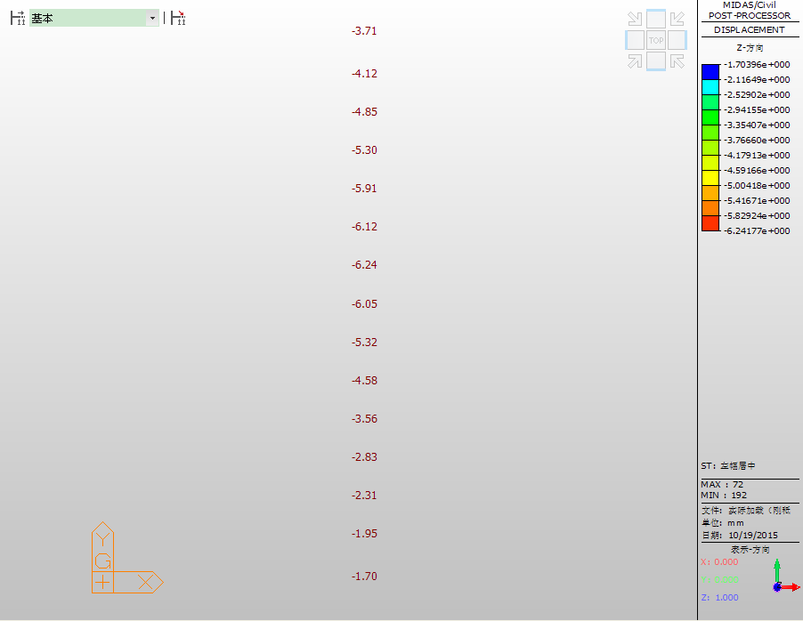

图 4‑20工况2静载控制截面理论挠度值(图中挠度向下为负，单位：mm，图中从上至下为L1~L15)

### 工况3测试结果

(1)应变检测结果

**表 4‑11工况3应变原始数据处理表**

|  |  |  |  |  |  |  |  |  |  |  |  |  |  |
| --- | --- | --- | --- | --- | --- | --- | --- | --- | --- | --- | --- | --- | --- |
| **测点** | **初始读数** | | **工况3** | | **退载** | | **工况3** | | | | | | |
| **模数R** | **温度T** | **模数R** | **温度T** | **模数R** | **温度T** | **加载** | | **退载** | | **总应变** | **弹性应变** | **残余应变** |
| **ΔR** | **ΔT** | **ΔR** | **ΔT** |
| R1 | 606.9 | 28.3 | 622.1 | 28.3 | 606.8 | 28.4 | 15.2 | 0.0 | -0.1 | 0.1 | 57.4 | 57.4 | 0.0 |
| R2 | 695.3 | 28.2 | 706.9 | 28.3 | 695.3 | 28.3 | 11.6 | 0.1 | 0.0 | 0.1 | 44.0 | 43.8 | 0.2 |
| R3 | 691.6 | 28.2 | 702.1 | 28.3 | 691.1 | 28.4 | 10.5 | 0.1 | -0.5 | 0.2 | 39.8 | 39.8 | 0.0 |
| R4 | 566.7 | 28.1 | 574.9 | 28.2 | 566.4 | 28.3 | 8.2 | 0.1 | -0.3 | 0.2 | 31.1 | 31.1 | 0.0 |
| R5 | 737.5 | 28.3 | 746.9 | 28.4 | 736.9 | 28.4 | 9.4 | 0.1 | -0.6 | 0.1 | 35.7 | 35.7 | 0.0 |
| R6 | 710.2 | 28.1 | 718.3 | 28.1 | 710.3 | 28.2 | 8.1 | 0.0 | 0.1 | 0.1 | 30.6 | 30.0 | 0.6 |
| R7 | 1113.2 | 28.1 | 1119.5 | 28.2 | 1112.6 | 28.2 | 6.3 | 0.1 | -0.6 | 0.1 | 24.0 | 24.0 | 0.0 |
| R8 | 639.0 | 28.2 | 643.7 | 28.3 | 638.7 | 28.4 | 4.7 | 0.1 | -0.3 | 0.2 | 17.9 | 17.9 | 0.0 |
| R9 | 656.9 | 28.2 | 660.7 | 28.3 | 656.6 | 28.4 | 3.8 | 0.1 | -0.3 | 0.2 | 14.5 | 14.5 | 0.0 |
| R10 | 588.9 | 28.1 | 591.1 | 28.2 | 588.5 | 28.3 | 2.2 | 0.1 | -0.4 | 0.2 | 8.5 | 8.5 | 0.0 |
| R11 | 670.6 | 28.1 | 672.9 | 28.2 | 670.3 | 28.3 | 2.3 | 0.1 | -0.3 | 0.2 | 8.9 | 8.9 | 0.0 |
| R12 | 673.7 | 28.0 | 674.8 | 28.1 | 673.3 | 28.2 | 1.1 | 0.1 | -0.4 | 0.2 | 4.3 | 4.3 | 0.0 |
| R13 | 790.3 | 27.9 | 790.9 | 28.0 | 789.6 | 28.1 | 0.6 | 0.1 | -0.7 | 0.2 | 2.4 | 2.4 | 0.0 |
| R14 | 689.2 | 28.0 | 689.7 | 28.1 | 688.7 | 28.2 | 0.5 | 0.1 | -0.5 | 0.2 | 2.1 | 2.1 | 0.0 |
| R15 | 751.2 | 28.1 | 752.2 | 28.2 | 750.7 | 28.3 | 1.0 | 0.1 | -0.5 | 0.2 | 4.0 | 4.0 | 0.0 |
| 备注：应变换算值＝3.70×1.0200190×ΔR +1.80×ΔT | | | | | | | | | | | | | |

**表 4‑12工况3应变检测结果汇总表**

|  |  |  |  |  |  |  |  |
| --- | --- | --- | --- | --- | --- | --- | --- |
| **测点号** | **实测应变值(με)** | | | **满载应力 理论值(MPa)** | **满载理论应变值(με)** | **校验系数** | **相对残余 应变** |
| **总应变** | **弹性应变** | **残余应变** |
| R1 | 57.4 | 57.4 | 0.0 | 5.10 | 147.8 | 0.39 | 0.00% |
| R2 | 44.0 | 43.8 | 0.2 | 4.72 | 136.8 | 0.32 | 0.45% |
| R3 | 39.8 | 39.8 | 0.0 | 4.24 | 122.9 | 0.32 | 0.00% |
| R4 | 31.1 | 31.1 | 0.0 | 3.72 | 107.8 | 0.29 | 0.00% |
| R5 | 35.7 | 35.7 | 0.0 | 3.03 | 87.8 | 0.41 | 0.00% |
| R6 | 30.6 | 30.0 | 0.6 | 2.40 | 69.6 | 0.43 | 1.96% |
| R7 | 24.0 | 24.0 | 0.0 | 1.78 | 51.6 | 0.47 | 0.00% |
| R8 | 17.9 | 17.9 | 0.0 | 1.30 | 37.7 | 0.48 | 0.00% |
| R9 | 14.5 | 14.5 | 0.0 | 0.95 | 27.5 | 0.53 | 0.00% |
| R10 | 8.5 | 8.5 | 0.0 | 0.69 | 20.0 | 0.43 | 0.00% |
| R11 | 8.9 | 8.9 | 0.0 | 0.49 | 14.2 | 0.63 | 0.00% |
| R12 | 4.3 | 4.3 | 0.0 | 0.35 | 10.1 | 0.42 | 0.00% |
| R13 | 2.4 | 2.4 | 0.0 | 0.29 | 8.4 | 0.29 | 0.00% |
| R14 | 2.1 | 2.1 | 0.0 | 0.25 | 7.2 | 0.29 | 0.00% |
| R15 | 4.0 | 4.0 | 0.0 | 0.16 | 4.6 | 0.86 | 0.00% |
| 备注：应变ε(με)=σ(MPa)×100/3.45；拉应变为正 | | | | | | | |

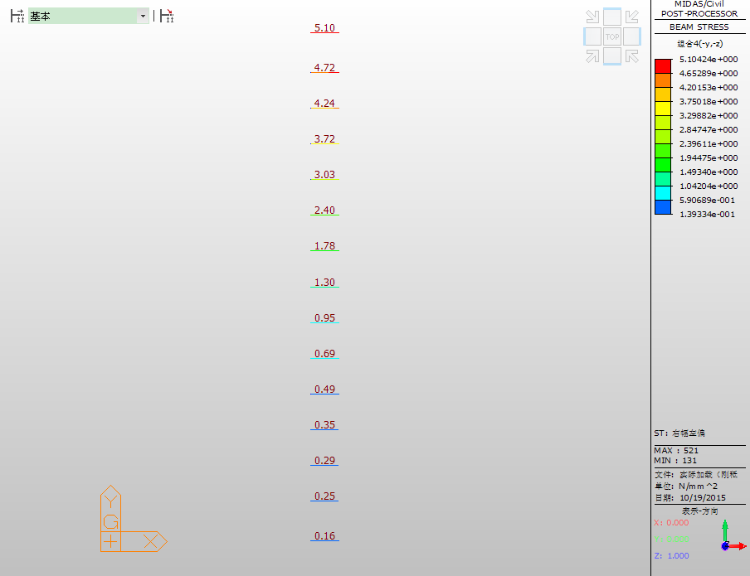

图 4‑21 工况3静载控制截面理论应力值(MPa，图中从上至下为R1~R15)



图4‑22 工况3应变实测值与理论计算值的关系曲线

(2)挠度检测结果

**表 4‑13 工况3挠度原始数据处理表**

|  |  |  |  |  |  |  |
| --- | --- | --- | --- | --- | --- | --- |
| **挠度值计算mm** | | | | | | |
| **测点** | **初始读数** | **工况3**  **满载** | **退载** | **总挠度** | **弹性挠度** | **残余变形** |
| R1 | 7.60 | 10.57 | 7.65 | 2.97 | 2.92 | 0.05 |
| R2 | 11.64 | 14.55 | 11.64 | 2.91 | 2.91 | 0.00 |
| R3 | 7.87 | 10.67 | 7.83 | 2.80 | 2.80 | 0.00 |
| R4 | 7.39 | 10.10 | 7.38 | 2.71 | 2.71 | 0.00 |
| R5 | 12.01 | 14.29 | 11.99 | 2.28 | 2.28 | 0.00 |
| R6 | 9.66 | 11.55 | 9.63 | 1.89 | 1.89 | 0.00 |
| R7 | 6.89 | 8.35 | 6.84 | 1.46 | 1.46 | 0.00 |
| R8 | 11.54 | 12.62 | 11.48 | 1.08 | 1.08 | 0.00 |
| R9 | 10.92 | 11.85 | 10.91 | 0.93 | 0.93 | 0.00 |
| R10 | 6.66 | 7.27 | 6.60 | 0.61 | 0.61 | 0.00 |
| R11 | 9.51 | 9.95 | 9.44 | 0.44 | 0.44 | 0.00 |
| R12 | 7.90 | 8.27 | 7.87 | 0.37 | 0.37 | 0.00 |
| R13 | 9.32 | 9.60 | 9.30 | 0.28 | 0.28 | 0.00 |
| R14 | 8.70 | 8.89 | 8.65 | 0.19 | 0.19 | 0.00 |
| R15 | 8.15 | 8.23 | 8.06 | 0.08 | 0.08 | 0.00 |
| 备注：总挠度=满载-初读；残余变形=退载-初读；弹性挠度=总挠度-残余变形 | | | | | | |

**表 4‑14 工况3挠度检测结果汇总表**

|  |  |  |  |  |  |  |
| --- | --- | --- | --- | --- | --- | --- |
| **测点号** | **实测值（mm）** | | | **满载理论值（mm）** | **校验系数** | **相对残**  **余变形** |
| **总变形** | **弹性变形** | **残余变形** |
| R1 | 2.97 | 2.92 | 0.05 | 8.16 | 0.36 | 1.68% |
| R2 | 2.91 | 2.91 | 0.00 | 7.56 | 0.38 | 0.00% |
| R3 | 2.80 | 2.80 | 0.00 | 7.01 | 0.40 | 0.00% |
| R4 | 2.71 | 2.71 | 0.00 | 6.03 | 0.45 | 0.00% |
| R5 | 2.28 | 2.28 | 0.00 | 5.12 | 0.45 | 0.00% |
| R6 | 1.89 | 1.89 | 0.00 | 3.84 | 0.49 | 0.00% |
| R7 | 1.46 | 1.46 | 0.00 | 2.89 | 0.51 | 0.00% |
| R8 | 1.08 | 1.08 | 0.00 | 2.18 | 0.50 | 0.00% |
| R9 | 0.93 | 0.93 | 0.00 | 1.64 | 0.57 | 0.00% |
| R10 | 0.61 | 0.61 | 0.00 | 1.24 | 0.49 | 0.00% |
| R11 | 0.44 | 0.44 | 0.00 | 0.92 | 0.48 | 0.00% |
| R12 | 0.37 | 0.37 | 0.00 | 0.69 | 0.54 | 0.00% |
| R13 | 0.28 | 0.28 | 0.00 | 0.5 | 0.56 | 0.00% |
| R14 | 0.19 | 0.19 | 0.00 | 0.35 | 0.54 | 0.00% |
| R15 | 0.08 | 0.08 | 0.00 | 0.23 | 0.35 | 0.00% |
| 备注：向下挠度为正 | | | | | | |



图 4‑23 工况3挠度实测值与理论计算值的关系曲线

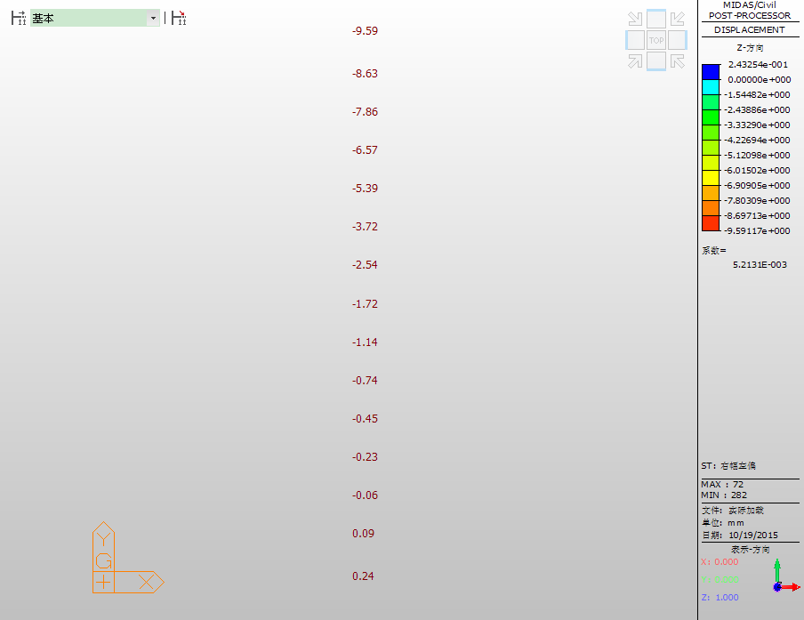

图 4‑24工况3静载控制截面理论挠度值(图中挠度向下为负，单位：mm，图中从上至下为R1~R15)

### 工况4测试结果

(1)应变检测结果

**表 4‑15工况4应变原始数据处理表**

|  |  |  |  |  |  |  |  |  |  |  |  |  |  |
| --- | --- | --- | --- | --- | --- | --- | --- | --- | --- | --- | --- | --- | --- |
| **测点** | **初始读数** | | **工况4** | | **退载** | | **工况4** | | | | | | |
| **模数R** | **温度T** | **模数R** | **温度T** | **模数R** | **温度T** | **加载** | | **退载** | | **总应变** | **弹性应变** | **残余应变** |
| **ΔR** | **ΔT** | **ΔR** | **ΔT** |
| R1 | 606.8 | 28.4 | 614.5 | 28.5 | 605.1 | 29.0 | 7.7 | 0.1 | -1.7 | 0.6 | 29.2 | 29.2 | 0.0 |
| R2 | 695.3 | 28.3 | 701.7 | 28.4 | 694.7 | 28.9 | 6.4 | 0.1 | -0.6 | 0.6 | 24.3 | 24.3 | 0.0 |
| R3 | 691.1 | 28.4 | 698.4 | 28.4 | 689.9 | 28.9 | 7.3 | 0.0 | -1.2 | 0.5 | 27.6 | 27.6 | 0.0 |
| R4 | 566.4 | 28.3 | 575.7 | 28.4 | 565.3 | 28.8 | 9.3 | 0.1 | -1.1 | 0.5 | 35.3 | 35.3 | 0.0 |
| R5 | 736.9 | 28.4 | 749.1 | 28.5 | 735.7 | 28.9 | 12.2 | 0.1 | -1.2 | 0.5 | 46.2 | 46.2 | 0.0 |
| R6 | 710.3 | 28.2 | 721.4 | 28.3 | 710.8 | 28.7 | 11.1 | 0.1 | 0.5 | 0.5 | 42.1 | 39.3 | 2.8 |
| R7 | 1112.6 | 28.2 | 1124.1 | 28.3 | 1111.0 | 28.7 | 11.5 | 0.1 | -1.6 | 0.5 | 43.6 | 43.6 | 0.0 |
| R8 | 638.7 | 28.4 | 650.6 | 28.5 | 638.5 | 28.9 | 11.9 | 0.1 | -0.2 | 0.5 | 45.1 | 45.0 | 0.1 |
| R9 | 656.6 | 28.4 | 667.3 | 28.5 | 655.7 | 28.8 | 10.7 | 0.1 | -0.9 | 0.4 | 40.6 | 40.6 | 0.0 |
| R10 | 588.5 | 28.3 | 597.5 | 28.4 | 587.6 | 28.7 | 9.0 | 0.1 | -0.9 | 0.4 | 34.1 | 34.1 | 0.0 |
| R11 | 670.3 | 28.3 | 680.1 | 28.5 | 669.5 | 28.7 | 9.8 | 0.2 | -0.8 | 0.4 | 37.3 | 37.3 | 0.0 |
| R12 | 673.3 | 28.2 | 680.0 | 28.4 | 672.4 | 28.6 | 6.7 | 0.2 | -0.9 | 0.4 | 25.6 | 25.6 | 0.0 |
| R13 | 789.6 | 28.1 | 794.8 | 28.3 | 788.6 | 28.5 | 5.2 | 0.2 | -1.0 | 0.4 | 20.0 | 20.0 | 0.0 |
| R14 | 688.7 | 28.2 | 691.5 | 28.4 | 687.1 | 28.6 | 2.8 | 0.2 | -1.6 | 0.4 | 10.9 | 10.9 | 0.0 |
| R15 | 750.7 | 28.3 | 756.1 | 28.6 | 749.9 | 28.9 | 5.4 | 0.3 | -0.8 | 0.6 | 20.9 | 20.9 | 0.0 |
| 备注：应变换算值＝3.70×1.0200190×ΔR +1.80×ΔT | | | | | | | | | | | | | |

**表 4‑16工况4应变检测结果汇总表**

|  |  |  |  |  |  |  |  |
| --- | --- | --- | --- | --- | --- | --- | --- |
| **测点号** | **实测应变值(με)** | | | **满载应力 理论值(MPa)** | **满载理论应变值(με)** | **校验系数** | **相对残余 应变** |
| **总应变** | **弹性应变** | **残余应变** |
| R1 | 29.2 | 29.2 | 0.0 | 2.25 | 65.2 | 0.45 | 0.00% |
| R2 | 24.3 | 24.3 | 0.0 | 2.62 | 75.9 | 0.32 | 0.00% |
| R3 | 27.6 | 27.6 | 0.0 | 3.20 | 92.8 | 0.30 | 0.00% |
| R4 | 35.3 | 35.3 | 0.0 | 3.47 | 100.6 | 0.35 | 0.00% |
| R5 | 46.2 | 46.2 | 0.0 | 3.85 | 111.6 | 0.41 | 0.00% |
| R6 | 42.1 | 39.3 | 2.8 | 3.79 | 109.9 | 0.36 | 6.65% |
| R7 | 43.6 | 43.6 | 0.0 | 3.81 | 110.4 | 0.39 | 0.00% |
| R8 | 45.1 | 45.0 | 0.1 | 3.66 | 106.1 | 0.42 | 0.22% |
| R9 | 40.6 | 40.6 | 0.0 | 3.34 | 96.8 | 0.42 | 0.00% |
| R10 | 34.1 | 34.1 | 0.0 | 2.81 | 81.4 | 0.42 | 0.00% |
| R11 | 37.3 | 37.3 | 0.0 | 2.28 | 66.1 | 0.56 | 0.00% |
| R12 | 25.6 | 25.6 | 0.0 | 1.77 | 51.3 | 0.50 | 0.00% |
| R13 | 20.0 | 20.0 | 0.0 | 1.39 | 40.3 | 0.50 | 0.00% |
| R14 | 10.9 | 10.9 | 0.0 | 1.14 | 33.0 | 0.33 | 0.00% |
| R15 | 20.9 | 20.9 | 0.0 | 0.97 | 28.1 | 0.74 | 0.00% |
| 备注：应变ε(με)=σ(MPa)×100/3.45；拉应变为正 | | | | | | | |

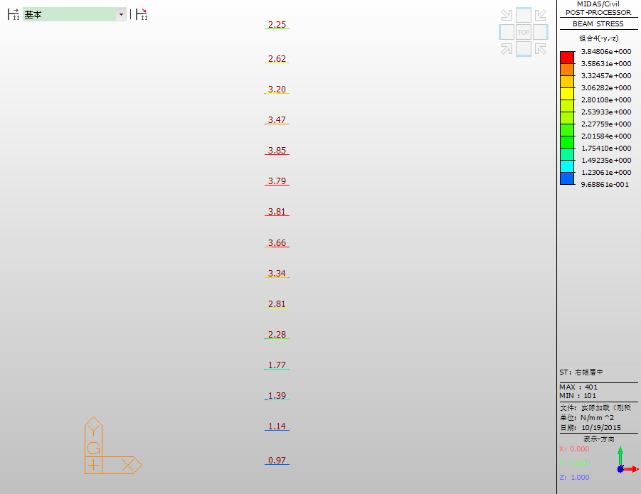

图 4‑25 工况4静载控制截面理论应力值(MPa，图中从上至下为R1~R15)



图4‑26 工况4应变实测值与理论计算值的关系曲线

(2)挠度检测结果

**表 4‑17 工况4挠度原始数据处理表**

|  |  |  |  |  |  |  |
| --- | --- | --- | --- | --- | --- | --- |
| **挠度值计算mm** | | | | | | |
| **测点** | **初始读数** | **工况4**  **满载** | **退载** | **总挠度** | **弹性挠度** | **残余变形** |
| R1 | 7.65 | 8.90 | 7.45 | 1.25 | 1.25 | 0.00 |
| R2 | 11.64 | 13.15 | 11.46 | 1.51 | 1.51 | 0.00 |
| R3 | 7.83 | 9.59 | 7.73 | 1.76 | 1.76 | 0.00 |
| R4 | 7.38 | 9.52 | 7.28 | 2.14 | 2.14 | 0.00 |
| R5 | 11.99 | 14.48 | 11.91 | 2.49 | 2.49 | 0.00 |
| R6 | 9.63 | 12.41 | 9.62 | 2.78 | 2.78 | 0.00 |
| R7 | 6.84 | 9.71 | 6.82 | 2.87 | 2.87 | 0.00 |
| R8 | 11.48 | 14.40 | 11.48 | 2.92 | 2.92 | 0.00 |
| R9 | 10.91 | 13.81 | 10.90 | 2.90 | 2.90 | 0.00 |
| R10 | 6.60 | 9.27 | 6.59 | 2.67 | 2.67 | 0.00 |
| R11 | 9.44 | 11.65 | 9.40 | 2.21 | 2.21 | 0.00 |
| R12 | 7.87 | 9.73 | 7.81 | 1.86 | 1.86 | 0.00 |
| R13 | 9.30 | 10.79 | 9.27 | 1.49 | 1.49 | 0.00 |
| R14 | 8.65 | 9.89 | 8.70 | 1.24 | 1.19 | 0.05 |
| R15 | 8.06 | 9.08 | 8.15 | 1.02 | 0.93 | 0.09 |
| 备注：总挠度=满载-初读；残余变形=退载-初读；弹性挠度=总挠度-残余变形 | | | | | | |

**表 4‑18 工况4挠度检测结果汇总表**

|  |  |  |  |  |  |  |
| --- | --- | --- | --- | --- | --- | --- |
| **测点号** | **实测值（mm）** | | | **满载理论值（mm）** | **校验系数** | **相对残**  **余变形** |
| **总变形** | **弹性变形** | **残余变形** |
| R1 | 1.25 | 1.25 | 0.00 | 3.68 | 0.34 | 0.00% |
| R2 | 1.51 | 1.51 | 0.00 | 4.08 | 0.37 | 0.00% |
| R3 | 1.76 | 1.76 | 0.00 | 4.8 | 0.37 | 0.00% |
| R4 | 2.14 | 2.14 | 0.00 | 5.26 | 0.41 | 0.00% |
| R5 | 2.49 | 2.49 | 0.00 | 5.87 | 0.42 | 0.00% |
| R6 | 2.78 | 2.78 | 0.00 | 6.11 | 0.45 | 0.00% |
| R7 | 2.87 | 2.87 | 0.00 | 6.26 | 0.46 | 0.00% |
| R8 | 2.92 | 2.92 | 0.00 | 6.1 | 0.48 | 0.00% |
| R9 | 2.90 | 2.90 | 0.00 | 5.39 | 0.54 | 0.00% |
| R10 | 2.67 | 2.67 | 0.00 | 4.65 | 0.57 | 0.00% |
| R11 | 2.21 | 2.21 | 0.00 | 3.61 | 0.61 | 0.00% |
| R12 | 1.86 | 1.86 | 0.00 | 2.87 | 0.65 | 0.00% |
| R13 | 1.49 | 1.49 | 0.00 | 2.35 | 0.63 | 0.00% |
| R14 | 1.24 | 1.19 | 0.05 | 1.99 | 0.62 | 4.03% |
| R15 | 1.02 | 0.93 | 0.09 | 1.73 | 0.59 | 8.82% |
| 备注：向下挠度为正 | | | | | | |



图 4‑27 工况4挠度实测值与理论计算值的关系曲线

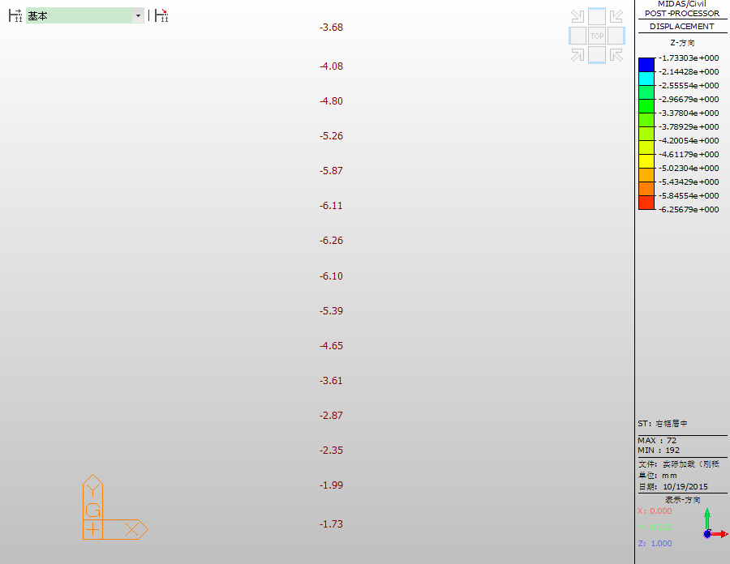

图 4‑28工况4静载控制截面理论挠度值(图中挠度向下为负，单位：mm，图中从上至下为R1~R15)

(以下无正文)