Supplementary Material
SpineCobbAnalyzer System Operation and Validation Guide
The source code, executable software, test images, raw data, and operational materials are available from the corresponding author upon reasonable request. To obtain the executable file in .exe format, please contact us at 1817533112@qq.com or 2781642414@qq.com.
The following section describes the operating procedures for the graphical user interface (GUI) after running the source code in Visual Studio Code (VS Code).
Before the first run, install the dependencies listed in requirements.txt. Copy the installation command provided below into the VS Code terminal and execute it. For detailed instructions on installation, operation, and troubleshooting, please refer to the Installation and Usage.txt file.
All data and finite element projection images required for software testing and validation are provided in the data folder.
The numbered labels in the following figures correspond directly to the step numbers in this guide. Please follow them in sequence.
Run the Spine_COBB_Analyzer.py file in the SpineCobbAnalyzer folder.
1. Language setting (top-right corner): If the interface is in Chinese, click the language toggle to switch to English. If already in English, skip this step.
2. Click [Auto A-Cobb] to enter the automated A-Cobb measurement module.
3. Click [Pareto Coupled Analysis] to enter the Pareto decision mode.
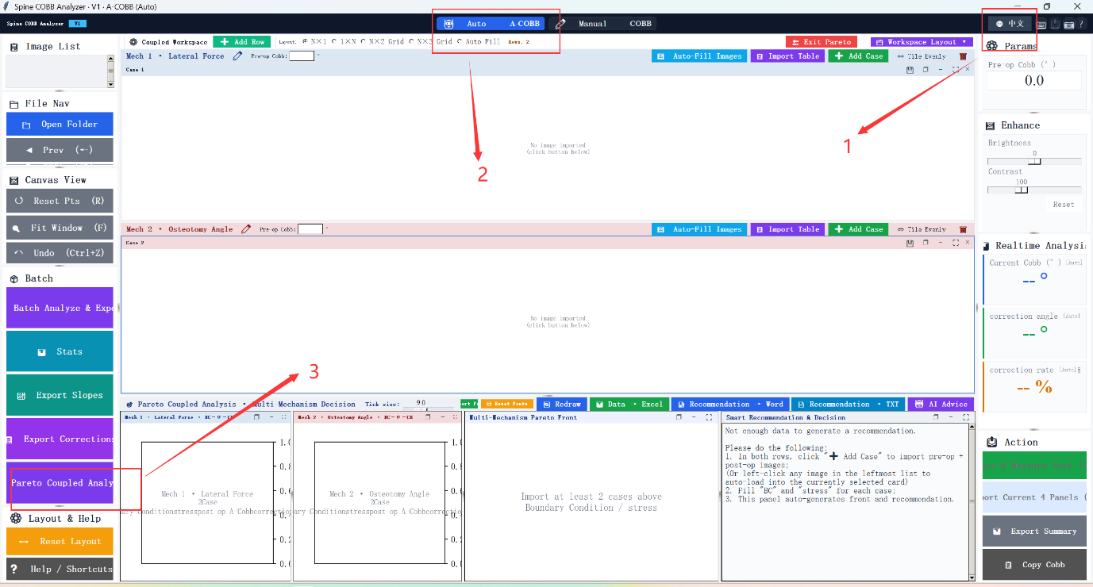
Figure 1 — Software launch screen
4. Enter the patient's pre-operative A-Cobb angle in the baseline field. For the case in this study, enter 84.85°.
5. Click [Import Table]. In the file dialog, select the pre-formatted data table containing boundary conditions (transverse force values, in N) and the corresponding spinal cord gray- and white-matter Von Mises stress values for each of the 10 load cases.
6. Confirm the selected file: Abaqus-exported data for all 10 transverse-force load cases, including force boundary conditions and gray/white-matter stress indicators.

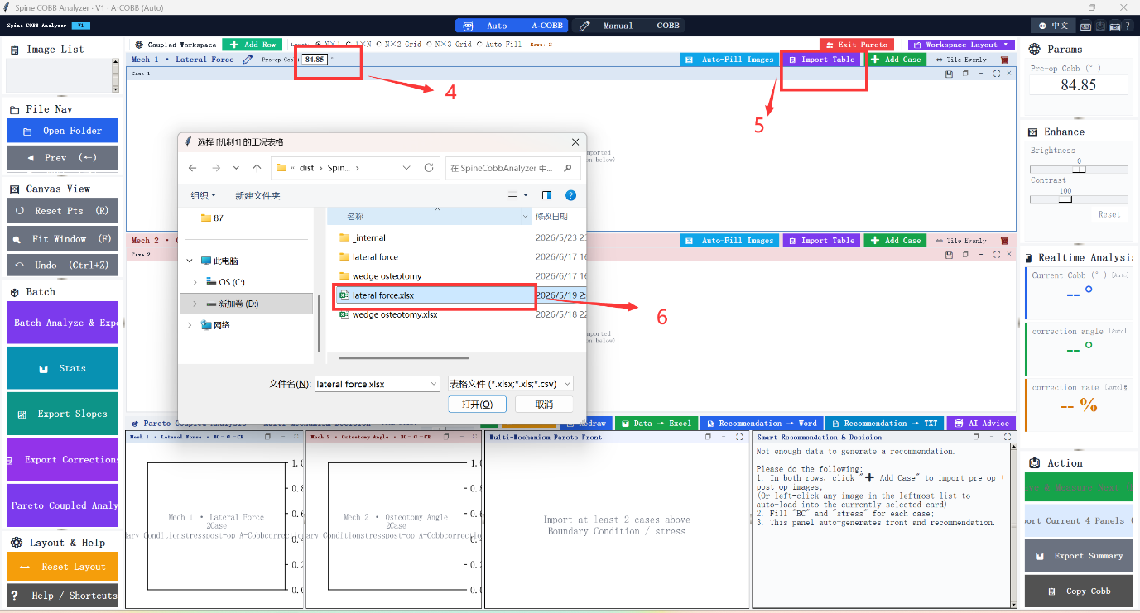
Figure 2 — Baseline input and data table import (Transverse Force mechanism)

7. Click [Open Folder]. In the file dialog, navigate to the folder containing the post-correction coronal projection images for all transverse-force load cases.
8. Confirm the selected folder: Abaqus-exported coronal projection images for all 10 transverse-force load cases.
9. Click [Auto Fit Image]. The software automatically assigns each image in the Image List to its corresponding load-case panel.
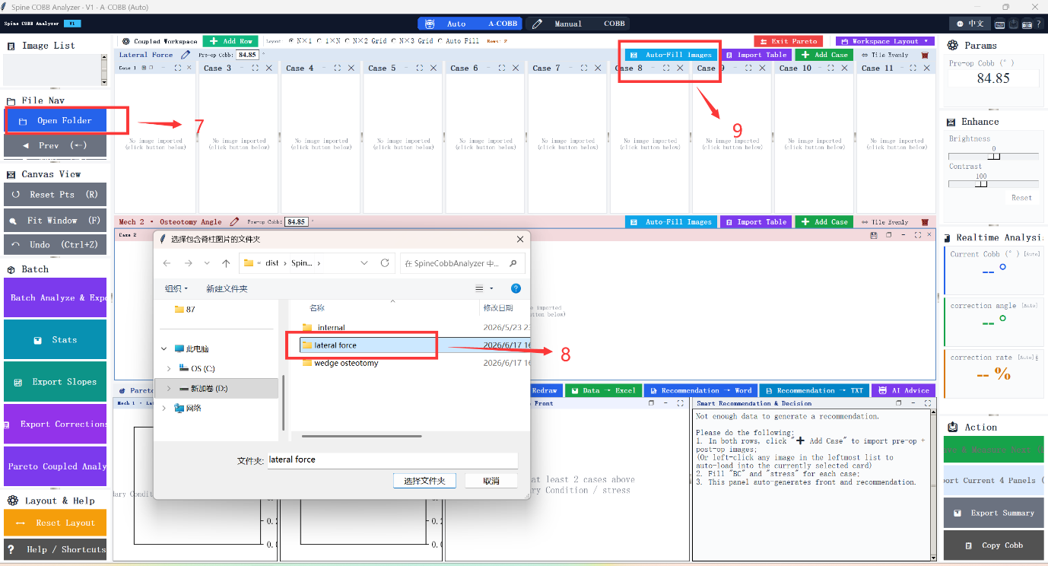
Figure 3 — Coronal projection image import (Transverse Force mechanism)

Repeat Steps 4–9 for the wedge osteotomy mechanism. When prompted, select the osteotomy data files and image folder instead.
10. Enter the same baseline A-Cobb angle (84.85°). Retain the value from Step 4 if still displayed.
11. Click [Import Table]. Select the osteotomy data table containing boundary conditions (osteotomy angles, in degrees) and the corresponding gray/white-matter Von Mises stress values for all 10 osteotomy load cases.
12. Confirm the selected file: Abaqus-exported data for all 10 wedge-osteotomy load cases (angles 5°–50°), including osteotomy angle boundary conditions and gray/white-matter stress indicators.
13. Click [Open Folder]. Navigate to the folder containing the post-correction coronal projection images for all osteotomy load cases.
14. Confirm the selected folder: Abaqus-exported coronal projection images for all 10 wedge-osteotomy load cases.
15. Click [Auto Fit Image] to assign each osteotomy image to its corresponding load-case panel.
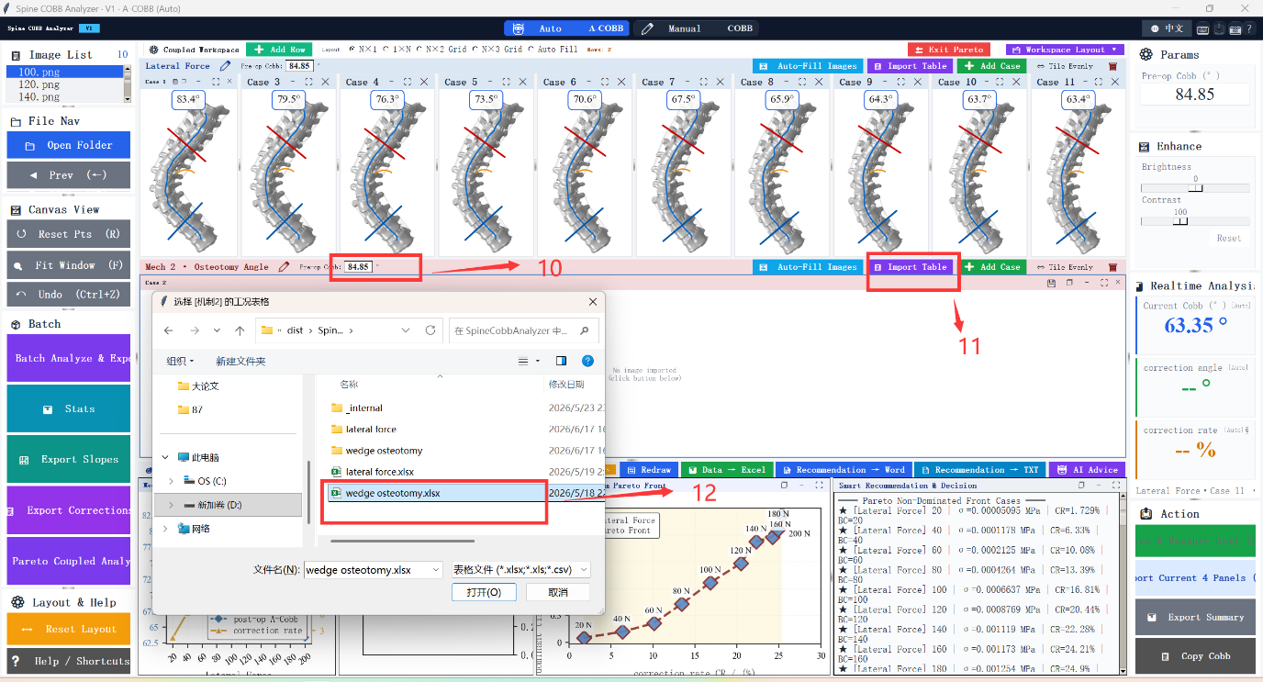
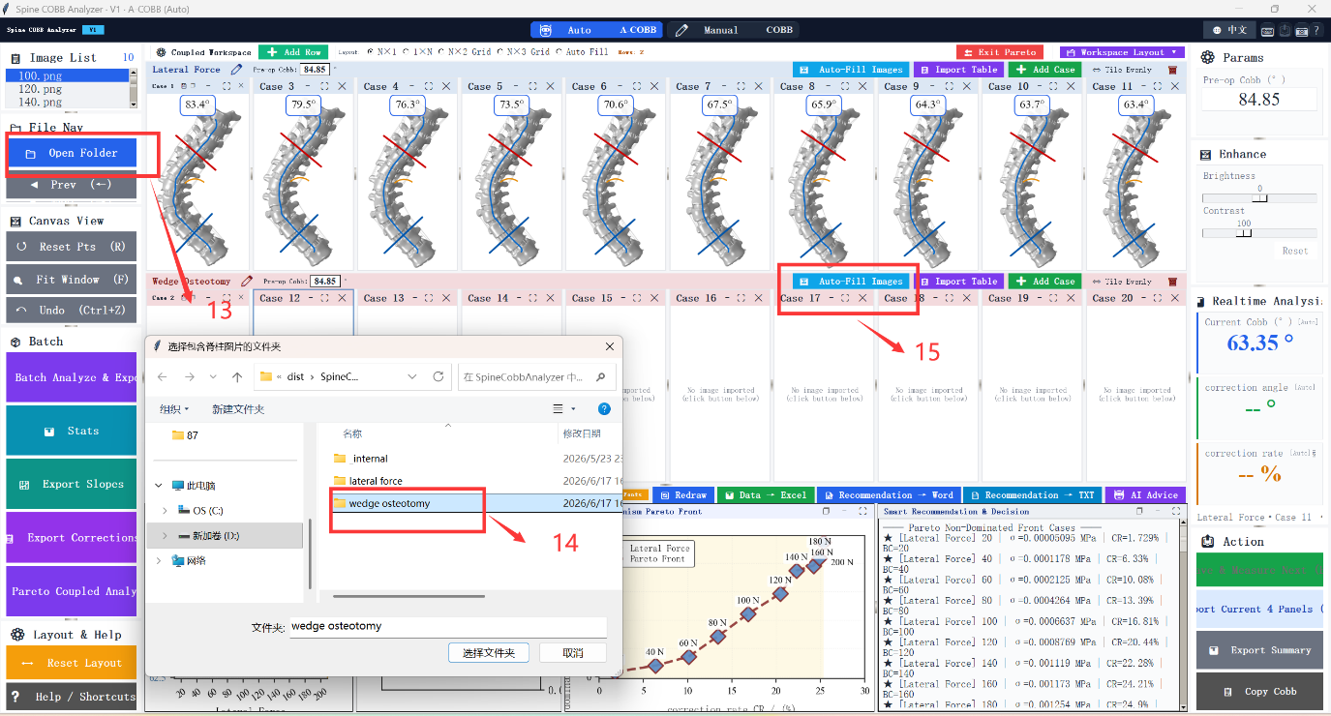
Figures 4–5 — Data table and image import (Wedge Osteotomy mechanism, Steps 10–15)

All outputs — charts, tables, measured A-Cobb values, and correction rates — can be exported with a single click.
16. Built-in Pareto decision chart: plots dominant-tissue stress versus correction rate for both mechanisms, with the Pareto frontier and the mechanism-switching threshold at CR ≈ 14.64% as reported in the main text.
17. Built-in Pareto decision summary: lists the recommended mechanism for each correction-rate interval — CR < 14.64%: Transverse Force preferred; CR 14.64%–25.33%: both feasible; CR > 25.33%: Wedge Osteotomy only.
18. AI-assisted interpretation (optional): if an API key is configured, click [AI Analysis] for automated clinical commentary. This is supplementary and does not affect the core Pareto computation.
19.点击 Date→Excel可导出所有主要数据，表格示例
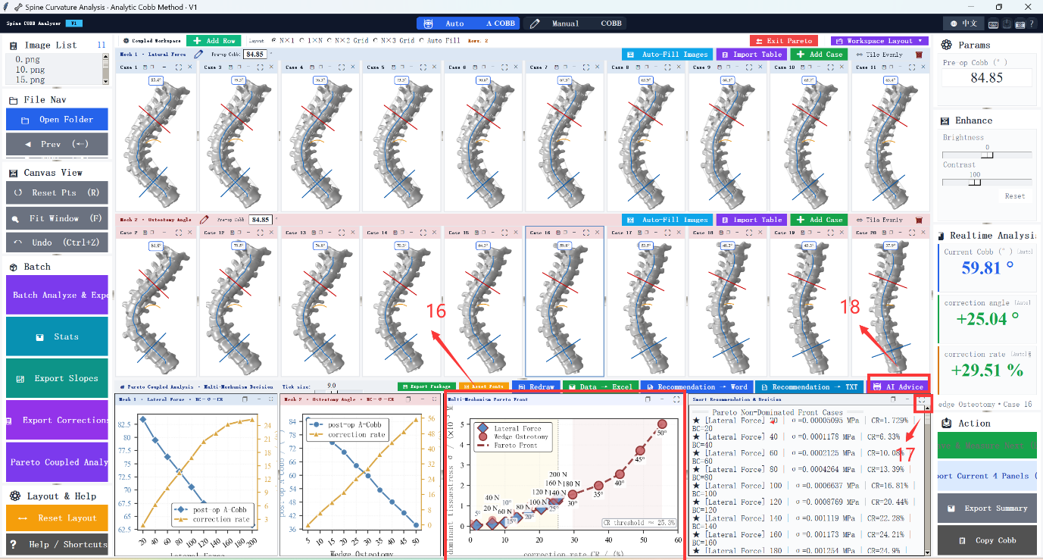
Figure 6 — Analysis results and export

