TODO List:

* Finish get function
* DOM operation, event operation, and a list to define watching element
* New flow function and it unit test
* Exports wa to global variable.
* ~~Push data to queue when ajax failed.~~
* Performance API.
* Check if the localStorage is fulled.
* A configuration that setting if wa should send data to server before page load event, default is false.
* Cross domain request method for IE6,7.
* A function that detect how user leave the page, is refresh, or jump, or other situation. This should merge with get Function
* Should allow to push null value for a type.
* XPATH function
* What will happen to the browser session cookie if user open two window then close the first one. Maybe save the session id to localStorage can solve this problem. use window ID that store in the JS memory.
* Judge whether the event is a user-trigger one or simulate one by some means?
* **Change the ssg report’s chart to jason’s chart(**[**http://c0043993.itcs.hp.com:8080/price-hierarchy/**](http://c0043993.itcs.hp.com:8080/price-hierarchy/)**)**
* Reduce cookie operation??? But what if user open to window at the same time.
* Have a configure file that contain what element should be measure
* GPS/WIFI location plugin using phonegap to collect GEO info
* ~~New Local storage and it’s unit test.~~ use iframe for storage in IE6,7,8
* Unit test for ~~post~~, id
* ~~Time service~~ and unit Test
* ~~New push function~~. If pass just one argument and it is a string, convert it to Array.
* ~~Rewrite the post module for fixing the promise release(when success), this should be done in then callback~~
* ~~New group function and it unit test~~
* ~~Queue function. And it unit test~~
* ~~Init function, Sending data of local storage to server when wa first initialization.~~
* ~~WrapData function(delete local storage after request sending function called)~~
* ~~A configuration function. Combine with push. This config should replace the old setInfo function to prevent the call to _wa.function from throw error~~
* ~~Local Storage function in old wa~~

Web analytic的价值

1. 用数字来描述用户体验,用数据体现用户需求
2. 根据用户行为数据为销售做决策,让公司掌握客户

当需要在某个module(a)里exclude另一个module(b)时,需要在define的依赖中引用b,并且不能在a模块的声明函数的参数中指定b的别名,需要在声明函数内部制定一个变量,然后用var moduleB = require(‘b’)的方式引用,然后判断moduleB是否为null.因为grunt task 会自动将exclude的module指向nullModule.

Detect the mouse position or the ‘alt’ key state when the unload event happens.

if(event.clientX>document.body.clientWidth&&event.clientY<0||event.altKey)

Data from taobao and its definition: http://shu.taobao.com/about?spm=0.0.0.0.SdWUUS

Ideas:

* Workflow. What first thing user want to see or have seen, second…:
  + View route report(not valuable to optimus)
  + User action on single page
* Store data in local and send it to server later
* A timer the provide method(start, pause, resume, reset, now, elapse) to record the time of the specific event, this time should use UTC time, pause should return the current time stamp and stop this timer, pause will make it continue and return current time stamp, elapse can return how much time elapse since the timer begin(minus the pause time)
* A report tells how much time user spend on waiting while program interact with background, and how long before they react on ui
* When tracking Screen stay time, there should be a delay function to detect whether user still focus in this screen(eg: user focus on a text input), or capture when disSelected some word.
* Word or sentence user selected on page
* Interaction Event tracking??
* How user interact with system element? --- block content hover effect, combined this with mouse over tracking
* User Search result (not valuable in hp)
* How much times does a user abort/abandon his mission(like add/update)
* Frequency of usage of each function, help to find the most import work and adjust UI layout
* Session on mobile of each activities
* How much time does user need to select an option from dropdown list
* User touch location on the screen, This like mouse move on pc
* Two method to get page snapshot:
  + Take screen shot of each page action result, give them a code, use this code while recording user action, then you can know what situation is when user do a specified action.
  + Use dom serialize to get the order and className, id of current page, then get the page’s css, with these things, maybe the page can be regenerate. Set code for div, a labels, id, class to reduce the size of serialize string.
* Tracking when user use the app can let business/marketing decide when to push new feature to user.
* Tracking function using timestamp to know what things user like/need to do at what time
* Session tracking how user make mistake
* Tracking transaction action
* The most important method to get result is using comparerison.
* Action flow record: should able to record optional action, delete recorded action. Should have a record list, each action saved in this list, group by flow, the newest add to the newest previous action. Check the last action of the newest flow when adding an action(Check if this action can be added by examine the previous action and check its previous exclude list). Should have a start action list, and an end action list. But where this list should put? Each action stage should contain operation and it’s result, put these into the report may show more things.
* For each session, use the page load timestamp(which means the begin of page) to find the end of each flow.
* Screen stay: this data explain if user interesting in this part, if user feel confuse about this part, if user is making a decision, but without comparision, this data may not be so sensitive. So A/B test should be apply for this data. And if we combined average screen stay with user group or where user comes from, screen stay may be more significative(which may tell you what kind of user is more interesting in this function). Or we can put screen stay time with sales data, then we may get the relationship between user decision time.
* Learning curve: This data shows how much time a user need to finish the step from newbie to middle, This data may reflect the age of user, The working experience. This data should combined with action flow record. And this must related to specified scenario,
* How to design the queue function, queue must have a local storage function, queue will automatically add the local storage data to itself.
* Compare each region’s learning curve
* If there is a local storage function, there may be a lot data saved if app use offline mode, and when app connect to internet these data will be send and may block the original traffic. How to solve this issue? Separate the big request into small request, in this way, the IE6-7 could use image get function to transfer data.
* How to handle action before page refresh. Add it to local storage.
* Because the QA’s work is to fulfill his job, they will not consider whether hardware A is suitable to hardware B. while the user’s work is not like that, they may think carefully while they making decision, so the time difference between QA and user is the user’s hesitation time.
* User operation across multi system, what they will do after complete in system A, continue in system B, or just hold on, why? This can affect the business process flow, the user re-act time can affect something.
* Change the session id, etc. from cookie to localStorage?? How to manage the expires of session id if using this solution. Maybe combine with the short id in cookie.
* Use flash cookie to replace ie storage? or use iframe? Using iframe may be a better solution, in this case, should write a script to operate the iframe, and a html file contain script in it and can operate the user data under the same domain.
* Set the action code, and tagName code to replace the full name of action or tagName to reduce the length of send data.
* Can promise be used in the queue? How? It can’t, the promise can’t change it’s state from outside, use observer mode instead.
* Use iframe to send cross domain request in IE6,7. And there should be a callback in the page that the form submit to.
* Give user a tag base on his action, if user id exist, use it; if not, use IP address and region. Then we can get what merchandise these user like and buy. The tag can be used to recommend merchandise to the specify user.
* Give a merchandize several tags, when user enter the merchandize, record these tags to the user view log, then analytic the tags belong to the user, then we can get what scope of this user may like, then use this scope in the recommendation of merchandize. But how to collect this merchandize tags? The search condition user input can be one way to collect the merchandize tag.
* User receive information and take response in a specify context, if user make mistake, is the text in this context mislead him? If this happen, the user may click what they think can be clicked, track it.
* What response the user will act after watching a fancy animate? go back and watch again? check the source code?
* Give user three lucky draw per day to see what kind of merchandise he may like. And will he buy this merchandise when giving a discount and how much the discount is.
* How to record page view depth.
* Start the website analysis with a site map and a task flow diagram is a better choice.
* How to handle the data that generate from the error client time? These data may produce by user change his system time.
  + The incorrect data like producing by user changing his machine time, should be move to an error data table, which in this case, means the data 1-2 hours before/over the server time(change to GMT), should be move to another table exclude from report data.
* Using what data/action to analytic the viewing time, so we can get the pure time of user thinking. These may be useful: the QA action time, the merchandise property…
* Use poisson distribution to predicate the amount of user today. Which the sample is today’s visit number. Assume the probability that user visit in one minute is equal.
* Record the user mouse stop element after a specify interval; User may stop their mouse pointer (not all user, BTW:check how much user will do that action) on multiple elements, especially the mouse stop action will give them extra information about this merchandise, observer the relation between mouse stop time, final click and final buy.
* An interval that call the sending function automatically, and send something like screen blur, screen stay, if the mouse or keyboard action is inactive, or something else. If set the interval to 30 second, then if the page leaving request failed, the page leaving time point should be the last request made by client + 15 ~ 29 second.
* Use ‘Type One Error’ hypothesis to test whether each variable (view time, view order) can effect the probability of THIS user buying a merchandise??? Some user may buying a merchandize by a very quick look.
* How to identify the meaningless operation of user
* Decompose user action time, user reflect time, window blur time, focus time, reading time, thinking time.

Pattern:

* Use tracking to model a user character, may not have detail like age, job, but reaction time, favorite behavior. This may need another system that store a lot of user model and data to analytic.
* We may get what merchandise user like in the webStore base on what he visit firstly, secondly, and thirdly, what they bought. We may also get when user buy a merchandise, is he buy it immediately after he saw it, or is he buy it after visit a lot of merchandise in the same category, or is he buy this merchandise a few day later after he put it into shopping car, or is he buy this merchandise with other merchandise and what the others is.
* The price, the attached merchandise user bough may reflect the experience, the eduction level, age of the user. But in further consideration, how to separate these attribute for each individual? The price can be separate into cost and profit, the attached merchandise value can be compare with the main merchandise via its price, value. These two kind of data can be used to analytic the persona of a specified user (user who bough a merchandise with a high price may be rich) .
* The useless action (like click on space area) may reflect the user character.
* The mouse stop on merchandise action may reflect if user is familiar with the online shopping and has a character that make decision quickly.
* About tracking user frustration on the specify task: user may try at least 1 time, and their will quit the job finally, or just put it away(maybe they will come back later or not)
* User get help: user stay a while in some step, then their act faster than they act before this stop. Often this scenario will happen on the newbie,
* To recognize whether the user is a newbie or an expert, we may compare his action time with QA’s action in a specify action flow (like choose a specify item from a lot of items, or find a category from menu, just like action in SCE left side menu). This will help the designer a lot.
* When i see something interesting, and I notice there is a share button around, I will share it immediately, but after I read the whole text, I may lose the impulse to share this thing.
* After user bought the merchandise, if the amount is lower than the average amount of people who bought these things, he may interesting in buying it again. Maybe this also related to the re-buy times of this merchandise, the re-search times of the user, the property of the merchandise.
* User will look at the picture repeatedly. These picture may include small picture that can be zoom in/out, introduce picture in the context of merchandise introduction.
* There should be two kind of time spending: time spending on chosen item (add to shopping car); time spending on check item in shopping car. With these two kind of time spending, we may get the character of the specified user (combined with mean time spending of all user).
* Amount of visual detail, amount of text, distractions on images, other distractions from a browsing/purchase task) could affects viewing time.
* User may minimize the browser window/tab while page is loading, and when this action happen, the user enter time point should be when he reactive the window/tab.
* After search, the user viewing time on result page could reflect the interest in this keyword/merchandise/item. This pattern is also suitable in the scenario the user didn’t use the explicit key word (which means a wrong search). But beware, this is different from user use a wrong spell of the key word.
* If user being interrupt by other thing, they may move their mouse out of the window, this action can be capture by detect the mouse position (plus the width/height of scroll bar); they may change the focus of current page to other program/page.
* 由于需要加工的信息量超出了消费者所能承受的范围，那么他们就可能会放弃选择，或者在有限的几个品牌中进行选择. The scenario may be this: user search a keyword, and many result show up, then his have no time to check all of it (even if all of it are very related to what he want to find) and select the most expensive merchandise in his vision.
* 首先把时间分解成不同的部分,然后把这些子集用统计学方法分组,把这些组排序,再根据用户性格样本给各个组命名,这样就能得出用户性格分布,也许还会需要时间之外的数据来辅助分析.
* 消费者经常使用的一条捷径是通过产品的可见特征来推测其内在属性.So we need an action tracking while user view merchandise picture.

Reading:

* User reading will impact by our surroundings (am I in a loud coffee shop or otherwise distracted?), our availability (am I busy with something else?), our needs (am I skimming for something specific?), and more. So tracking where the user reading the information is a good idea to understand his character. For example, if a user read very fast in  the past, and read very slow suddenly, that means he may be interrupt by something, after getting what device he used, we may get the result that the user is busy when he use mobile app.
* User may double click on what make they confuse, then copy and search it while google, or some other ways to understand it. This type of data should combined with the screen stay time to figure out whether user is really confuse in these part. Because user will get a pause when he meet something he can’t understand while reading the text.
* Reading acuity depends on several factors, starting with the task the reader intends to accomplish. Most findings agree that ease of reading relies on the visual feel and precision of the text’s setting (how much effort it takes to discern one letterform from another), combined with the reader’s own proficiency.

UI impact:

* Hiding some information like user comments, ranking detail in a layer, when user move mouse on this item, show the details and we can track how much time he spend on the detail information. But how to apply this in APP?
* When user stop his mouse on a paragraph in the article detail page, add a white background-color to this paragraph and give a gray background to the whole article background-color or the whole page background-color.

Statics:

* Combine every actions in each step together (mean, sum), and use central limit theorem to analytic it. Then we will get a binomial distribution of success and fail.

Should do:

* Use browser navigator ‘performance’ API, and add a fall back function for IE8
* Plugin function?? If have, then mobile and lower plugin plugin

General report:

Focus on all user, tells the general user experience and software performance.

Segment report:

Focus on a specific group of user, or the specify user behavior of each stage/scenario.

* Like the user behavior on two different ui

Web-basic action:

keyword searches, navigation paths(which can tells you what make the user decide), click-patterns, reading information in a specified context

How we read: http://alistapart.com/article/how-we-read

Analytic focus on:

Who, what, when, how, where

* Who:
  + who use it.
  + what character user belong to,
  + Who is your potential buyer.
* What:
  + what they have done in this product
  + what they want from this product(purpose of users)
  + what the most important/useful function the user think is in this product(like usage)
  + What drive user to use this product.
  + What action user will take after using this product/function.
* When:
  + when user use this product
  + How long they use this product each time
  + when user exist this product
* How:
  + How they interact with this product,
  + How user finish their work actually(for A/B test),
  + Is the way of organize content make the user convenient to finish their job,
  + How their feel about this product, did they feel frustration while finishing their job?
* Where:
  + where our use comes from,
  + where they use this product(for multi-platform product),
  + Where is your potential buyer.

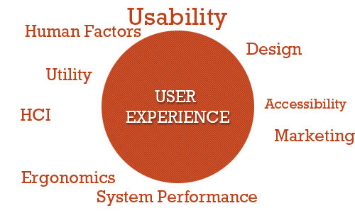

How to rebuild the persona of user:

http://boxesandarrows.com/building-a-data-backed-persona/

Data from customer service call centers, user surveys and interviews

Build persona for new user and returning user

Build persona to help product iteration, the user is always changing: new user comes, old user leaves, old user character always changes( from poor to rich, single to parent)

The amount of time for which a person views an object depends on a variety of factors

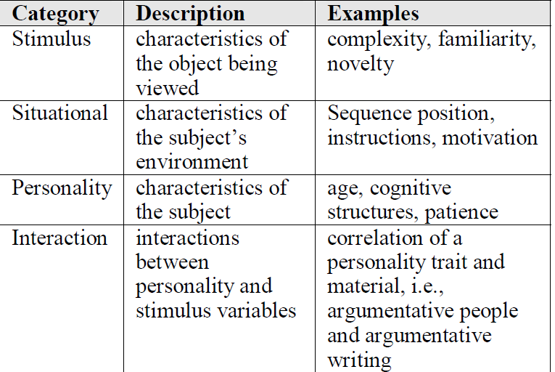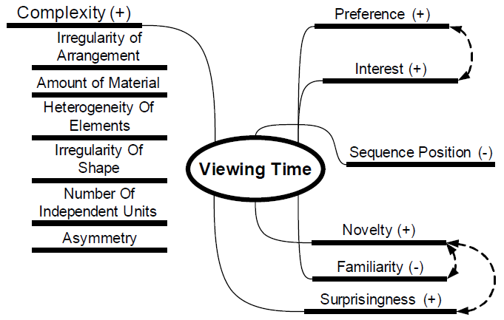

由于每个个体是不同的,所以在处理数据较少的个个体时,应该使用统计学的方法(比如加权平均值)来平衡的取得这个个体的viewing time分布情况,但这个统计学的方法应该是基于这个个体所属群体的.

建模,将所有购买过的单,与关闭的单放在一起,利用一些统计学方法把他们归类

然后把新生成,但没有结算的订单放入这个模型,计算这个点周围成交订单与未成交订单的数量,以此预测此订单是否会成交.

如果会成交/不成交,则可以给出适当的折扣,优惠已吸引用户,此优惠应当是当日或更短时间内有效.

放入模型前,订单应该考虑:

成交价格

给出的优惠

生成订单到付款的时间

这些因素会影响订单的位置,需要用这些因素,并对此订单做加权

未成交的订单包括:

用户关闭的(要考虑下错单的情况,然后加权)

超时自动关闭的订单