嘉定区2016-2017学年第二学期教学质量监测
高三年级英语学科试卷
2017.4
考生注意：
1.考试时间120分钟，试卷满分140分。
2.本次考试设试卷和答题纸两部分。所有答题必须涂（选择题）或写（非选择题）在答题纸上，做在试卷上一律不得分。
3.答题前，务必在答题纸上填写准考证号和姓名，并将核对后的条形码贴在指定位置上，在答题纸反面清楚地填写姓名。
Listening Comprehension
Section A
Directions: In Section A, you will hear ten short conversations between two speakers. At the end of each conversation, a question will be asked about what was said. The conversations and the questions will be spoken only once. After you hear a conversation and the question about it, read the four possible answers on your paper, and decide which one is the best answer to the question you have heard.
- A. Getting part-time jobs.
B. Planning winter holiday.
C. Making some money.
D. Visiting their parents.
2. A. Landlord and renter. B. Tradesman and customer.
C. Receptionist and guest. D. Husband and wife.
3. A. 11:10 B. 11:00 C. 11:20 D. 11:30
4. A. A dress-up party. B. The tailor’s
C. The theater. D. A shopping mall.
5. A. The performance. B. The seats.
C. The price. D. The lights.
6. A. She thanked the man for buying it.
B. Her boyfriend gave it to her as a gift.
C. She bought the skirt on her birthday.
D. It was a wedding gift from her friends.
7. A. They are quite different in painting skills.
B. Neither of them is good at house-painting.
C. They are equally good at house-painting.
D. Both of them will be asked to paint the house.
8. A. He needs some change.
B. He seldom counts his money.
C. He doesn’t have that much cash.
D. He owes the woman twenty dollars.
9. A. He prefers to eat out.
B. He wants to order the food.
C. He doesn’t like Japanese food.
D. He hopes to pay for the meal.
10. A. He doesn’t want Jenny to get into trouble.
B. He doesn’t agree with the woman’s remark.
C. He thinks Jenny’s workload too heavy at college.
D. He believes many college students are running wild.

Section B
Directions: In Section B, you will hear two short passages and one longer conversation, and you will be asked several questions on each of the passages and the longer conversation. The passages and the longer conversation will be read twice, but the questions will be spoken only once. When you hear a question, read the four possible answers on your paper and decide which one would be the best answer to the question you have heard.
[来源:学科网]hai
Questions 11 through 13 are based on the following passage.
11. A. Genders and personalities.
B. Genders and ages.
C. Ages and schools.
D. Ages and grades.
12. A. Educational reforms will be announced.
B. The investigation results will be released.
C. Shanghai students will do less homework.
D. Shanghai students will face new challenges.
13. A. Shanghai reports a new way to give students assignments.
B. Shanghai seeks to reduce homework burden on students.
C. Shanghai releases measures to help students less-stressful.
D. Shanghai shares its successful experience in education.

Questions 14 through16 are based on the following speech.
14. A. He was new to the class.
B. He was tired of literature.
C. He had an attention disorder.
D. He wanted to take the task home.
15. A. He had good sight. B. He made a great invention.
C. He gave up reading. D. He learned a lot form school.
16. A. Angry. B. Impatient. C. Sympathetic. D. Encouraging.

Questions 17 through 20 are based on the following conversation.
17. A. Functions of drinks in the lunch special.
B. Preference of drink temperature.
C. Links between temperature and drinks.
D. Benefits of different free drinks.
18. A. Unhealthy. B. Strange. C. Generally good. D. Beneficial.
19. A. Because they make blood move quickly.
B. Because they are good for the sick.
C. Because they can help to lose weight.
D. Because they make her feel calm.
20. A. Hot drinks can help people to cool themselves.
B. Hot drinks aid in digestion and narrow blood vessels.
C. Hot drinks can help to fight a cold and ease pain.
D. Hot drinks make body warmer and exercise easily.

II. Grammar and Vocabulary
Section A
Directions: After reading the passage below, fill in the blanks to make the passage coherent and grammatically correct. For the blanks with a given word, fill in each blank with the proper form of the given word; for the other blanks, use one word that best fits each blank.

Whether in the workplace or the football field , effective teamwork can produce amazing results , However , _____21_______(work) successfully as a team is not as easy as it may seem. Effective teamwork certainly does not just happen automatically , it takes a great deal of hard work and compromise . There are a number of factors ____22___must be in place to make a good team.
Effective leadership is one of the most important factors of good teamwork . The team’s leader should possess the skills ____23____(create) a positive working environment and motivate and inspire the team members to talk a positive approach to work and be committed. An effective team leader will promote a high level of spirit and make them feel ____24_____（value）
Communication is a vital factor of all interpersonal relationship and especially that of a team . Team members must be able to express their feelings , share ideas and see each other’s opinions.
Conflicts will arise ____25____well a team functions together . The best way to deal with conflicts is to have some organized methods of handling conflicts. Team members should be able to voice their concerns ____26_____fear of offending others. Instead of avoiding conflict issues , a practical approach that ____27____(settle) them quickly is much better . It is often advised that the team leader sit with the conflicting parties and help work out their differences without taking sides and try to remain objective if possible .
The team leader ___28____set a good example to create good teamwork . In order to keep team members positive and motivated , the team leader ____29_____needs to show these qualities . The team turns to the leader for support and guidance . So any negative words or behaviors on the leader’s part can be disastrous.
Regardless of ___30_____type of work you are in , knowing how to effectively work on and with a team is going to be extremely important to your success and that of your team.

Section B
Directions: Fill in each blank with a proper word chosen from the box. Each word can be used only once. Note that there is one word more than you need.
A. approach B. shape C. previously D. evident E. secret F. date
G. hardly H. remains I. irrelevant J. potential K. particularly

Swedish Archaeologists Make New Discoveries
Archaeologists have begun exploring an unknown ancient city at a village called Vlochos , five hours north of Athens . The Archaeological ____31______are scattered on and around the Strongiloveni hill on the great Thessaliam plains and can be traced to several historical periods.
“What used to be considered remains of some _____32____settlement can now be upgraded to remains of a city higher significance than _____33______thought,” says Robin Ronnland , PhD student in Classical Archaeology and Ancient History at the university of Gotheoburg and leader of the firework.
“We came across the site which has never been explored before in connection with another project last year and retailed the great __34_____right away .”
Working together with the Swedish Institute at Athens and the local archaeological service in Karditsa , the Vlochos Archacological Project (VLAP) was started with an aim to explore the remains . The project’s research team completed the first field season during two weeks in September 2016.
Ronnlund says that the hill is hiding many ____35_____. Remains of towers , walls and city gates can be found on the mountaintop and slopes , but __36_____anything is visible on the ground below . The ambition is to avoid digging and instead use ____37____such as ground—penetrating radar. This will enable the team to leave the site in the same ____38____as it was in when they arrived. The success of this method is _____39____from the results of the first field season.
“ We found a town square and a street network that indicate that we are dealing with quite a large city . The area inside the city wall measured over 40 hectares . We also found ancient pottery and coins that can help to ___40____the city . Our oldest finds are from around 500 BC, but the city seems to have flourished mainly from the fourth to the third century BC before it was abandoned for some reason , maybe in connection with the Roman conquest of the area.
Ronnlund believes that the Swedish-Greek project can provide important clues as to what happened during this violent period in Greek history.

III. Reading Comprehension
Section A
Directions: For each blank in the following passage there are four words or phrases marked A, B, C and D. Fill in each blank with the word or phrase that best fits the context.

Why College is Not Home
The college years are supposed to be a time for important growth in autonomy (自主性) and the development of adult identity . However , now they are becoming an ___41____period of adolescence , during which many of today’s students are not shouldered with adult _____42____.
In the past two decades , continued connections with and ___43____on family , thanks to cell phones , email and social media , have increased significantly . Some parents go so far as to help with coursework . Instead of promoting the idea of college as a passage from the shelter of the family to autonomy ,universities have ____44_____to the idea that they should provide the same environment as that of the home.
To prepare for increased autonomy and responsibility , college need to be a time of ___45____and experimentation . This process involves “trying on” new ways of thinking about oneself both intellectually and personally ._____46_____we should provide “safe spaces” within colleges , we must also make it safe to express opinions and challenge majority views.____47_____ growth and flexibility are fostered by strict debate and questioning .
Learning to deal with the ___48____world is equally important . Because a college community （群体） differs from the family , many students will struggle to find a sense of ____49___. If students rely on administrations to ___50_____their social behavior and thinking pattern ,they are not facing the challenge of finding an identity ,within a larger and complex community .
______51___,the tendency for universities to monitor and __52_____student behavior runs up against another characteristic of young adults: the response to being controlled by their elders . If acceptable social behavior is too strictly defined (规定)， the insensitive or aggressive behavior that administrators are seeking to minimize many actually be _____53___. It is not surprising that young people are likely to burst out , particularly when there are reasons to do so .
Our generation once joined hands and stood from at times of national emergence . What is lacking today is the _____54____between desire for autonomy and their understanding of an unsafe world. Therefore , there is the desire for their home to be replacement homes and not places to experience growth .But Every college discussion about community values ,social climates and behavior should include ___55__of the development importance of students autonomy and self-regulation.

41. A. expanded B. educational C. expected D. extended
42. A. responsibilities B. abilities C. knowledge D. experience
43. A. concentration B. dependence C. influence D. decision
44. A. give up B. give away C. give in D. give out
45. A. instruction B. exploration C. reflection D. preparation
46. A. When B. While C. Since D. If
47. A. Intellectual B. Spiritual C. Logical D. Psychological
48. A. adult B. virtual C. real D. social
49. A. satisfaction B. duty C. belonging D. curiosity
50. A. understand B. train C. protect D. regulate
51. A. Therefore B. Moreover C. Thus D. However
52. A. change B. criticize C. shape D. motivate
53. A. encouraged B. challenged C. agreed D. realized
54. A. difference B. tension C. balance D. conflict
55. A. observation B. recognition C. determination D. judgment

Section B
Directions:
Read the following three passages. Each passage is followed by several questions or unfinished statements. For each of them there are four choices marked A. B, C and D. Choose the one that fits best according to the information given in the passage you have just read.
(A)

The Right Thing
“ Hi , Mrs , Grady ,” said Mark when their neighbor opened her door. “ Would you like us to shovel your sidewalk and driveway ?” Shoveling was Jamie’s idea , a way to earn enough money for the new Ocean Kingdom video game that came out the next day .
Mrs .Grady was happy , “ That would be wonderful , boys . I think the job is getting to be too much for me .
“It will cost 10 dollars ,” Jamie said .” If that’s OK “, Mark added .
‘ Oh dear , “ Mrs. Grady said disappointedly , “ I haven’t been able to get to the bank . I can offer homemade cookies ,but I realize that’s not what you had in mind .”
Mark was going to say that Mrs . Grady could pay them another time , but Jamie cut him off .“ We’ll come back later .”
Mrs. Grady doesn’t look like the person who’d come to his rescue last summer when Mr. Dunn’s collie , Goldie had just wanted to play , but Mark didn’t feel comfortable around big dogs . He wanted to call for help , but his tongue seemed locked behind his teeth. Then Mrs . Grady ‘s front door had flown open . She must have seen him from across the street. ‘ Hold on , Mark . I’m coming !” “ Goldie” she’d called . As soon as Goldie had turned her head , Mrs . Grady had slipped between Mark and the dog . She wasn’t much taller than Mark , but she’d stood firm as a rock in front of him. ‘ Goldie , go home!” Then she’d swept her broom to hurry the dog along .” Get!” Goldie had obeyed.
When Mark showed thanks to Mrs.Grady , Mrs. Grady laughed .” It was nothing . Good neighbors watch out for each other , don’t they ? “
And now Mrs. Grady needed Mark as much as he’d needed her last summer. He smiled and waved at Mrs. Grady , then his shovel deep into the snow.
“ Hey!” Jamie shouted . “What are you doing ?” Mark couldn’t explain about Goldie and watching out for neighbors .” I like Mrs. Grady’s cookies ,” he said .

56. Why did Jamie and Mark plan to clear the snow for Mrs .Grany at first?
A. To help the lady B. To earn pocket money
C. To do volunteer work D. To visit New Kingdom
57. Mrs . Grady couldn’t pay them most probably because ________.
A. she didn’t have enough cash B. she couldn’t find the bank
C. she thought it was worthless D. she couldn’t afford it
58. According to the story, which of the following word can not be used to describe Mrs.Grady ?
A. Positive B. Helpful C. Brave D. Hopeful
59. Which of the following proverb can best summarize the story ?
A. A penny saved is a penny earned B. Kindness is repaid with kindness
C. A clear conscience D. Actions speak louder than work

B
This is What a Real Sliver Dollar Looks Like
If you trust in the yen , the euro , and the dollar --------stop reading
Because this is a story about the sliver coin , EVERYDODY wants .
You read the headlines. You know that troubled economic times have put global currency on a rollercoaster(过山车) ride. But millions have found a smarter way to build longterm value with highgrade collectable silver. And right now, those people are lining up to secure some of the last 2012 U．S.Mint Silver Eagles, America's Newest Silver Eagle Dollars. Today, you can graduate to the front of that line. Buy now and you can own these brilliant uncirculated Silver Dollars for only $38.95!
You Can't Afford to Lose
Why are we releasing(发行) this silver dollar for such a remarkable price? Because we want to introduce you to what hundreds of thousands of smart collectors and satisfied customers have known since 1984—New York Mint is the place to find the world's finest highgrade coins. That's why we're offering you this Brilliant Uncirculated 2012 U．S.Silver Eagle for as little as $37.45(plus s/h)．
Timing is Everything
Our advice? Keep this to yourself. Because the more people who know about this offer, the worse it is for you. Demand for Silver Eagles in 2011 broke records. Experts predict that 2012 Silver Eagles may break them all over again. Due to rapid changes in the price of silver, prices may be higher or lower and are subject to(受……影响) change without notice. Supplies are limited. Call immediately to add these Silver Eagles to your holdings before it's too late.
Offer Limited to 40 per household
2012 American Silver Eagle Coin
Your cost 14 Coins $38.95 each＋s/h
59 Coins $38.45 each＋s/h
1019 Coins $37.95 each＋s/h
2040 Coins $37.45 each＋s/h
Note：$10 s/h(shipping and handling) for each purchase
For fastest service, call tollfree 24 hours a day
18882017143
Offer Code(代码) ASE17704
Please mention this code when you call.
New York Mint
14101 Southcross Drive W．， Dept.ASE17704
Burnsville, Minnesota 55337
www.NewYorkMint.com

60. Suppose you want to purchase seven 2017 U.S . Mint Sliver Engles by post , you should pay at least _________.
A. $ 273.55 B. $263.55 C. $275.65 D. $266.55
61. The 2017 Sliver Eagle is worth purchasing mainly because _________
A. the price of the coin is favorable B. the coin is of lasting high quality
C. the coin is popular among collectors D. it can be circulated as a currency
62. If you are not willing to pay for the service , you can purchase the silver coin by _________.
A. shopping on www.New York Mint .com
B. dialing the number 1-888-201-7143
C. writing to the enterprise
D. lining up in front of the stores in person

C
"Today, technical innovations dominate our everyday life in many areas. New technologies, however, always are associated with risks -- and these are also seen by laymen," says Christoph Böhmert, first author of the recently published study and researcher of the Science Communication Group of KIT's Institute for German Studies. "It is crucial to enable adequate communication between science and society, which does not only consider scientific findings, but also concerns of the population." The study clearly showed that communication of risks may be complicated sometimes. Information on efficient precautions was found to lead to an increased risk perception by the recipients of the information.
In their study, the researchers analyzed communication about a technology that has become indispensable in our life -- mobile communications and the electromagnetic fields （电磁场）on which it is based. All over the world, radiation protection authorities, such as the German Federal Office for Radiation Protection, communicate the current state of research into risks of electromagnetic fields as follows: Investigations made and all findings obtained so far do not allow any conclusions to be drawn with respect to mobile communications being a risk for human health. But, the experts continue, there still are knowledge gaps as regards long-term impacts. Then, measures are recommended to reduce exposure of the individual to electromagnetic fields.
It had been known from previous studies already that information on precautions may increase worries. It had been suspected that people conclude from the recommendation of precautions that there really is a risk. This effect was not confirmed by the recent study. The scientists rather attributed the increased worries to a lack of knowledge about the propagation(传播) of electromagnetic fields.
Within the framework of the study, the recommended precautions were submitted to 1717 Australians, together with one of six information brochures providing scientific background information. When test persons were given not only the recommendations, but also explained why observation of these tips strongly reduces their exposure to electromagnetic fields, worries increased. For example, scientists explained to the test persons that telephone conversations with a headset largely reduce exposure. When a mobile phone is located ten centimeters instead of just one centimeter away from the ear, the electric power absorbed by the ear is about one hundredth of the initial value. Hence, the own mobile phone usually causes an exposure that by far exceeds that of mobile communications stations that are generally referred to as "cellphone towers." While the scientists wanted to explain the effectiveness of precautions, test persons mainly considered this information to be an indication of their mobile phone -- not the transmission towers -- being dangerous. As a result, they perceived increased risk potentials for telephone conversations with their mobile phones.
"The study reveals that messages on precautions and information are a double-edged sword in terms of subjective risk perception. Their use should be far better understood," Boehmert says.
63. Which of the following statements is TRUE according to the passage ?
A. Adequate information on efficient precautions can relieve the concerns of the public
B. Mobile communications definitely do harm to people’s health in the long run.
C. Information about technologies and their risks may have undesired side effects.
D. Observation of the precautions can help reduce the concerns of the public
66. According to the passage ,we can conclude that the best way to relieve the inappriate worries is to __________.
A. enable the users to know better of science and technology .
B. produce new electric products with a lower radiation value
C. provide the public with less information on effective precaution
D. inform the public about the potential risks with more patience
65. The word “ precaution” ( first appears in paragraph 1) in bold letters has the closets meaning to _______-
A. introduction B. intention C. recommendation D. prevetion
66. Which of the following might be the best title of the passage ?
A. Science and Technology : A Double –edged Sword
B. Technical Innovation : Worries and Information
C. Science and Technology: Security Tips for Users
D. Technical Innovations : Effectiveness of Precautions .
Section C
Directions: Read the following passage. Fill in each blank with a proper sentence given in the box. Each sentence can be used only once. Note that there are two more sentences than you need.

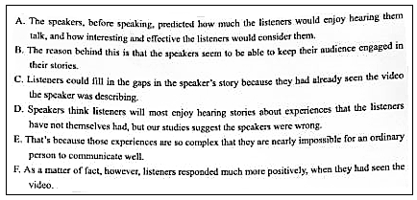
To Please Your Friends, Tell Them What They Already Knew
The research emeraged out of some real-life observations shared by Gilbert and co-authors Gus Cooney and Timothy D. Wilson：“Conversation is the most common of all human social activities, and doing it well requires that we know what our conversation partners most want to hear.___67___”says psychological scientist Daniel T, Gilbert of Harvard University.
“When our friends try to tell us about movies we’ve never seen or albums we’ve never heard, we usually find ourselves bored, confused, and underwhelmed. ___68___. And yet, as soon as it’s our turn to speak, we do exactlly the same thing to our friends – with exactly the same consequences. We wanted to understand why this happens.”Gilbert explains. The researchers decided to do this by conducting a series of experiments.
In their first experiment, the researchers assigned participants to groups of three, with one person acting as the speaker and the other two acting as listeners. Speakers watched a video and then tried do describe it to the listeners. Some of the listeners had seen the video the speakere was describing, and others had not.
___69___. When the speakers were done speaking, the listeners rated them on these aspects. The results showed that speakers’ predictions were exactly backwards. Speakers expected listeners to respond more positively to their stories when the listeners had not seen the video they were describing ___70___. Although speakers expected listeners to enjoy hearing about a novel experience more than a familiar one, it was actually the other way around.
A second study showed that when asked to predict their own reactions before hearing the story, listeners made the same mistake that speakers did.

Ⅳ. Summary Writing
Directions：Read the following passage. Summarize the main idea and the main point(s) of the passage in no more than 60 words. Use your own words as far as possible.

Moving My Curfew

For some time now , I have had an 8:00 p.m. curfew ---the time by which I have to be at home , even on weekends. When I was younger , I didn’t really complain . But now I have reached an age when this curfew is no longer suitable . For several reasons , it is clearly time to move my curfew to 10:00 p.m. on weekends.
First of all , I ’m soon going to be an adult , like all teenagers , I need practice handling the greater freedom that goes along with being an adult . When teenagers don’t get practice handling freedom , they often make many serious mistakes. For example , some teenagers go away to college and suddenly they don’t know how to handle it , and they get into trouble . I believe it is better to increase freedom gradually . That may the teenager learners how to handle freedom responsibly . I believe I could handle a later curfew without making serious mistakes in judgment.
A later curfew is also important to me because I’m an active student . As you know , I am often on the committee in charge of running extra-curricular activities .Because of my present curfew , I have to finish school activities over an hour before they are over. Others students must take over for me when I leave . A 10:00 curfew would allow me to stay until the end of school functions and give me enough time to get home without rushing .
Finally , I am a teenager who can be trusted to handle a 10:00 p.m curfew . I know that many teenagers cannot handle much responsibility . However , I am clearly not that kind of teenager. I have proven myself to be a very responsible person . For example , I have never been in serious trouble , either at school or in the company . I also hold a part-time job and still manage to maintain a “B” average in school . In other words , I am a person who uses my time wisely , meets responsibilities an stays out of trouble .
V. Translation
Directions: Translate the following sentences into English, using the words given in the brackets.

72. 现如今人们越来越关注自己的生活品质。（concerned）

73. 春游的小学生们没能抵制住商贩们的花言巧语。（resist）

74. 只有通过参与志愿者活动才能有效地增强中学生服务大众的责任感。（Only ）

75. 家用轿车普及带来的便利不容否认，但随之产生的能源浪费、空气污染和交通拥堵等问题发人深思。（While）

VI. Guided Writing
Directions: Write an English composition in 120-150 words according to the instructions given below in Chinese.
假如你是某英语报读者信箱栏目的编辑Alex. 请你根据Tom 来信反映的问题写一封信。
Dear Alex,
I got a mean message online from someone at school . They say I ’m stupid and ugly . I feel sad and worried . I don’t know what to do . Please help me .
From Tom

你的回信须包含以下要点：
①安慰Tom
② 提出解决问题的办法

嘉定区2016-2017学年第二学期教学质量监测
高三年级英语学科试卷答案

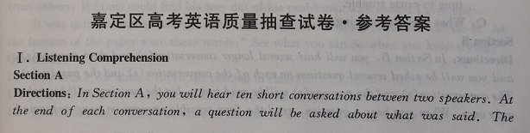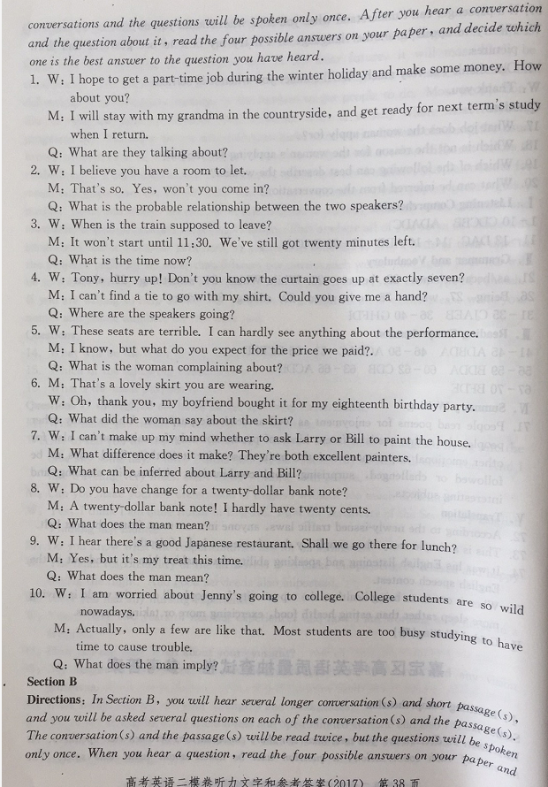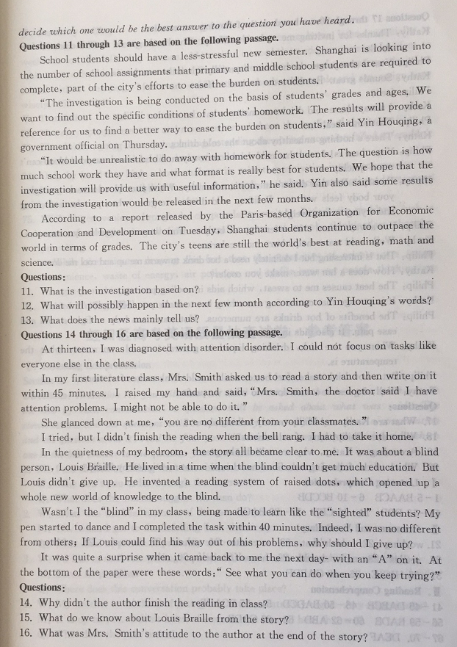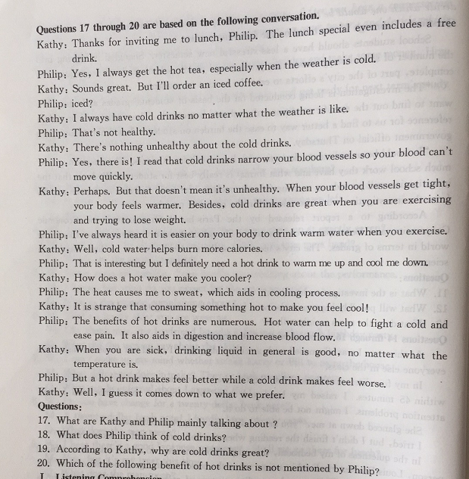

参考答案：

1-10 BAACB BCCDB
11-20 DBB CBD BACB

21working 22. which/that 23. to create 24. valued 25. however 26. without 27. settles 28. must /should 29. himself/ herself 30. what

31-40 HICJE GABDF
41-45 DABCB 46-50 BADCD 51-55 BCADB
56-59 BADB
60-62 ABD
63-66 CABD
67-70 DEAF

Summary writing
Though still a teenager, the writer demands to come home later, especially at weekends for the following reasons. More time is needed greater freedom to achieve smooth transition to an adult. Besides, the writer can perform various duties at school without hurrying. Moreover, unlike others, he is responsible and can assign time wisely. (55 words)

Translation :
72. Nowadays people are more and more concerned about the quality of their own life.
73. The children going for a spring outing / attending the spring excursion failed to / couldn’t resist the sweet words of the dealers/ vendors.
74. Only by involving high school students in volunteer activities in the community can their sense of responsibility to serve the people be enhanced / strengthened / improved effectively
75. While the convenience brought by car popularity can’t be denied, the problems such as waste of energy , air pollution and traffic jams ,set people thinking/ are thought-provoking.
While there is no denying that the fact the popularity of private cars brings convenience, waste of energy, air pollution and traffic jams set people thinking / are thought-provoking.

