宝山区
II. Grammar and Vocabulary
Section A
Directions: Read the following two passages. Fill in the blanks to make the passage coherent. For the blanks with a given word, fill in each blank with the proper form of the given word. For the other blanks, fill in each blank with one proper word. Make sure that your answers are grammatically correct.
Surviving Art Tradition
Native American Indians expressed themselves through their artwork, which is carved onto totem（图腾）poles. Many people hold the belief (21) ___that_______all Native American Indian tribes （部落）carve的totem poles, but this is far from the truth . Carving totem poles was a tradition among many tribes , especially those that lived along the Pacific coast (22)___which___where__/on which____forest grew. However , those Native American Indians who lived in the south west and the plains , and Indians , but (23)______fewer___(few) trees to carve than Pacific tribes.
The height of totem poles can vary considerably . Long ago totem poles (24) ___were founded___ (find) to stand around 12m tall . Today , Native American Indian artists continue to care trees, but some totem poles are short and are used in homes as decoration .(25) _It_______is not surprising that a genuine pole will cost more than $1500 per meter because traditionally carved totem involve a great deal of work , craftsmanship and time to produce.
The raising of a totem pole is an important celebration among the India tribe . A hole is dug for the pole to stand in . The pole is carried to the site in a ceremony which other hundreds of people attend. Ropes are used (26)_____to raise_____(raise) the pole into place. Singing and dancing to drums accompanies the pole raising . Often poles are raised in this way (27) _that__before_ the carving begins . Carvers do their jobs then on the site.
Many people believe that totem poles are religious symbols , but this idea is false. Instead of (28) ______acting____(act) as religious symbols , carvings represent the tribal nation and convey the tribes’ history . The story of a totem pole is frequently passed down from generation to generation . Having the story documented this way helps keep this tradition (29) _recognized___ (recognize) in our history . These days , many totem poles no longer exist (30) _______in_becaue of_________ decay and rot. However , there are still some tribes that continue to practice this ancient are form , and these totem poles are still being enjoyed by collections of tribal art.
Section B
Directions: Read the following three passages. Each passage is followed by several questions or unfinished statements. For each of them there are four choices marked A, B, C and D. Choose the one that fits best according to the information given in the passage you have just read.

(A)

When Frank and I stepped through the post office doors, there was a crowd gathered, gawking at the new fixture on the wall like a chorus of wide-mouthed frogs. I had to get closer, and that was where being a girl that's scrawnier than a wire fence came in handy. Fortunately, Frank, my twin of eleven years, was just the same.
"Come on." I said, grabbing his hand, and we slid through the cracks between people until we spilled out in front.
Finally I got a good look. It was fixed to the plaster next to the postmaster's window, the place of honor usually reserved for the Wanted posters. Beady-eyed Zedekiah Smith, the bank robber, still hung there, but even he had been pushed aside for something more important.
A telephone. The first one in town.
"How's it work?" Noah Crawford called out. Noah's the best fix-it man around, and I could tell he was itching to get his fingers on those shiny knobs.
"Don't rightly know," answered the postmaster, and he tugged at his goatee as if it might tell him. "I do know the sound of your voice moves along wires strung on poles. It's sort of like the telegraph, only you hear words instead of dots and dashes."
"Ah," the crowd murmured, and I felt my own mouth move along.
I gazed at that gleaming wood box and something happened inside me. Something — I can only guess — that might be like falling in love. The thought of talking into that box — of making my voice sail through wires in the sky — it took over my brain. I couldn't get it out.
"Frank," I whispered to my twin. "I have to use that telephone."
Five minutes later, Frank towed me up Main Street, toward home. "Liza — " he began, but I cut him off. We two thought so much alike, I had Frank's questions answered before he even asked.

C56. People crowded in the post office because ___________.
A. they were attracted by a new poster B. the postmaster was delivering a speech
C. they were curious about the telephone D. there was a wanted bank robber captured
D57. Which of the following is Not True according to the passage?
A. Many people stared at the new device in open-mouthed amazement.
B. The slight-figured twins managed to push to the front of the crowd.
C. Even the best fix-it man in the town got no idea about the new device.
D. The postmaster didn’t know anything about how the telephone worked.
A58. By“It took over my brain. I couldn’t get it out.”, we get a clear picture of the girl’s ______.
A. eagerness to use the telephone B. fascination for the wood box
C. puzzlement over the strange sound D. determination to fly in the sky
C59. What is the passage mainly about?
A. The twins’ frustrating experiences in the town.
B. A special assembly called in the local post office.
C. People’s reaction to the arrival of the first telephone.
D. A great celebration of the start of telephone service.

（B）
Welcome to the LUSH Life!
Out values are at the core of everything we do. From morally sourcing each ingredient and piece of packing to creating fresh, innovative cosmetics by hand, you’ll find a world of love and care in every product. Breathe deeply and soak up everything inside this box：we’ve made it just for you!
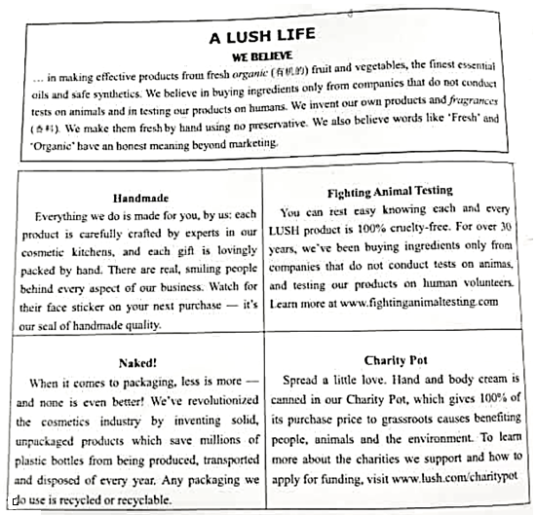
B60. From the leaflet, we can get to know all the following facts about LUSH except _____.
A. providing financial support to society
B. taking the lead in cosmetics marketing
C. testing on humans instead of on animals
D. crafting and packing their products by hand
A61. In the section Naked!, LUSH claims that they _______.
A. advocate recyclable or even no packaging
B. sell cosmetics without any wrapping paper
C. have invented some recyclable cosmetics
D. have improved ways of transporting products
D62. What is LUSH’s business philosophy we can find from the leaflet?
A. The market image of a company should make way for its beliefs.
B. Cosmetics are among the essentials of our lives in modern society.
C. Homegrown vegetables and fruit are natural and reliable sources of cosmetics.
D. Social responsibilities of a company can go hand in hand with profit making.

（C）
Since quitting can start feelings such as guilt and shame, we often do everything possible to avoid it. “We’re taught from our earlist days that if you quit something. It means you’re a failure,” says counseling psychologist Will Meek. He, however, suggests we view quitting differently.
Quitting is like deciding to rearrange a room: you’ve grown comfortable with the status, and it can be hard to picture the end result or even see why change is necessary. And yet, there’s the upsetting feeling that you’re no longer entirely satisfied with your current circumstances, perhaps even that you’ve stopped making progress. While it’s not out of the question for feeling or regret to surface after a major refit, leaving a position, project or situation can reveal exciting possibilities, making you feel inspired and renewed.
Quitting, often happens in situations where we’re unhappy, fearful or have determined we have no other choice, factors that can have opposing effects on our health. Perhaps you find your work unfulfilling, or you’ve jumped into a new relationship before you’re ready —and, as a result, you’re operating under intense pressure.“If stress is enduring and not managed well, it can start to take a toll.” says Meek. According to the American Psychological Association, long-term, ongoing stress can increase the risk for high blood pressure and heart attack, so walking away from whatever is causing it can deliver significant physical and emotional health benefits.“We often see a reduction in the stress hormone cortisol（应激激素皮质醇）, which can lower blood pressure and may even decrease the heart rate,”says Dr Alex Lickerman, a GP and expert on developing mental adaptability.
Leaving situations that fail to bring you joy can leave you with sufficient time to explore where your heart is truly leading you. In a study that was published in 1999, then Harvard University professor Hermina Ibarra looked at how bankers tried different roles that required new skill sets—someone who spent a lot of time dealing with computers, for instance, was asked to take on personal interactions. Subjects were especially drawn to acting out a version of their future solves through ‘imitation strategies’—an approach they compared to ‘trying on different clothes,’ Mark Franklin, the president of CareerCyles, suggests a similar approach as a way to figure out what your true desires might be in your post-quitting life and foresee your future self.“Pretend to be a certain kind of person, or go and meet others who are doing what you want to do.” he says,“ Try it on, see how it feels and decide if it’s a good fit for you.”It may not feel like it at the time, but just moving on from a situation that’s not quite right can help you get back on track.

C63. It can be inferred from paragraph 2 that quitting may bring us feelings of being both ____.
A. guilty and ashamed B. stupid and enthusiastic
C. troubled and hopeful D. inspired and determined
D64. The phrase “take a toll”（paragraph 3）can be best replaced by“_____”.
A. develop mental adaptability B. bring about changes
C. keep up the pressure D. have a bad effect
A65. An approach suggested by Mark Franklin similar to ‘trying on different clothes’ is for _______.
A. helping people find what truly suits them in career
B. telling capable employees from inadequate ones
C. training employees to acquire different working skills
D. providing people with opportunities to have a role play
D66. It can be concluded from the passage that ______.
A. quitting is track that only the timid will choose to follow
B. personal interaction can be must for reducing emotional pressure
C. mental adaptability can be improved by the stress hormone cortisol
D. knowing when to stop is wise and may make dreams happen
Section C
Directions: Complete the following passage by using the sentences given below. Each sentence can be used only once. Note that there are two more sentences than you need.

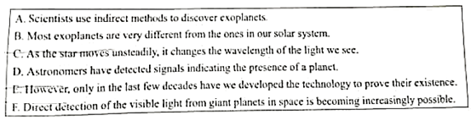
Exoplanets：The Hunt Is On
Today scientists believe that planets could outnumber the stars. For centuries, scientists and natural philosophers have proposed that stars in the night sky have planetary systems similar to our own solar system. The existence of extrasolar planets, or exoplanets, has long been discussed. ___67E___ Although not the first exoplanet discovery, a planet near a sun-like star was discovered by astronomers in 1995. This kicked off an era of exoplanet hunting, with thousands of discoveries and confirmations following in its wake.
__B_68___ However, in 2015 NASA’s Kepler space telescope found its first Earth-sized planet in a “habitable”zone. This is the distance form a star where surface temperatures of a planet wouldn’t be too hot or too cold for liquid water. So far, only a small slice of our galaxy, the Milky Way, has been explored. Even so, scientists have confirmed over 3,500 exoplanets, with more being added every day.
To detect exoplanets, scientists use data from a variety of sources. Large ground-based telescopes, earth-circling and sun-circling satellites all collect different types of information. Because exoplanets are so far away and very close to stars, it is very difficult to see them directly. _A__69___ For example, when an exoplanet moves between its star and us, it causes a small drop in the star’s brightness. Measuring this drop is the transit（凌日）method of discovery. NASA’S Kepler space telescope has discovered many exoplanets this way.
As a planet circles a star, it pulls on it and causes it to shake. _C__70___ Measuring these slight changes is the radial velocity（径向速度）method of discovering planets. It is one of the most productive methods for finding and confirming exoplanets.
These are just two examples of the many methods scientists use in their hunt for exoplanets, hoping for more information and enhanced detail. As time progresses and technology improves, who knows what else we may find!

