虹口区2016-2017学年第二学期教学质量监测
高三年级英语学科试卷
2017.4
考生注意：
1.考试时间120分钟，试卷满分140分。
2.本次考试设试卷和答题纸两部分。所有答题必须涂（选择题）或写（非选择题）在答题纸上，做在试卷上一律不得分。
3.答题前，务必在答题纸上填写准考证号和姓名，并将核对后的条形码贴在指定位置上，在答题纸反面清楚地填写姓名。
第 I 卷 (共100分)
I. Listening Comprehension
Section A
Directions: In Section A, you will hear ten short conversations between two speakers. At the end of each conversation, a question will be asked about what was said. The conversations and the questions will be spoken only once. After you hear a conversation and the question about it, read the four possible answers on your paper, and decide which one is the best answer to the question you have heard.

1. | A. Go to the office | B. Keep calling | C. Try online booking | D. See a doctor
2. | A. A reporter | B. An athlete | C. A fisherman | D. An organizer
3. | A. At a post office |  | B. At a fast-food restaurant
 | C. At a booking office |  | D. At a check-in desk
4. | A. He already has plans. |  | B. The woman should decide where to eat.
 | C. He will make a reservation. |  | D. The woman can ask her brother for advice.
5. | A. He got wet in the rain. |  | B. The shower was out of order.
 | C. He didn’t hear the phone ringing. |  | D. He got out of the shower to answer the phone.
6. | A. Reasonable | B. Bright | C. Serious | D. Ridiculous
7. | A. Send leaflets | B. Go sightseeing | C. Do some gardening | D. Visit a lawyer
8. | A. Her doorbell doesn’t need repair. |  | B. She didn’t expect him to come so early
 | C. The man has just arrived on time. |  | D. It is not the right time for her.
9. | A. She won’t go to the beach if it rains. |  | B. She would like the man to go to the beach.
 | C. It will clear up tomorrow. |  | D. It was pouring when she was at the beach.
10. | A. What to take up as a hobby. |  | B. How to keep fit.
 | C. How to handle pressure. |  | D. What to play with.
Section B
Directions: In Section B, you will hear two short passages and one longer conversation, and you will be asked several questions on each of the passages and the conversation. The passages and the conversation will be read twice, but the questions will be spoken only once. When you hear a question, read the four possible answers on your paper and decide which one would be the best answer to the question you have heard.
Questions 11 through 13 are based on the following passage.

11. | A. Greet guests and talk to hotel staff.
 | B. Have breakfast and examine room service.
 | C. Prepare for the meeting and write new reports.
 | D. Review the previous night’s reports and check emails.
12. | A. Saying hello to every guest. | B. Considering different bath requirements.
 | C. Dining with a different staff member. | D. Holding various operational meetings.
13. | A. A day’s life of a hotel manager. | B. The daily routine at a hotel.
 | C. Hotel service and improvement. | D. Meetings attended by a hotel manager.

Questions 14 through 16 are based on the following passage.

14. | A. Educating children. | B. Saving rare animals.
 | C. Recreating an environment. | D. Making a profit.
15. | A. Because animals make visitors stressful. | B. Because animals must live their lives in cages.
 | C. Because animals can feel bored and sad. | D. Because animals are in danger of extinction.
16. | A. They are still useful and necessary.
 | B. They have more disadvantages than advantages.
 | C. They are a perfect environment for animals.
 | D. They are recreative places for animals.

Questions 17 through 20 are based on the following conversation.

17. A. Tuesday. | B. Wednesday. | C. Thursday. | D. Friday.
18. A. Either is acceptable. |  | B. The guest doesn’t mind it.
C. The guest does mind it. |  | D. It’s up to the hotel waitress.
19. A. 400 dollars | B. 600 dollars | C. 800 dollars | D. 1200 dollars
20. A. There is no free WiFi access in the rooms of the hotel
B. There is only WiFi access in the lobby of the hotel
C. There is no free Internet access in the hotel
D. There is no Internet access in the hotel
II. Grammar and Vocabulary
Section A
Directions: After reading the passage below, fill in the blanks to make the passage coherent and grammatically correct. For the blanks with a given word, fill in each blank with the proper form of the given word; for the other blanks, use one word that best fits each blank.
Loss of Biodiversity (生物多样性) Affects Human Society
If a species of bee disappears forever or a particular plant is extinct, what does it have to do with us humans? Well, according to a team of international scientists, biodiversity is dropping below levels (21) ______ (consider) safe for the health and happiness of human societies.
The issue is that everything is inter-connected and ecosystems support our societies (22) ______ they provide us with, for example, food, fibres and fuels. If species go on disappearing, this can disturb many vital processes (23) ______ crop pollination (授粉) and the decomposition (分解) of waste.
A framework which defines the environmental limits within (24) ______ humans can really operate -- called planetary boundaries -- says (25) ______ (lose) more than 10% of the biodiversity in an area places the local ecosystem at risk. Ecosystems are all different but this percentage is considered as a good measure of safety.
A study published in the magazine Science suggests that 58% of the world’s land surface (26) ______ (reduce) below this level already. These areas house 71% of the global population. Professor Andy Purvis, from Imperial College London and the Natural History Museum, is one of the authors of the study. He says, “Once we’re the wrong side of the boundary, (27) ______ doesn’t mean everything goes wrong immediately, but there is a remarkable higher risk (28) ______ things will go badly wrong.”
The researchers found that grasslands, savannas and shrub lands were most affected by biodiversity loss on average. Purvis hopes this report (29) ______ become a wake-up call to those who design policies. Here’s his warning: “Decision-makers worry a lot about economic recessions (衰退), but an ecological recession could have even (30) ______ (bad) consequences – and the biodiversity damage we’ve had means we’re at risk of that happening. Until and unless we can bring biodiversity back up, we’re playing ecological roulette (轮盘赌).”

Section B
Directions: Fill in each blank with a proper word chosen from the box. Each word can be used only once. Note that there is one word more than you need.

A. characteristic B. environmentally C. announced D. imports E. exposing
F. invest G. extensively H. acquire I. machinery J. competitiveness K. crucial

China Set to Make Own Ballpoint Pen Tips
One of China’s major stainless steel (不锈钢) producers has independently developed the special steel needed to make the ballpoint pen tips and plans to mass-produce the material to replace __31__ in two years.
The group has spent five years on research and development to __32__ the technology, ending a long-term Chinese reliance on foreign pen tips.
Without this technology, China’s pen manufacturers, which produce 38 billion ballpoint pens per year, have had to purchase the __33__ parts from overseas markets, costing the industry $17.3 million a year, according to the China National Light Industry Council.
“It will be one of our __34__ products in the long run, and we will try more materials for tips of ballpoint pens to remain competitive,” said Li Jianmin, director of TISCO’s research and development center.
Wang Huimian, TISCO’s senior engineer, said the company will __35__ more financial resources and manpower to develop next-generation ballpoint pen tips in a(n) __36__ friendly way to further compete with rivals in Japan and Switzerland.
“If these real economy-related factors are underdeveloped, its key __37__ won’t be strong,” said Wang.
The pen tip issue was first brought into the spotlight by Premier Li Keqiang in January last year, __38__ a major issue facing Chinese manufacturers — weak competitiveness in key technology.
Making such products requires high-precision __39__ and extremely-thin steel plates. Special microelements must be added to liquid steel to make a quality tip that can write continually for at least 800 meters.
Eager to enhance its earning ability, the company __40__ that it planned to produce 10.5 million metric tons of steel this year, including 4.5 million stainless steel products.
Zhao Ying, a researcher at the Institute of Industrial Economics of the Chinese Academy of Social Sciences in Beijing, said, “All these elements can be reached only through long-term investment and increasing development,” he said.
III. Reading Comprehension
Section A
Directions: For each blank in the following passage there are four words or phrases marked A, B, C and D. Fill in each blank with the word or phrase that best fits the context.
Throughout history, many lives have been lost at the hands of severe weather. Meteorologists (气象学家) and scientists alike are always investigating new ways to increase the warning time for storms, with the hope of reducing the __41__ of lives. In the past few decades, local weather radar advancements have been made, which allow for better accuracy in __42__ the paths of storms.
Meteorologists and scientists have been able to successfully track severe thunderstorms and possible tornadoes by using an advanced tracking system called NEXRAD (Next-Generation Radar). NEXRAD is a tracking network __43__ 158 Doppler weather radars. And during a storm this high-resolution computerized __44__ takes readings on the amount of precipitation (降水) in the air, the movements in the clouds, and the wind speeds.
These __45__ are bounced back to a local weather computer, and a colorful image appears on the screen, giving meteorologists a clear picture of what kind of weather is on the horizon. This final image is what you see when the meteorologist breaks in with severe weather reports and warnings. __46__, on your television screen you will see a computer animated image of the approaching storm.
If the storm is severe enough, then the National Weather Service (NWS) will __47__ severe weather reports of severe thunderstorm warnings for your area. __48__, the storm captured on the radar will have produced strong readable winds, detectable lightning, and some hail (冰雹). Paying attention to the weather map is __49__ when severe weather is around.
On the television screen you will see several colors on the precipitation map, __50__ from blue (the lightest) to black (the heaviest). If the colors for your __51__ area are yellow, take caution. If the colors range between orange and red, take cover immediately, as damaging winds and dangerous lightning have been reported.
When local weather radar in Atlanta, Georgia reported high winds, __52__ wind patterns and large hail earlier this year, the National Weather Service issued a tornado __53__. Meteorologists in the area used the collected data to predict what path the storm would take, __54__ which areas needed to be warned.
Thanks to this technology, most residents received the severe weather reports early enough to seek __55__ before the storm hit. Paying attention to your local weather source during severe weather plays a vital role in your safety.

41.A. loss | B. increase | C. protection | D. value
42.A. changing | B. controlling | C. predicting | D. guiding
43.A. faced with | B. exposed to | C. involved in | D. made up of
44.A. structure | B. system | C. mode | D. style
45.A. figures | B. data | C. readings | D. statistics
46. A. Most likely | B. Most evidently | C. Most interestingly | D. Most importantly
47.A. decide | B. estimate | C. handle | D. issue
48.A. By the way | B. In that case | C. To some extent | D. On the contrary
49.A. vital | B. reasonable | C. normal | D. available
50.A. expanding | B. spreading | C. ranging | D. extending
51.A. proper | B. specific | C. typical | D. regular
52.A. straight | B. unique | C. general | D. circular
53.A. process | B. threat | C. warning | D. sign
54.A. indicating | B. recognizing | C. revealing | D. recommending
55.A. rescue | B. residence | C. support | D. shelter
Section B
Directions: Read the following three passages. Each passage is followed by several questions or unfinished statements. For each of them there are four choices marked A, B, C and D. Choose the one that fits best according to the information given in the passage you have just read.
(A)
In this section we consider what you can do to train your brain to improve your game playing skills.
1. Daily workout
It is very easy to find tactical puzzles and train. However, you must try to solve them. Don’t just stare at the position for 10 seconds and then turn to the solution. You won’t learn anything. Have a go at trying to solve the puzzle. If you got it right then great ---- well done. However, if you got it wrong, then have another look. Ask yourself questions such as the following:
- Why did I get it wrong?
- What was wrong with my solution?
- What was the weakness that the tactic exploited?
Where can you find tactical puzzles?
It’s easy. They are everywhere. Many newspapers, including Independent, and magazines have a daily or weekly chess puzzle. Key “chess puzzles” into Google and you’ll find a whole load of them. There are plenty of puzzle books.
2. Use software
Nowadays chess software is terribly cheap. World Champion Vladimir Kramnik recently lost a match 4 – 2 against a software program. This program is available for about ￡30.
In general, people use chess software for the wrong reasons. They often play game after game against the machine and get beaten every time. Bored with this, they turn the playing level right down so that the program is almost playing random moves and then they can beat it every time and feel better.
Neither method will help you improve. However, chess software can be a fantastically useful learning tool if used in two particular ways.
The first is if you have tried to solve a puzzle but it’s a bit too difficult and you don’t really understand the solution. Never mind ---- well done for trying. Now set the position up on the program and try different moves. Chess software is faultless at tactical play. It will instantly tell you the right and wrong moves and why they do or don’t work.
Secondly you can run over games you have played to learn where you have gone wrong and where you could have improved. Get into the habit of keeping the score (i.e. writing down the moves) of games that you play. This will help you to improve and refine your understanding of tactical themes and patterns.

56. What would be the best title of this passage?
A. How to Train Your Brain
B. Where to Find Tactical Puzzles
C. Daily Workout and Use of Software
D. How to Improve Your Chess-Playing Skills
57. The underlined part “tactical puzzles” in the second paragraph most probably means ______.
A. puzzles making us better understand themes and patterns of difficult games
B. puzzles showing us how to train our brains to think more effectively
C. puzzles teaching us some skills to play more difficult games
D. puzzles only teaching us how to play chess games well
58. Which of the following would be the right way of using chess software?
A. Playing as many games against the machine as possible.
B. Always trying difficult puzzles to improve your chess skills.
C. Running over games you’ve played to learn from mistakes and improve.
D. Turning the playing level down to build your self confidence and feel better.
59. What does the writer think about chess software?
A. Chess software will help a lot if properly used.
B. Chess software below 30 pounds is too cheap to use.
C. Chess software is a fantastically useful learning tool in daily work.
D. Chess software helps improve understanding of tactical themes and patterns.

(B)
Innovation for Everyone – Career Skills for Life
Invitation to Alumni (校友) Networking Event Organized by University of Warwick and British Council
We are delighted to invite you to an alumni networking event on Tuesday 14 March, 7-9 pm at the Le Royal Méridien Hotel, Shanghai. The event is organized by the University of Warwick and the British Council and is open to all alumni.
Come and join us for refreshments, followed by four short presentations on the importance of innovation and entrepreneurship (创业) skills in your career and the launch of new career initiatives for students and alumni, before spending time networking with friends and other UK alumni over a buffet dinner.

The place for this event is the Le Royal Méridien Hotel, No.789 Nanjing East Road, Huangpu District, Shanghai. The Le Royal Méridien Hotel is located in People's Square in Shanghai and is easily accessed by subway, bus or taxi.
DATE AND TIME
Tue 14 March 2017
19:00 – 21:00 CST
LOCATION
Le Royal Méridien Hotel
No.789 Nanjing East Road
Huangpu District
Shanghai
PROGRAMME
7:00 pm | Registration and welcome refreshments
7:15 – 7:25 pm | “An overview of Graduate Employability (就业能力) among UK-educated Chinese Alumni and British Council Activities to Support Alumni Career Development”, Cathy He, Head of Education Services, British Council
7:25 – 7:35 pm | “The Importance of Career Planning: from the SJTU Viewpoint”, Mr Shen, Shanghai Jiao Tong University Careers
7:35 – 7:45 pm | “The Importance of Innovation Skills Throughout Your Career: An Employer Viewpoint”, John Hung, Managing Partner, China Consumer & Industrial Products Industry and Automotive Sector, Deloitte, China
7:45 – 7:55 pm | “New Resources to Enhance the Employability of Chinese Students and Graduates”, Esther de Perlaky, International Manager, University of Warwick
8:00 – 9:00 pm | Networking and banquet buffet dinner
Free but up to 80 tickets, please register via READ MORE.

60. The main purpose of holding this alumni networking event is ______.
A. to invite the alumni for refreshments
B. to spend time networking with the alumni
C. to help the alumni to launch new career initiatives
D. to share the experience of innovation and career skills for life
61. The people attending the event are most probably those ______.
A. UK-educated Chinese Alumni
B. only from University of Warwick
C. UK-educated Alumni and their friends
D. UK-educated Chinese Alumni and from the SJTU
62. What do the four short presentations mainly talk about?
A. How to improve the employability of the alumni.
B. How to help the alumni find and improve employment.
C. How to enhance the employability in career development.
D. How to make career planning and train the alumni’s innovation skills.

(C)
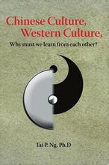
Culture can affect not just language and customs, but also how people experience the world on surprisingly basic levels.
Researchers, with the help of brain scans, have uncovered shocking differences in perception (感知) between Westerners and Asians, what they see when they look at a city street, for example, or even how they perceive a simple line in a square, according to findings published in a leading science journal.
In western countries, culture makes people think of themselves as highly independent entities (实体). When looking at scenes, Westerners tend to focus more on central objects than on their surroundings. East Asian cultures, however, emphasize inter-dependence. When Easterners look at a scene, they tend to focus on surroundings as well as the object.
Using an experiment involving two tasks, Dr Hedden asked subjects to look at a line simply to estimate its length, a task that is played to American strengths. In another, they estimated the line’s length relative to the size of a square, an easier task for the Asians.
The level of brain activity, by tracking blood flow, was then measured by Brain Scanners. The experiment found that although there was no difference in performance, and the tasks were very easy, the levels of activity in the subjects’ brains were different. For the Americans, areas linked to attention lit up more, when they worked on the task they tended to find more difficult -- estimating the line’s size relative to the square. For the Asians, the attention areas lit up more during the harder task also -- estimating the line’s length without comparing it to the square. The findings are a reflection of more than ten years of previous experimental research into east-west differences.
In one study, for instance, researchers offered people a choice among five pens; four red and one green. Easterners were more likely to choose a red pen while Westerners were more likely to choose the green one.
Culture is not affecting how you see the world, but how you choose to understand and internalize (使内化) it. But such habits can be changed. Some psychological studies suggest that when an Easterner goes to the West or vice versa, habits of thought and perception also begin to change. Such research gives us clues on how our brain works and is hopeful for us to develop programs to improve our memory, memory techniques and enhance and accelerate our learning skills.

63. According to the passage, Chinese people are most likely to _____.
A. more emphasize independent thinking
B. always focus more on their surroundings
C. focus more on the context as well as the object
D. think of Westerners as highly independent entities
64. We know from the passage that people’s brains will be more active when _____.
A. the task is much easier B. the blood flow is tracked
C. people begin to choose colors D. the task is more difficult
65. What do the findings of the experiments mentioned in the passage indicate?
A. They indicate that culture has a great impact on the way people talk and behave.
B. They show that Easterners and Westerners have great differences in perceiving the world.
C. They suggest that people’s habits of thought and perception can be changed in different cultures.
D. They make it clear that Easterners and Westerners lay emphasis on different things.
66. It can be inferred from the passage that _____.
A. Easterners prefer collectivism to individualism
B. East Asian cultures lay more emphasis on independence
C. It took over ten years to find out how to improve our brainpower
D. Americans will change their habits of perception when they’re in Britain

Section C
Directions: Read the passage carefully. Fill in each blank with a proper sentence given in the box. Each sentence can be used only once. Note that there are two more sentences than you need.

A. The greatest advantage of the tutorial system is the individual attention that students receive.
B. Tutorials can be considered the backbone of undergraduate teaching at Oxford.
C. Sometimes, the student may leave a tutorial with only a reading list and the title of the next essay.
D. Tutorials can greatly enhance the undergraduates’ academic performance.
E. The greatest advantage of the tutorial system is the various curriculums that students receive.
F. In the mean time, tutorials are also beneficial for developing students’ skills of critical analysis.
The Tutorial System of Oxford University
In the University of Oxford, teaching is conducted primarily through the tutorial system. It is one of the most unique and well-known methods of teaching across the world.
The weekly tutorial consists of a one-hour meeting between the tutor and small numbers of students (usually two to four). During this time, an essay prepared specifically for that tutorial is read by students and commented upon by the tutor. At the end of the tutorial, the tutor will assign the topic of study for the coming week and suggest readings. __67__ Meanwhile, they are also complemented by departmental lectures which are conducted on a university wide basis, lab work, and seminars (研讨会) often with groups of perhaps 10 students.
Tutorials have gained their reputation because of the close relationship they maintain between the tutor and the student. The tutorial system provides undergraduates with direct and in most cases weekly contact with tutors in their academic fields. __68__
Before the weekly tutorial, students are required to prepare an essay or other works, which they read or present to the tutor. During each tutorial, students are expected to communicate, debate, analyze and critique the ideas of others as well as their own in conversations with the professor and fellow-students. The tutorial system has great value that it creates learning and assessment opportunities which are highly authentic (可靠的) and difficult to fake, as the student’s work is discussed on the spot.
__69__ The contrast between tutorials and large lectures common in the American universities is obvious. In the typical American university, students are taught by the same specialists, in the same manner, and held to the same standards.
However, during tutorials, students have the opportunity to explore their own ideas directly with experts in particular subjects. __70__ As a result, students must engage in extensive independent reading and research, using the resources available, under the guidance of the tutor.

IV. Summary Writing
Directions: Read the following passage. Summarize the main idea and the main point(s) of the passage in no more than 60 words. Use your own words as far as possible.

How Safe Is Your Bed?
Do you consider your bed a safe place of rest and calm? Do you sink into a mattress (床垫) after a hard day’s work and feel tension and stress drain away as you rest your weary head on a soft pillow? Well, you might not feel so relaxed if you knew that tiny pests were hiding there! It seems that beds may not be such a good place for our health and happiness ---- they could actually be making us ill!
Recent studies have shown that bacteria, fungi and dust mites (螨虫), some smaller than the diameter of a hair, live in our bedding. When we move around in our sleep, we disturb them and they are bounced up into the air -- which we then breathe in as we sleep. According to the American Lung Association, four out of five households in the United States now have high levels of dust mites, although it’s not the mites themselves that cause the problems, but their droppings. These are “highly allergenic (致敏的)” according to Dr William Berger, a fellow with the American Academy of Allergy, Asthma and Immunology. “Even if you aren’t allergic… they can still irritate you, the way pepper would if it blew into your nose and eyes.”
Brendan Boor, Assistant Professor of Civil Engineering, who carries out bed research, also found that bed dust in the air leads to allergies -- causing watery eyes, sneezing, coughs and asthma. He has recommended ways to limit our exposure to these boring allergens:
Firstly, he suggests vacuuming your mattress regularly – weekly, or even daily. He also recommends doing away with carpets and washing floors. Using allergen-proof bed covers, he says, can reduce the risk of getting allergies. In addition, washing bedding and pillows frequently can help, as can a portable air cleaner placed near the bed.
If you do as Brendan Boor suggests, you will breathe in cleaner air as you sleep … or will you? Is it really safe for you to go back in your bed?

（请将答案写在答题纸上）
第II卷（共40分）
I. Translation
Directions: Translate the following sentences into English, using the words given in the brackets.

- 看到他的表情，我忍不住把实情告诉了他。(resist)

- 随着时间的推移，那本日记上的字迹现在已模糊不清，难以辨认。（With）

- 把难记的单词或句子同一件有趣的事情联系起来，记住它们就轻而易举了。（associate）

- 正是因为学习方法因人而异，所以在学习和生活中适合你的不一定就适合我。（vary）

II. Guided Writing
Directions: Write an English composition in 120-150 words according to the instructions given below in Chinese.
腾讯公司（Tencent Company）就微信用户的阅读偏好做了一项调查，调查结果如下图。请你仔细观察这张图片，然后谈谈这张图片反映出的现象或问题，并向微信用户提出你的建议。
注意：作文中不得出现你自己的真实姓名、班级及学校。
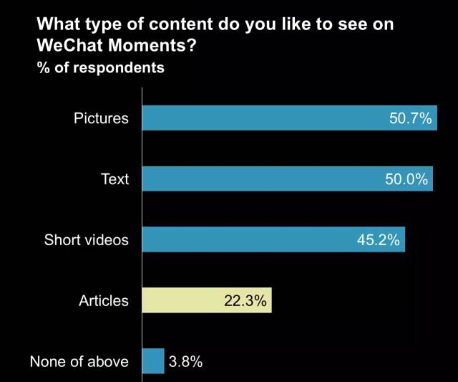
提示：WeChat: 微信
Moments: 朋友圈
respondents: 受访者
Text: 微信朋友圈文章
Articles: 微信公众号文章

（请将作文写在答题纸上）

虹口区2016-2017学年第二学期教学质量监测
高三年级英语学科试卷
参考答案
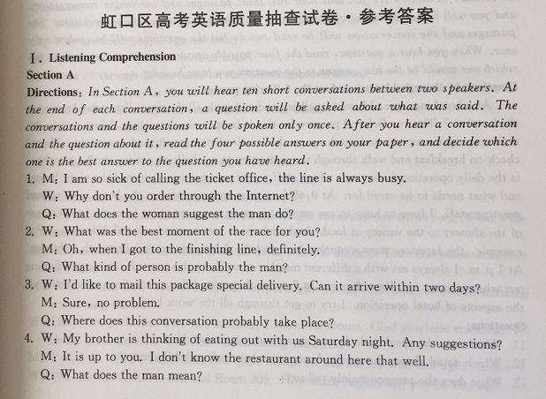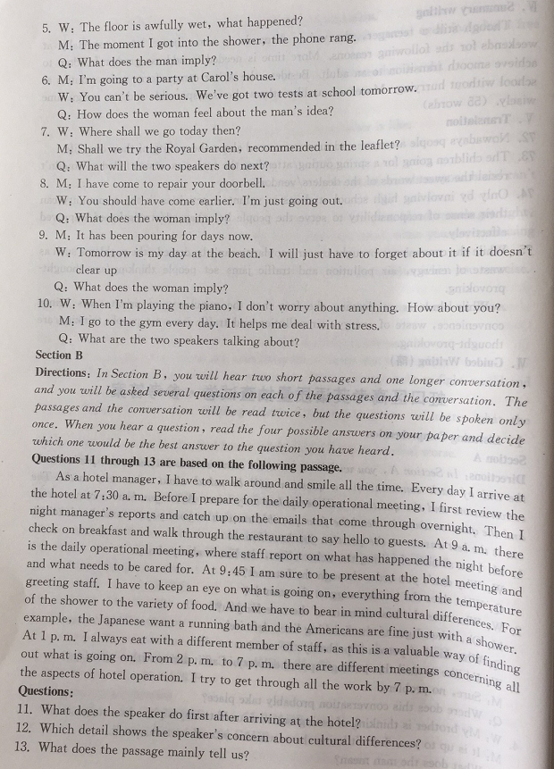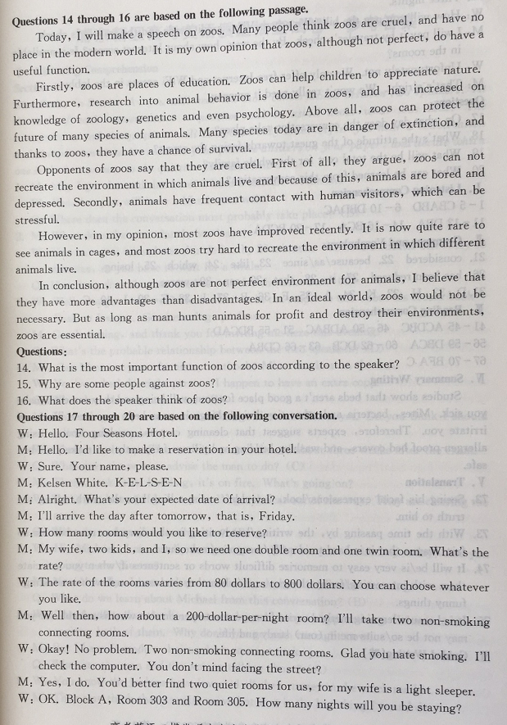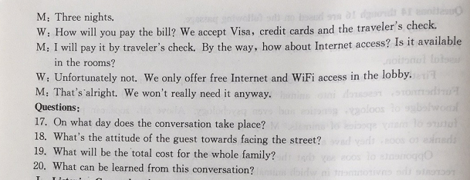
听力部分：
1-5: CBABD 6-10: DBDAC 11-13: DBA 14-16: BCA
17-20: BCDA
语法：
21. considered 22. because / as / since 23. like 24. which 25. losing 26. has been reduced
27. it 28. that 29. can 30. worse
词汇:
31.D 32. H 33. K 34. A 35. F 36. B 37. J 38. E 39. I 40. C
完形填空：
41-45: ACDBC 46-50: ADBAC 51-55: BDCAD
阅读理解：
56-59: DBCA 60-62: DCB 63-66: CDBA
选句填空：
67-70: BFA C
概要写作：
Studies show that beds aren’t a good place for your well-being and they can even make you sick. Mites, bacteria and other tiny living things in your beds can cause illness or irritate you. Therefore, experts suggest that cleaning carpets, washing floors, using allergen-proof bed covers, and washing bedding and pillows frequently can make your bed safe.
翻译：
1. Seeing his facial expressions / look, I couldn’t resist telling him the truth / telling the truth to him.
2. With the time passing by, the writing / handwriting in the diary has now become so faint / vague that it is hard to identify / recognize / make out.
3. It will be / is very easy to memorize difficult words or sentences if / when you associate them with interesting / funny things. / … if / when they are associated with interesting / funny things.
4. It is because learning method varies from person to person that what is suitable for you may not be so / suits me in (our) study and life.
作文：
（略）

