
长宁、金山区2016-2017学年第二学期教学质量监测
高三年级英语学科试卷
2017.4
考生注意：
1.考试时间120分钟，试卷满分140分。
2.本次考试设试卷和答题纸两部分。所有答题必须涂（选择题）或写（非选择题）在答题纸上，做在试卷上一律不得分。
3.答题前，务必在答题纸上填写准考证号和姓名，并将核对后的条形码贴在指定位置上，在答题纸反面清楚地填写姓名。

I. Listening Comprehension
Section A
1. A. At a train station. B. At a travel agency.
C. At a bus station. D. At an airport.
2. A. Receptionist and guest. B. Teacher and student.
C. Boss and secretary. D. Husband and wife.
3. A. $5 B. $10 C. $15 D. $50
4. A. Confused. B. Annoyed. C. Embarrassed. D. Bored.
5. A. Planning to phone a friend. B. Camping in the countryside.
C. Touring in a wonderful city. D. Discussing a weekend plan.
6. A. The woman will soon be a superstar.
B. Camping in the countryside.
C. The woman should find a new partner.
D. The woman should not give up.
7. A. To a dress-up party. B. To the tailor’s.
C. To the theater. D. To a shopping mall.
8. A. Youngsters don’t really know what fashion is.
B. Styles change more quickly than necessary.
C. People should care more about their appearance.
D. It’s not sensible to go after designer clothing.
9. A. He will have an agent serve the woman.
B. The woman should buy an apartment.
C. He will talk to the woman in a moment.
D. The woman should pay the rent first.
10. A. Keep working at the restaurant.
B. Wash dishes for her in the kitchen.
C. Stop delivering flowers every day.
D. Leave the present job to work for her.
Section B
Directions: In Section B, you will hear several longer conversation(s) and short passage(s), and you will be asked several questions on each of the conversation(s) and the passage(s). The conversation(s) and the passage(s) will be read twice, but the questions will be spoken only once. When you hear a question, read the four possible answers on your paper and decide which one is the best answer to the question you have heard.
Questions 11 through 13 are based on the following passage.
11. A. The location. B. The scenery. C. The seafood. D. The culture.
12. A. Attract whales to the closershore. B. Tell people where to see whales.
C. Warn people to stay away from shore. D. Go around to gather enough visitors.
13. A. It is held every other year in summer.
B. It helps Whale Crier to show his talents.
C. It guarantees every to find something to enjoy.
D. It is one of the best eco-art festivals in South Africa.
Questions 14 through 16 are based on the following passage.
14. A. Weak bones. B. Loose teeth C. Skin problems. D. Heart diseases.
15. A. Having food rich in vitamin.
B. Walking midday in the sun with no suncream.
C. Taking vitamin D pills every day.
D. Wearing darker coloured clothes and sunhats.
16. A. To analyze the common causes of lack of vitamin D.
B. To encourage people to be exposed to the sun for vitamin D.
C. To emphasize the importance of vitamin D in one’s health
D. To introduce some different ways to gain vitamin D.
Questions 17 through 20 are based on the following conversation.
17. A. She wants to find a topic for her research.
B. She tries to help the man with his paper.
C. She hopes to learn how to write a paper.
D. She plans to work on a similar topic.
18. A. In 1813. B. In 1826. C. In 1839. D. In 1856.
19. A. They are mainly grown for the domestic market.
B. They were introduced to China from Australia.
C. They were the first plant to be planted in England.
D. They are kept warm in large plastic houses.
20. A. Growth of domestic economy in Australia.
B. Export and import of bananas in Australia.
C. History of banana cultivation in Australia.
D. Role of agriculture in Australian economy.
II. Grammar and Vocabulary
Section A
Directions: Read the following two passages. Fill in the blanks to make the passage coherent. For the blanks with a given word, fill in each blank with the proper form of the given word. For the other blanks, fill in each blank with one proper word. Make sure that your answers are grammatically correct.
Surviving Art Tradition
Native American Indians expressed themselves through their artwork, which is carved onto totem (图腾)poles. Many people hold the belief (21) __________all Native American Indian tribes (部落) carve的totem poles, but this is far from the truth . Carving totem poles was a tradition among many tribes , especially those that lived along the Pacific coast (22)____________forest grew. However , those Native American Indians who lived in the south west and the plains , and Indians , but (23)_____ (few) trees to carve than Pacific tribes.
The height of totem poles can vary considerably . Long ago totem poles (24)___________(find) to stand around 12m tall . Today , Native American Indian artists continue to care trees, but some totem poles are short and are used in homes as decoration .(25)_____________is not surprising that a genuine pole will cost more than $1500 per meter because traditionally carved totem involve a great deal of work , craftsmanship and time to produce.
The raising of a totem pole is an important celebration among the India tribe . A hole is dug for the pole to stand in . The pole is carried to the site in a ceremony which other hundreds of people attend. Ropes are used (26)__________(raise) the pole into place. Singing and dancing to drums accompanies the pole raising . Often poles are raised in this way (27)___________the carving begins . Carvers do their jobs then on the site.
Many people believe that totem poles are religious symbols , but this idea is false. Instead of (28) __________(act) as religious symbols , carvings represent the tribal nation and convey the tribes’ history . The story of a totem pole is frequently passed down from generation to generation . Having the story documented this way helps keep this tradition (29) __________(recognize) in our history . These days , many totem poles no longer exist (30)_______ __________ decay and rot. However , there are still some tribes that continue to practice this ancient are form , and these totem poles are still being enjoyed by collections of tribal art.
Section B
Directions: Complete the following passage by using the words in the box. Each word can only be used once. Note that there is one word more than you need.
A. acknowledging B. bottled C. consequences
D. demanding E. financial F. Further
G. inappropriately H. handle I. negative
J. neglect K. unresolved
Emotional Debt
Many people today live under the weight of debt from loans or credit cards . As harmful as ___31_______ debt is , there is another form of debt that is even more damaging------emotional debt.
Dr . James Richards states that emotional debt occurs …when we experience emotional pain that remain ______32___.” If the pain is not dealt with , it will affect us our entire lives. Throughout the years , we have chances for happiness , love and success . But unresolved pain can emerge , causing us to respond in ways that aren’t reasonable , resulting in destroyed relationships and lost opportunities . Another ___33____result of emotional debt is that our friends and loved ones are affected by it and pay a high price. When we have a tendency to respond _____34____, we often hurt those around us . Unfortunately our unsettled problems sometimes become too much for them to _____35____ causing them to abandon the relationship .
People with destructive patterns should check their lives for signs of unresolved pain , for your emotional debt can come from various forms of past unfair , cruel or violent treatment or ____36_____. You may be holding onto painful memories of controlling parents or very_____37_____teachers , also you may not have dealt with the pain of a broken relationship or the death of a loved one. Any negative emotion that you have controlled over the year can come back to cause harm when you least expect it.
Recognize your feelings , but don’t focus on them all the time , because ___38______and challenging your pain is difficult , but recognizing it is the first step toward dealing with it . Admit you are angry about the past , and discuss it with someone you trust , or write it down because this will ease some of the danger and hatred you’ve kept _____39____ up for years . Refuse to be a victim and accept responsibility for dealing with your painful past because this puts you in charge and limits the power your emotions have over you .
Take specific steps to resolve your emotional debt now rather than deal with the___40_____later .
III. Reading Comprehension
Section A
Directions: For each blank in the following passage there are four words or phrases marked A, B, C and D. Fill in each blank with the word or phrase that best fits the context.
Ask S iri if she’s a woman. Go ahead; try it. She’ll tell you she’s ______41_____. “Like cacti. And certain species of fish,” she might say. So is Amazon’s Alexa, Microsoft’s Cortana, Samsung’s S Voice, and Google Now. But, man, do they ever sound a lot like women. ____42_______, we think of them as ladies too. (In Old Norse, Siri translates to “a beautiful woman who leads you to victory.”) We assign female pronouns to them, and, in turn, they fold feminine turns of phrase into their robotic and occasionally inane answers to our requests.
If we prize gender diversity in other areas of daily life, why does our tech sound so_____43______? The biggest reason for the female phone fixation rests in social science. “Research indicates there’s likely to be greater accept ance of female____44_______,” says Karl MacDorman, an associate professor at Indiana University who specializes in human-computer interaction. MacDorman and his team played clips of male and female voices to people of both genders, then asked them to identify which they _____45______. The researchers also measured the way participants responded to the voices. In a 2011 paper, they reported that both women and men said female voices came across as warmer. _____46______, women even showed a subconscious preference for responding to females; men remained subconsciously neutral.
Why the_______47____? Stanford University communications professor Clifford Nass, who coauthored the field’s seminal book, Wired for Speech, wrote that people tend to perceive female voices as helping them solve their problems by themselves, while they view male voices as authority figures who tell them the answers to their problems. We want_____48______ to help us, but we also want to be the boss of it, so we are more likely to opt for a female interface.
This tendency suggests that companies will make a better impression on a______49_____group of customers with a woman’s voice. But not just any voice. It has to______50_____a brand’s p ersonality. For help with that, companies often turn to Greg Pal, vice president of marketing, strategy, and business development at Nuance Communications, which licenses its _____51______ of more than 100 voices. Pal insists that some brands choose male s peakers. He turned on his iPhone and pulled up the Domino’s Pizza app, which has an assistant, Dom. He sounded like my high school English teacher—educated and helpful but not______52_____. That’s about right for a brand attempting to ____53_______ guys ordering pies before the big game.
As voice technology improves, though, designers say diversity will too. Many devices already let you _______54____ a voice interface. Homer Simpson can tell you where to take a left on your GPS device. And Siri can become a sir, if you take the time to ___55________. Want to know how to do it? Ask her. She’ll tell you in her uniquely warm, helpful—and female—tone.
41. A. robotic B. high-tech C. genderless D. creative
42. A. Culturally B. Obviously C. Grammatically D. Undoubtedly
43. A. female B. ridiculous C. professional D. reasonable
44. A. charm B. researchers C. speech D. participants
45. A. accepted B. misunderstood C. studied D. preferred
46. A. In practice B. On the contrary C. By this means D. At first
47. A. neutrality B. prejudice C. authority D. conscience
48. A. interaction B. technology C. personality D. society
49. A. more sociable B. more talented C. broader D. wealthier
50. A. improve B. develop C. admire D. suit
51. A. market B. business C. research D. library
52. A. strange B. bossy C. reliable D. unique
53. A. appeal to B. look into C. meet with D. run after
54. A. build B. tailor C. play D. improve
55. A. repeat B. assist C. reprogram D. communicate
Section B
Directions: Read the following three passages. Each passage is followed by several questions or unfinished statements. For each of them there are four choices marked A, B, C and D. Choose the one that fits best according to the information given in the passage you have just read.
(A)
This is the opening of a short story in a town in the United States by Alison Randall
When Frank and I stepped through the post office doors, there was a crowd gathered, gawking at the new fixture on the wall like a chorus of wide-mouthed frogs. I had to get closer, and that was where being a girl that's scrawnier than a wire fence came in handy. Fortunately, Frank, my twin of eleven years, was just the same.
"Come on." I said, grabbing his hand, and we slid through the cracks between people until we spilled out in front.
Finally I got a good look. It was fixed to the plaster next to the postmaster's window, the place of honor usually reserved for the Wanted posters. Beady-eyed Zedekiah Smith, the bank robber, still hung there, but even he had been pushed aside for something more important.
A telephone. The first one in town.
"How's it work?" Noah Crawford called out. Noah's the best fix-it man around, and I could tell he was itching to get his fingers on those shiny knobs.
"Don't rightly know," answered the postmaster, and he tugged at his goatee as if it might tell him. "I do know the sound of your voice moves along wires strung on poles. It's sort of like the telegraph, only you hear words instead of dots and dashes."
"Ah," the crowd murmured, and I felt my own mouth move along.
I gazed at that gleaming wood box and something happened inside me. Something — I can only guess — that might be like falling in love. The thought of talking into that box — of making my voice sail through wires in the sky — it took over my brain. I couldn't get it out.
"Frank," I whispered to my twin. "I have to use that telephone."
Five minutes later, Frank towed me up Main Street, toward home. "Liza — " he began, but I cut him off. We two thought so much alike, I had Frank's questions answered before he even asked.
56. People crowded in the post office because ___________.
A. they were attracted by a new poster
B. the postmaster was delivering a speech
C. they were curious about the telephone
D. there was a wanted bank robber captured
57. Which of the following is Not True according to the passage?
A. Many people stared at the new device in open-mouthed amazement.
B. The slight-figured twins managed to push to the front of the crowd.
C. Even the best fix-it man in the town got no idea about the new device.
D. The postmaster didn’t know anything about how the telephone worked.
58. By“ It took over my brain. I couldn’t get it out.”,we get a clear picture of the girl’s ______.
A. eagerness to use the telephone
B. fascination for the wood box
C. puzzlement over the strange sound
D. determination to fly in the sky
59. What is the passage mainly about?
A. The twins’ frustrating experiences in the town.
B. A special assembly called in the local post office.
C. People’s reaction to the arrival of the first telephone.
D. A great celebration of the start of telephone service.
(B)
Welcome to the LUSH Life!
Out values are at the core of everything we do. From morally sourcing each ingredient and piece of packing to creating fresh, innovative cosmetics by hand, you’ll find a world of love and care in every product. Breathe deeply and soak up everything inside this box: we’ve made it just for you!

A LUSH LIFE
WE BELIEVE
…in making effective products from fresh organic(有机的) fruit and vegetables, the finest essential oils and safe synthetics. We believe in buying ingredients only from companies that do not conduct tests on animals and in testing our products on humans. We invent our own products and fragrances(香料). We make them fresh by hand using no preservative. We also believe words like ‘Fresh’ and ‘Organic’ have an honest meaning beyond marketing.

Handmade | Fighting Animal Testing
Everything we do is made for you, by us: each product is carefully crafted by experts in our cosmetic kitchens, and each gift is lovingly packed by hand. There are real, smiling people behind every aspect of our business. Watch for their face sticker on your next purchase--it’s our seal of handmade quality. | You can rest easy knowing each and every LUSH product is 100% cruelty-free. For over 30 years, we’ve been buying ingredients only from companies that do not conduct tests on animas, and testing our products on human volunteers.  Learn more at www.fightinganimaltesting.com
Naked!  When it comes to packaging, less is more--and none is even better! We’ve revolutionized the cosmetics industry by inventing solid, unpackaged products which save millions of plastic bottles from being produced, transported and disposed of every year. Any packaging we do use is recycled or recyclable. | Charity Pot  Spread a little love. Hand and body cream  is canned in our Charity Pot, which gives 100%  of its purchase price to grassroots causes benefiting people, animals and the environment.  To learn more about the charities we support and how to apply for funding, visit www.lush.com/charitypot

60. From the leaflet, we can get to know all the following facts about LUSH except _____.
A. providing financial support to society
B. taking the lead in cosmetics marketing
C. testing on humans instead of on animals
D. crafting and packing their products by hand
61. In the section Naked!, LUSH claims that they _______.
A. advocate recyclable or even no packaging
B. sell cosmetics without any wrapping paper
C. have invented some recyclable cosmetics
D. have improved ways of transporting products
62. What is LUSH’s business philosophy we can find from the leaflet?
A. The market image of a company should make way for its beliefs.
B. Cosmetics are among the essentials of our lives in modern society.
C. Homegrown vegetables and fruit are natural and reliable sources of cosmetics.
D. Social responsibilities of a company can go hand in hand with profit making.
(C)
Since quitting can start feelings such as guilt and shame, we often do everything possible to avoid it. “We’re taught from our earlist days that if you quit something. It means you’re a failure,”says counseling psychologist Will Meek. He, however, suggests we view quitting differently.
Quitting is like deciding to rearrange a room: yo u’ve grown comfortable with the status, and it can be hard to picture the end result or even see why change is necessary. And yet, there’s the upsetting feeling that you’re no longer entirely satisfied with your current circumstances, perhaps even that you’ve stopped making progress. While it’s not out of the question for feeling or regret to surface after a major refit, leaving a position, project or situation can reveal exciting possibilities, making you feel inspired and renewed.
Quitting, often happens in situations where we’re unhappy, fearful or have determined we have no other choice, factors that can have opposing effects on our health. Perhaps you find your work unfulfilling, or you’ve jumped into a new relationship before you’re ready —and, as a result, you’re operating under intense pressure.“If stress is enduring and not managed well, it can start to take a toll.” says Meek. According to the American Psychological Association, long-term, ongoing stress can increase the risk for high blood pressure and heart attack, so walking away from whatever is causing it can deliver significant physical and emotional health benefits.“We often see a reduction in the stress hormone cortisol (应激激素皮质醇), which can lower blood pressure and may even decrease the heart rate,” says Dr Alex Lickerman, a GP and expert on developing mental adaptability.
Leaving situations that fail to bring you joy can leave you with sufficient time to explore where your heart is truly leading you. In a study that was published in 1999, then Harvard University professor Hermina Ibarra looked at how bankers tried different roles that required new skill sets—someone who spent a lot of time dealing with computers, for instance, was asked to take on personal interactions. Subjects were especially drawn to acting out a version of their future solves through …imitation strategies’—an approach they compared to …trying on different clothes,’ Mark Franklin, the president of CareerCyles, suggests a similar approach as a way to figure out what your true desires might be in your post-quitting life and foresee your future self.“Pretend to be a certain kind of person, or go and meet others who are doing what you want to do.” he says, “Try it on, see how it feels and decide if it’s a good fit for you.”It may not feel like it at the time, but just moving on from a situation that’s not quite right can help you get back on track.
63. It can be inferred from paragraph 2 that quitting may bring us feelings of being both ____.
A. guilty and ashamed
B. stupid and enthusiastic
C. troubled and hopeful
D. inspired and determined
64. The phrase “take a toll”(paragraph 3)can be best replaced by“_____”.
A. develop mental adaptability
B. bring about changes
C. keep up the pressure
D. have a bad effect
65. An approach suggested by Mark Franklin similar to …trying on different clothes’ is for
_______.
A. helping people find what truly suits them in career
B. telling capable employees from inadequate ones
C. training employees to acquire different working skills
D. providing people with opportunities to have a role play
66. It can be concluded from the passage that ______.
A. quitting is track that only the timid will choose to follow
B. personal interaction can be must for reducing emotional pressure
C. mental adaptability can be improved by the stress hormone cortisol
D. knowing when to stop is wise and may make dreams happen
Section C
Directions: Complete the following passage by using the sentences given below. Each sentence can be used only once. Note that there are two more sentences than you need.

A. Scientists use indirect methods to discover exoplanets.
B. Most exoplanets are very different from the ones in our solar system.
C. As the star moves unsteadily, it changes the wavelength of the light we see.
D. Astronomers have detected signals indicating the presence of a planet
E. However, we have developed the technology to prove their existence only in the last few decades.
F. Direct detection of the visible light from giant planets in space is becoming increasingly possible.

Exoplanets(外行星): The Hunt Is On
Today scientists believe that planets could outnumber the stars. For centuries, scientists and natural philosophers have proposed that stars in the night sky have planetary systems similar to our own solar system. The existence of extrasolar planets, or exoplanets, has long been discussed. ___67___ Although not the first exoplanet discovery, a planet near a sun-like star was discovered by astronomers in 1995. This kicked off an era of exoplanet hunting, with thousands of discoveries and confirmations following in its wake.
___68___ However, in 2015 NASA’s Kepler space telescope found its first Earth-sized planet in a “habitable” zone. This is the distance form a star where surface temperatures of a planet wouldn’t be too hot or too cold for liquid water. So far, only a small slice of our galaxy, the Milky Way, has been explored. Even so, scientists have confirmed over 3,500 exoplanets, with more being added every day.
To detect exoplanets, scientists use data from a variety of sources. Large ground-based telescopes, earth-circling and sun-circling satellites all collect different types of information. Because exoplanets are so far away and very close to stars, it is very difficult to see them directly. ___69___ For example, when an exoplanet moves between its star and us, it causes a small drop in the star’s brightness. Measuring this drop is the transit(凌日)method of discovery. NASA’S Kepler space t elescope has discovered many exoplanets this way.
As a planet circles a star, it pulls on it and causes it to shake. ___70___ Measuring these
slight changes is the radial velocity(径向速度)method of discovering planets. It is one of the most productive methods for finding and confirming exoplanets.
These are just two examples of the many methods scientists use in their hunt for exoplanets, hoping for more information and enhanced detail. As time progresses and technology improves, who knows what else we may find!
Ⅳ.Summary Writing
Hope
Nothing in my life had prepared me for what I had to do. Choosing my words carefully, and fighting to stay calm, I told my 4-year-old daughter that her grandmother had suffered a stroke(中风),that she was unconscious, and that the doctors said she would probably never wake up. As she moved closer to me, Amelia looked at me, eyes bright, and said, “Maybe Grandma will be okay.”“Maybe she will,” I said, keeping back the tears, But I knew better. I was flying up to Myrtle Beach, South Carolina, from our Florida home in the morning to say good-bye to my mom.
The rest of that awful week, I joined my brother and father sitting by my mother’s side in the hospital room. I held her hand and talked to her. I told her that we still needed her. I told her that it wasn’t time to leave yet. I told her how much I loved her. And I told her that her little granddaughter, Amelia, believed that she’d get better. The doctors, with all their years of training and experience, offered no hope for recovery. The damage was simply too extensive.
Then, a couple of weeks later, an odd thing happened. Mom woke up. She regained consciousness. Persevered through a long and tough recovery, during which she had to learn to walk, read, and write all over again, and eventually returned home to Dad. The only one who wasn’t shocked was Amerlia. The doctors couldn’t explain it. Amelia didn’t need to. Hope came as naturally to her as breathings.
So why are we so afraid to hope sometimes? Maybe it’s because over the year, life’s disappointments can turn us to disillusionment(理想破灭). How many times have you heard someone say:“Hope for the best, expect the worst”?That’s not really hope at all.
Hope is being able to look at our world with all of the joy and wonder of a child.
____________________________________________________________________________________________________________________________________________________________________________________________
V. Translation
Directions: Translate the following sentences into English, using the words given in the brackets.
72. 只有多练，你才能提高驾驶技术。（only）

73. 在旅游旺季机票订得越早越便宜。（book）

74. 无论白天在学校发生了什么事情，晚上要尽量把负担卸下。（No matter）

75.随着互联网的发展，海量信息唾手可得，或许你觉得再也没有必要去图书馆了。（need n.）

VI.Guided Writing
古人云:“儿行千里母担忧。”你今年暑期计划与朋友结伴出国旅游,但是你母亲对此担心不已,未予准许。现请你给母亲写一封电子邮件以消除母亲对你的种种担忧,具体要求如下:
①陈述你出国旅游的理由;
②通过事例说明你对生活和困难有应对能力。

长宁、金山区2016-2017学年第二学期教学质量监测
高三年级英语学科试卷答案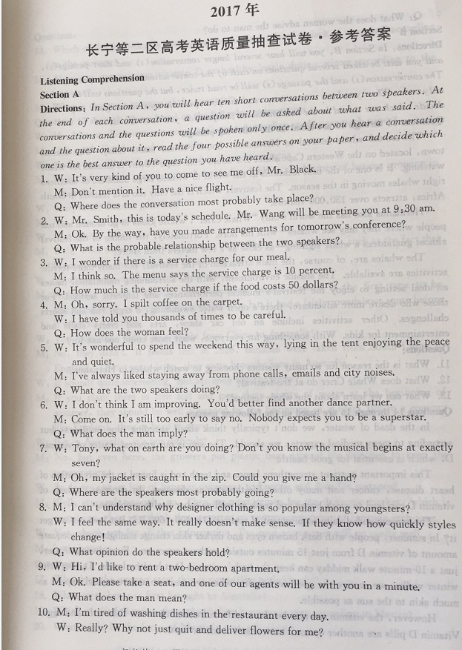 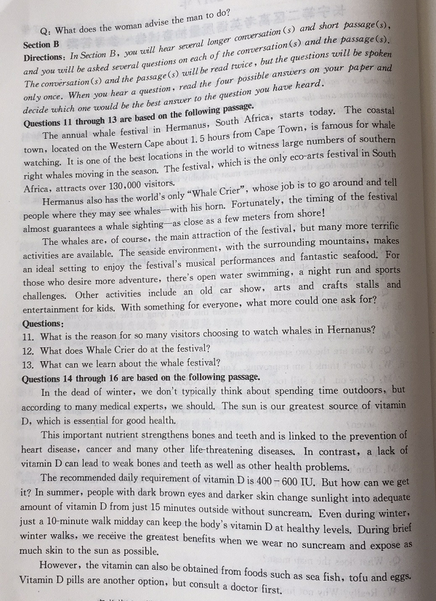
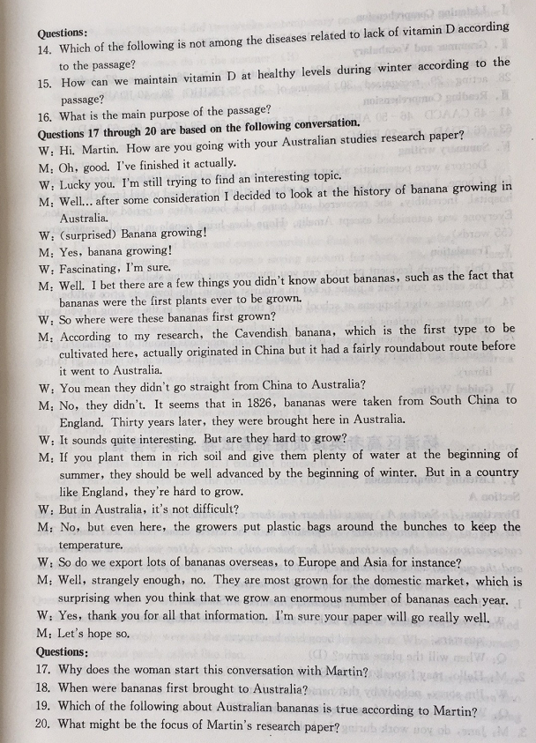
I. Listening Comprehension
1-5 DCABB 6-10 DCDAD 7-13 ABC 14-16 CBB 17-20 ADAC
II. Grammar and Vocabulary
21. that 22. where 23. fewer 24. were found 25. It
26. to raise 27. before 28. acting 29. recognized 30. because of
31-35 EKIGH 36-40 JDABC
Ⅲ. Reading Comprehension
41-45 CAACD 46-50 ABBCD 51-55 DBABC
56-59 CDAC 60-62 BAD 63-66 CDAD 67-30 EBAC
Ⅳ. Summary writing
Doctors were pessimistic about my mother’s stroke while my little daughter, Amelia, full of hope. I passed on Amelia’s hope when our family gathered to bid farewell to her in hospital. Incredibly, she recovered and came back home after a period of restoration. Everyone was astonished except Amelia. Hope does bring people in trouble amazement.(55 words)
Translating
72. Only through frequent practice can you improve your driving skills
73. The earlier you book a plane ticket in a tourist season , the lower its price will be .
74. No matter what happen at school during the day , as early in the evening as you can , put all your burden down.
75. With the development / growth of the Internet , an enormous amount of information is at hand./ at our fingertips / available so that you may think there is no need to go to the library . VI. Guided Writing
略

