闵行、松江区2016-2017学年第二学期教学质量监测
高三年级英语学科试卷
2017.4
考生注意：
1.考试时间120分钟，试卷满分140分。
2.本次考试设试卷和答题纸两部分。所有答题必须涂（选择题）或写（非选择题）在答题纸上，做在试卷上一律不得分。
3.答题前，务必在答题纸上填写准考证号和姓名，并将核对后的条形码贴在指定位置上，在答题纸反面清楚地填写姓名。
I. Listening Comprehension
Section A
Directions: In Section A, you will hear ten short conversations between two speakers. At the end of each conversation, a question will be asked about what was said. The conversations and the questions will be spoken only once. After you hear a conversation and the question about it, read the four possible answers on your paper, and decide which one is the best answer to the question you have heard.
1. A. At 12:30. B. At 13:00. C. At 13:30. D. At 14:00.
2. A. In a hospital. B. In a police station.
C. In a garage. D. In a post-office.
3. A. Wash clothes. B. Clean the backyard.
C. Sit in the backyard. D. Enjoy the tea.
4. A. He doesn’t want to watch TV tonight.
B. He prefers to watch the baseball game.
C. He’d rather see the movie.
D. He hasn’t decided what to watch tonight.
5. A. How to check computer files.
B. How to write computer programs.
C. How to apply for a computer course.
D. How to assemble a computer.
6. A. She thinks it wrong to choose either of the books.
B. She finds it difficult to choose one from the two books.
C. She thinks either of the books will be Ok.
D. She doesn’t like either of the two books.
7. A. The application has been delayed for a week.
B. The job has been offered to someone else.
C. The man is not suitable for the position.
D. The man lacks the relevant experience.
8. A. Ambitious. B. Diligent. C. Aggressive. D. Considerate.
9. A. She is strict with discipline.
B. She has missed some lessons.
C. She can’t give good lessons.
D. She fails to behave herself.
10.A. Working conditions should be improved for the employees.
B. The employees should be satisfied with the present working conditions.
C. He doesn’t think the employees should have the protest.
D. He is doubtful about the effect of the employees’ action.
Section B
Directions: In Section B, you will hear two passages and a longer conversation, and you will be asked several questions on each of the passages and the conversation. The passages and conversation will be read twice, but the questions will be spoken only once. When you hear a question, read the four possible answers on your paper and decide which one is the best answer to the question you have heard.
Questions 11 through 13 are based on the following news.
11. A. A jewelry shop. B. Shops in the City Mall.
C. A parked truck. D. A driver in the parking lot.
12. A. Leave the truck together.
B. Run back to the truck without helmets.
C. Run back to the truck separately.
D. Leave the truck without helmets.
13. A. The truck was originally painted white.
B. The truck had no registration plate.
C. The truck disappeared from the parking lot.
D. The truck was covered with silver material.
Questions 14 through 16 are based on the following passage.
14. A. In order to protect the weak and old ones.
B. In order to show beautiful shape of them.
C. In order to maintain physical strength.
D. In order to keep teamwork spirit.
15. A. How the birds decide the order of the group.
B. How the birds decide the route of the group.
C. How the birds decide the time of flying of the group.
D. How the birds decide who takes charge of the group.
16. A. Birds’ ability to keep order.
B. Birds’ flying pattern as a team.
C. Birds’ intention to migrate.
D. Birds’ skills to tell directions.
Questions 17 through 20 are based on the following conversation.
17. A. Beautiful scenery in the countryside.
B. Cross-country skiing.
C. Dangers of winter sports.
D. Pain and pleasure in sports.
18. A. He can’t find good examples to illustrate his point.
B. He can’t find a peaceful place to do the assignment.
C. He can’t decide whether to include the effort part of skiing.
D. He doesn’t know how to describe the beautiful country scenery.
19. A. New ideas come up as you write.
B. Much time is spent on collecting data.
C. It’s hard to find a proper topic.
D. The writer’s point of view often changes.
20. A. How to revise a paper in an academic manner.
B. How to polish your arguments in a paper.
C. How to tell the main ideas in a paper effectively.
D. How to decide on relevant content for a paper.

II. Grammar and Vocabulary
Section A
Directions: After reading the passage below, fill in the blanks to make the passage coherent and grammatically correct. For the blanks with a given word, fill in each blank with the proper form of the given word: for the other blanks, use one word that best fits each blank.
One steamy July afternoon in central Arkansas . I was working on my home office . My trusty printer was busy producing an important report (21)_______it simply stopped . After fifteen minutes of trying to repair , I decided to buy a new printer . Upon my return , my heart froze to see my house on fire .
(22)______having spent much of my life writing , I was speechless when facing this situation . I was lost for adequate words (23)_____ (describe ) the sick , sinking feeling of seeing my home , business , and belongings going up in flames along with photographs and memories (24)_____(collect) over a lifetime . But the panic that filled my shocked heart in that awful moment was for the nine cats that shared my home after (25)_____(rescue) from situations of ill-treatment and abandonment .
Responding to an early security -system warning , the amazing firefighters arrived immediately , (26)______the chemical smoke had already caused deaths . I examined and kissed each cat goodbye , extremely grateful that they had passed gently , without injuries or burns .
Only animal lovers really understand the unbelievable impact (27)______the loss of one beloved four-legged family member can have on your heart ,mind and soul . The loss of so many dearly loved creatures sent me in great sorrow.
After staying with a friend of mine for a couple of weeks, I was relocated to a furnished apartment . One evening , about a month after moving in , I (28)____
(occupy ) in writing a mystery novel , and at that time a "meow" sounded from outside the apartment door. Was it my mind playing tricks again?" More than once I had heard , seen or felt the brush of one of my departed funny roommates . The meow grew louder and more repetitive . Curious , I opened the door.
Sitting on the doorstep was a kitten with a black coat and alert eyes . A neighbor
(29)_____(walk) by picked him up and began petting him. When I remarked how cute her kitten was ,she explained that it had been born under a bridge and looked around for food . This kitty-loving neighbor was quick to offer an extra litter box if I was interested in giving him a home . My immediate reaction was "that's all I need !" without hesitation she put the cute kitten down . I thanked her and closed the door , determined to just let him stay (30)______home could be found .

Section B
a real
Directions: Fill in each blank with a proper word chosen from the box. Each word can be used only once. Note that there is one word more than you need
A. contrast B. unknown C. trapped D. responsibility E. willingness
F. external G. sense H. cease I. encounter J. indecisive K. passive
There are two basic ways see growth : one as a product , the other as a process . People have generally viewed personal growth as a(n)_____result or product that can easily be identified and measured . The worker who gets a promotion the students whose grades improve , the foreigner who learns a new language -all these are examples of people who have measurable results to show for their efforts.
By_____-the process of personal growth is much more difficult to determine , since by definition it is a journey and not the specific signposts or landmarks along the way . The process is not the road itself , but rather the attitude and feelings people have , their caution or courage , as we ______new experiences and unexpected obstacles. In this process , the journey never really ends. There are always new ways to experience the world , new ideas to try , new challenges to accept .
In order to grow , to travel new roads , people need to have a ___to take risks . And we are supposed to be ready to face the ____ , and to accept the possibility that we may "fail" at first . How we see ourselves as we try a new way of being is essential to our ability to grow. Do we perceive ourselves as quick an curious ? If so , then we tend to take more chances and to be more open to unfamiliar experiences . Do we think we're____and shy ? Then our__sense__of shyness can cause us to hesitate , to move slowly , and not to take a step until we know the ground is safe. Do we think we're slow to adapt to change to change or that we're not smart
enough to cope with a new challenge ? If so, then we are likely to take a more____ role or not try at all .
These feelings of insecurity and self-doubt are both unavoidable and necessary if we are to change and grow . We will____to grow , if we do not confront and overcome these internal fears and doubts , and if we protect ourselves too much . We become ____inside a shell of our own making .
III. Reading Comprehension
Section A
Directions: For each blank in the following passage there are four words or phrases marked A, B,C and D. Fill in each blank with the word or phrase that best fits the context.
To Apologize or Not to Apologize
Why difficult ?
When we do wrong to someone we know, even not__41__，we are generally expected
to apologize so as to improve the situation . But when we're acting as leaders , the circumstance are__42___.The act of apology is carried out not merely at the level
of the__43___but also at the level of the institution . It is a performance in which every word or expression ___44___ , as they become part of the public record . Refusing to apologize can be smart , or it can be stupid .So , readiness to apologize can be seen as a sign of strong character or as a sign of weakness .
Why now ?
The question of whether leaders should apologize publicly has never been more__45__.During the last decade or so , the United States in particular has developed an apology culture——apologies of all kinds and for all sorts of wrongdoings are made far more__46__than before. More newspaper writers have written about the growing importance of__47__-apologies . Meanwhile , more and more articles , advice colums , and radio and television programs have similarly dealt with the subject of __48____apologies . Although they are not carried out in the public places , we can't neglect the importance of this performance.
Why___49__?
Why do we apologize? Why do we ever put ourselves in situations likely to be difficult ,embarrassing , and even risky ? Leaders who apologize publicly could be an easy target for_50___.They are expected to appear strong and capable . And whether they make public statements of any kind , their individual and institutional reputations are in danger . Clearly , then ,leaders should not apologize often . For a leader to express apology , there needs to be a strong__51__.Leaders will publicly apologize if and when they think the costs of doing so are lower than the costs of not doing so.
Why refuse ?
Why is it that leaders so often try every means to___52__apologies , even when a public apology seems to be in order ? Their reasons can be individual or institutional. Because leaders are public figures , their apologies are likely to be personally uncomfortable and even___53_risky.Apologies can be signals for admitting mistakes and mistakes can be an indication of job insecurity . Leaders may also be afraid that__54__of a mistake will damage or destroy the organization for which they are responsible . There can be good reasons for hanging tough (硬撑) in tough situation , as we shall see ,but it is a high-risk___55__.
41. A. immediately B. intentionally C. occasionally D. accidentally
42.A. simple B. ridiculous C. abnormal D. different
43.A. individual B. company C. family D. society
44.A. conflicts B. matters C. appeals D. deceives
45.A. urgent B. risky C. boring D. simple
46.A. interestedly B. patiently C. frequently D. hopefully
47.A. faithful B. reliable C. confusing D. public
48.A. sincere B. acceptable C. private D. positive
49.A. bother B. reduce C. regret D. ignore
50.A. promotion B. criticism C. appreciation D. identification
51.A. personally B. will C. reason D. desire
52.A. attempt B. involve C. commit D. avoid
53.A. politically B. professionally C. academically D. physically
54.A. avoidance B . admission C. involvement D. elimination
55.A. fulfillment B. statement C. occupation D. strategy
Section B
Directions:
Read the following three passages. Each passage is followed by several questions or unfinished statements. For each of them there are four choices marked A. B, C and D. Choose the one that fits best according to the information given in the passage you have just read.
(A)
If your in-box is currently reporting unread messages in the hundreds or thousands, you might have a hard time believing the news: e-mail is on the decline.
At first blush, that might seem to be the case. The incoming generation, after all, doesn't do e-mail. Oh, they might have an account. They use it only as we would a fax machine: as a means to communicate with old-school folks like their parents or to fulfill the sign-up requirements of Web sites. They rarely check it, though.
Today's instant electronic memos-such as texting and Facebook and Twitter
messages-are more direct, more concentrated, more efficient. They go without the salutation(称呼语) and the signoff; we already know the "to" and ';from." Many corporations are moving to messaging networks for exactly that reason: more signal, less noise and less time. This trend is further evidence that store-and-forward systems such as e-mail and voicemail are outdated.Instead of my leaving you a lengthy message that you pick up later, I can now send you an unobtrusive, easily -consumed message that you can read-and respond to-on the go.
The decline of e-mail corresponds neatly to the dawn of the mobile era. Instantaneous(及时)written messages are different. These are neatly tailored to fit in just about any time: before a movie, in a taxi, waiting for lunch. And because these notes are invariably brief, they're a natural for smart phone typing. With these formats, you also have control over who can correspond with you, which you usually don't in e-mail. And especially on Facebook, instant messaging can take
on the character of a chat room, where several people can talk at once.
Does this mean e-mail is on its way to the dustbin of digital history? Not necessarily. E-mail still has certain advantages. On the other hand , tweets and texts feel ephemeral-you read them, then they're gone, into an endless string, e-mail still feels like something you have and that you can file, search and return to later. It's easy to imagine that it will continue to feel more appropriate for formal communications: agreements, important news, longer explanations.
So, e-mail won't go away completely. Remember, we've been through a transition like this not so long ago: when e-mail was on the rise, people said that postal mail was dead. That's not how it works. Postal mail found its smaller niche, and so will e-mail. Technology rarely replaces an institution completely; it just adds new avenues.
56. What would the incoming generation like to do with their e-mail accounts?
A. Contact close friends B. Send long messages
C. Fill in some forms D. Communicate with their colleagues
57. Which of the following is mainly discussed in the paragraph 3 and 4?
A. The possible reasons behind the decline of e-mail
B. The likes and dislikes of the young generation
C. The rapid development of e-communication channels
D. Evidence about the uncertain future of easily -consumed messages
58. What does the underlined word “ ephemeral” in paragraph 5 mean ?
A. Automatically -sending B. Randomly -written
C. Hardly -recognized D. Shortly -appearing
59. According to the passage , which of the following statements is true ?
A. It's too early to determine the decline of e-mail
B. E-mail has reasons to exist on its own advantage
C. E-mail , just like postal mail has come to its end
D. We should feel sorry for the decline of e-mail
（B)
The Film : The Great Gatsby (Based on Fitzgerald's Novel The Great Gatsby)
Director : Baz Luhrrmann Cast : Leonardo DiCaprio as Jay Gatsby
Film Reviews :
If you have never read the classic F. Scott Fitzgerald's novel The Great Gatsby, now is your chance to catch up - by watching the latest film adaptation. Because if there's one sentence to sum up the film, it would be: It's just like the book.
The use of music is almost reason enough to see the film. "Luhrmann is at his best mixing visual and musical styles together to create something wholly original, For example, in one of the most outstanding scenes in the film, the first party scene, Nick walks quickly from one party guest to another party guest trying to explain all the gossip about Gatsby until he is finally introduced to the man himself, while the most stirring version of Rhapsody in Blue(蓝色狂想曲), which was composed by American musician George Gershwin in 1924, is played in the background.
—Fox News
Director Baz Luhrmann's main challenge was either to find a visual equivalent(相等物)for Fitzgerald's elegant quality - the open secret of the book's popularity for so long time - or to match his own unusual personal strength with the material. He tries it both ways, with considerable degrees of success. Leonardo DiCaprio does a good and professional job as the socialite(社会名流) by recreating Fitzgerald's description of Gatsby's charm. "He can look at someone for an instant and understand how, perfectly, he or she wants to be seen.
-Time Magazine

About the Book and the Main Character :
Considered to be Fitzgerald's representative work, The Great Gatsby explores themes of idealism, resistance to change, social change, and excess, creating a portrait of the Jazz Age or he Roaring Twenties that has been described as a tale regarding the American Dream. Nick, the narrator, moves to New York for the summer to visit his cousin Daisy. His next-door neighbor is Jay Gatsby (Leonardo DiCaprio), who rarely contacts with others and is said to be a hero of the Great War. Gatsby claims to have attended Oxford University, but the evidence is suspect. As Nick learns more about Gatsby, every detail about him seems questionable, except his love for the Daisy. Though Daisy is married, Gatsby still loves her as his "golden girl". They first met when she was a young lady from a wealthy family and he was a working-class military officer. Daisy promised to wait for his return from the war. However, she married Tom, a classmate of Nick's. Having obtained a great fortune, Gatsby sets out to win her back again.
60. The Fox News review mentioned the first party scene in the film to_____.
A. reveal the fact that Nick wants to know more about Gatsby.
B. show the version of Rhapsody in Blue matches the film well.
C. prove that the director is good at combining visual and music.
D. convince us that the first scene is perfectly filmed by the director.
61. According to Time Magazine, what did Baz Luhrmann do to make the film a success?
A. He adapted the story in the novel as he wished.
B. He made the film more powerful than the book.
C. He mixed his style with the elegance of the book.
D. He changed the story to meet his own style.
62. Which of the following can be used to describe Gatsby?
A. Faithful and warm-hearted.
B. Charming and professional.
C. Selfish and timid.
D. Mysterious and devoted.
(C)
The British Medical Journal recently featured a strong response to what was judged an inappropriately merciful reaction by a medical school to a student cheating in an examination. Although we have insufficient reliable data about the extent of this phenomenon, its prevention, or its effective management, much can be concluded and acted upon on the basis of common sense.
There is general agreement that there should be zero tolerance of cheating in a profession based on trust and one on which human lives depend. It is reasonable to assume that cheaters in medical school will be more likely than others to continue to act dishonestly with patients, colleagues, and government.
The behaviors under question are multifactorial in origin. There are familial(家庭的), religious,and cultural values that are acquired long before medical school. For example, countries, cultures,and subcultures exist where bribes and dishonest behaviour are very normal. There are secondary schools in which neither staff nor students tolerate cheating and others where cheating is common;there are homes which cultivate young people with high standards of moral behaviour and otherswhich leave moral training to the harmful influence of television and the market place.
Medical schools reflect society and cannot be expected to remedy all the ills of a society. The selection process of medical students might be expected to favour applicants with positive moral behaviour. Medical schools should be the major focus of attention for cultivating future doctors with moral sensitivity. Unfortunately there are troubling data that suggest that during medical school the moral behaviour of medical students does not necessarily improve; indeed, moral development may actually stop or even regress (倒退) .
It is critical that the academic and clinical leaders of the institution set a personal example on moral behaviour. Medical schools must do something to make sure that their students are expected to be clear from day one. The development of a school's culture of moral behaviour requires cooperation with the students in which they play an active role in its creation and developing. Moreover, the school's examination system and general treatment of students must be fair. Finally,
the treatment of infractions must be firm, fair, transparent(透明的)
63. What does the author say about cheating in medical schools?
A. Extensive research has been done about this phenomenon.
B. We have sufficient data to prove that prevention is possible.
C. We know that this phenomenon exists in every medical school.
D. We still need more reliable data to know how serious it is.
64. According to the author, it is important to prevent cheating in medical schools because_____.
A. the medical profession is based on trust.
B. there is zero tolerance of cheating in medicine
C. the medical profession depends on the government.
D. cheating exists extensively in medical schools.
64. Which of the following statements will the author probably agree with?
A. Medical schools should make a less competitive environment for students.
B. Outstanding people should create a set of moral standards to be followed.
C. Medical students should be positive in creating and preserving moral behavior
D. We should focus on the cause-and-effect of the cheating in exams in medical schools.
66. Which of the following can be implied from the passage?
A. It makes little sense to talk about medical school student cheating in exams.
B. Medical schools haven't been doing well to help students develop morally.
C. Cheating in exams is tolerable outride of medical school circle.
D. Elimination of exams helps cultivate healthier characters of medical school students.
Section C
Directions: Read the following passage. Fill in each blank with a proper sentence given in the box. Each sentence can be used only once. Note that there are two more sentences than you need
A. If you associate with distinguished people, you are likely to find yourself with better opportunities.
B.Challenge-yourself to expand your business knowledge through interactions with people at regular time.
C. In addition, the chances, if any, arc low that you can find a satisfactory job in an economic situation like this.
D. Once you have a couple of targets, think about why and what interests you.
E. Tliat is to say, the people you keep company with determine your character development.
F. Job searching under pressure often results in nervous interviewing and decision-making from relatively few options.

The worse time to look for a job is when you feel desperate and must have a new one immediately. 67 If you are not in need of an immediate career change, here arc ways you can improve your long-term career prospects today;
Identify at least two different roles. You do not have to be qualified for these positions today, nor do they have to exist in your company. However, these roles should be related to your current skill set. They are career options that look interesting. 68 Pay close attention to what appeals to you, and write it down. This will give insight into your motivations and targets.
Subscribe to a career specific magazine. Knowledge is power in the workplace. All businesses must stay relevant to their customers in order to win the competitions and increase revenue (收益) .Reading about industry trends, advancements and success stories keeps you in touch with market conditions. This information allows you to see which companies and professionals are leading the pack. You can follow their examples in your own workplace. 69
Do exceptional work. In any role, there is a way to perform at your best. Look for ways to deliver a top performance. Show up early, be flexible to new assignments, have a positive attitude, cooperate with other departments, pay attention to the little details.
Be professionally curious. Talk to people about their careers. Learn more about how success is measured in other roles, departments and companies. Ask people their thoughts on different industries. 70 People hire people. You never know what connections may be relevant when you start your next job search, so develop a habit of making good connections no matter where you go. Take the time to learn about others, and be helpful when you can.
As in all things in life, getting in front of a different task early is always less stressful than reacting to a career surprise. Changing jobs is to be expected. No matter how secure you feel today, the time will come when either you or your employer decide it is time to change.

IV. Summary Writing
Directions: Read the following passage. Summarize the main idea and the main points of the passage in no more than 60 words. Use your own words as far as possible.
There are various means consumers can do if they find that an item they bought is faulty or in some other way does not live up to the manufacturer's claims. A simple and common method used by many consumer is to complain directly to the store manager. In general, the "higher up" his or her complaint, the faster he or she can expect it to be settled. In such a case, it is usually settled in the consumer's favor, assuming he or she has a just claim.
Consumers should complain in person whenever possible, but if they cannot get to the place of purchase, it is acceptable to phone or write the complaint in a letter.
Complaining is usually most effective when it is done politely but firmly, and especially when the consumer can demonstrate what is wrong with the item in question. If this cannot be done, the consumer will succeed best by presenting specific information as to what is wrong, rather than by making general statements. For example, "The left speaker does not work at all and the sound coming out of the right one is unclear" is better than "This stereo does not work". The store manager may advise the consumer to write to the manufacturer. If so, the consumer should do this,
stating the complaint as politely and firmly as possible. If a polite complaint does not achieve the desired result, the consumer can go to a step further. She or he can threaten to take the seller to court or report the seller to a private or public organization responsible for protecting consumer's rights.

V. Translation
Directions: Translate the following sentences into English, using the words given in the brackets.
72.看孩子们在沙滩上打排球很有趣。 (fun)

73.我刚交卷就意识到少回答了一个问题。 (Hardly...)

74.这本词典需要做彻底修改，什么时候再版还不得而知。 (revise)

75.这种收音机已经很落伍了，不增加新功能的话很难有销路。 (unless)

76.公共场所全面禁言有助于人们养成健康的生活习惯，并能有效预防某些疾病的发生。( prevent)

VI．Guided Writing
Directions: Write an English composition in 120-150 words according to the instructions given below in Chinese.
某英文网站正举办征文活动，题目是The Most Useful Skill I Have Ever Learned，请以此写一篇征文。你的文章比须包括：
·这项技能是什么？你是通过什么方式学会的7
·举例说明为什么你觉得它最有用。
（注：文中不得出现真实的姓名及学校名称）
假设你们学校拟给高三学生放三天假，各班可以自由安排。现有两个方案可以供同学们选
择：1、野外拓展训练（outward bound training）；2、在家自习功课。假设你班班长正在征集意见，请你给班长发邮件，说明通过对两个方案的比较，你会选择哪一个，并简要说明你做出这个选择的理由。

闵行、松江区2016-2017学年第二学期教学质量监测
高三年级英语学科试卷答案
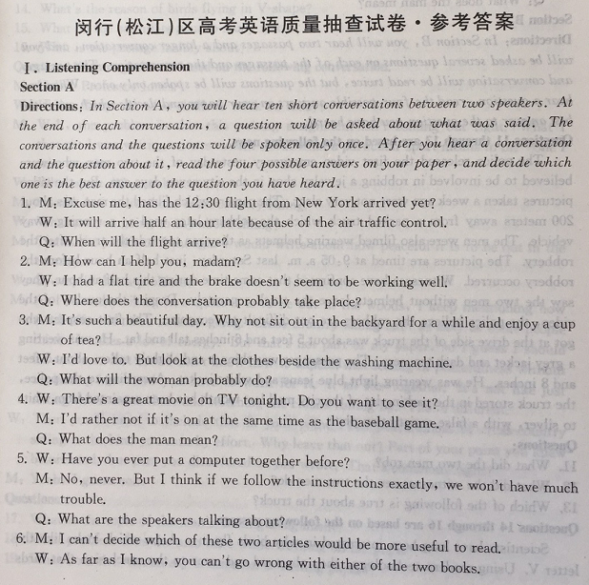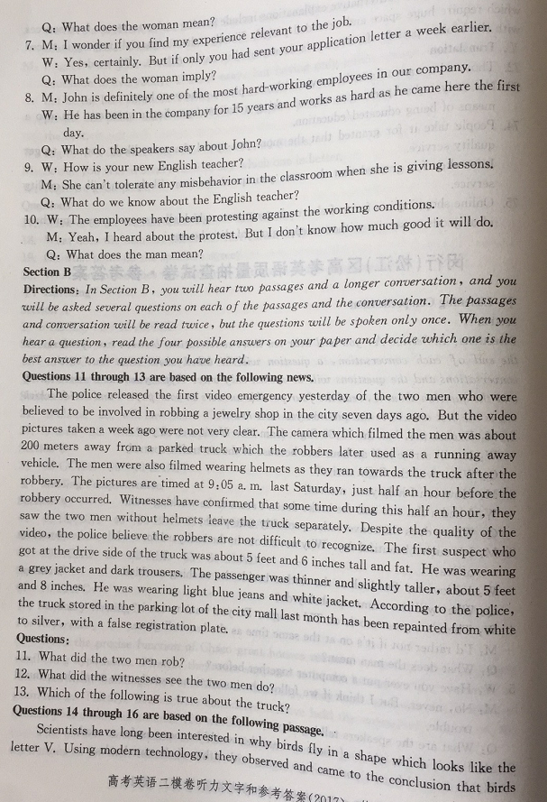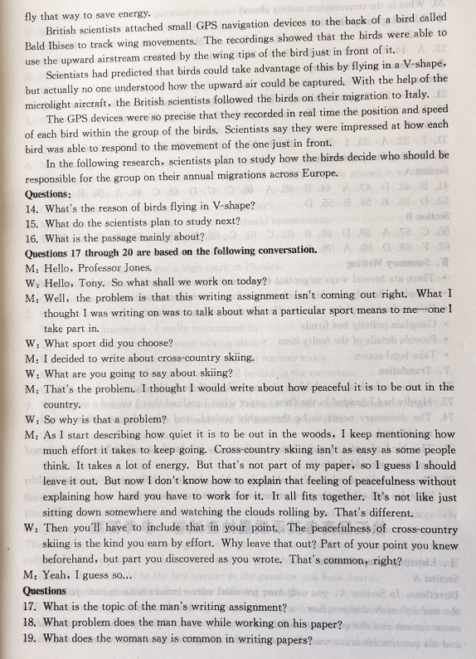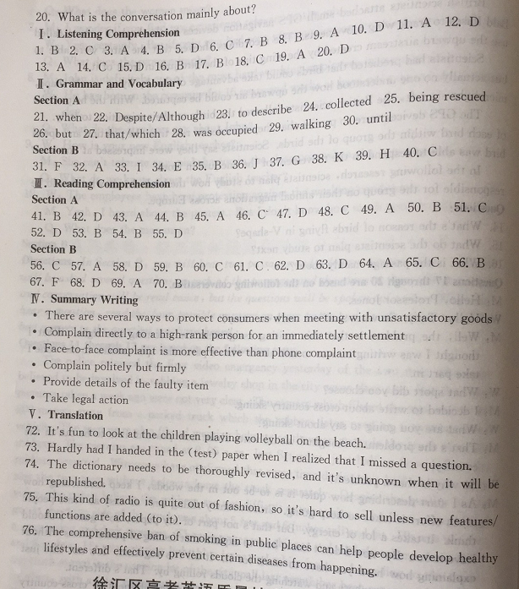
1-5 BCABD 6-10 CBBAD
11-15 ADACD 16-20 BBCAD
21. when 22. Despite /Although 23. to describe 24. collected
25. being rescued 26. but 27. that/ which 28. was occupied
29.Walking 30. until
31-35 FAIEB 36-40 JGKHC
41-45 BDABA 46-50 CDCAB
51-55 CDBBD
56-60 CADBC 61-65 CDDAC
66-70 BFDAB
Summary writing
参考答案：
. There are several ways to protect consumers when meeting with unsatisfactory goods.
. Complain directly to a high-rank person for an immediately settlement.
. Face-to-face complaint is more effective than phone complaint.
. Complain politely but firmly
. Provide details of the faulty team
. Take legal action
翻译
72. It's fun to look at the children playing volleyball on the beach .
73. Hardly had I handed in the test paper when I realized I missed a question.
74. The dictionary needs to be thoroughly revised , and it's unknown when it will be republished .
75. This kind of radio is quite out of fashion , so it's hard to sell unless new features/ functions are added (to it).
76. The comprehensive ban of smoking in public places can help people develop healthy lifestyles and effectively prevent certain diseases from happening .

