
青浦区2016-2017学年第二学期教学质量监测
高三年级英语学科试卷
2017.4
考生注意：
1.考试时间120分钟，试卷满分140分。
2.本次考试设试卷和答题纸两部分。所有答题必须涂（选择题）或写（非选择题）在答题纸上，做在试卷上一律不得分。
3.答题前，务必在答题纸上填写准考证号和姓名，并将核对后的条形码贴在指定位置上，在答题纸反面清楚地填写姓名。
I. Listening Comprehension
Section A
Directions: In Section A, you will hear ten short conversations between two speakers. At the end of each conversation, a question will be asked about what was said. The conversations and the questions will be spoken only once. After you hear a conversation and the question about it, read the four possible answers on your paper, and decide which one is the best answer to the question you have heard.
1. A. At a train station B. At a travel agency C. At a bus station D. At an airport
2. A. Receptionist and guest B. Teacher and student
C. Boss and secretary D. Husband and wife
3. A. $5 B. $10 C. $15 D. $50
4. A. Confused B. Annoyed C. Embarrassed D. Bored
5. A. Planning to phone to friend B. Camping in the countryside
C. Touring in a wonderful city D. Discussing a weekend plan
6. A. The woman will soon be a superstar
B. The woman did not practice hard
C. The woman should find a new partner
D. The woman should not give up
7. A. To a dress-up party B. To the tailor’s
C. To the theater D. To a shopping mall
8. A Youngsters don’t really know what fashion is
B. Styles change more quickly than necessary
C. People should care more about their appearance
D. It’s not sensible to go after designer clothing
9. A. He will have an agent serve the woman
B. The woman should buy an apartment
C. He will talk to the woman in a moment
D. The woman should pay the rent first
10. A. Keep working at the restaurant B. Wash dishes for her in the kitchen
C. Stop delivering flowers every day D. Leave the present job to work for her
Section B
Directions: In Section B, you will hear several longer conversation(s) and short passage(s), and you will be asked several questions on each of the conversation(s) and the passage(s). The conversation(s) and the passage(s) will be read twice, but the questions will be spoken only once. When you hear a question, read the four possible answers on your paper and decide which one is the best answer to the question you have heard.
Questions 11 through 13 are based on the following passage.
11. A. The location B. The scenery C. The seafood D. The culture
12. A. Attract whales to the closer shore B. Tell people where to see whales
C. Warn people to stay away from shore D. Go around to gather enough visitors
13. A. It is held every other year in summer
B. It helps Whale Crier to show his talents
C. It guarantees everyone to find something to enjoy
D. It is one of the best eco-arts festivals in South Africa
Questions 14 through 16 are based on the following passage.
14. A. Weak bones B. Loose teeth C. Skin problems D. Heart diseases
15. A. Having food rich in vitamin
B. Walking midday in the sun with no suncream
C. Taking vitamin D pills every day
D. Wearing darker coloured clothes and sunhats
16. A. To analyze the common causes of lack of vitamin D
B. To encourage people to be exposed to the sun for vitamin D
C. To emphasize the importance of vitamin D in one’s health
D. To introduce some different ways to gain vitamin D
Questions 17 through 20 are based on the following conversation.
17. A. She wants to find a topic for her research B. She tries to help the man with his paper
C. She hopes to learn how to write a paper D. She plans to work on a similar topic
18. A. In 1813 B. In 1826 C. In 1839 D. In 1856
19. A. They are mainly grown fro the domestic market
B. They were introduced to China from Australia
C. They were the first plant to be planted in England
D. They are kept warm in large plastic houses
20. A. Growth of domestic economy in Australia
B. Export and import of bananas in Australia
C. History of banana cultivation in Australia
D. Role of agriculture in Australian economy
II. Grammar and Vocabulary
Section A
Directions: After reading the passage below, fill in the blanks to make the passage coherent and grammatically correct. For the blanks with a given word, fill in each blank with the proper form of the given word; for the other blanks, use one word that best fits each blank.
From street food to museums, Chinese food hot in US
From baozi in Boston to jianbing in New York, traditional Chinese street food are popping up in the US. meizhou Dongpo opened its first US restaurant in Beverly Hills, California, in 2013, with offerings from its menu in China. Locally (21)________(hire) chefs were sent to China for training. Next spring, Beijing’s Dadong, known for its Peking Duck, (22)__________(open) a flagship US restaurant in Manhattan.
Xi’an Famous Foods is about to have its 12th location in New York near the Museum of Modern Art. Its original location, established in 2005, was the first restaurant (23) __________(bring) Xi’an cuisine to the US.
Chinese food is also the stuff of museum exhibits. A current exhibition at the Museum of Chinese in America in New York called. Sour Sweet, Bitter, Spicy: Stories of Chinese Food and Identity in America(24)_______(raise)the food to an art form, literally.
On a recent October afternoon, people stood on line for the offerings of Hangzhou-based Gan Qi Shi’s first overseas baozi shop, in Harvard Square in Cambridge, Massachusetts. The US chain adopted the English neme of Tom’s BaoBao. “I used to grab burgers and Korean tofu soup (25)__________in needed a quick bite,” said Wang Na, a Chinese grad student at Harvard. “Now I get two baozi. They are(26)_________(healthy), and taste like home.”
In New York, Mr. Bing, a food stand serving Beijing jianbing, was named “Rookie of the Year’s at the 2016 Vendy Awards, (27)____recognizes the city’s best food carts. Mr. Bring is Brain Goldberg, a New York native who, as a student in 1998 in Beijing, settled on his favorite (28)_______40 different jianbing and purchased the recipe from a street vendor(小贩). He then flew the vendor to Hong Kong, where the first Mr. Bing booth opened in 2012, (29)_______the master could teach his employees how to make the real deal.
Meanwhile, (30)______growing number of bubble tea shops can be found in the US, helping diners to wash down the tasty food from China.
Section B
Directions: Fill in each blank with a proper word chosen from the box. Each word can be used only once. Note that there is one word more than you need.
A. acknowledging B. bottled C. consequences D. demanding E. financial F. further
G. handle H. inappropriately I. negative J. neglect K. unresolved
Emotional Debt
Many people today live under the weight of debt from loans or credit cards. As harmful as__31__ debt is, there is another form of debt that is even more damaging-emotional debt.
Dr.James Richards states that emotional debt occurs ‘when we experience emotional pain that remain ____32___.” If the pain is not dealt with, it will affect us our entire lives. Throughout the years, we have chances for happiness, love and success. But unresolved pain can emerge, causing us to respond in ways that aren’t reasonable, resulting in destroyed relationships and lost opportunities. Another ___33____result of emotional debt is that our friends and loved ones are affected by it and pay a high price.
When we have a tendency to respond____34____, we often hurt those around us. Unfortunately our unsettled problems sometimes become too much for them to ___35___ causing them to abandon the relationship.
People with destructive patterns should check their lives for signs of unresolved pain, for your emotional debt can come from various forms of past unfair, cruel or violent treatment or ___36_____. You may be holding onto painful memories of controlling parents or very ____37____teachers, also you may not have dealt with the pain of a broken relationship or the death of a loved one. Any negative emotion that you have controlled over the year can come back to cause harm when you least expect it.
Recognize your feelings, but don’t focus on them all the time, because ___38____and challenging your pain is difficult, but recognizing it is the first step toward dealing with it . Admit you are angry about the past, and discuss it with someone you trust, or write it down because this will ease some of the danger and hatred you’ve kept ___39___ up for years. Refuse to be a victim and accept responsibility for dealing with your painful past because this puts you in charge and limits the power your emotions have over you.
Take specific steps to resolve your emotional debt now rather than deal with the___40___later.
III. Reading Comprehension
Section A
Directions: For each blank in the following passage there are four words or phrases marked A, B, C and D. Fill in each blank with the word or phrase that best fits the context.
Ask Siri if she’s woman. Go ahead: try it. She’ll tell you she’s___41___. “Like cacti, a certain species of fish,” she might say. So is Amazon’s Alexa, Microsoft’s Cortana, Samusng’s Voice, and Google Now. But, man, do they ever sound a lot like women? ____42____, we think of them as ladies too. In Old Norse(古挪威语), Siri translates to “a beautiful woman who leads you to victory”. We assign female pronouns to them, and, in turn, they fold female turns of phrase into their robotic and occasionally silly answers to our requests.
If we prize gender diversity(多样性) in other areas of daily life, why does our tech sound so____43____? The biggest reason for the female phone fixation rests in social science. “Research indicates there’s likely to be greater acceptance of female____44____,” says Karl MacDorman, a professor at Indiana University who specializes in human computer interaction. MacDorman and his team played clips of male and female voices to people of both genders, then asked them to identify which they____45____. The researchers also measured the way participants responded to the voices. In a 2011 paper, they reported that both women and men said female voices came across as warmer. ____46____, women even showed a subconscious preference for responding to females; men remained subconsciously neutral.
Why the____47____? Stanford University communications professor Clifford Nass wrote that people tend to see female voices as helping them solve their problems by themselves, while they view male voices as authority figures who tell them the answers to their problems. We want____48____ to help us, but we also want to be the boss of it, so we are more likely to choose a female interface(接口程序).
This tendency suggests that companies will make a better impression on a ____49____ group of customers with a woman's voice. But not just any voice. It has to ____50____ a brand’s personality. For help with that, companies often turn to Greg Pal, vice president of marketing, strategy, and business development at Nuance Communications, which licenses its ____51____of more than 100 voices. Pal insists that some brands choose male speakers. He turned on his iPhone and pulled up the Domino's Pizza app, which has an assistant, Dom. He sounded like a high school English teacher--educated and helpful but not ____52____. That's about right for a brand attempting to ____53____ guys ordering pies before the big game.
As voice technology improves, though, designers say diversity will too. Many devices already let you ____54____ a voice interface. For example. Homer Simpson, a famous cartoon character can tell you where to take a left on our GPS device. And Siri can become a sir, if you take the time to____55____. Want to know how to do it? Ask her. She'll tell you in her uniquely warm, helpful and female tone.
41. A. robotic B. high-tech C. genderless D. creative
42.A. Culturally B. Obviously C. Grammatically D. Undoubtedly
43.A. female B. ridiculous C. professional D. reasonable
44. A. charm B. professors C. speech D. participants
45.A. accepted B. misunderstood C. studied D. preferred
46. A. In practice B. On the contrary C. By this means D. At first
47. A. neutrality B. prejudice C. authority D. conscience
48. A. interaction B. technology C. personality D. society
49. A. more sociable B. more talented C. broader D. wealthier
50. A. improve B. develop C. admire D. suit
51. A. market B. business C. research D. library
52.A. strange B. bossy C. reliable D. unique
53. A. appeal to B. look into C. meet with D. run after
54. A. educate B. customize C. leave D. answer
55. A. repeat B. assist C. reprogram D. communicate
Section B
Directions:
Read the following three passage. Each passage is followed by several questions or unfinished statements. For each of them there are four choices marked A. B, C and D. Choose the one that fits best according to the information given in the passage you have just read.
(A)
This is the opening of a short story in a town in the United States by Alison Randall
When Frank and I stepped through the post office doors. there was a crowd gathered, looking at the new device on the wall with amazement like a crowd of wide-mouthed frogs. I had to get closer. and that was where being a girl that’s skinnier than a wire fence came in handy. Fortunately, Frank, my twin of eleven years, was just the same.
“Come on.” I said, grabbing his hand, and we slid through the cracks between people until we spilled out in front.
Finally I got a good look. It was fixed to the plaster(石灰板) next to the postmaster's window, the place of honour usually reserved for the Wanted posters. Beady-eyed Zedekiah Smith, the bank robber, still hung there, but even he had been pushed aside for something more important.
A telephone. The first one in town.
“How’s it work?” Noah Crawford called out. Noah’s the best fix-it man around, and I could tell he was dying to get his fingers on those shiny buttons.
“Don’t rightly know,” answer the postmaster, and he pulled hard at his beard as if it might tell him. “I do know the sound of your voice moves along wires strung on poles. It’s sort of like the telegraph, only you hear words instead of dots and dashes.”
“Ah,” the crowd whispered, and I felt my own mouth move along.
I gazed at the shiny wood box and something happened inside me. Something--I can only guess--that might be like falling in love. The thought of talking into that box--of making my voice sail through wires in the sky--it took over my brain. I couldn't get it out.
“Frank,” I whispered to my twin. “I have to use that telephone.”
Five minutes later, Frank dragged me to Main Street, toward borne. “Liza--” he began, but I cut him off. We two thought so much alike, I had Frank’s questions answered before he even asked.
56. People crowded in the post office because________.
A. a new poster grabbed their attention B. the postmaster was delivering a speech
C. they were curious about the telephone D. there was a wanted bank robber captured
57. Which of the following is not true according to the passage?
A. Many people stared at the new device in open-mouthed amazement.
B. The slight-figured twins managed to push to the front of the crowd.
C. Even the best fix-it may in the town got no idea about the new device:
D. The postmaster didn’t know anything about how the telephone worked.
58. By “…it took over my brain. I couldn't get it out.”, we get a clear picture of the girl’s______.
A. eagerness to use the telephone B. fascination for the wood box
C. puzzlement over the strange sound D. determination to fly in the sky
59. What is the passage mainly about?
A. The twins’ frustrating experiences in the town.
B. A special assembly called in the local post office.
C. People’s reaction to the arrival of tile first telephone.
D. A great celebration of the start of telephone service.
(B)
LUSH
Welcome to the LUSH life!
FRESH HANDMADE COSMETICS www.lush.com
Our values are at the core of everything we do. From morally sourcing each ingredient and piece of packaging to creating fresh, innovative cosmetics by hand, you’ll find a world of love and care in every product. Breathe deeply and soak up everything inside this box: we’ve made it just for you!
A LUSH LIFE
WE BELIEVE
…in making effective products from fresh organic(有机的) fruit and vegetables, the finest essential oils and safe synthetics. We believe in buying ingredients only from companies that do not conduct tests on animals and in testing our products on humans. We invent our own products and fragrances(香料). We make them fresh by hand using no preservative. We also believe words like ‘Fresh’ and ‘Organic’ have an honest meaning beyond marketing.

Handmade | Fighting Animal Testing
Everything we do is made for you, by us: each product is carefully crafted by experts in our cosmetic kitchens, and each gift is lovingly packed by hand. There are real, smiling people behind every aspect of our business. Watch for their face sticker on your next purchase--it’s our seal of handmade quality. | You can rest easy knowing each and every LUSH product is 100% cruelty-free. For over 30 years, we’ve been buying ingredients only from companies that do not conduct tests on animas, and testing our products on human volunteers.  Learn more at www.fightinganimaltesting.com
Naked!  When it comes to packaging, less is more--and none is even better! We’ve revolutionized the cosmetics industry by inventing solid, unpackaged products which save millions of plastic bottles from being produced, transported and disposed of every year. Any packaging we do use is recycled or recyclable. | Charity Pot  Spread a little love. Hand and body cream  is canned in our Charity Pot, which gives 100%  of its purchase price to grassroots causes benefiting people, animals and the environment.  To learn more about the charities we support and how to apply for funding, visit www.lush.com/charitypot
60. From the leaflet, we can get to know all the following facts about LUSH except______.
A. providing financial support to society B. taking the lead in cosmetics marketing
C. testing on humans instead of on animals D. crafting and packing their products by hand
61. In the section Naked!, LUSH claims that they______.
A. advocate recyclable or even no packaging
B. sell cosmetics without any wrapping paper
C. have invented some refillable cosmetics
D. have improved ways of transporting products
62. What is LLSH’s business philosophy we can find from the leaflet?
A. The market image of a company should make way for its beliefs.
B. Cosmetics are among the essentials of our lives in modern society.
C. Homegrown vegetables and fruit are natural and reliable sources of cosmetics.
D. Social responsibilities of a company can go hand in hand with profit making.
(C )
Since quitting can start feelings such as guilt and shame, we often do everything possible to avoid it, “We’re taught from our earliest days that if you quit something, it means you’re a failure," says the psychologist Will Meek. He, however, suggests we view quitting differently.
Quitting is like deciding to rearrange a room: you’ve grown comfortable with the status, and it can be hard to picture the end result or even see why change is necessary. And yet, there's the upsetting feeling that you’re no longer entirely satisfied with your current circumstances, perhaps even that you’ve stopped making progress. While it's not out of the question for feelings of regret to surface after a major refit, leaving a position, project or situation can reveal exciting possibilities, making you feel inspired and renewed.
Quitting, often happens in situations where we're unhappy, fearful or have determined we have no other choice, factors that can have ill effects on our health. Perhaps you find your work unfulfilling, or you've jumped into a new relationship before you're ready--and, as a result, you're operating under intense pressure. “If stress is enduring and not managed well, it can start to take a toll,” says Meek. According to the American Psychological Association, long-term, ongoing stress can increase the risk for high blood pressure and heart attack so walking away from whatever is causing it can deliver significant physical and emotional health benefits. “We often see a reduction in the stress hormone cortisol (应激激素皮质醇)”, which can lower blood pressure and may even decrease the heart rate,” says Dr Alex Lickerman, a GP and expert on developing mental adaptability.
Leaving situations that fail to bring you joy can leave you with sufficient time to explore where your heart is truly leading you. In a study that was published in 1999, then Harvard University professor Hermina Ibarra looked at how bankers tried different roles that required new skill sets--someone who spent a lot of time dealing with computers, for instance, was asked to take on personal interactions. Subjects(研究对象) were especially drawn to acting out a version of their future selves through ‘imitation strategies’ -- an approach they compared to ‘trying on different clothes.’ Mark Franklin, the president of CareerCycles, suggests a similar approach as a way to figure out what your true desires might be in your post-quitting life and foresee your future self. “Pretend to be a certain kind of person, or go and meet others who are doing what you want to do,” he says. “Try it on, see how it feels and decide if it's a good fit for you.” It may not feel like it at the time, but just moving on from a situation that's not quite right can help you get back on track.
63. It can be inferred from paragraph 2 that quitting may brim us feelings of being both ________.
A. guilty and ashamed B. stupid and enthusiastic
C. troubled and hopeful D. inspired and determined
64. The phrase “take a toll” (paragraph 3) can be best replaced by “________”.
A. developmental adaptability B. bring about changes
C. keep up the pressure D. have a bad effect
65. An approach suggested by Mark Franklin similar to ‘trying on different clothes’ is for________.
A. helping people find what truly suits them in career
B. telling capable employees from inadequate ones
C. training employees to acquire different working skills
D. providing people with opportunities to have a role play
66. It can be concluded from the passage that________.
A. quitting is a track that only the timid will choose to follow
B. personal interaction can be a must for reducing emotional pressure
C. mental adaptability can be improved by the stress hormone cortisol
D. knowing when to stop is wise and may make dreams happen
Section C
Directions: Read the following passage. Fill in each blank with a proper sentence given in the box. Each sentence can be used only once. Note that there are two more sentences than you need.
A. Scientists use indirect methods to discover exoplanets.
B. Most exoplanets are very different from the ones in our solar system.
C. As the star moves unsteadily, it changes the wavelength of the light we see.
D. Astronomers have detected signals indicating the presence of a planet
E. However, we have developed the technology to prove their existence only in the last few decades.
F. Direct detection of the visible light from giant planets in space is becoming increasingly possible.
Exoplanets(外行星): The Hunt Is On
Today scientists believe that planets could outnumber the stars. For centuries, scientists and natural philosophers have proposed that stars in the night sky have planetary systems similar to our own solar system. The existence of extrasolar planets, or exoplanets, has long been discussed. 67 Although not the first exoplanet discovery, a planet near a sun-like star was discovered by astronomers in 1995. This kicked off an cra of exoplanet hunting, with thousands of discoveries and confirmations following in its wake.
68 However, in 2015 NASA’s Kepler space telescope found its first Earth-sized planet in a “habitable” zone. This is the distance from a star where surface temperatures of a planet wouldn’t be too hot or too cold for liquid water. So far, only a small slice of our galaxy, the Millky, Way, has been explored. Even so, scientists have confirmed over 3,500 exoplanets, with more being added every day.
To detect exoplanets, scientists use data from a variety of sources. Lame ground-based telescopes, earth-circling and sun-circling satellites all collect different types of information. Because exoplanets are so far away and very close to stars, it is very difficult to see them directly. 69 For example, when an exoplanet moves between its star and us, it causes a small drop in the star’s brightness. Measuring this drop is the transit(凌日)method of discovery. NASA’s Kepler space telescope has discovered many exoplanets this way.
As a planet circles a star, it pulls on it and causes it to shake. 70 Measuring these slight changes is the radial velocity(径向速度)method of discovering planets. It is one of the most productive methods for finding and confirming exoplanets.
These are just two examples of the many methods scientists use in their hunt for exoplanets, hoping for more information and enhanced detail. As time progresses and technology improves, who knows what else we may find!

IV. Summary Writing
Directions: Read the following passage. Summarize the main idea and the main point(s)of the passage in no more than 60 words. Use your own words as far as possible.
Hope
Nothing in my life had prepared me for what I had to do. Choosing my words carefully, and fighting to stay calm, I told my 4-year-old daughter that her grandmother had suffered a stroke(中风), that she was unconscious, and that the doctors said she would probably never wake up. As she moved closer to me. Ameba looked at me, eyes bright, and said, “Maybe Grandma will be okay.” “Maybe she will,” I said, keeping back the tears. But I knew better. I was tying up to Myrtle Beach, South Carolina, from our Florida home in the morning to say good-bye to my mom.
The rest of that awful week, I joined my brother, and father sitting by my mother’s side in the hospital room. I held her hand and talked to her. I told her that we still needed her. I told her that it wasn’t time to leave yet. I told her how much I loved her. And I told her that her little granddaughter, Amelia, believed that she’d get better. The doctors, with all their years of training and experience, offered no hope for recovery. The damage was simply too extensive. A couple of weeks later, an odd thing which she had to learn to walk, read, and write all over again, and eventually returned home to Dad. The only one who wasn’t shocked was Amelia. The doctors couldn’t explain it. Amelia didn’t need to. Hope came as naturally to her as breathing.
So why are we so afraid to hope sometimes? Maybe it’s because over the years, life’s disappointments can turn us to disillusionment(理想破灭). How many times have you heard someone say: “Hope for the best, expect the worst”? that’s not really hope at all.
Hope is being able to look at our world with all of the joy and wonder of a child.
____________________________________________________________________________________________________________________________________________________________________________________________
V. Translation
Direction: Translate the following sentences into English, using the words given in the brackets.
72．演讲前，花点时间看一下提纲，你会更自信。（spend）

73．两年后这个主题公园将对公众开放，但是它是否盈利尚未确定。（remain）

74．诗歌大赛吸引了大批观众，他们从中领略了汉语的魅力。（which）

75．不管那个推销员如何极力鼓动，我还是能保持冷静没有买那套位于城东的房子。（No natter）

VI. Guided Writing
Directions: Write an English composition in 120-150 words according to the instructions given below in Chinese.
某英文网站正举办征文活动，题目是The Most Useful Skill I Have Ever Learned，请以此写一篇征文。你的文章必须包括：
●这项技能是什么？你是通过什么方式学会的？
●举例说明为什么你觉得它最有用。
（注：文中不得出现真实的姓名及学校名称）
__________________________________________________________________________________________________________________________________________________________________________________________________________________________________________________________________________________________

青浦区2016-2017学年第二学期教学质量监测
高三年级英语学科试卷答案
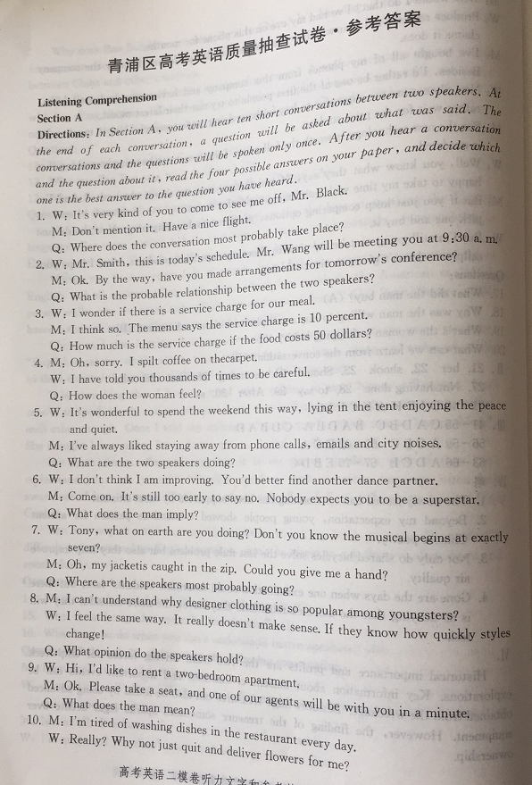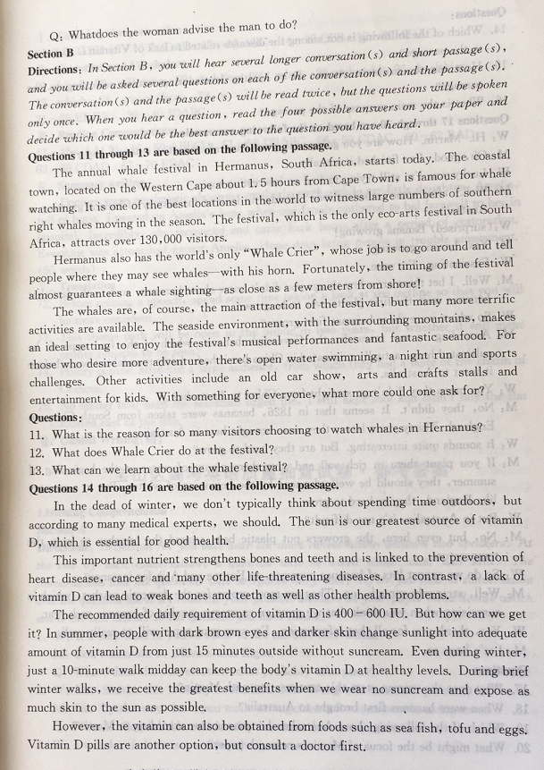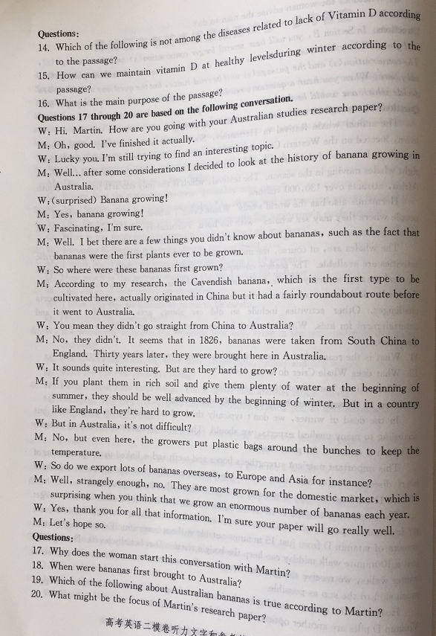
I. Listening Comprehension
1-5DCABB 6-10DCDAD 11-13ABC 14-16CBB 17-20ADAC
II. Grammar and Vocabulary
21. hired 22. will open 23. to bring 24. raises 25. when/if
26. healthier 27. which 28. among/from 29. so 30. a
31-35KEIHG 36-40JDABC
III. Reading Comprehension
41-45CAACD 46-50ABBCD 51-55DBABC 56-69CDAC 60-62BAD 63-66CDAD 67-70EBAC
IV. Summary writing
Doctors were pessimistic about my mother’s stroke while my little daughter, Amelia, full of hope. I passed on Amelia’s hope when our family gathered to bid farewell to her in hospital. Incredibly, she recovered and came back home after a period of restoration. Everyone was astonished except Ameba. Hope does bring people in trouble amazement.(55 words)
V. Translation
72. Before making a speech, spend some time taking a look at the outline so that you will be more confident.
73. This theme park will be open to the public in two years, but whether it will make profits remains to be seen.
74. Poetry contest attracted a large audience, from which they had a taste of the charm of Chinese.
75. No matter how hard the salesman urged me, I still kept cool and didn’t buy the flat located east of the
VI. Guided Writing(略)

