
宝山区2017-2018学年第二学期教学质量监测
高三年级英语学科试卷
2018.4
考生注意：
1.考试时间120分钟，试卷满分140分。
2.本次考试设试卷和答题纸两部分。所有答题必须涂（选择题）或写（非选择题）在答题纸上，做在试卷上一律不得分。
3.答题前，务必在答题纸上填写准考证号和姓名，并将核对后的条形码贴在指定位置上，在答题纸反面清楚地填写姓名。

I. Listening Comprehension
Section A
Directions: In Section A, you will hear ten short conversations between two speakers. At the end of each conversation, a question will be asked about what was said. The conversations and the questions will be spoken only once. After you hear a conversation and a question about it, read the four possible answers on your paper, and decide which one is the best answer
to the question you have heard.
1. A. It goes with her shoes. B. The color suits her.
C. The style doesn’t fit her well. D. It is a little bit expensive.
2. A. It was well organized. B. It was clean.
C. It was messed up. D. It was tidy.
3. A. He has been hiding lately.
B. He has been back home.
C. He has to work hard for travelling expenses.
D. He has been busy preparing his trip.
4. A. On the telephone. B. On the Internet.
C. In an office. D. At the woman’s home.
5. A. He agrees with the woman.
B. He hasn’t been to the play recently.
C. He doesn’t know much about basketball.
D. He doesn’t think the team has been playing well.
6. A. One. B. Two. C. Three. D. Four.
7. A. Finish his term paper. B. Hand in the paper.
C. Read it to the woman. D. Correct the errors in the paper.
8. A. She prefers to exercise in the afternoon.
B. The man should continue with his exercise.
C. It is important to make warming-up exercise.
D. The man should start to exercise one month later.
9. A. He regrets having taken up much of the professor’s time.
B. He has trouble getting along with the professor.
C. He knows the professor has run into trouble.
D. He knows the professor has been busy.
10. A. The plane is full. B. The flight is cancelled.
C. The plane is late. D. The plane has broken down.
Section B
Directions: In Section B, you will hear two passages and one longer conversation. After each passage or conversation, you will be asked several questions. The passages and conversation will be read twice, but the questions will be spoken only once. When you hear a question, read the four possible answers on your paper and decide which one is the best answer to the question you have heard.
Questions 11 through 13 are based on the following passage.
11. A. 16 years old. B. 11years old. C. 5 years old. D. 6 years old.
12. A. The life in London during World War II.
B. Figuring out how to cry on cue (暗示) .
C. Changing his Australian accent.
D. Working with the famous actors
13. A. The possibilities that acting provides.
B. The excitement that playing guitar brings.
C. The life of being accompanied by his mother.
D. The applause he is getting from the audience.
Questions 14 through 16 are based on the following passage.
14. A. A digital image B. A detailed map
C. A developed film D. A useful Facebook
15. A. Public security B. Computer software
C. Special offers D. Customers’ needs
16. A. It will be impossible. B. It will be popular.
C. It will be out of date. D. It will raise concerns.
Questions 17 through 20 are based on the following conversation.
17. A. The man speaker feels guilty. B. The woman speaker feels harmful.
C. Both speakers think it funny. D. Many students dislike the post.
18. A. Unhappy. B. Calm. C. Content. D. Pleased.
19. A. He treated Sam kindly. B. He made fun of Sam.
C. He learned to live with it. D. He pushed Sam downstairs.
20. A. Bullying is uncommon in the school.
B. The man speaker will apologize to Bill about what he posted about Bill.
C. The man speaker was fully convinced by the woman speaker.
D. The woman speaker thinks bullying does students harm in grades.
Ⅱ. Grammar and Vocabulary
Section A
Directions: After reading the passage below, fill in the blanks to make the passage coherent and grammatically correct. For the blanks with a given word, fill in each blank with the proper form of the given word; for the other blanks, use one word that best fits each blank.
How Much of the Jetsons’ World Has Become a Reality?
For most of our readers, The Jetsons may be an unfamiliar name. However, for many American born in or before the 1980s, it is a name we fondly remember. The Jetsons was a popular cartoon that featured a family living in an advanced world ___21___ people settle in houses built in the sky, work only three days a week and drive flying cars that resemble flying saucers. While sky-high houses and three-day workweeks don’t appear to be on the horizon, other visions of the future ___22___（turn）into practical realities.
Flying cars have been on the minds of scientists and inventors for decades. They are part of a typical imaging of the future fast-paced and luxurious, ___23___（allow）us to speed through the skies. As ___24___（see）in The Sky’s No longer the Limit, this flight of fancy may soon be a reality in Dubai. Aiming ___25___（become）the world’s most advanced city, Dubai is currently testing the first-ever flying taxi.
___26___ money still exists in its current cash-based form in The Jetsons, people today are looking toward a world where even cash is out-of-date. Bitcoin is a type of digital money that has taken the world by storm. Since its introduction, the money’s price ___27___（increase）to rates as high as US$ 19,000. This, however, may not predict well for the future of digital currency, as experts warn that Bitcoin is a bubble and ___28___ crash soon. It’s possible that some dreams of the future may still be ___29___ ______ our reach.
Other more probable technologies already exist, for example, future flying eye hospitals in A Hospital with Wings, unusual-engineered folding paper in Clever Folding and the population of endangered corals（珊瑚）in Lab-Bred Coral to the Rescue, etc. All these show ___30___ humans are already capable of. So, what else could the future have in store for us?

Section B
Directions：After reading the passage below, fill in each blank with a proper word given in the box. Each word can be used only once. Note that there is one more word than you need.
A. adapted B. harder C. alternatives D. features E. cooperation F. questions
G. accuracy H. captured I. regardless J. opposite K. analyzing

Computer reads brain activity to find out the music each person is listening to
In the experiment, six volunteers heard 40 pieces of classical music, rock, pop, jazz, and others. The Neural（神经的）fingerprint of each song on participants’ brain was ___31___ by the Magnetic Resonance（MR）machine while a computer was learning to identify the brain patterns drawn out by each musical piece. Musical ___32___ such as tone, volume, rhythm and beat were taken in account by the computer.
After that, researchers expected that the computer would be able to do the ___33___ way: identify which song participants were listening to, based on their brain activity –a technique known as brain decoding. When faced two options, the computer showed up to 85% ___34___ in identifying the correct song, which is a great performance, comparing to previous studies.
Researchers then pushed the test even ___35___ by providing not two but 10 options（e.g. one correct and nine wrong）to the computer. In this situation, the computer correctly identified the song in 74% of the decisions.
In the future, studies on brain decoding and machine learning will create possibilities of communication ___36___ any kind of written or spoken language.“Machines will be able to translate our musical thoughts into songs,”says Sebastian Hoefle, researcher from D’Or Institute and PhD student from Federal University of Rio de Janeiro, Brazil. The study is a result of a ___37___ between Brazilian researchers and colleagues from Germany, Finland and India.
According to Hoefle, brain decoding researches provide ___38___ to understand neural functioning and interact with it using artificial intelligence. In the future, he experts to find answers for ___39___ like“what musical characteristics make some people love a song while others don’t? Is our brain ___40___ to prefer a specific kind of music?”
[来源:学,科,网]
Ⅲ. Reading Comprehension
Section A
Directions：For each blank in the following passages there are four words or phrases marked A, B, C, and D. Fill in each blank with the word or phrase that best fits the context.
Having a clear picture in mind of what their future will look like can motivate students to keep going despite the challenges of college life. This ___41___ seems to be particularly effective for female students from relatively low socioeconomic status（SES）backgrounds says Mesmin Destin of Northwestern University in the US. College is a time of great opportunity for some, but can be ___42___ for others. It is often the first time that many students are away from the regular and familiar support of their family and friends. Weak students from lower SES backgrounds often encounter greater financial and psychological challenges than others, and this can lead to ___43___ and even withdrawal from difficult situations, such as when interacting with their lecturers or taking tests and exams.
Destin and his colleagues wanted to understand if students’ ___44___ to academic challenges improve when they look forward to the future. This idea is built around the theory of identity-based motivation. It holds that people can take positive action during times of unfavorable conditions when they ___45___ a successful future for themselves.
“The theory of identity-based motivation proposes that stimulating a focus on a successful future identity may be especially ___46___ in motivating students who are weak during challenging academic situations to develop a sense of action readiness,”explains Destin. This involves feeling ready and able to take appropriate action when ___47___ difficulty.
In two almost identical laboratory experiments—one involving 93 female students, the other 185 students（including 101 women）-- participants were first asked either to write about their past or their future ___48___. After their deep thoughts, the participants were filmed during an limited interview with a so-called lecturer, and then had to ___49___ a difficult academic test. The research team noted whether participants’ body language was bold and confident, and measured the amount of effort participants’ ___50___ the academic test.
The results were in agreement with the theory of identity – based motivation. Destin and his team found that having a successful future identity can prevent especially female students from lower SES backgrounds from ___51___ during challenging academic situations. Specially, lower SES women who wrote about their future identities displayed greater action ___52___ compared to those who considered their past. They showed more confident body language. It helped them to make more effort to tackle the test, and had an indirect effect on their ___53___.
“Simulating imagined successful future identities appears to provide a ___54___ pathway to enable weak students to effectively navigate everyday stressors,”says Destin.“The findings ___55___ suggest that certain students may benefit from strategies that remind them to image their successful futures before any difficult and important task that they might otherwise be likely to avoid.”

41. A. instruction B. strategy C. challenge D. psychology
42. A. disgraceful B. shameful C. harmful D. stressful
43. A. hesitation B. intention C. depression D. decision
44. A. willingness B. options C. responses D. applications
45. A. destroy B. imagine C. abandon D. substitute
46. A. powerful B. upright C. unique D. ambitious
47. A. avoiding B. overcoming C. surrendering D. encountering
48. A. experience B. suffering C. success D. failure
49. A. design B. complete C. comment D. revise
50. A. put away B. put on C. put out D. put into
51. A. withdrawing B. transforming C. advancing D. engaging
52. A. quantity B. dullness C. readiness D. inability
53. A. fascination B. ignorance C. dilemma D. performance
54. A. tolerable B. potential C. straight D. academic
55. A. therefore B. however C. otherwise D. meanwhile[来源:Z.xx.k.Com]

Section B[来源:学.科.网Z.X.X.K]
Directions：Read the following three passages. Each passage is followed by several questions or unfinished statements. For each of them there are four choices marked A, B, C, and D. Choose the one that fits best according to the information given in the passage you have just read.

（A）
I believe in getting lost. Lost in the text of the novel that is particular to your thoughts and feelings that you consider special. The song that reminds you of your childhood summers, where you close your eyes and lose yourself reliving a memory; feeling the warm wind brushing against your arm, the smell of the dusty sand that you stir up as you ride your bicycle, murmuring the tune of that song. Like the unprepared Sunday Drive, with no destination. You’re free to wander, take paths that you’ve never noticed, discover places you haven’t been. Then falling off on the path to lead you back home, leaving you to test directions and alertly absorb your surroundings in order to find your way back; that kind of lost.
I get lost daily, whether it’s in thought, or the unplanned drive I just decided to go on. Getting lost is an adventurous learning experience that trains you how to be more aware of your surroundings. A few of my most favorite memories involve physically getting lost. That one late night trip back to Ludington from Grand Rapids I took with a few friends. We finally realized we were going the wrong way when we hit South Haven, almost three hours out of our way. There was also the time where I got lost in the De Vos Place in Grand Rapids after the President’s Ball and then the parking garage for a solid two hours. I felt like my life was that one scene of an American television situation comedy, minus the air conditioner. At the time, these are nervous experiences that get your anxiety pumping. You’re fearful that you won’t be safe, but it always works itself out in the end. Physically losing yourself prepares you for how you manage when you emotionally or mentally lose yourself.
You don’t always have to be lost in a literal sense to“get lost”and some of the time, losing yourself may not be a positive experience. There are times where I lose sight of who I am. While lost, I test our metaphorical paths and sometimes they turn out to be the right direction and other times they were a wrong turn. I make note of these wrong turns, so I can avoid them further on up the road of finding my way back to who I am.[来源:Zxxk.Com]
In Walden, Henry David Thoreau wrote“Not till we are lost, in other words not till we have lost the world, do we begin to find ourselves, and realize where we are and the infinite extent of our relations.”Getting lost fuels my curiosity and teaches me lessons on finding my way back to the right track. I believe in getting lost through day dreams, a misplacement, adventures, and difficult times where you make discoveries about yourself and the atmosphere around you. In order to truly find yourself, I believe that you should put down the map and get wonderfully lost.

56. In the first paragraph, the author mainly expresses that ______.
A. lost in a novel is a special feeling B. songs remind us of past experiences
C. wandering is a wonderful discovery D. getting lost brings us benefits
57. The author mentions the experiences of physically getting lost（in paragraph 2）in order to say _______.
A. physically getting lost is most difficult to deal with
B. we can enjoy trips while physically getting lost
C. people are easy to get physically lost in our daily life
D. we realize our surroundings while physically getting lost
58. Words from Henry David Thoreau（in the last paragraph）imply that getting lost ______.
A. enables us to look within and to see outward
B. pulls people back into the previous moment
C. enables us to remind ourselves of adventures
D. helps us enjoy ourselves wherever we are
59. Which of the following might be the best title of the passage?
A. I Once Was Lost B. Wonderfully Lost
C. Physically Getting Lost D. Mentally Getting Lost

（B）
Two in three Americans shower once a day or more, according to a YouGov poll. Here’s why you might be better off showering less frequently（and here are other ways you might be showering wrong）
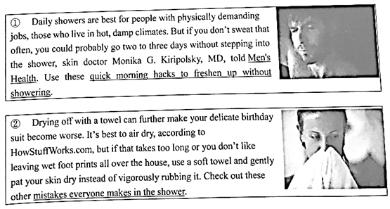
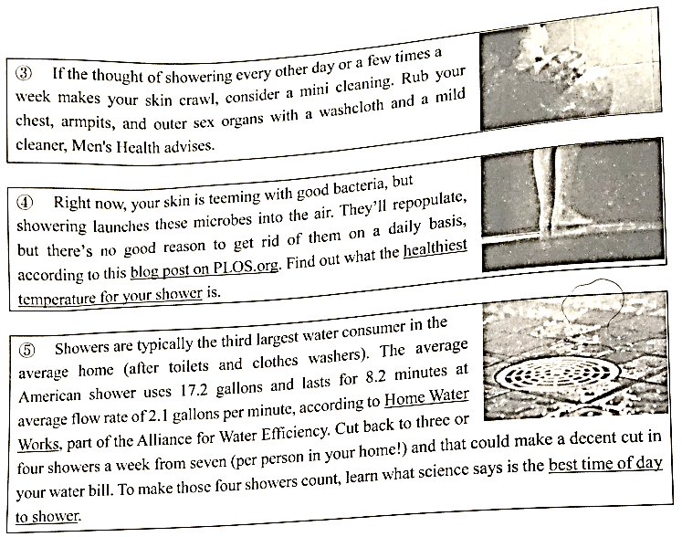

60. What’s the whole passage mainly about?
A. Reasons you can probably get away with showering less.
B. Advice you can take on how to shower more and better.
C. Harmful effects made on you through showering less.
D. Benefits you can get from showering on a daily basis.
61. This passage provides us with the following further detailed information Except ___.
A. the best time of day to shower B. the proper temperature for your shower
C. the other ways you shower wrong D. the other ways to cut your water bill
62. Which of the following is Not a reason why you should shower less?
A. Showering gets rid of good bacteria.
B. You’re absolutely as dirty as you think.[来源:学_科_网Z_X_X_K]
C. Towel drying causes damage to your skin.
D. You only really need to wash your smelly parts.

（C）
Social norms of right and wrong are vital to a well-functioning society. However, such moral standards are changeable and the psychological mechanisms（机制）driving this change are unknown. Now, researchers at Karolinska Institutet report that our view of selfish and unselfish behaviors changes depending on how common they are.[来源:学科网]
The results are based on a combination of behavioral experiments, mathematical models and computer simulations. In the experiments, the participants first observed other people’s behavior in a so-called“public goods game,”in which players receive a sum of money and then choose either to invest it to varying degrees so that it benefits everyone in the group, or to keep it for themselves. After every round, the participants were asked to judge the different choices as morally right or wrong, and whether the choices ought to be punished with a reduction in how much the players gained.
Unselfish behavior was considered more morally right than selfish, but both behaviors were judged to be more moral and less deserving of punishment if the majority exhibited them than if they were uncommon. The commonness of the selfish behavior also affected the participants’ willingness to themselves pay to punish selfishness.[来源:学_科_网Z_X_X_K]
“Tolerance of selfish behavior increased when the majority of the players kept the money for themselves, which surprised me,”says principal investigator Andreas Olsson, senior lecturer at Karolinska Institutet’s Department of Clinical Neuroscience.“The fact that a behavior is common doesn’t automatically mean that it’s right – this idea is based on faulty logic that confuses facts with moral values.”
The study shows our view of what is morally right and wrong has strong similarities with social comformity, in that we tend to adapt ourselves to the people around us and how they behave. This means that changes in our social environment can quickly alter our moral compass.
“This is interesting from several angles, and could explain why moral attitudes change over time, such as those towards public goods or legality,”says Bjorn Lindstrom, postdoc at University of Zurich and Karolinska Institutet’s Department of Clinical Neuroscience.

63. According to Andreas Olsson’s analysis, if people accept selfish behavior, they actually _____.
A. get facts and moral values mixed up B. misunderstand social mechanisms
C. follow the logic of their own D. consider it correct and reasonable[来源:Zxxk.Com]
64. It can be concluded that the participants in the experiments are punished if ______.
A. they can’t play“public goods game”
B. invest the money to benefit group members
C. they behave differently from the majority
D. they keep the money for themselves
65. According to the passage, what is morally right or wrong is shaped by the following Except ___.
A. the way people around us behave B. changes in our social environment
C. personal standards of values and attitudes D. how widespread a particular behavior is
66. Which of the following might be the best title of the passage?
A. The psychological mechanisms behind attitude change
B. Behavior is considered more moral the more common it is
C. Our view of selfish and unselfish behaviors
D. Moral standards of selfish and unselfish behaviors

Section C
Directions：Complete the following passage by using the sentences in the box. Each sentences can only be used once. Note that there are two sentences more than you need.
A. They thus focused on two elements that are typical for contemporary work environments.
B. The researchers used online questionnaires to obtain data.
C. The notion that obtaining external feedback about one’s idea is essential for increasing creativity is deeply rooted in society.
D. The most important in that: when an organization stimulates feedback seeking, it needs to ensure that this work environment is excellent enough to use the benefits of feedback.
E. The question, however, is whether these beneficial effects always occur.
F. The creative achievements were assessed by their direct managers.
[来源:学_科_网Z_X_X_K]
Seeking feedback not always sufficient for stimulating creativity
It is widely believed that seeking feedback from colleagues, managers, friends and family enhances employees’ creativity. But is this always the case? No, a positive effect depends on the work, environment. This is the conclusion of new joint research study led by UvA work and organizational psychologist Roy Sijbom.
___67___ For example, managers are encouraged to engage customers in order to confirm whether their business model is workable and scholars attend conferences to obtain feedback on their research results. A definite assumption is that individuals who have obtained feedback will also actually（be able to）use it.
“The idea is simple: seeking feedback from different sources – also known as feedback source variety – benefits one’s creativity since it leads to a greater diversity of viewpoints”，says Sijbom.“And the more diverse the viewpoints, the more it benefits one’s creativity because by combing all the different viewpoints new perspectives will emerge that in turn will result in more creativity. ___68___”
The researchers examined how specific characteristics of the immediate work environment influence the relationship between feedback source variety and creative performance. ___69___ One is the recognized rate of change of performance standards. The other is the extent to which employees feel they have sufficient time to develop creative ideas at work（experienced creative time pressure）.“We discovered a growing relationship between the search for input from a variety of feedback sources and creativity, but only when performance standards within an organization are changing and when a relatively low creative time pressure is experienced”，says Sijbom.
Sijbom offers several recommendations.“___70___ In a more concrete sense, organizations can, for example, consider using feedback workshops in which employees are encouraged to reflect on diverse feedback and equipped with techniques and strategies on how to absorb feedback in their daily work. In addition, managers should not only stimulate their employees to actively cultivate relationships with potential feedback sources within and outside the organization, but also provide sufficient time to process the feedback obtained from these relationships.”

Ⅳ. Summary Writing
71. Directions: Read the following passage. Summarize the main idea and the main point(s) of the passage in no more than 60 words. Use your own words as far as possible.

Screen-addicted teens are unhappy
A new study explored the link between adolescent life satisfaction and screen time. Researchers found that teens who spent more time in front of screen devices – playing computer games, using social media, texting and video chatting –were less happy than those who invested more time in non-screen activities like sports, reading newspapers and magazines, and face-to-face social interaction.
Total screen avoidance doesn’t lead to happiness either. The greater unhappiness among those with no screen exposure could be due to several factors, Twenge, the leading researcher said.“It could be that they are left out of the social scene of high school, that it’s very difficult to carry on friendships in high school these days without texting at all or being on social media.”It is also possible that those kids are outliers, Twenge said –teens with special needs or in special education, or those whose screens have been taken away from them by parents.
The key to digital media use and happiness is limited use. The happiest teens used digital media a little less than an hour per day. But after a daily hour of screen time, unhappiness rises steadily along with increasing screen time, the researchers report in the journal Emotion.
“Make effort to spend no more than two hours a day on digital media, and try to increase the amount of time you spend seeing friends face-to-face and exercising—two activities reliably linked to greater happiness.”Twenge said.
“By far the largest change in teen’s lives between 2012 and 2016 was the increase in the amount of time they spent on digital media, and the following decline in in-person social activities and sleep,” the leading researcher said.“The arrival of the smartphone is the most reasonable explanation for the sudden decrease in teens’ psychological well-being.”

Ⅴ. Translation
Directions: Translate the following sentences into English, using the words given in the brackets.
72. 我对这场比赛的结果抱乐观态度。（optimistic）

73. 许多人把迟到看作是一个小问题，其实不然。（think）

74. 无人驾驶技术解决了人们的困惑，使开车打电话成为可能。（…it…）

75. 人生中最可怕的不是你即使努力了仍一事无成，而是碌碌无为却以平凡可贵安慰自己。（…not…but…）

Ⅵ. Guided Writing
76. Directions: Write an English composition in 120-150 words according to the picture below.
当你走进教室，发现黑板上画着一幅形象丑陋的漫画，旁边还写着你的名字。你当时是愤怒谴责还是一笑了之?请你写一篇短文，内容包括：
- 根据你的想象简述漫画的内容及此漫画的心情；
- 你当时是选择上述哪一种解决方式并比较说明你选择这种解决方式的理由。

宝山区2017-2018学年第二学期教学质量监测
高三年级英语学科试卷答案
第一大题第1至10小题，每题1分；第11至20，每题1.5分；共25分
1-5 BCDAD 6-10 CDBAC 11-13 BCA 14-16 ADB 17-20 BACD
第二大题每小题1分，共20分
21. where 22. have been /are/ being turned 23. allowing 24. seen
25. to become 26. While/ Though /Although 27. has increased 28. may/ might/ should
29.within 30.to
31. H 32. D 33. J 34. G 35. B 36. I 37. E 38. C 39. F 40. A
第三大题第41题至55小题，每题1分；第56至70小题，每题2分。共45分
41-45 BDACB 46-50 ADCBD 51-55 ACDBA
56-59 DDAB 60-62 ADB 63-66 ACCB 67-70 CEAD
71、略
72-75：
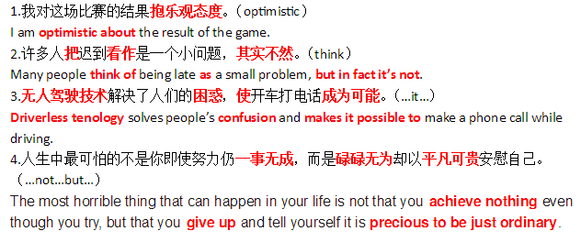
76、写作（略）

