**普陀区**

II. Grammar and Vocabulary

Section A

**Directions:** After reading the passage below, fill in the blanks to make the passage coherent and grammatically correct. For the blanks with a given word, fill in each blank with the proper form of the given word; for the other blanks, use one word that best fits each blank.

Wildlife in Decline

The populations of Earth’s wild vertebrates (脊椎动物）have declined by 58% over the past four decades, according to *the Living Planet Report 2016* published by the World Wildlife Fund.

Climate change and activities such as deforestation and *poaching*（偷猎）are in large part (21)______(blame) for the decline. If the trend continues, by 2020, the world (22)________(lose) two-thirds of its vertebrate biodiversity. “Sadly, there is no sign yet (23)________ this rate will decrease,” the report says.

“Across land, fresh water and the oceans, human activities are forcing wildlife populations to the edge," says Marco Lambertini, director-general of WWF International.

The Living Planet Report is published every two years. It aims to provide an assessment of the state of the world’s wildlife. The 2016 study included 3700 different species of birds, fish, mammals, amphibians and reptiles around the world. The team collected data from more than 3000 sources, including government statistics and surveys (24) ______ (carry) out by conservation groups. They then analyzed (25) ______ the population sizes had changed over time.

Lambertini said some groups of animals had done worse than others. ''We do see particularly strong declines (26) ______ the freshwater environment. For freshwater species alone, the decline stands at 81% since 1970. This is related to the way that water (27)________(use) and taken out of freshwater systems, and also to the *fragmentation*（分裂）of freshwater systems through dam building, for example.”

The report also highlighted other species, such as African elephants, (28) ________ nave suffered huge declines in recent years, and sharks, which are threatened by overfishing.

(29) ________ ________ ________ all the terrifying facts, however, some conservationists say there is still hope. “One of the things that I think is the most important is that these wild animals haven't yet gone extinct,” said Robin Freeman, head of the Zoological Society of London. “On the whole, (30) ________ are not dying out, and that means we still have opportunities to do something about the decline.”

**Section B**

**Directions:** Fill in each blank with a proper word chosen from the box. Each word can be used only once. Note that there is one word more than you need.

|  |
| --- |
| A. contribute B. flows C. fundamental D. lays E. notes F. outline  G. reflect H. respectively I. shared J. serve K. uncertainly |

***Leadership Traits***（特质）

My job puts me in contact with extraordinary leaders in many fields. So I tend to ____31____ a lot on leadership and how we can inspire successful teamwork, cooperation, and partnerships. In my experience, it is clear that the most successful leaders—both men and women—always demonstrate three ____32____(adj.) traits.

**Trustworthiness**

Leaders must set an example of honesty and justice and earn the trust of their teams through their everyday actions. When you do so with positive energy and enthusiasm for shared____33____ goals and purpose, you can deeply connect with your team and customers. A culture of trust enables you to empower employees and ____34____ the foundation for communication, accountability, and continuous improvement.

**Compassion** (共情)

You can't forget that organizational success ____35____ from the hearts and minds of the men and women you lead. Rather than treating your people as you’d like to be treated, treat them as they would like to be treated. Small gestures like choosing face-to-face meetings or sending personal ____36____ can have an enormous impact on the spirits of the teams. In addition to thanks and praise, you must also understand people’s needs, pressures, and individual goals, which will allow you to lead them more effectively and ____37____ to their personal ambitions and professional development.

**Decisiveness**

In times of ____38____ employees long for clarity. As a leader, you won't always have all of the answers—no one expects you to—so you must be open to listening and learning from others. Once you understand a particular challenge and ____39____ the options, you have to be confident in making bold and optimistic decisions.

Successful leadership demands a lifelong commitment to sharpening these three basic skills. Wherever you have the opportunity to ____40____, the qualities of trustworthiness, compassion, and decisiveness are the keys to leadership and organizational success.

Boxing is a popular sport that many people seem to be fascinated by. Newspapers, magazines and sports programmes on TV frequently ____41____ boxing matches. Professional boxers earn a lot of money, and successful boxers are ____42____ as big heroes.

It seems to me that some people, especially men, find it ____43____ because it is an aggressive sport. When they watch a boxing match, they can t ____44____ the winning boxer, and this gives them the feeling of being a t ____45____ themselves. It is a fact that many people have feelings of aggression

**III. Reading Comprehension**

**Section A**

**Directions:** For each blank in the following passage there are four words or phrases marked A, B, C and D. Fill in each blank with the word or phrase that best fits the context.

Boxing is a popular sport that many people seem to be fascinated by . Newspapers , magazines and sports programmes on TV frequently _________boxing matches . Professional boxers earn a lot of money , and successful boxers are _______as big heroes.

It seems to me that people , especially men ,find it _______because it is an aggressive sport . When they watch a boxing match , they can _______ the winning boxer , and this gives them the feeling of being a ______ themselves . It is a fact that many people have feeling of aggression from time to time , but they cannot show their _______in their everyday lives . Watching a boxing match gives them an outlet for this aggression .

However , there is a ______side to boxing . It can be a very dangerous sport . Although boxers wear gloves during the fights , and amateur boxers ______have to wear helmets , there have frequently been accident in both professional and amateur boxing , sometimes with ________consequences . Boxers have suffered from head injuries , and occasionally , fighters have even been killed as a result of being knocked out in the__________. Furthermore , studies have shown that there are often long-term effects of boxing , in the form of serious brain _______,even if a boxer has never been knocked out .

I am personally not at all in ______of aggressive sports like boxing . I think it would be better if less time was _______to aggressive sports on TV, and we welcomed more men and women from non-aggressive sports as our heroes and heroines in our society . I believe that the world is aggressive enough already ! Of course , people like _______sports , and so do I , but I think that ______other people in an aggressive way is not something that should be regarded as a sport.

41. A. broadcast B. cover C. host D. design

42. A. kept B. individual C. thought D. treated

43. A. appealing B. subjective C. violent D. challenging

44. A. pick up B. believe in C. identify with D. long for

45. A. winner B. spectator C. inspector D. trainer

46. A. ambition B. aggression C. energy D. strength

47. A. positive B. indifferent C. deadly D. negative

48. A. otherwise B. somehow C. even D. barely

49. A. dramatic B. eye-catching C. emotional D. special

50. A. court B. ring C. pitch D. yard

51. A. loss B. drain C. damage D. disorder

52. A. favour B. process C. charge D. power

53. A. shifted B. transformed C. given D. delivered

54. A. competitive B. quiet C. cooperative D. regular

55. A. invading B. insulting C. teasing D. hitting

**Section B**

**Directions:**

Read the following three passages. Each passage is followed by several questions or unfinished statements. For each of them there are four choices marked A. B, C and D. Choose the one that fits best according to the information given in the passage you have just read.**(A)**

**Frankenstein**

Frankenstein was a book by Mary Shelly ----it’s been adapted for the screen dozens of times. The story of Frankenstein is told through a series of letters written by Captain Robert Walton to his sister , as he leads an expedition （长征）to the North Pole . On the way , he meets Victor Frankenstein , who tells Walton the story of his life. Frankenstein is the surname of the guy who creates the monster . The monster doesn’t actually have a game . Anyway , Victor is a scientist who’s desperate to discover the secret of life . After years of study , he makes an enormous creature out of human remains and brings it to life . Victor intends it to be beautiful . Unfortunately , the creature turns out really hideous , and Victor runs away in terror . Although the monster is good and kind , humans are scared of it . When they mistreat it , the monster becomes angry and evil . Wanting revenge on its creator , the monster murders Dr. Frankenstein’s brother , his wife , and his best friend . When Victor figures out the monster is behind all the deaths , he swears to track it down and kill it .

This book was written in 1816, right after a period called the Enlightenment . The Enlightenment emphasized the pursuit of knowledge and reason , and gave rise to the scientific method . Mary Shelley criticized the Enlightenment through the character of Victor Frankenstein , “ He is a negative example of an Enlightenment scientist -------he pursues knowledge at any cost , and his obsession with discovering the secret of life destroys him , as well as his friends and family .” Some Enlightenment thinkers might have seen such a loss as necessary for the advancement of science , but not Mary Shelley . She and her husband , poet Percy Shelly , were part of the Romanic Movement in art and literature . Romancism was a reacrion against the Enlightenment’s embrace of rationality and reason . The Romantics emphasized emotion over rationality , and thought people should feel awe and terror in regard to nature . Frankenstein incorporates all these ideas. To Shelley , Frankenstein doesn’t fear and respect the world of nature enough ------she says that by tempering with nature , he brings about complete disaster . Frankenstein is not just a great Romantic novel . It’s also considered one of the first major works of science fiction . It influences a whole generation of writers , and the monster has become one of the most recognizable figures in Western culture.

56. Which of the following is closest in the meaning to ‘hideous’ in Paragraph 1?

A. Unattractive B. Engaging C. Charming D. Handsome

57. What is Victor Frankenstein’s fatal weakness?

A. His love of science B. His rejection of his own creation

C. His lack of respect for nature D. His inability to form human relationship

58. How was the Romantic era different from the Enlightenment ?

A. The Romantic era emphasized emotion ; the Enlightenment emphasized reason .

B. The Romantic era occurred during the 20th century ; the Enlightenment occurred during the 19th century .

C. The Romantic era emphasized poetry ; the Enlightenment emphasized prose .

D. The Romantic era saw major scientific discoveries ; the Enlightenment was an era of literary discovery .

59. What effect did “ Frankenstein” have on later works of fiction ?

A. It inspired books about the Enlightenment B. It inspired technical writing

C. It inspired books of poetry D. It inspired science-fiction writing

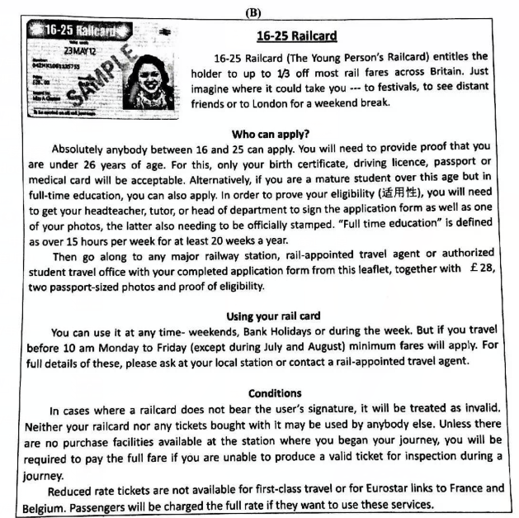

60. If you are a 22-year-old nurse , you can apply for the railcard without ________.

A. the signature of your director B $ 28

C. application form D. passport-sized photos

61. The 1/3 OFF discount may not apply for the railcard holders who travel at _______.

A. 11 pm on Sunday in August B. 7. am on Tuesday in February

C. 7 am on Monday in July D. 11 pm on Friday in March

62. Which of the following is True according to the leaflet ?

A. If you railcard doesn’t have your name signed , it will be used by someone else.

B. The benefits of a railcard are transferable to your friend of your age .

C. If you have no ticket but have boarded a train , you will still be eligible for a discounted ticket

D. If railcard holders wish to use the Eurostar network , they must pay the full fare.

**The ‘ Phone Stack(堆)’Game**

Whenever Michael Carl , the fashion market director at Vanity Fair , goes out to dinner with friends , he plays something, called the “ phone stack” game : Everyone places their phones in the middle of the table ; whoever looks at their device before the check arrives picks up the bill . As smartphones continue to burrow(钻入) their way into our lives , and wearable devices like Google Glass threaten to eat into our person space even further , overburdened users are carving out their own device-free zones with special tricks and life hacks .

“Disconnecting is a luxury that we all need ,” Lesley M. M. Blume , a New York writer keeps her phone away from the dinner table at home .” The expectation that we must always be available to employers ,colleague, family : It creates a real obstacle in trying to set aside private time . But that private time is more important than ever. “ Much of the digital detoxing （戒毒）is centered on the home , where urgent e-mails from co-workers , texts from friends , Instagram photos from acquaintances and updates on Facebook get together to disturb domestic quietness.

A popular method is to appoint a kind of cellphone lockbox , like the milk tin that Brandon Holley , the former editor of lucky magazine , uses. “ If my phones is buzzing or lighting up , it’s still a distraction , so it goes in the box . “, said Ms. Holley , who lives in a row house in Red Hook , Brooklyn , with her son ,Smith , and husband , John .” It’s not something I want my kid to see.” Sleep is a big factor , which is why some people draw the cellphone-free line at the bedroom.” I don’t want to sleep next to something that is a charged ball of information with photos an e-mails ,” said Peter Som , the fashion designer , who keeps his phone plugged in the living room overnight .” “It definitely is a head clearer and describes daytime and sleep time clearly .”

Households with young children are especially mindful about being overconnected , with parents sensitive to how children may imitate bad habits . But it’s not just inside the home where users are separating themselves from the habit . Cellphone overusers are making efforts to disconnect in social settings ,whether at the request of the host or in the form of friendly competition . The phone-stack game is a lighthearted way for friends to police against rude behavior when eating out . The game gained popularity after Brian Perez, a dancer in Los Angeles , posted the idea online.

63. What might be the reason for Michael Carl to play the “ phone stack” game?

A. His friends aren’t willing to pay for the meal voluntarily .

B. He wants to do some funny things with those phones

C. He has been fed up with digital devices being present everywhere

D. The wearable devices have brought threats to his privacy .

64.Why is it difficulty for people to break away from their digital device at home ?

A. Because they have to do some work at home

B. Because they are expected to be always available to the outside

C. Because people have been addicted to digital devices.

D. Because digital devices can enrich people’s family life.

65. What does Peter Som do to ensure his sleeping quality at night ?

A. He puts his phone in the living room .

B. He ignores any information in the phone

C. He deletes all information in his phone

D. He puts his phones in a lockbox

66. Why does the phone-stack game become popular as soon as it is posted online?

A. The game helps create a harmonious relationship among friends.

B. The game makes the host get along well with the guest

C. The game can prevent children from imitating their parents’ behavior

D. The game meets people’s demand for keeping away from phones easily

**Section C**

**Directions:** Read the following passage. Fill in each blank with a proper sentence given in the box. Each sentence can be used only once. Note that there are two more sentences than you need.

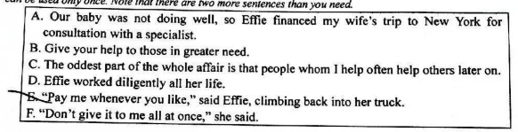

“Any apple today ?”, Effie asked cheerfully at my window ,. I followed her to her truck and bought a kilo . On credit , of course . Cash was the one thing in the world I lacked just them .

All pretense （借口）of payment was drooped when our funds , food and fuel decreased to alarming lows. Effie came often , always bringing some gift: a jar of peaches or some firewood . There were other generosities.___________

Effie was not a rich woman . Her income , derived from investment she had made while running an interior decorating shop , had never exceeded $200 a month , which she supplemented by selling her apples .But she always managed to help someone poorer .

Years passed before I was able to return the money Effie had given me from time to time . She was ill now and had aged rapidly in the last year .” Here , darling , “ I said , “ is what I owe you ,” _____________” Give it back as I gave it to you -----a little at a time.” “ I think she believed there was magic in the slow discharge of a love debt.

The simple fact is that I never repaid the whole amount to Effie , for she died a few weeks later . By now , the few dollars Effie gave me have been multiplied many times . But a curious thing began to happen .

___________At that time , it seemed that my debt would forever go unsettled . So the account can never be marked closed , for Effie’s love will go on in hearts that have never known her .