**Description of Software’s Major features**

The primary function of the By Default question system is to provide a simple way for students to ask their professor/TA’s a question without needing to send them an email.

Students receive an email at the start of the semester from the system that directs them to register an account (if there is not already an account attached to their email) which will automatically add the student to the class that the email was sent for. The student will then be able to send questions to their instructors so that they can respond to them. They are also able to view the public FAQ and all of the questions they have asked in the class they are currently viewing.

The instructor is able to log in with an account created for them by an admin and then are able to respond to open questions sent to the class they are currently viewing. The instructor is also able to select to add a question to the public FAQ for their class at the time that they respond to a student’s question. They are also able to view all of the questions that they have responded to.

The admin is able to create instructor accounts, send the mass registration email to students at the beginning of a semester, as well as edit some of the personal information pertaining to users.

**Sign in form (used on login page)**

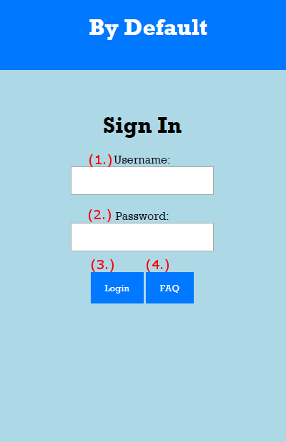

1. Username text field
2. Password text field
3. Login button, pressed after username and password are entered
4. Link to FAQ

**Banner/Navigation form (used on all pages except login)**



1. Link to home page for currently logged in user.
2. Link to view questions page for current user. Only visible for students and instructors.
3. Link to FAQ page. Visible to all users regardless of login state.
4. Login/Logout button. It is displayed as login when not logged in and displayed as logout when logged in.

**FAQ Class Select (used on the FAQ’s landing page)**

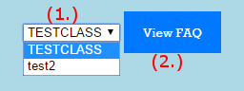

1. Drop down class selection.
2. Link to FAQ for selected class.

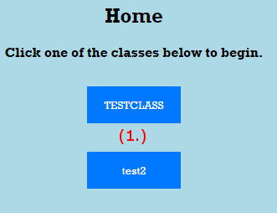**Homepage Class Selection (used on instructor and student home pages)**

1. Displays the names of classes that the user is currently connected to. Links to the ask question form for students and the response form for instructors.

**Ask Question Form (used on ask question page)**

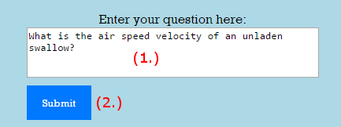

1. Text area where the student can enter their question.
2. Submit button which will add the question to the database and allow it to be answered by an instructor.

**Instructor Question Selection (used on question selection page)**

1. Link to response page for the corresponding question. Each open question will have a table row with a link of this type.

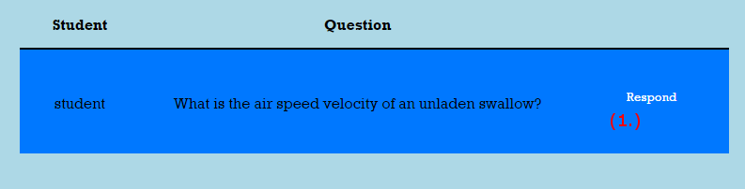

**Response Form (used on instructor response page)**

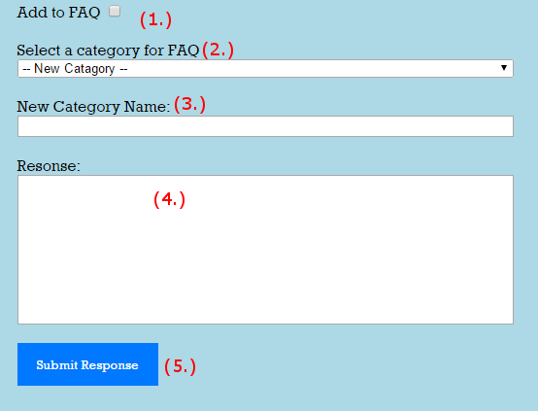

1. Checkbox that allows parts 2 and 3 to be read.
2. Dropdown selection for which category the question should be added to (only functional when 1 is checked)
3. Text box for a new category (only functional when 1 is checked and 2 is set to -- New Category --).
4. Area where the instructor’s response is typed.
5. Submit which will add the response to the question and set the category if the appropriate fields are set (1 is checked).

**Create Instructor Form (used on add instructor page)**

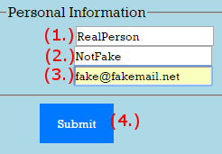

1. Text box for first name of new instructor.
2. Text box for last name of new instructor.
3. Text box for email address of new instructor.
4. Submit button that creates the new instructor.

**Batch Enroll New Students (used on add students page)**

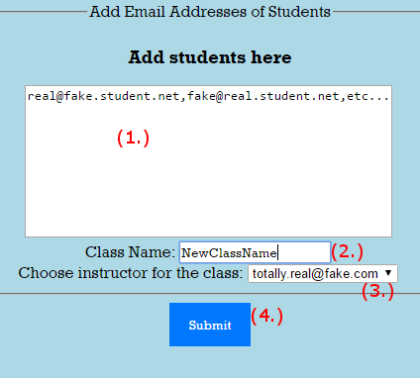

1. Text Area where the admin will enter the emails of the new students that are to be added to the class
2. Text box for the name of the new class to be created.
3. Dropdown area to select an instructor for the new class.
4. Submit button that will send the registration emails and create the new class.

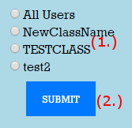

**Edit Users, Select Class Form (used on edit/review users page)**

1. Radio buttons what will allow the admin to view users by specific class or all users.
2. Submit button that will take the admin to the page for the selected option.

**Edit Users, Select User Form (used on edit/review users page)**

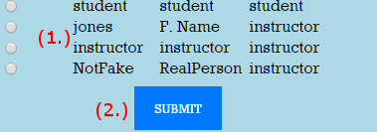

1. Radio buttons that will allow the admin to select the corresponding user.
2. Submit button that will take the admin to the page for editing the user information of the selected user.

**Edit User Form (used on the edit user page)**

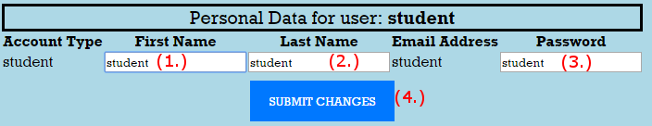

1. Text box where the new first name can be entered.
2. Text box where the new last name can be entered.
3. Text box where the new password can be entered.
4. Submit button that saves the changes made to the selected user.

**Scrum Minutes**

**October 6th, 2016**

**DAILY SCRUM MEETING**

The meeting was called to order and all members of the team were present.

Topics discussed at this meeting were:

1. Scrum Master selected: Zachary Resler will serve as our Scrum Master for Sprint 0.
2. User Stories: all team members will generate a list of user stories to discuss at our weekly meeting this Friday. From that, the team will develop our final set of PBI’s to present to the Product Owner, Mr. Rock.
3. Task Board: We decided to formalize our task board at the weekly meeting tomorrow.
4. HTML/CSS: Ian suggested that we appoint only one individual from the team to handle the CSS portion of the code. That will insure that the styling of each page will be consistent throughout. The team agreed to that and will make it a point of order in our Friday meeting.
5. Use Cases: Clarification was again made as to the distinction between use cases and user stories.

**October 7th, 2016**

**WEEKLY MEETING**

Location: Golda Meir, LC W111 Conference Room

All team members were present at the meeting.

Matters discussed included:

1. We became more familiar with our joint Trello account, the site our team has selected for use of their Scrum management tools. Our initial task board was completed.
2. We went over all of our user stories. Each of us compiled a list and we vetted the best user stories to become our PBI’s. Individual member tasks were assigned to the team to satisfy Sprint 0.
3. The team spent time discussing the implementation plan for each of our web pages associated with the project. We concluded that we will need at least 8 screens for the project. We assigned one member of our team to implement the .css files that will join our .html.

**October 11th, 2016**

**DAILY SCRUM MEETING**

The meeting was called to order and all members of the team were present.

Topics discussed at this meeting were:

1. We discussed the task board with our Product Owner. From his input, we agreed to revise it to meet the specifications that were described. This will be done at Friday's weekly meeting. We will submit a new task board after the board is re-drafted.
2. Each team member gave an update on their tasks.
3. A reminder was made that all tasks that were assigned at the last weekly meeting is to be completed by the evening of Wednesday, 10/12, so that Ian can create uniform styling  with CSS to all of the .html files.
4. A presentation will be made to the Product Owner at the conclusion of our weekly meeting on Friday. It will be done via email with all team members included in the distribution.

**October 13th, 2016**

**DAILY SCRUM MEETING**

The meeting was called to order and all members of the team were present.

Topics discussed at this meeting were:

1. Ian announced that he has completed styling four of the .html files with CSS.
2. We discussed integrating all of the .html with a single CSS style sheet. Which will require changing the .html pages as needed so that they share common attributes.
3. Specifications of the Student Home Page and the Instructor Home page was brought up today. There was uncertainty as to whether the instructor should have the ability to edit and delete from the FAQ. The Product Owner declared that he does want that capability within the project.
4. Consideration was made for a cool name for the project.
5. At tomorrow's weekly meeting, consideration will be made as to how we'll conduct the Sprint Review Meeting schedule for next Tuesday.

**October 14th, 2016**

**WEEKLY MEETING**

Location: Golda Meir, LC W111 Conference Room

All team members were present at the meeting.

1. The team spent much of the time creating a organizational chart of the relationships between the various web pages that comprise our FAQ System.
2. We added additional web pages to our system to define unique steps in the login process. A separate login screen now combines with the System Home Page, for instance.
3. The team developed our ideas for our Sprint 0 Review Meeting to be held in the upcoming week.
4. Tasks were distributed to each member and deadlines were set to accomplish them.

**October 27th, 2016**

**DAILY SCRUM MEETING**

All team members were present at the meeting.

Topics discussed were:

1. Developed more realistic timeframes for our tasklist.

2. Scrum Master was selected as Ian.

3. Re-worded many of our user stories.

**November 3rd, 2016**

**DAILY SCRUM MEETING**

All team members were present at the meeting.

Topics discussed were:

1. Zack posted an alpha version of his code on the shared drive

2. Jay will upload his code as he is unable to make the weekly meeting.

**November 8th, 2016**

**DAILY SCRUM MEETING**

All team members were present at the meeting.

Topics discussed were:

1. Updated our taskboard.

2. Damien combined the code of all of the group into one. A big contribution.

3. Edited the burn-down chart.

4. Revised the backlog items for the next sprint.

5. Discussed the proper use of test cases in our code and the need to revise as necessary.

**November 10th, 2016**

**DAILY SCRUM MEETING**

All team members were present at the meeting.

Topics discussed were:

1. Discussed adding more testing to our project,

2. The Registration section of the project has yet to be completed. Ron will have the completed code by next week Monday.

3. Made changes to the backlog.

4. Weekly meeting scheduled for tomorrow at 10:00 AM at the library conference room.

**November 11th, 2016**

**WEEKLY MEETING**

* Groomed the backlog, refined some of the items in order to make them more specific
* Clarified the acceptance criteria for each backlog item
* Created tasks for each backlog item
* Assigned tasks to complete over the following week

**November 15th, 2016**

**DAILY SCRUM MEETING**

All team members were present at the meeting.

Topics discussed were:

1. Registration module is nearly complete.

2.  Idea for meeting before next tuesday (11/22) in order to go over the presentation

3. most are in the process of making unit tests for modules

4. Weekly meeting scheduled for friday at 10:00 AM at the library conference room.

**November 18th, 2016**

**WEEKLY MEETING**

* Discussed current status of project
* Went over the html test runner
* set a meeting date for monday to discuss the presentation

**November 29th, 2016**

**DAILY MEETING**

* Created new PBIs for sprint 3

**December 1st, 2016**

**DAILY MEETING**

* Discussed ways to standardize all of the html pages

**December 2nd, 2016**

**WEEKLY MEETING**

* Refined PBIs for sprint 3

**PBIs**

**Categorize FAQ**

**Description:** System that allows instructors to store selected questions and allows students to view said questions regardless of login state.

**Acceptance Criteria:** As an Instructor, I would like each question to have exactly one category so that answers can be found easier by students

**Instructor Registration System**

**Acceptance Criteria:**

1. Instructor can enter student ID's to create their base accounts and send them a key so that they can be added to the class.

**Categories in Answer System**

**Description:** As an Instructor, I would like to be able to create new question categories.

**Acceptance Criteria:**

1. Instructors can create new FAQ categories
2. Questions in the FAQ have a category.
3. questions not in the FAQ do not have a category
4. unanswered questions do not have a category

**Answer a Question**

**Description:** As an Instructor, I would like to be able to respond manually to uncommon questions since the FAQ will not contain the necessary answer.

**Acceptance Criteria:**

1. Instructor can respond to a question manually
2. Instructor can create a new category to an answer
3. Instructor can set a previously created category to an answer

View previous answers/questions

Decription: As a student, I would like to be able to view any responses to questions I have asked the professor.

Acceptance Criteria:

1. Student can see any questions they have previously sent
2. Student can only see the questions for the class they are currently looking at
3. Student can only see their questions

View previous answers

Description: As a student, I would like to be able to view any responses to questions I have asked the professor.

Acceptance Criteria:

1. Student can view answers to questions they have asked

View questions

Decr: As an Instructor I can view questions sent to me by students.

AC:

1. User can view questions sent to them.
   1. User cannot see questions not sent to them

View faq w/o login

D: As a Student, I would like to be able to view the FAQ section of the site without needing to log in.

AC:

* 1. All users can view FAQ
  2. All users will have to select a class in order to look at the FAQs for a given class
  3. The FAQ will be ordered by category

Student Registration System

D: As an Instructor, I shall use student ID’s to set up students to register so that they will be able to set up an account on the site.

AC:

* 1. Student can enter a key (sent to them by email) that will add them to a class
  2. Students that enter a "bad" code, will see an error message and they wont be added to any class.
  3. Students can edit their account information.