Chapters 20-21 HW (Circuits)
2026-04-03
This HW is due on Test Day, TEST DATE.

Questions and figures are from OpenStax College Physics, 2e (Chapter 20-21) unless otherwise noted.

Ohm’s Law Problems (Chapter 20)
2
- (P2) A total of 600 C of charge passes through a flashlight in 0.500 h. What is the average current?
- (P18) What current flows through the bulb of a 3.00-V flashlight when its hot resistance is 3.60 Ω?
- (P21) How many volts are supplied to operate an indicator light on a DVD player that has a resistance of 140 Ω, given that 25.0 mA passes through it?

Circuits Concepts
- (CQ2) Car batteries are rated in ampere-hours ( A h). To what physical quantity do ampere-hours correspond (voltage, charge, current, resistance, etc), and what relationship do ampere-hours have to energy content?
- (Original Question) Is current directly proportional or inversely proportional to voltage? Why does this make sense?

Equivalent Resistance Problems (Chapter 21)
2
- (P2) (a) What is the resistance of a 100-$Ω$, a 2.50-k$Ω$ , and a 4.00-k$Ω$ resistor connected in series? (b) In parallel?
- (P3) What are the largest and smallest resistances you can obtain by connecting a 36.0-$Ω$, a 50.0-$Ω$, and a 700-$Ω$ resistor together?
- (Original Problem) Find the current going through the battery in the circuit shown in Figure 1.
- Original Figure.
- (Giancoli Ch 19 P16) Determine (a) the equivalent resistance of the circuit shown in Figure 2, (b) thee voltage acros each resistor, and (c) the current through each resistor.
- 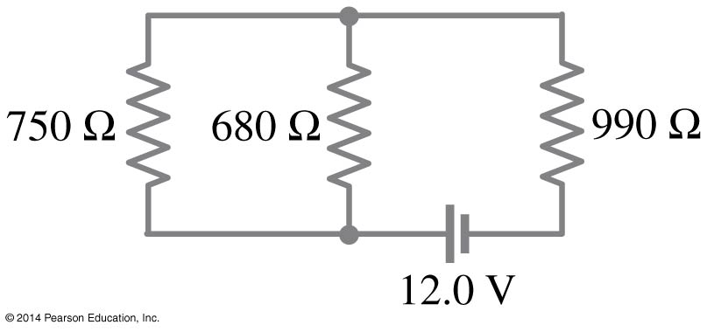
- Giancolli Figure 19-48.

Equivalent Resistance Concepts
- (Original Question) What happens to resistance when bulbs are wired in series? Why does this make sense?
- (Original Question) What happens to resistance when bulbs are wired in parallel? Why does this make sense?

2
- (P1) (a) What is the resistance of ten 275-$Ω$ resistors connected in series? (b) In parallel?
- (Original Problem) Find the current going through the battery in the circuit shown in Figure 3.
- Original Figure.

Bonus
- Calculate the equivalent resistance of a cube that has a 1-ohm resistor along each edge, as shown in Figure 4,
- Original Figure. Each resistor has a value of 1 Ω

Equations

Electrostatics Equations
$$\begin{aligned}F&=\frac{kq_{1}q_{2}}{r^{2}}&E&≡\frac{F}{q}=\frac{kq}{r^{2}}&V&≡\frac{PE}{q}=-\frac{W}{q}\end{aligned}$$

Circuits Equations
$$\begin{aligned}I&≡\frac{Δq}{t}&V&=IR&P&=IV=I^{2}R=\frac{V^{2}}{R}\end{aligned}$$
$$\begin{aligned}R_{eq}&=R_{1}+R_{2}+⋯&\frac{1}{R_{eq}}&=\frac{1}{R_{1}}+\frac{1}{R_{2}}+⋮\end{aligned}$$

Unit Conversions
$$\begin{aligned} × {10}^{3} mC&=1 C& × {10}^{6} \text{μ}C&=1 C& × {10}^{9} nC&=1 C\end{aligned}$$

Constants
Coulomb Constant | $$k=9.0 × {10}^{9} \text{Nm/C}​^{2}$$
Charge of electron/proton | $$e=±1.60 × {10}^{-19} \text{C}$$
Electron mass | $$m_{e}=9.11 × {10}^{-31} \text{kg}$$
Proton mass | $$m_{p}=1.673 × {10}^{-27} \text{kg}$$
Neutron mass | $$m_{n}=1.675 × {10}^{-27} \text{kg}$$

Selected Answers
2

