Chapter 7 Homework (Work & Energy)
Questions and figures are from OpenStax College Physics, 2nd ed, (Chapter 7) or Giancolli Physics: Principles with Applications, 7th ed, (Chapter 6) unless otherwise noted. unless otherwise noted.
- (P1) How much work does a supermarket checkout attendant do on a can of soup he pushes 0.600 m horizontally with a force of 5.00 N? Express your answer in joules and kilocalories.
- (P2) A 75.0-kg person climbs stairs, gaining 2.50 meters in height. Find the work done to accomplish this task. (Neglect friction in your calculations.)
- (P6) How much work is done by the boy pulling his sister 30.0 m in a wagon as shown in Figure 1? Assume no friction acts on the wagon.
- 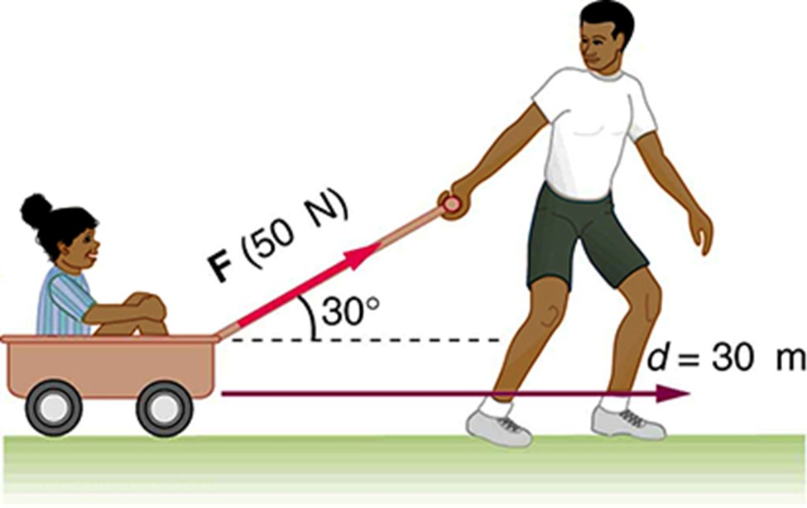
- (OpenStax Figure 7.33) The boy does work on the system of the wagon and the child when he pulls them as shown.
- Bonus (Giancolli P7) In a certain library, the first shelf is 15.0 cm off the ground, and the remaining four shelves are each spaced 38.0 cm above the previous one. If the average book has a meass of 1.40 kg with a height of 22.0 cm, and an average shelf holds 28 books (standing vertically), how much work is required to fill all the shelves, assuming the books are all laying flat on the floor to start?
- (Giancolli CQ2) Can a centripetal force ever do work on an object? Explain.
- (Giancolli CQ4) Can the normal force on an object ever do work? Explain.
- (Giancolli MC1) You push very hard on a heavy desk, trying to move it. You do work on the desk in which of the following situations?
- (Original Question) What is the speed of a 1500-kg airplane with 7,350,000 J of Kinetic Energy?
- (P10) (a) How fast must a 3000-kg elephant move to have the same kinetic energy as a 65.0-kg sprinter running at 10.0 m/s? (b) Discuss how the larger energies needed for the movement of larger animals would relate to metabolic rates.
- (Giancolli P16) (a) If the kinetic energy of a particle is tripled, by what factor has its speed increased? (b) If the speed of a particle is halved, by what factor does its kinetic energy change?
- (Original Question) Two cars are traveling down the highway. Car #1 has three times speed as Car #2, but Car #2 has four times the mass of Car #1. Which car has the larger kinetic energy, and by how much?
- (Original Diagram) Car #1 has three times speed as Car #2, but Car #2 has four times the mass of Car #1.
- (P16) A hydroelectric power facility (see Figure 3) converts the gravitational potential energy of water behind a dam to electric energy. (a) What is the gravitational potential energy relative to the generators of a lake of volume 50 km³ (mass = 5.00 × 10¹³ kg), given that the lake has an average height of 40.0 m above the generators? (b) Compare this with the energy stored in a 9-megaton fusion bomb (3.8 × 10¹⁶ J).
- 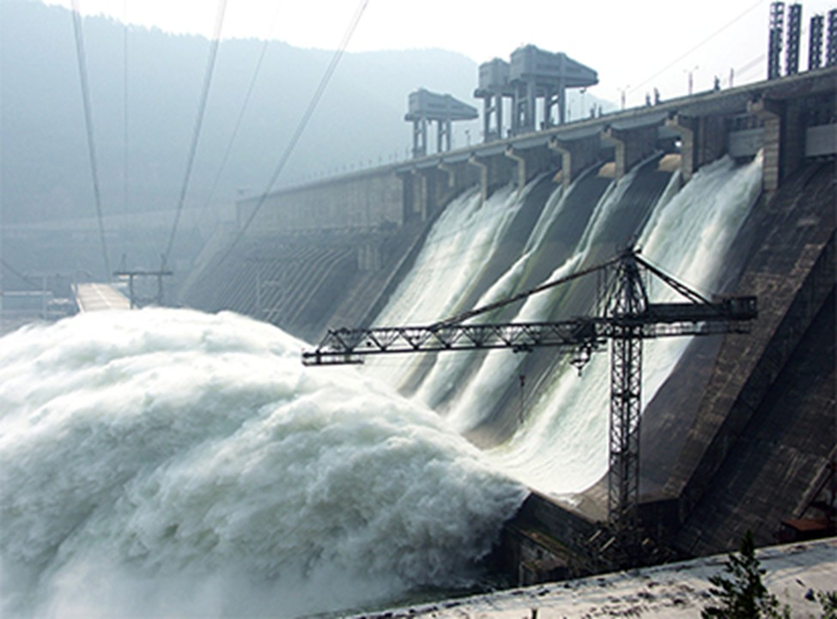
- (OpenStax Figure 7.35) Hydroelectric facility (credit: Denis Belevich, Wikimedia Commons)
- (Giancolli P27) A spring has a spring constant $k$ of 88.0 N/m. How much must this spring be compressed to store 45.0 J of potential energy?
- (Original Question) Calculate the total mechanical energy of a 0.56-kg football thrown. At the top of its flight, it has a speed of 22 m/s and it is 6.8 m off the ground.
- (CQ9) What is a conservative force?
- (CQ8) Does the work you do on a book when you lift it onto a shelf depend on the path taken? On the time taken? On the height of the shelf? On the mass of the book?
- (CQ12) What is the relationship of potential energy to conservative force?
- (Original Question) A 1750-kg car is initially at rest on a flat surface. The driver accelerates the car, covering a distance of 87 meters. The net force acting on the car averages out to 4800 Newtons. What is the final velocity of the car?
- (P22) A 5.00 × 10⁵ kg subway train is brought to a stop from a speed of 0.500 m/s in 0.400 m by a large spring bumper at the end of its track. What is the force constant $k$ of the spring?
- (Giancolli P38) A 62-kg trampoline artist jumps upward from the top of a platform with a vertical speed of 4.5 m/s. (a) How fast is he going as he lands on the trampoline, 2.0 m below (Figure 4)? (b) If the trampoline behaves like a spring of spring constant 5.8 × 10⁴ N/m, how far down does he depress it?
- 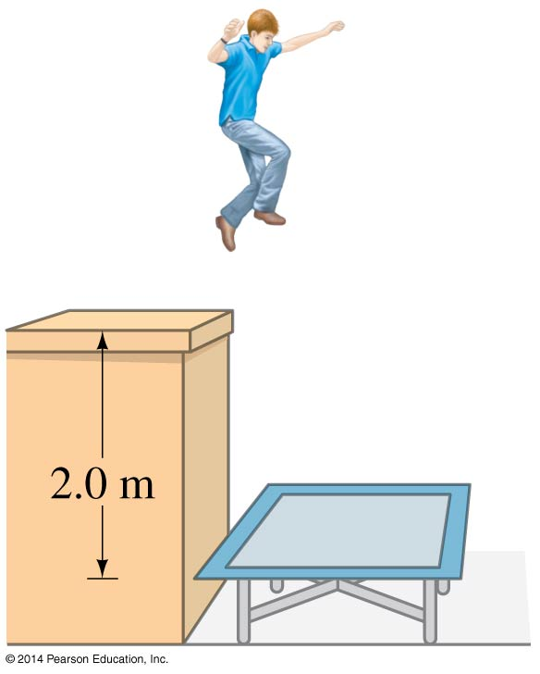
- Giancolli Figure 6-40
- (Original Question) A roller coaster of mass 1000 kg starts from rest at the top of a 50 m hill, as shown in Figure 5. The tracks are frictionless. (a) How fast is it going when it gets to the ground. (b) How fast is it going when it gets to the top of the next hill, which is 35 m tall? (c) Now, let’s add friction to this problem. With friction, the roller coaster does not make it to the top of the second hill; instead, it only reaches a height of 32 m before stopping. How much work is done by friction?
- (Original Diagram) A roller coaster.
- Bonus (Giancolli P41) Chris jumps off a bridge witha bungee cord (a heavy stretchable cord) tied around his ankle, as shown in Figure 6. He fall for 15 m before the bugee cord begins to stretch. Chris’s mass is 75 kg and we assume the cord obeys Hooke’s law with $k=55$ N/m. If we neglect air resistance, estimate the distance $d$ below the bridge Chris’s foot will be before coming to a stop. Ignore the mass of the cord (not realistic, however) and treat Chris as a particle
- 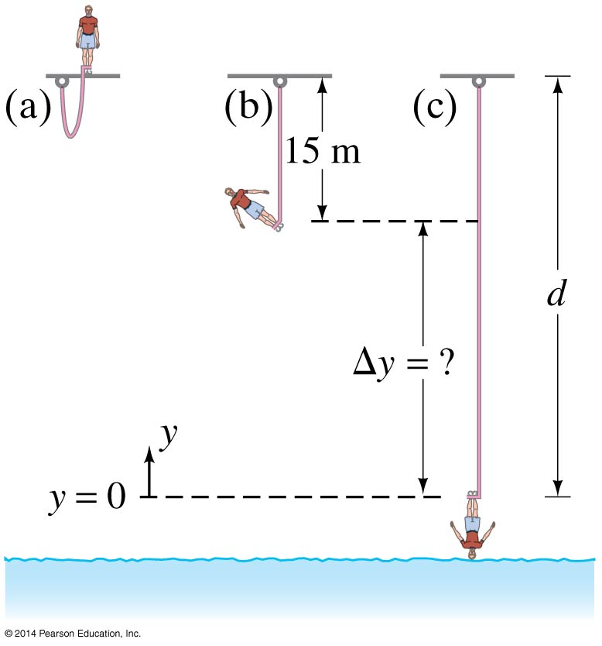
- (Giancolli Fig 6-42) (a) Bungee jumper about to jump. (b) Bungee cord at its unstretched length. (c) Maximum stretch of cord
- (Giancolli CQ13) What happens to the gravitational potential energy when water at the top of a waterfall falls to the pool below?
- (Giancolli MC9, modified) Two balls are thrown off a building with the same speed, one straight up and one at a 45$​^{∘}$ angle. Which ball will have the greater final speed just before it hits the ground?
- (Giancolli MC10, modify) A skier starts from rest at the top of each of the hills shown in Figure 7. There is no friction. Rank the final velocities of the skier at the bottom of each hill
- 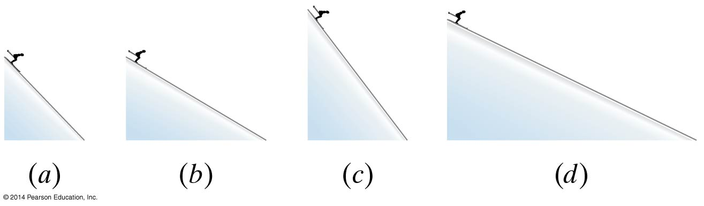
- Giancolli Figure 6-34
- (P40) (a) What is the available energy content, in joules, of a battery that operates a 2.00-W electric clock for 18 months? (b) How long can a battery that can supply 8.00 × 10⁴ J run a pocket calculator that consumes energy at the rate of 1.00 × 10⁻³ W?
- (Giancolli P57) How long will it take a 2750-W motor to lift a 385-kg piano to a sixth-story window 16.0 m above?
- (Giancolli P60) If a car generates 18 hp when traveling at a steady 25 m/s, what must be the average force exerted on the car due to friction and air resistance? ($1 hp=746 W$)
- Bonus! (P61) A 75.0-kg cross-country skier is climbing a ${3.0}^{∘}$ slope at a constant speed of 2.00 m/s and encounters air resistance of 25.0 N. Find his power output for work done against the gravitational force and air resistance. (b) What average force does he exert backward on the snow to accomplish this? (c) If he continues to exert this force and to experience the same air resistance when he reaches a level area, how long will it take him to reach a velocity of 10.0 m/s?
- (CQ18) Most electrical appliances are rated in watts. Does this rating depend on how long the appliance is on? (When off, it is a zero-watt device.) Explain in terms of the definition of power.

