**LAB –**

**Designing a Ball Measurement Lab**

|  |  |  |  |
| --- | --- | --- | --- |
| **Pre-lab:**   1. What can we measure on the different balls? Make a list of as many things as possible.  * Circumference * Diameter * Radius * Surface Area * Volume * Bounce Height * Weight  1. Identify each of the following (there may be more than one).  |  |  |  | | --- | --- | --- | | Independent Variables   * Drop height * Type of ball | Dependent Variables   * Bounce height | Control Variables   * Surface (ground) * Initial Force (zero) | |

**Purpose:**

To determine how drop height and type of ball will affect bounce height.

**Procedure:**

Materials:

* Your group needs: two different balls, one meter stick
* Everybody needs: a computer to take data.

When you are ready to start the experiment:

* Drop the ball
* Stand back and watch how high the ball bounces
* Record the Data

**Data:**

Experiment #1: Drop height vs. bounce height for a golf ball

Constant: Ball type = golf ball

|  |  |  |  |  |
| --- | --- | --- | --- | --- |
| Drop Height (cm) | Bounce Height (cm) | | | |
| Trial #1 | Trial #2 | Trial #3 | Average |
| 100 | 83cm | 82cm | 84cm | 83cm |
| 90 | 73cm | 71cm | 75cm | 73cm |
| 80 | 67cm | 67cm | 66cm | 66.7cm |
| 70 | 60cm | 61cm | 59cm | 60cm |
| 60 | 53cm | 51cm | 52cm | 52cm |

Experiment #2: Drop height vs. bounce height for a ball-pit ball

Constant: Ball type = ball-pit ball

|  |  |  |  |  |
| --- | --- | --- | --- | --- |
| Drop Height (cm) | Bounce Height (cm) | | | |
| Trial #1 | Trial #2 | Trial #3 | Average |
| 100 | 45cm | 34cm | 42cm | 40.3 |
| 90 | 37cm | 39cm | 35cm | 37cm |
| 80 | 35cm | 38cm | 38cm | 37cm |
| 70 | 32cm | 33cm | 30cm | 31.7 |
| 60 | 29cm | 29cm | 28cm | 28.7 |

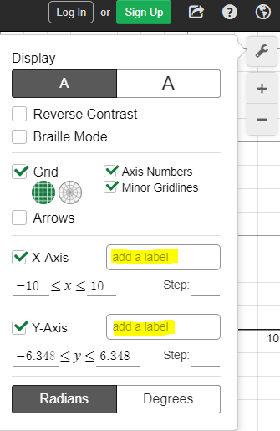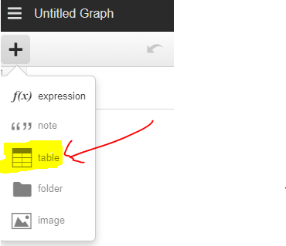**Graph:**

Go to [www.desmos.com/calculator](http://www.desmos.com/calculator) to graph your data.

1. Start by making a table by clicking the “+” icon at the top left (see Figure 1).
2. Make sure to label the axes using the wrench icon at the right. (see Figure 2).
3. Zoom out so that you can see the whole graph and so that it fills the page.
4. 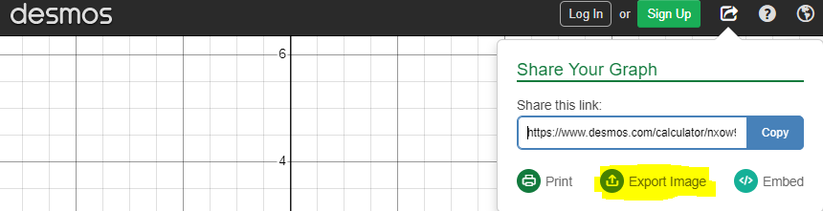Create two best fit lines by graphing the equations:

Figure 3

Figure 2

Figure 1

$y1\sim m1x1+b1$

$y2\sim m2x2+b2$

1. Copy a picture of your graph using the export button. Click “Export Image”. (see Figure 3). Right click the image then click “copy”. Paste the image in this document
2. Also, copy and paste the “share this link” link in the export button. This will be helpful if you need to make adjustments to your graph later.

|  |
| --- |
| Copy a picture of your graph below: |
|  |
| Shared Graph Link: <https://www.desmos.com/calculator/zfjkqyh74s> |
| **Legend/Key:**  Make a key for your graph. What do the colors represent?   * Green = golf ball * *Purple = ball pit ball* |
| **Best Fit Lines:**  What are the equations of each best fit line?  Line 1: y=0.75x+6.94  Line 2: $y=0.285x+12.14$ |

**Conclusion Questions:**

What is the physical meaning of these best fit lines?

They are comparing how high each ball bounced based off of where it was dropped from. Steeper lines mean the ball is ‘bouncier’.

Why was it important to draw a best fit line?

There are many data points. The best fit line summarizes the data points into one number (the slope).