**LAB –**

**Designing a Ball Measurement Lab**

|  |  |  |  |
| --- | --- | --- | --- |
| **Pre-lab:**   1. What can we measure on the different balls? Make a list of as many things as possible.  * Click or tap here to enter text.  1. Identify each of the following (there may be more than one).  |  |  |  | | --- | --- | --- | | Independent Variables   * Click or tap here to enter text. | Dependent Variables   * Click or tap here to enter text. | Control Variables   * Click or tap here to enter text. | |

**Purpose:**

Click or tap here to enter text.

**Procedure:**

Materials:

* Your group needs: two different balls, one meter stick
* Everybody needs: a computer to take data.

When you are ready to start the experiment:

* Drop the ball
* Stand back and watch how high the ball bounces
* Record the Data

**Data:**

Experiment #1: Click or tap to enter title here.

Constant: Click or tap to enter any constants here.

|  |  |  |  |  |
| --- | --- | --- | --- | --- |
| Drop Height (cm) | Bounce Height (cm) | | | |
| Trial #1 | Trial #2 | Trial #3 | Average |
|  |  |  |  |  |
|  |  |  |  |  |
|  |  |  |  |  |
|  |  |  |  |  |
|  |  |  |  |  |

Experiment #2: Click or tap to enter title here.

Constant: Click or tap to enter any constants here.

|  |  |  |  |  |
| --- | --- | --- | --- | --- |
| Drop Height (cm) | Bounce Height (cm) | | | |
| Trial #1 | Trial #2 | Trial #3 | Average |
|  |  |  |  |  |
|  |  |  |  |  |
|  |  |  |  |  |
|  |  |  |  |  |
|  |  |  |  |  |

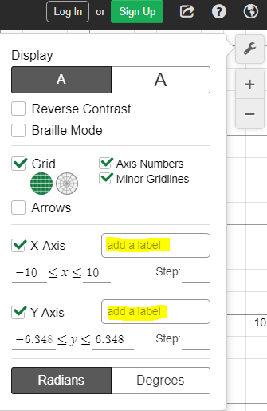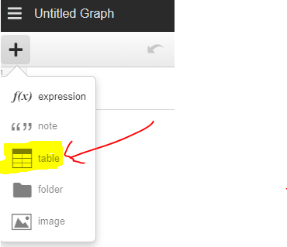**Graph:**

Go to [www.desmos.com/calculator](http://www.desmos.com/calculator) to graph your data.

1. Start by making a table by clicking the “+” icon at the top left (see Figure 1).
2. Make sure to label the axes using the wrench icon at the right. (see Figure 2).
3. Zoom out so that you can see the whole graph and so that it fills the page.
4. 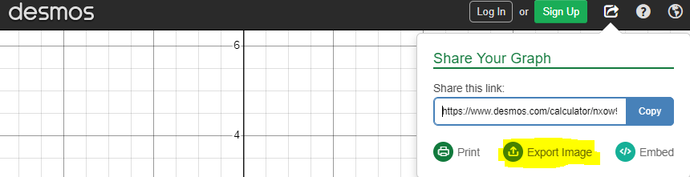Create two best fit lines by graphing the equations:

Figure 3

Figure 2

Figure 1

$y1\sim m1x1+b1$

$y2\sim m2x2+b2$

1. Copy a picture of your graph using the export button. Click “Export Image”. (see Figure 3). Right click the image then click “copy”. Paste the image in this document
2. Also, copy and paste the “share this link” link in the export button. This will be helpful if you need to make adjustments to your graph later.

|  |
| --- |
| Copy a picture of your graph below: |
|  |
| Shared Graph Link: Click or tap here to enter text. |
| **Legend/Key:**  Make a key for your graph. What do the colors represent?   * Click or tap here to enter text. |
| **Best Fit Lines:**  What are the equations of each best fit line?  Line 1: $Click or tap here to enter text.$ Line 2: $Click or tap here to enter text.$ |

**Conclusion Questions:**

What is the physical meaning of these best fit lines?

Click or tap here to enter text.

Why was it important to draw a best fit line?

Click or tap here to enter text.