RECORD LOG

Contains all steps performed when completing Assignment 1 specification.

PART1 – Set up new Virtual Machine

1. Create a new virtual machine named ClientPro.

I’ve cloned the Client1 snapshot which we used during lab 1.
This is because I had issues creating a new VM and when importing a new client from the resources folder, I imported the wrong VM with no mal user. Which may not matter, but to accommodate consistency and simplicity I’ve just cloned the “Prior to interface management” snapshot.

2. Storage controller IDE should be installed already so I won’t need to assign the Ubuntu .iso file.

3. For the graphics controller I have left it as the default VMSVGA
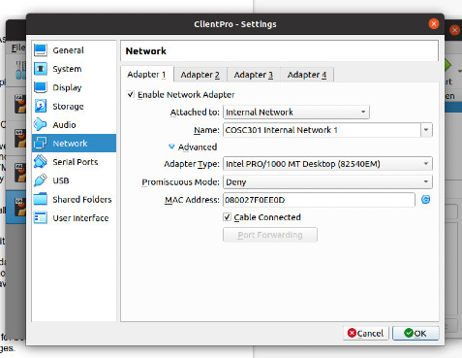
4. This network will have one enabled adapter (as shown above).
Adapter1 connected to the internal network “COSC301 Internal Network 1”. This will make connection testing easier as I already have a client configured to this network from the labs.

5. ClientPro is now ready to startup.

6. Disable Automatic Network Manager for the adapter, so that Ubuntu does not override my network configuration changes.

7. enter “ifconfig” into the terminal, just to ensure the network is as expected.
Which it is, we have an eth0 connection with no IPv4 or IPv6 compatibility (yet),
and the loopback address for both IPv4 and IPv6.
I also ran “ifconfig -a” which is not shown in the screenshot, just to ensure there were no hidden interface configurations (which there weren’t).
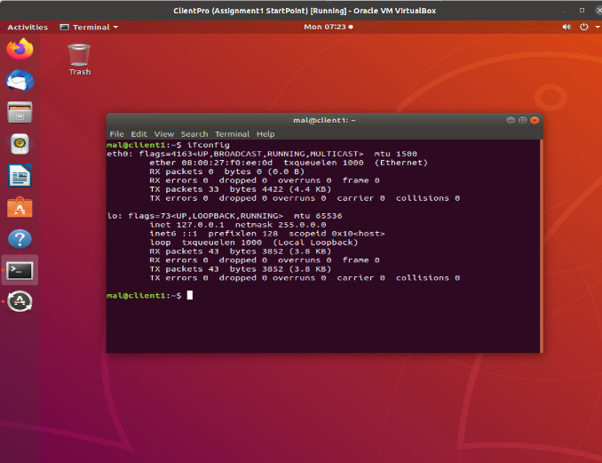
8. Configure the interface, I want this Client to be able to interact with my other clients from labs so I’ll use the IPv4 address 192.168.1.3
Indicating the client is the third device on the LAN 192.168.1.0/24

Terminal command will be:
sudo ifconfig eth0 192.168.1.3 netmask 255.255.255.0 up

which sets the eth0 interface configuration to the IP address 192.168.1.3 and brings the network up.

9. We can see it worked with “ifconfig eth0” as shown below. The eth0 interface now has the IPv4 address specified.
I also “pinged” the original client1 to ensure the interface works.

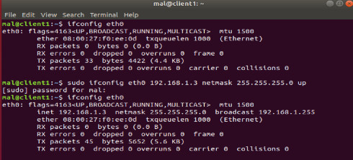

10. Add eth0 to the interfaces folder (using root privileges) so that Network Manager will not overwrite my changes.
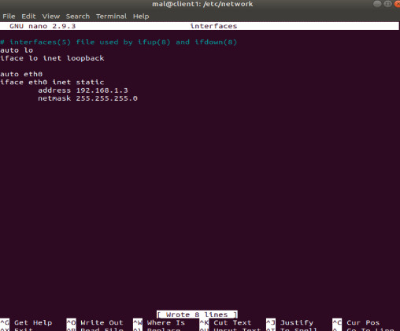

11. reboot to make sure my configuration changes stay the same.
IPv4 address is expected but now an IPv6 address has been added automatically.
inet6 fe80::a00:27ff:fef0:ee0d
This is the link-local IPv6 address that get’s automatically generated using my eth0 MAC address.
This is generated automatically by the SLAAC protocol because the address config management is not set.
12. IPv4 is configured and working as expected so I’ve taken a snapshot of this point,
(in case I mess up later.)

13. IPv6 is automatically configured on startup which is what the assignment spec has asked for.
14. TESTING:
I’ve pinged the radvd client using the IPv6 connection from Client Pro,
and have also pinged ClientPro from radvd, to ensure the connection works both ways.
IPv4 is not configured on radvd so I’ve tested IPv4 using Client1 from labs.
Connection also works both ways, (tested using ping).

