|  |  |  |  |  |  |  |  |  |  |  |  |  |  |  |  |  |  |  |  |  |  |  |  |  |  |  |
| --- | --- | --- | --- | --- | --- | --- | --- | --- | --- | --- | --- | --- | --- | --- | --- | --- | --- | --- | --- | --- | --- | --- | --- | --- | --- | --- |
| |  |  |  |  |  |  |  |  |  |  |  |  |  |  |  |  |  |  |  |  |  |  |  |  |  |  | | --- | --- | --- | --- | --- | --- | --- | --- | --- | --- | --- | --- | --- | --- | --- | --- | --- | --- | --- | --- | --- | --- | --- | --- | --- | --- | | |  |  | | --- | --- | | For office use only | | | T1 | ________________ | | T2 | ________________ | | T3 | ________________ | | T4 | ________________ | | |  | | --- | | Team Control Number **55888** | |  | | Problem Chosen **A** | | |  |  | | --- | --- | | For office use only | | | F1 | ________________ | | F2 | ________________ | | F3 | ________________ | | F4 | ________________ | |   **2017 MCM/ICM Summary Sheet**. |

AS the Institute of Risk Management of South Africa reported in 2015 that the Kariba dam is in dire need of maintenance. In this paper, we study 3 options which are of interest to the Zambezi River Authority.

**Firstly**, we evaluate these three options, where the cost includes that of electricity, labor and materials, and the security is when the dam is to be repaired next time. For Option 1, we calculate the minimum repairing cost is $ 6.9248 billion but only 13 years after next repairing. For the option two, we through the comparison for purchasing power to calculate reconstruction costs. And we should plus the loss that is stagnant power generation time. Overall, the option two will cost $44.3088 billion, without repairing at least 60 years. For option 3, we estimate the construction costs through calculate the sectional area overall dams, then find out the construction cost of common medium - sized earth - rock dam by integrating the great data. In general, the cost of Option 1 will generate less cost and less impact on the electricity supply for southern Africa comparing with Option 2 and is benefit of the protection for the Lake Kariba. But Option 2 could prolong the use of the dam. For Option 3, we will promptly and efficiently dispatch the water and have great advantages on the safety and economic.

**Secondly**, we get lots of data to construct and depict a great deal of 2D/3D maps about each section of riverside and river through the different angle. Then we choose 23 points as the candidates by comprehensive calculation including altitude, terrain, reservoir population and so on. In the 23 candidates, the reservoir water level is at least 30 m below the height of the lowest point of the upper reach for the balance of costs and safety. For the similar natural conditions, we assume these dams have the roughly equal unit construction cost of water project and approximately think the dam costs have the positive correlation about sectional area set as objective function. Based on the last the 2D/3D figures and the data, we divide it into 8 sections, then we establish a goal programming model by restricting that is storage capacity, power generation, water level. At last, we conclude that we need to build 14 dams. Aiming at the problems of reservoir optimization water management dispatching, an improvement coevolutionary genetic algorithm is described. It is applied to 14 reservoirs to optimize water management dispatching in the lower reaches of the Zambezi river. The results from the real example calculation indicate that when this algorithm is used to solve the problem of the optimization dispatching of reservoir water supply, the results are reliable and rational with high calculation efficiency.

**KEYWORDS: Objective programming;**[**Poisson distribution**](http://dict.youdao.com/w/Poisson%20distribution/#keyfrom=E2Ctranslation)**; Manning equation;0-1 programming; Genetic algorithm**

Content

1. Restatement of the Problem 2

2. Introduction 3

3.Assumptions 3

4.Symbol Descriptions 3

5.The model of Requirement 1 4

5.1.1 problem analysis 4

5.1.2model building 5

5.1.3 model solution 5

5.1.4 comprehensive analysis 6

6. The model of Requirement 2 6

Question one：how to select the place 6

6.1.1. Basic Requirements of Address Selection 6

6.1.2. Topographic mapping 7

6.1.3 model building 9

6.1.4 Model solving 11

6.1.5 Model test 12

Question two：Reservoir Optimization Water Management Based on Genetic Algorithm 14

7.2.1 Preparation for modeling 14

7.2.2 model building 15

7.2.3 comprehensive analysis 15

8 References 16

## 1. Restatement of the Problem

Zambezi river [1] has been locating on the south of the Africa thousands of years, which provides the abundant vitality for the whole creatures. Because of the richly resource endowed by nature，the one of the biggest dam—Kariba dam is established over this river, which light the million homes for the Southern Africa. The arch dam was constructed between 1956 and 1959 and supplies water to two underground hydropower plants located on the north bank in Zambia and on the south bank in Zimbabwe. Water is released from the reservoir through six sluice gates. In the first 20 years after the dam was constructed there were sustained heavy spillage episodes resulting in erosion of the bedrock to 80 m below the normal water level. This has resulted in instability of the plunge pool making the dam wall unstable and unsafe. So, we must take the necessary action.

A number of options are available to the Zambezi River Authority (ZRA) that might  
address the situation. Three options in particular are of interest to ZRA:  
(Option 1) Repairing the existing Kariba Dam,  
(Option 2) Rebuilding the existing Kariba Dam, or  
(Option 3) Removing the Kariba Dam and replacing it with a series of ten to twenty smaller dams along the Zambezi River.

▲ **Requirement 1** ZRA management requires a brief assessment of the three  
options listed, with sufficient detail to provide an overview of potential costs and  
benefits associated with each option. This requirement should not exceed two  
pages in length, and must be provided in addition to your main report

▲**Requirement 2** requires an analysis of the third option. First, the number and location of the multiple dam systems are determined. The water storage capacity of the multiple dam system is comparable to that of the original Kariba reservoir. The cost of the system is relative to the safety A reasonable model is proposed for the flood period, the drought period to make reasonable treatment of water flow programs, in addition, assuming some extreme cases, these extreme situations into the model, and explain the specific contingency plans.

**1.1 Interpretation of these problems**

●We will find some information on the Kariba dam, the geographical environment of the Zambian River, demographic and economic conditions and other factors affecting the Kariba dam.

●We will present a comprehensive evaluation model for the different models.

●We will integrate geography, population, economic and other factors give a reasonable mathematical model to determine the establishment of several dams. In addition, the model will consider the influence of ecology and so on.

## 2. Introduction

Kariba dam is in Zambia between Zambia and the Kariba gorge, the dam was built in 1955, completed in 1959 to use. The dam has two power stations in the north and south, providing power to Zambia and Zimbabwe respectively. Once the dam collapse, will directly threaten Zambia, Zimbabwe, Mozambique and Malawi four countries more than 3.5 million residents of life, property safety and the region's electricity supply. While the African Kariba faced collapse crisis in urgent need of maintenance works.

Kariba reservoir dam was built in 1959, completed in 1955, 220km long, 40km wide, 118 meters high, an area of ​​5580 square kilometers, the normal water level is 487.79m, dead water level 475.5m, the largest capacity of 18 billion Cubic meter, the normal storage level below the regulation capacity of 60.85 billion square meters. Kaliba Lake hydropower generating capacity of 500, the dam has two power stations in the north and south, respectively, Zambia and Zimbabwe to provide electricity. Zambezi River average depth of 29m, the deepest 97m, rainy season began in November to April the following year. The tributaries of the two sides of the strait are asymmetric, and the tributaries of the north include the Kafue, Luangwa and Shire rivers.。

## 3.Assumptions

●It is assumed that the reconstruction period is the same as the time when the dam was built

●In exploring water depth, the riverbed and the river is approximately parallel.

●In the Zambezi River map to take enough points to simulate the Zambezi River landscape, assuming the error is negligible.

●In calculating the amount of electricity generated, the loss rate is the average of the maximum loss rate and the minimum loss rate of the power generation system.

## 4.Symbol Descriptions

**Table 1**

|  |  |
| --- | --- |
| **Meaning** | **Symbol** |
| **Requirement 1 model** | |
| Diving tank needs repair time |  |
| Number of dams not available each year |  |
| Average annual generating capacity of Kariba dam (MW) |  |
| Dam restoration time |  |
| The cost of constructing the dam for the first time |  |
| CPI |  |
| Per megawatt of electricity |  |
| Rehabilitation of dams |  |
| Total cost of rebuilding dams |  |
| **Requirement 2 model** | |
| The upper reaches of the dam part of the minimum altitude of |  |
| —corresponding water level of dam site |  |
| —corresponding reservoir length of dam site |  |
| —corresponding dam width of the dam site |  |
| the original Kariba reservoir annual average storage capacity |  |
| —average reservoir width corresponding to the dam site |  |
| —the corresponding abscissa of the dam |  |
| —the corresponding ordinate of the dam |  |
| — abscissa of intersection point between dam water level and river fitting curve |  |

## 5.The model of Requirement 1

### 5.1.1 problem analysis

When we calculate the cost, we need to calculate the loss of electricity, the manpower fee and the material fee. Now we talk about the cost finding techniques of project one: The result of generating profits per year divided by the number of sluices is just the profit for each gate. The result of the number of each sluice gate cannot be used multiplies the profits for each gate, which are also the losses of electricity. Through the accumulation of annual losing profits, we can get the total loss of electricity, and we couple it with the manpower fee and material fee, then we can get the cost of project one.  
 Then let's have a look at the cost finding techniques of project two: The result of the cost of building Kariba multiplies by price rises is the cost of building the dam. Within the reconstruction period, the dam can't produce electricity, so the result of reconstruction time multiplies by the originally profits is the loss of electricity per year. Then we combine these two parts and we can get the cost of project two.

### 5.1.2model building

Option one: cost finding techniques of repairing the dam: It costs t1 years to repair the jump sink, and when we repair the jump sink, there's no electricity can be produced. The annual average electricity the Kariba Dam produces is s megawatts, and the cost is q per megawatts. When we are repairing the sluice gate, after t1 years, we can begin producing electricity by using the sluice gates that don't begin repairing, and the total time of repairing dam is x years. The number of unavailable dams are Xi, i=1...x, the combination of manpower fee and material fee is D. The total cost of Option one M1:

(1)

Time interval The number of dam failures in the year t is N（t）obey the Poisson distribution，which value is λ（λ>0 constant）.

Probability distribution function：，The time interval from the next failure，could be calculated by making the probability of occurrence equal to 80%.

Option two: The cost of rebuilding the dam: The cost of building the dam for the first time is m, the price rises are l, and it costs t2 years to finish it.

The total cost of Option two M2:

(2)

### 5.1.3 model solution

According to the data, it needs 3 years to repair the jump sink. The annual average earnings of generating capacity Sq=555.4 hundred million$, it needs 8 years to repair 6 sluice gates, and the manpower fee and material fee are 2.6 hundred million. To make M1 the minimum, we've got the number of unavailable sluices, as follow table:

**Table 2**

|  |  |  |  |  |  |  |  |  |
| --- | --- | --- | --- | --- | --- | --- | --- | --- |
| time | First year | Second year | Third year | Fourth | Fifth | Sixth | Seventh | Eighth |
| The number of unavailable sluices | 6 | 6 | 6 | 2 | 2 | 2 | 2 | 1 |

So, we can know the cost of Option one is 3335 hundred million. If the rebuilding time and the building time is the same, t2=4, according to the data, price rises level is 9 times than the level in1959. The cost of Option two is 262.1488 billion$.

The next repaired time： ， the next repaired time is 13 years.

**Table 3**

|  |  |  |
| --- | --- | --- |
| Options | Option one | Option two |
| Cost | $ 6.9248 billion | $44.3088 billion |
| Times till next service | 13 | >60 |

### 5.1.4 comprehensive analysis

Like all artificial buildings, a dam has its birth, aging, illness, and death and their process and rules.

Through the result of the model, the cost of Option one is much less than the cost of rebuilding a dam or replacing it with a smaller one. Besides, it has smaller influence on electricity supply of Zimbabwe and Zambia during the maintenance. And it is important that it can still be carried out on the water dispatching during the maintenance, and arrange the repairing time correctly according to the climate of the Zambezi river and the condition of the dam. So, the potential cost is low and can promise quick returns during the maintenance. It is obvious that repairing the dam is an important emergency measure to solve the problems Kariba Dan has.

Option two rebuilding the dam can prolong the age of the dam, what's more, the technology of building dams is better, and we are more experienced and we can guarantee the security of it. By remolding the water turbine and the dam structure, we can increase capacity, and reduce the condition of electricity limited in Zimbabwe and Zambia. The profits after the construction is long-term and the later cost of maintenance and potential cost is stable.

Option three use 10~20 smaller dams to replace the former dam. Through intelligent site selection and scientific rebuilding, we can use water better and more free. It has great superiority on security and economy by increasing the number of dams. More dams can help reduce the pressure of dams, and it can be more efficient to deal with the extreme situations, such as earthquake and flood. Of course, building several dams can make it modular to build one dam. So, it has great superiority on construction efficiency, and it can be put into production gradually during the construction. We'll use data to discuss it more meticulously by next model.

## 6. The model of Requirement 2

### Question one：how to select the place

### 6.1.1. Basic Requirements of Address Selection

a、Geographical factors

The idol selects that the depressions or basins with thin opening which has the sufficient storage capacity and catchment area is easily to build because of the less engineering quantity.

b、Geological factors

Having the geological structure and stability, without the fault or karst topography

c、social factors

The less economic loss

Reduce the impact on the population

### 6.1.2. Topographic mapping

**Figure 1 Riverside section A contour line model**

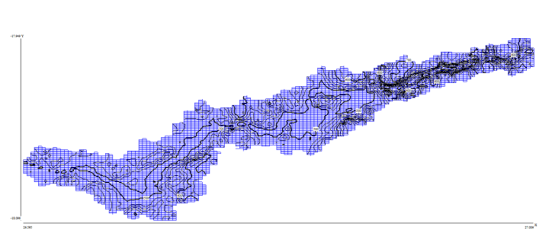

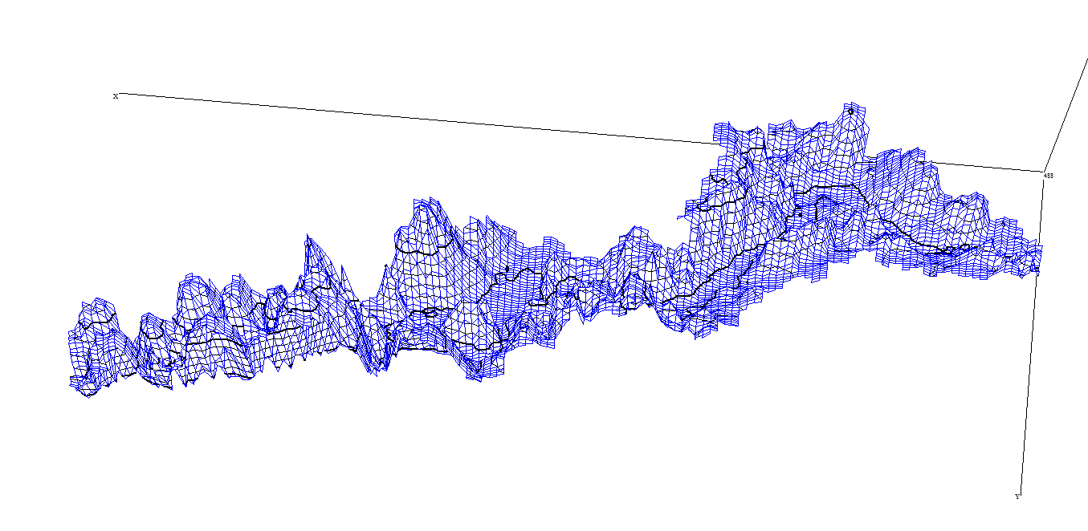

**Figure 2 Riverside section A 3D model**

Step one：We divided the upstream rivers into A, B, C, D, and E, respectively, and we simulated the original landforms with data height. Above the A section as an example：

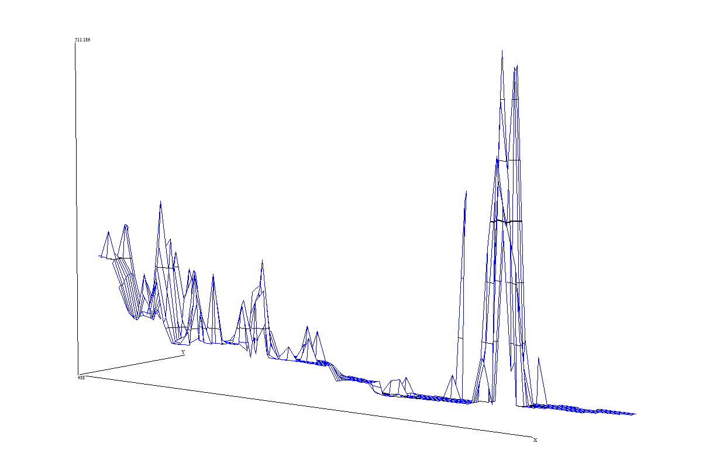

**Figure 3 River section A 3D model**The height of the river bank and the height of the river are obviously different, so it can be used as the candidate location of the site. * B, C, D and E are the same as in paragraph A.

At Kariba Lake, we collected the latitude and longitude and altitude of 3977 sites, simulating the landscape of Lake Kariba:

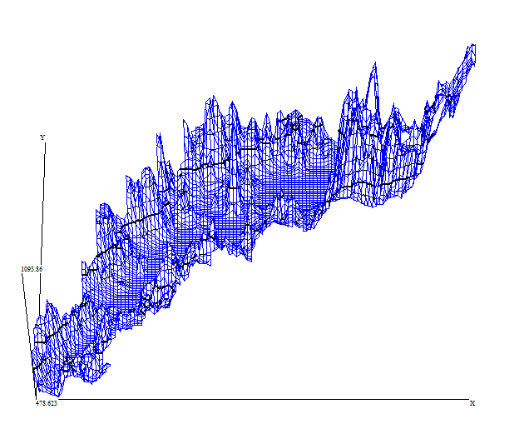 **Figure 4 River section A 3D model**

Can be seen in the collection to take a few non-standard points, remove the non-standard points, we can see the lake line on the flat, and because of the wide Kariba Lake.

In the downstream we collected 2115 points, the generation of three-dimensional image as shown: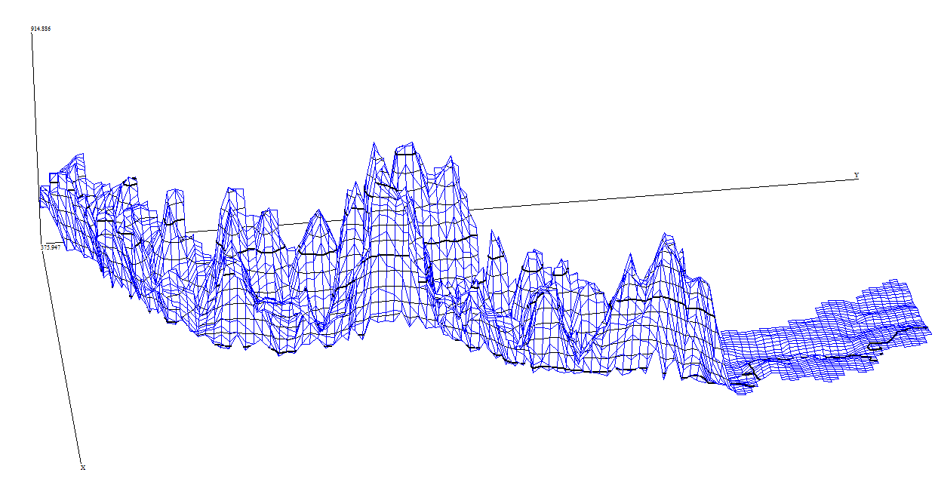**Figure 5 River section A 3D model**

That shows several points can be selected downstream to build a dam.

Step two：Population Distribution：

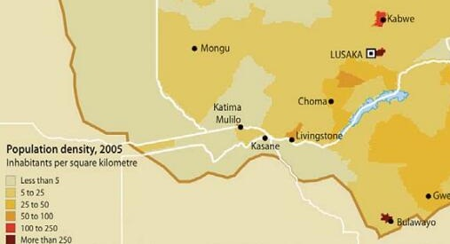

**Figure 6 River section A 3D model**

We should get away from densely populated areas。

In summary，we inferred the 23 points as the candidates by comprehensive calculation:

**Figure 7 River section A 3D model**

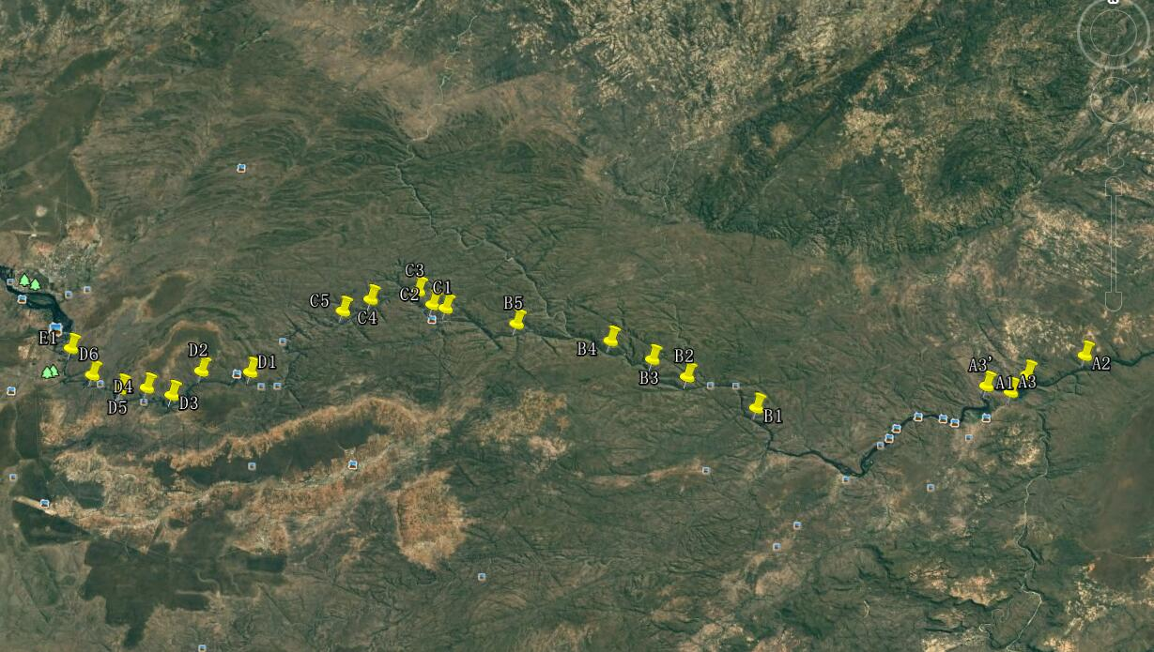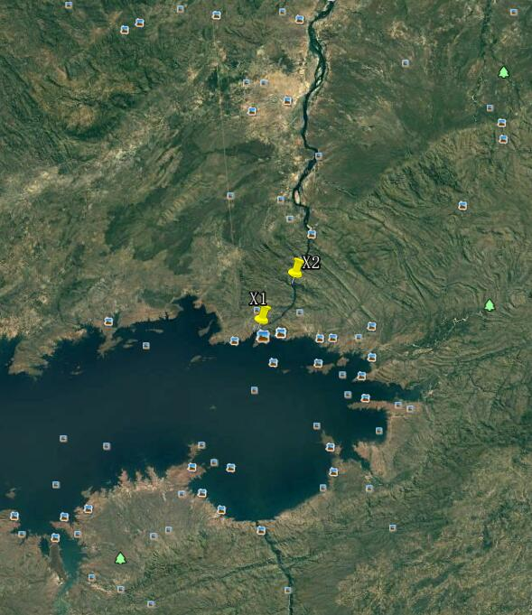

### 6.1.3 model building

Assuming that the water storage capacity of each dam is the same, the corresponding water level at each dam site is  （）, The upper reaches of the dam part of the minimum altitude is  water level ，（）,

0—1 programming，if we get the i-th point ,the value is 1.If not, the value is 0.



Storage capacity 

Get the  into the interpolation function ，can find the corresponding abscissa ，and 

 is the level of dam

，(3)

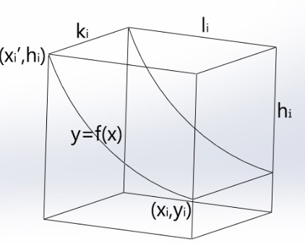

**Figure 8 River section A 3D model**

Total power generation from multiple dam systems：

Electric energy calculation formula：Q is the flow rate, that is the volume of water passing through the turbine per unit of time,，units ，（Dam surface height is generally in equilibrium state, the inflow of water is equal to the outflow of water），H is the difference of the water. In the process from the water into electrical energy, energy will loss. The actual output of the hydropower station is , is generating efficiency，k is output coefficient of hydropower station，for the medium hydropower station，the value of k is 6.5-8.0 generally.

Installed capacity：

，

P is greater than or equal to the original power generation 。

Objective function：cut down the costs, that is the ：

，

s.t.



### 6.1.4 Model solving

|  |  |
| --- | --- |
| section | The interpolation function |
| A |  |
| B |  |
| C |  |
| D |  |
| E |  |

According to the above-established model，the average water storage capacity of Kariba dam is 680，data on the length and height of the selected points of the river from the starting point of each channel are given，through the interpolation，get the each interpolation function for each river，

**Table 4**

|  |  |  |  |  |  |  |  |  |  |  |  |  |  |  |
| --- | --- | --- | --- | --- | --- | --- | --- | --- | --- | --- | --- | --- | --- | --- |
| point | 1 | 2 | 3 | 4 | 5 | 6 | 7 | 8 | 9 | 10 | 11 | 12 | 13 | 14 |
| longitude | 17°59‘’56.71‘’ | 18°00’07.63‘’ | 18°00’05.44‘’ | 17°58′42.17″ | 17°58′40.09″ | 17°55′03.68″ | 17°53′53.61″ | 17°54′55.73″ | 17°56′01.59″ | 17°57′12.63″ | 18°00′13.30″ | 18°01′05.34″ | 18°00′13.94″ | 16°31′19.52″ |
| latitude | 25°52‘’39.20’‘ | 25°56’52.24‘’ | 25°58‘’14.53‘’ | 25°59′40.61″ | 26°03′09.79″ | 26°09′01.94″ | 26°13′42.15″ | 26°15′17.48″ | 26°19′46.32″ | 26°25′47.52″ | 26°51′16.89″ | 26°10′19.89″ | 26°50′58.58″ | 28°45′40.90 |

For the selected 23 pre-selected dam site latitude and longitude, the dam river width, the average width of the upstream section of the corresponding dam site, and the distance from the beginning of the river see annex. Water dam length through the interpolation function to represent the height, the use of lingo The software solves the established model. The number of dam sites obtained is 14, and the corresponding dam addresses are shown in the following figure.

**Table 5**

### 6.1.5 Model test

Although the water storage capacity of the reservoir is the same as the original, but each dam had the original river water, so the construction of the dam system for Kariba Lake share of water than Kariba Lake water storage capacity is small, the actual sharing value and Kariba the difference between the original reservoir water storage capacity.

The Manning equation is used to calculate the original riverbed height, so we introduce the angle between the river and the riverbed。

schematic diagram as follow：

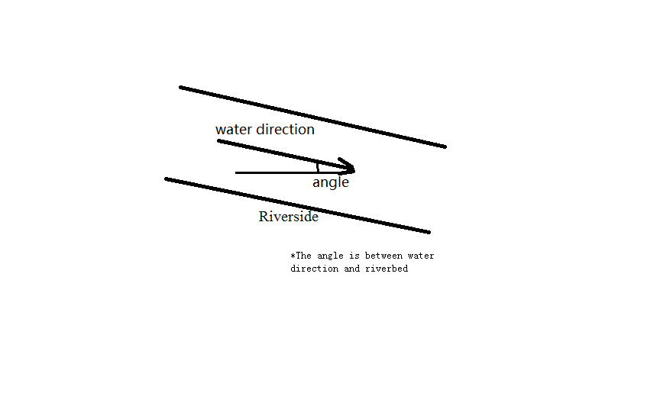

**Figure 9 River section A 3D model**

According to the schematic diagram we can see that if we want the angle of the water flow to the riverbed, we need to calculate the derivative of the five fitting functions. The corresponding derivative value for each distance is the tangent of the distance to the riverbed.

Take the distance between the sampling points of the river as the abscissa, the height of the sampling point as the vertical axis, to get a two-dimensional flow trends, the upstream section A as an example：

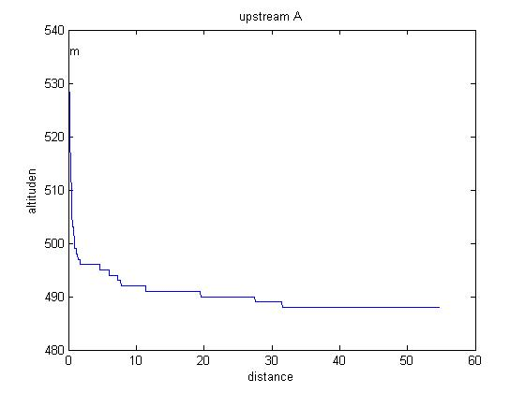

**Figure 10 River section A 3D model**

But obviously the curve is not smooth enough, so we polynomial curve fitting of the data, five times the fitting accuracy is high enough, the collection effect is good, so we final five data fitting：

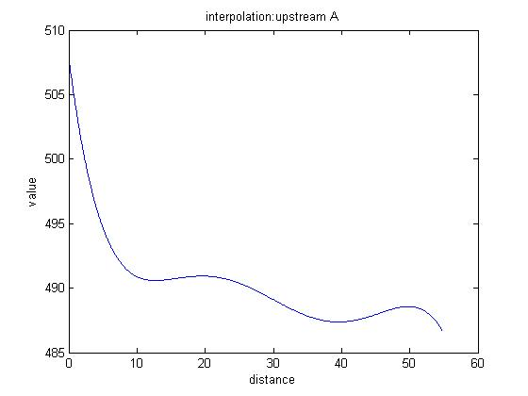**Figure 11 River section A 3D model**

By fitting the function to find the angle, we obtain the tangent of the angle corresponding to each distance by obtaining the derivative：

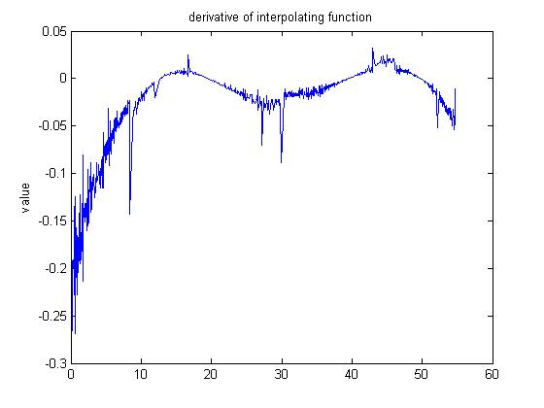 **Figure 12 River section A 3D model**

*so on。

At the downstream, we derive the tangent value distribution for the fitting function：

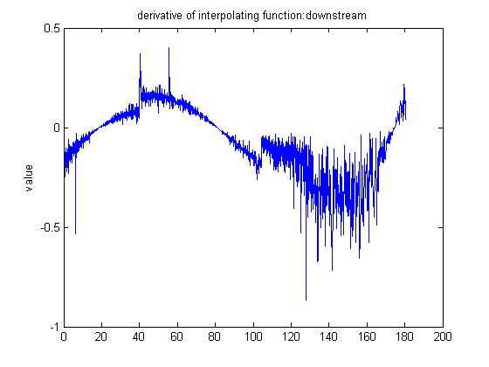 **Figure 13 River section A 3D model**

The original water level can be obtained by Manning equation：

(6)，（Re[1]

:500—57,—discharge area）

c—Chezy coefficient

R—hydraulic radius

—hydraulic gradient

And the sum of the water quantity of the original river in the reservoir reaches：



The actual amount of water shared by the reservoirs for the Kariba reservoir：116 cubic kilometers

### Question two：Reservoir Optimization Water Management Based on Genetic Algorithm

### 7.2.1 Preparation for modeling

In computer science and operation research, a genetic algorithm (GA [2]) is a metaheuristic inspired by the process of natural selection that belongs to the larger class of evolutionary algorithms (EA). Genetic algorithms are commonly used to generate high-quality solutions to optimization and search problems by relying on bio-inspired operators such as mutation, crossover and selection

### 7.2.2 model building

Optimal dispatch model for water management of reservoirs The model objective function and constraints are as follows[3].  
（1）Objective function

(7)

（2）Restrictions  
a. constraint of Water balance constraint

(8)

b. constraint of Reservoir capacity

(9)

c. constraint of Water supply

(10)

d. constraint of Water demand

(11)

e. Variable non-negative constraints: All variables are non-negative

Where  is t period of water demand;

is t period to the water supply;

,are i dam t time interval, the end of the capacity

### 7.2.3 comprehensive analysis

Genetic algorithms often exist the slow convergence rate or the other defects, and often uses a fixed penalty factor of the conventional penalty function method to deal with constraints, which will lead to the problem that dimension is difficult to unity and the search accuracy inaccurate moreover premature convergence to the local optimal solution.

So, with the Co - evolutionary thought we raise the research on Optimal Scheduling of Reservoir System Management based on Co - evolutionary Genetic Algorithm by improvement of the global convergence of the genetic algorithm by means of cooperative competition between two kinds of populations which represent the decision solution and the penalty factor.

Step1：Individual encoding. The reservoir in the period t allows the water level range is divided into m divided, and then use the integer 1, 2, ..., m said, each individual vector (gene) is the true value of reservoir water level.

Step2: Initial decision-making population and penalty factor population. The water level of the cascade reservoir is taken as the decision variable, and its dimension is the product of the number of reservoirs and the number of time periods. The population Z of the initial reservoir is randomly generated and the population size is L1. The population Y with the penalty factor of L2 is randomly generated with the penalty factors ω1 and ω2 as the penalty factors.

Step3: Use equation (7) as the fitness function to evaluate the advantages and disadvantages of everyone in the population.

Step4: Genetic manipulation of decision-making and penalty-factor populations. Each subpopulation Z in decision population M is denoted by the same number of individuals in population Y as the penalty factor, and GA is used to evolve until the number of iterations is reached.

Step5: Iteration of the algorithm. After the generation co-evolution is complete, the process returns to Step 4 until the convergence criterion of the algorithm is reached.

Step6: Output of the optimal solution. By comparing all the historical best solutions obtained from the population M, the optimal solution is obtained as the final solution output, and the optimal individual in the population Y is the optimal penalty factor.

## 8 References

[1] https://en.wikipedia.org/wiki/Kariba_Dam

[2] Zhang Xiaoxian, Gao Xuenian《Hydraulics》

[3] Fjerstad P A, Sikandar A S. Next Generation Parallel Computing for LargeScale Reservoir Simulation: Proceedings ofthe SPE International Improved Oil Recovery Conference inAsia Pacific[C]. 2005: 3341

[4] Chen Lihua, Mei Yadong, Dong Yajie, et al. Improved genetic algorithm and its application in optimal dispatch ofcascade reservoirs [ J]. Journal of Hydraulic Engineering,