1. Write a js method, when user click on button, display random integer below it.  
   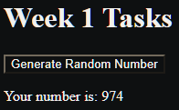
2. Write js function to format number up to specified decimal places.   
   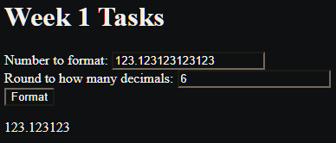
3. Check particular sub-word exist in a string or not e.g. i am learning js: 'js' exists or not  
   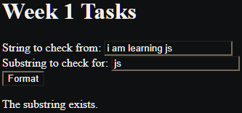
4. Given year leap year or not (29 in feb)  
   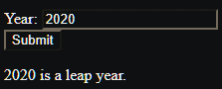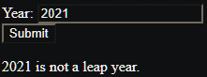
5. ATM Machine and style it

balance & query

withdraw (amount)

~~change pin~~

~~mini statement~~

~~saving & current acc.~~

~~print receipt~~

enter pin number  
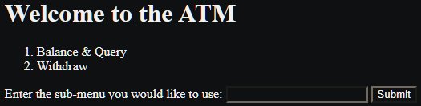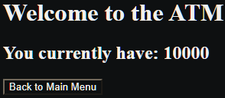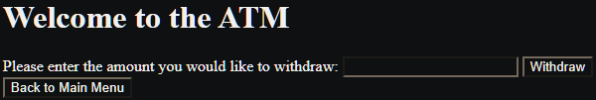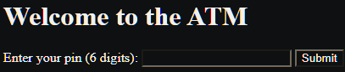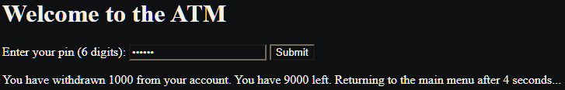

1. Add only even numbers in an array (array elements to be input by user)  
   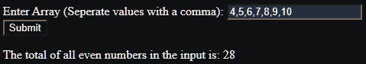
2. Biggest of even number in an array [10, 12, 90, 93, 707]: biggest even number is 90  
   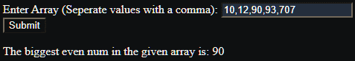
3. Add two array [10,20,30] + [1,2,3]: [11, 22, 33]  
   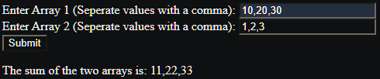
4. Reverse an array(with loops) [10, 78, 0]: [0, 78, 10]  
   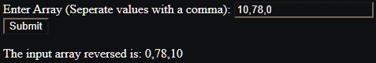
5. Reverse a string using loops  
   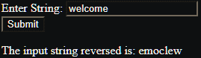
6. Remove duplicate items from an array [10, 50,20 67, 10, 20]: remove 10, 20   
   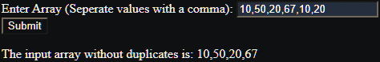
7. Ask user, remove a specific element from an array [12, 56, 89]: remove 1 element  
   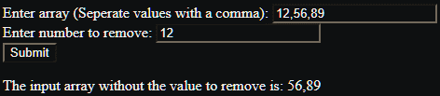
8. Get the largest odd and even number in an array [10, 12, 900, 93, 707].

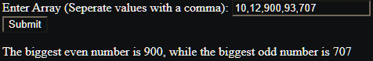

1. Take 3 inputs from user and structure them into objects.  
   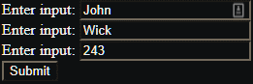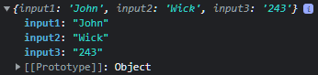
2. Create a class Car: city(),specialFeature()

name, brand, color, manufacture

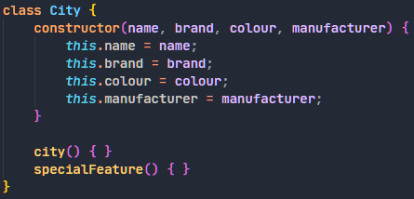

1. Create a class Book: type_of_book()

no. of pages, type of pages, author

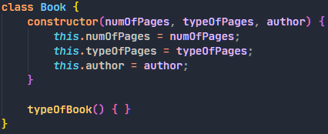

1. Create a class Animal: walk(), eat(), climb()

gender, name, disease

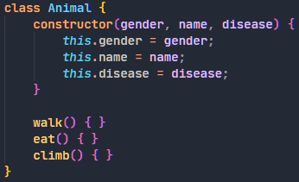

1. Inheritance: parent electronics (methods: name, version, company name): childclass(laptop, ipad, mobile, tablet):

class child {

configuration()

price()

}   
