1. Create employee data in a data.js file and include following fields (name, age, DOB, salary, designation, image, department).

Display name, image, designation in UI. Whenever user hover over any name, display complete employee data in alert/modal.  
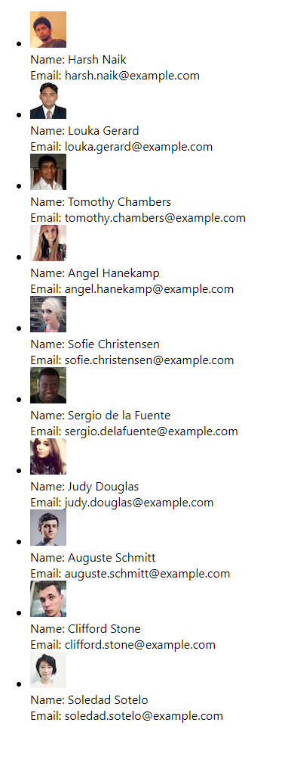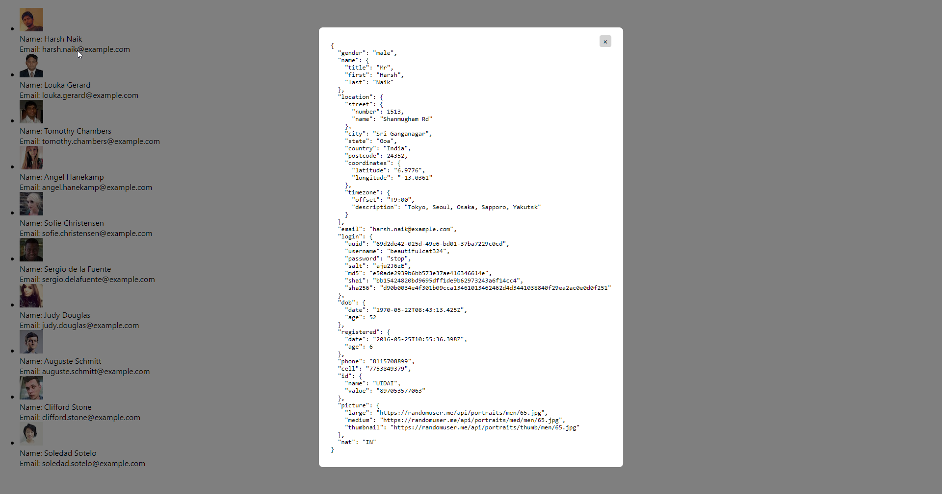

1. Create an array of objects of grocery data, send data from 1 component to another and display it (Function -> Function)  
   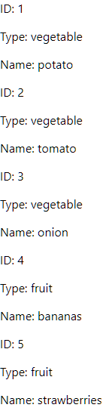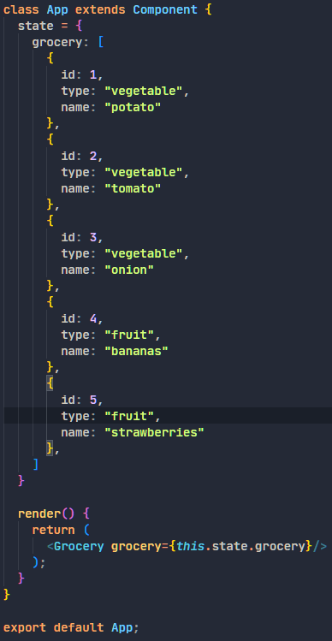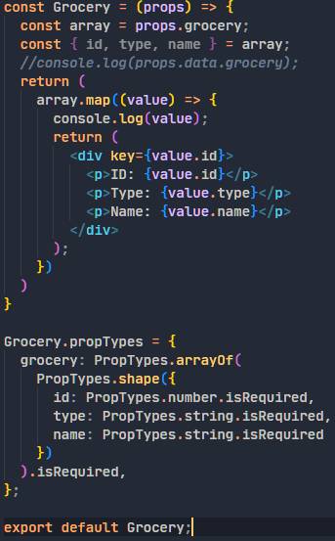
2. Create an object pass data from 1 class based to another class based data and display it (Hint: this.props). (Class -> Class)  
   