* In session-7 task, Q-1, 2, 3 add Props Validation.

Added for Q2 & Q3

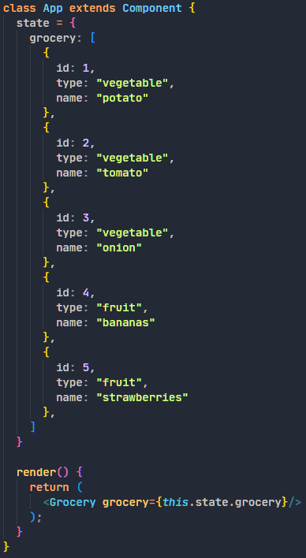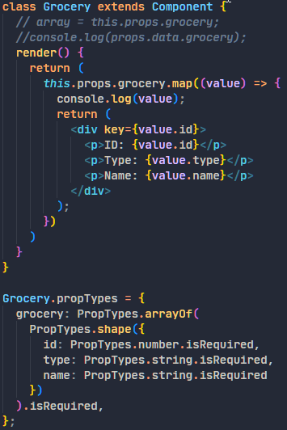

If the data (id is not number) is wrong:

