* Add api and get first 5 records from api data using using class based component and display data in a function based component.

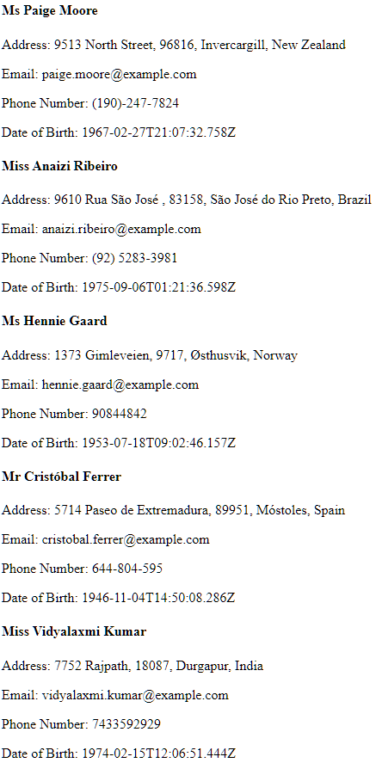 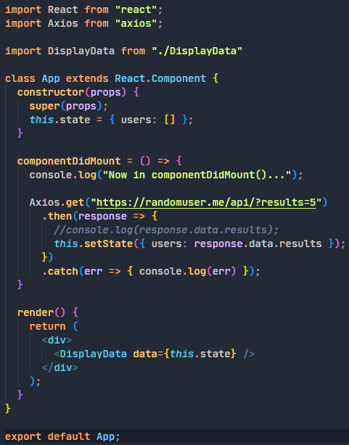 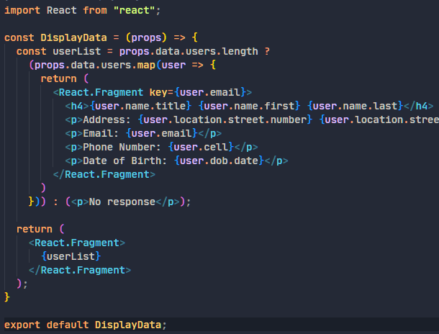

* Create a state (score). Take input from user of score. If it is greater than prev state then, update the state, otherwise not. (Show messages in pop-up/modal like points update).  
  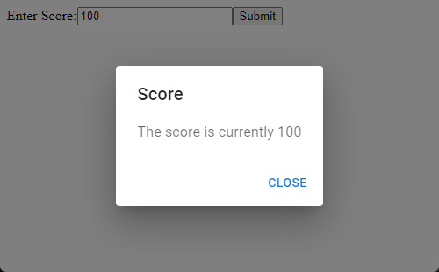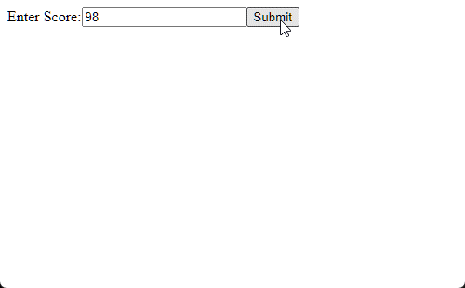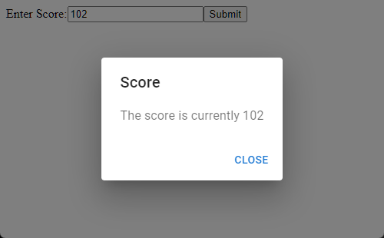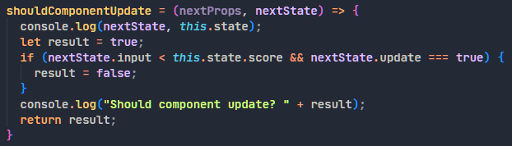
* Read more about: https://blog.logrocket.com/react-lifecycle-methods-tutorial-examples/#whatarereactlifecyclemethods