1. Create a Hoc that add random color to background of 2 component.  
   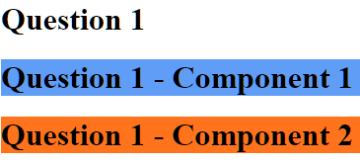 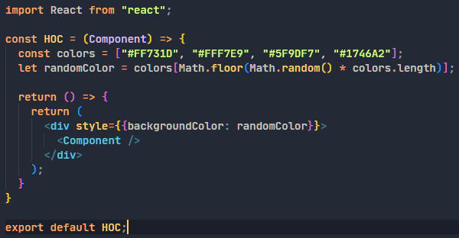
2. Advance task (use lodash.js)
3. symmetric difference of 2 arrays

const arrOne = [{

    id: 20,

    name: 'alex'

}, {

    id: 30,

    name: 'alina'

}]

const arrTwo = [{

    id: 40,

    name: 'hello'

}, {

    id: 30,

    name: 'world'

}]

result = [{

    id: 20,

    name: 'alex'

}, {

    id: 40,

    name: 'hello'

}]

&&

res= [{

     id: 30,

     name: alina

},{

        id: 30,

        name: ‘world’

    }]

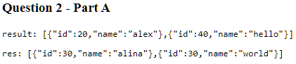 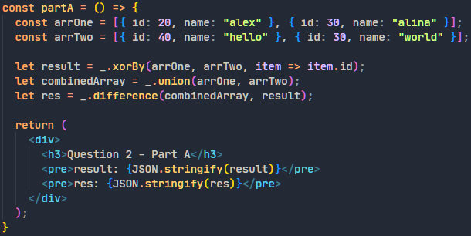

1. const str = ['u', 'ec']

const arr = [{

    storageVal: 'u',

     table: ['E', 'F']

},{

    storageVal: 'data',

    id: 3

}, {

    storageVal: 'ec',

    table: ['E']

}]

get all the tables ['E', 'F'], ['E']

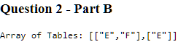 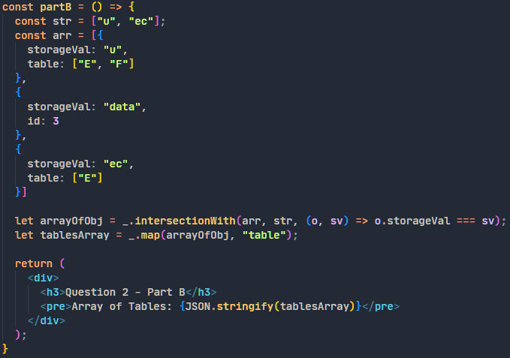

1. Flatten an array const a = [['E'], ['F']]

Output: ['E', 'F']

 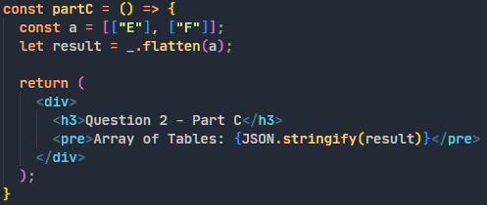

1. const t = ['E', 'F'], [['F'], ['G']]

Output: ['E', 'G', 'F']

 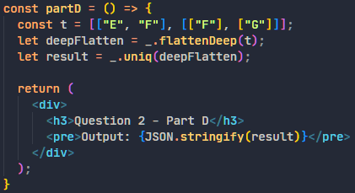

1. Create a search box (Optional)
2. Complete below tasks using Hooks

* Create an array of object and update its second index

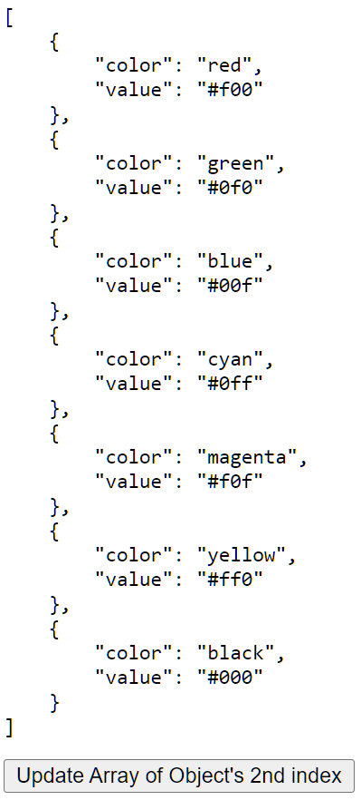 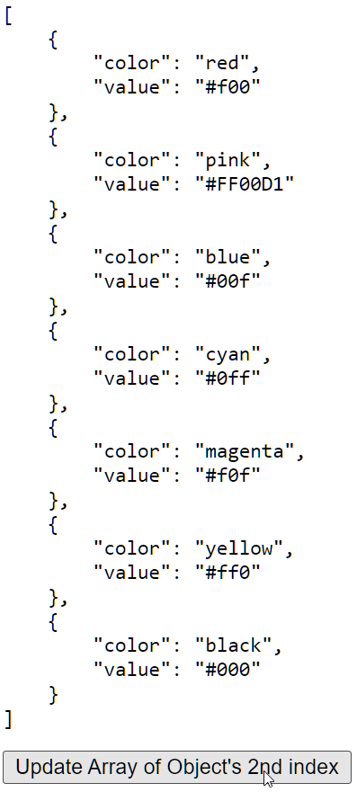 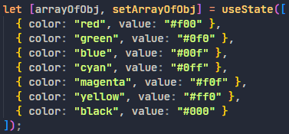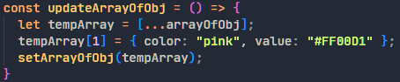 

* Create an object, update it's 2 property values

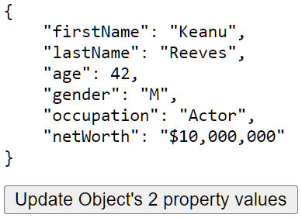 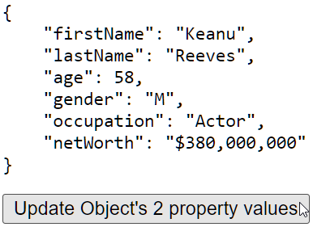   

* Practice all datatypes for state variable

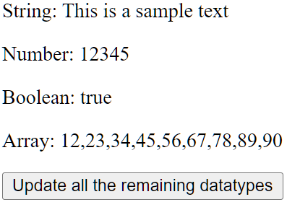 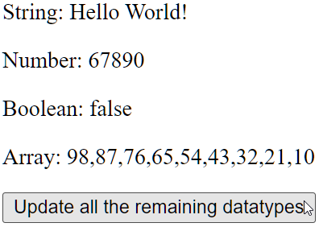 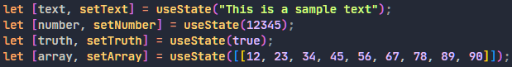 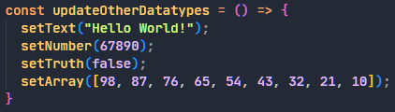 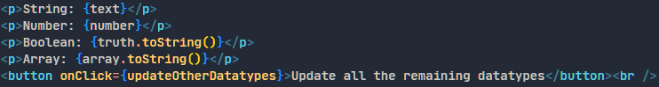

1. Create a form using Functional Component. Add validation. (Controlled Input)

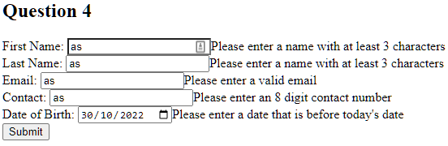 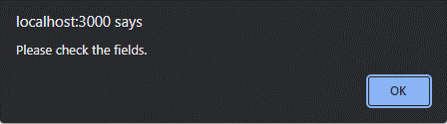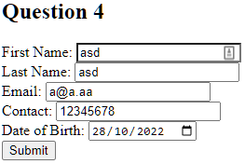 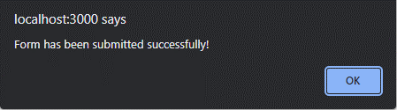

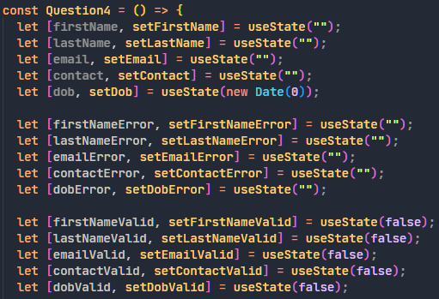

1. Practice Refs for Function & Class Component

