1. Create a to-do application with Storybook and recoil.

It will contain header, footer, form in the UI.

Capture data from user and display below in the form of cards.

There should be delete button on each card, when user click on it delete the record user has clicked on.

Implement tree-shaking.

Clean Page:  
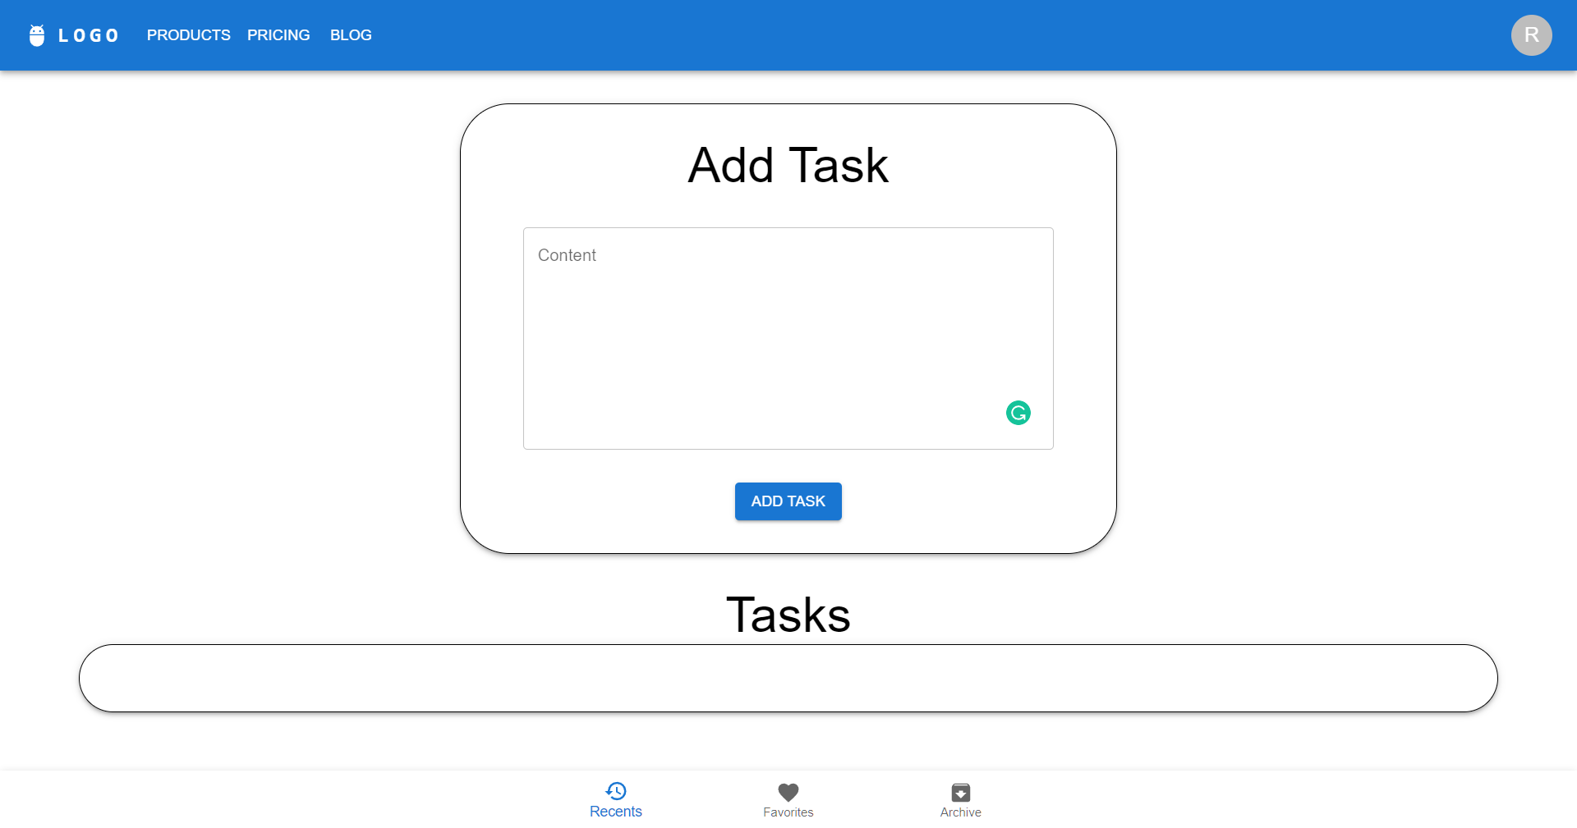

onClick handler to add a new task to the Atom:

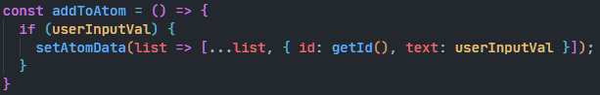

After adding some tasks to the atom: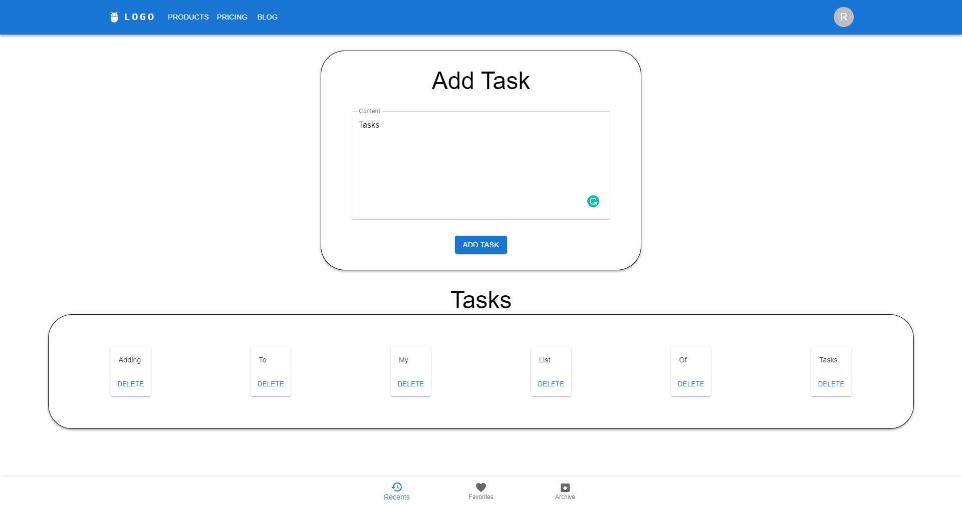

Clicking on the “Delete” button on the “My” task:

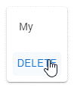

After clicking on the button:

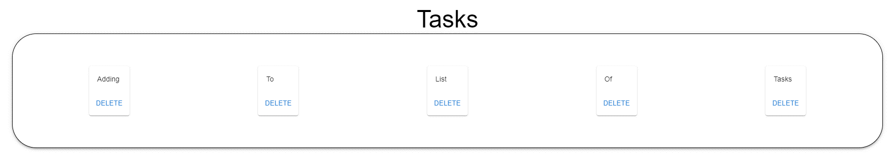

Handler function for the “Delete” button:

