1. Create an application using React and Redux, material UI, bootstrap storybook.

Create a leader board score website. Website should have information of dashboard, about, contact, score, popular player data.

On dashboard page, capture input of score and name of player. On submit, display data in score page.

Add carousel, media, images, videos, content inside dashboard, about, contact page.

Dashboard

Create a form and add fields in the form, add Form Validation

After submitted the form, give notification score added successfully.

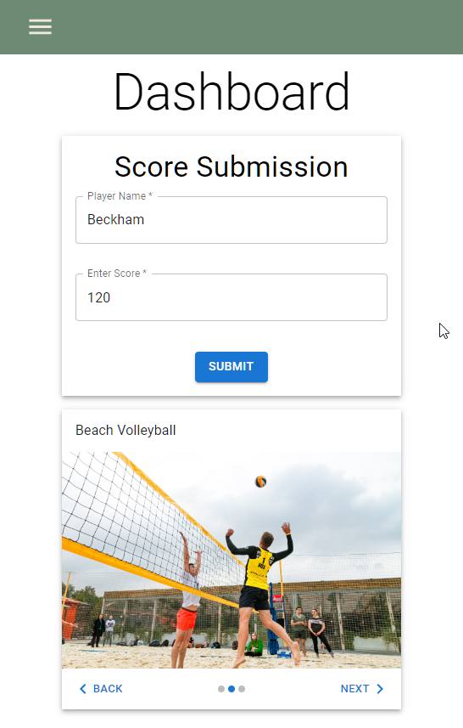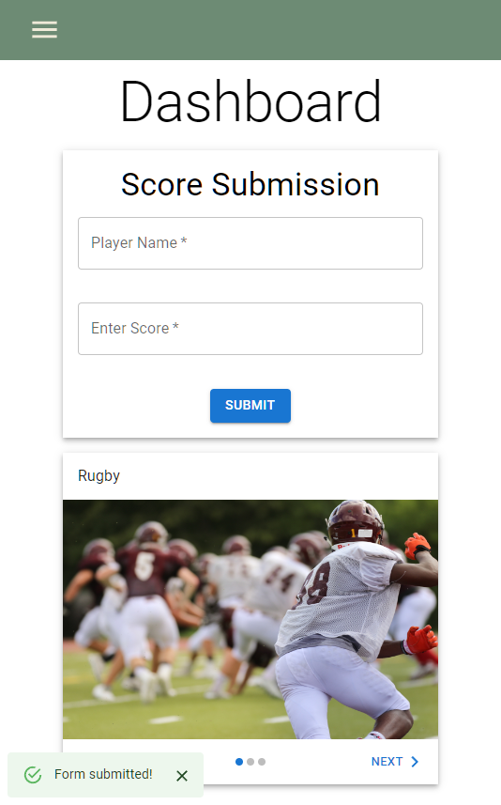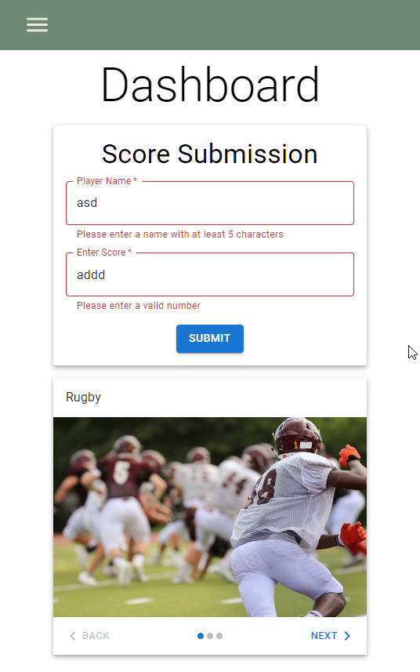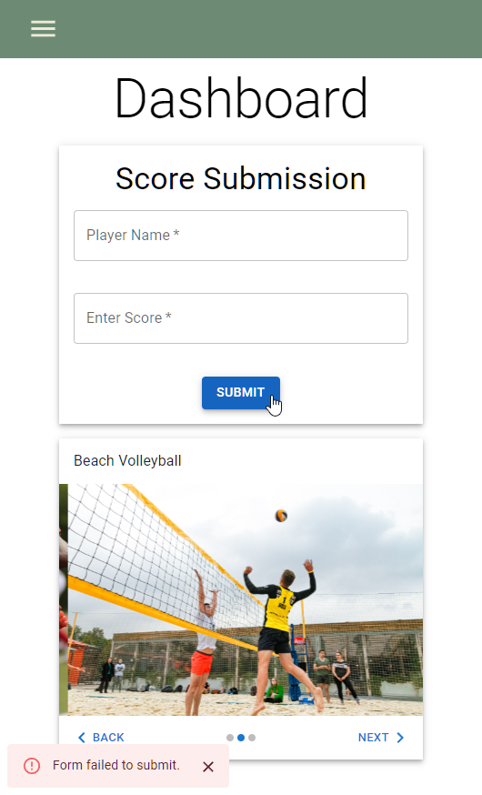

Contact Us Page (Optional)

Add 3 Cards for Location, Contact Number, Email Id.

About Us Page (Optional)

Here, add media and content, carousel, images, video.

Popular player  
Will fetch data from a third-party API and display it on page.  
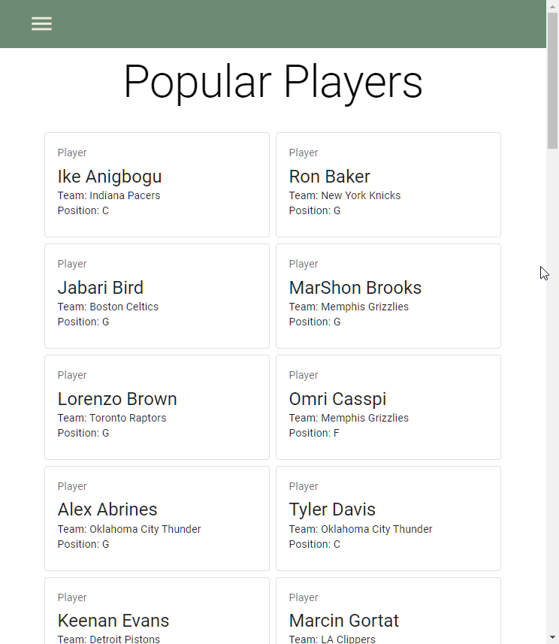

Score Page

Display all the score data added by the admin, (Optional) admin should be able to delete the record.

