1. 改装5mA量程的电流表并校准

，经计算，

|  |  |  |  |  |  |
| --- | --- | --- | --- | --- | --- |
| 实验次数 | 1 | 2 | 3 | 4 | 5 |
| 电流计示数 | 0.18 | 0.36 | 0.61 | 0.80 | 0.98 |
|  | 0.90 | 1.80 | 3.05 | 4.00 | 4.90 |
|  | 0.90 | 1.80 | 3.00 | 3.80 | 4.80 |
|  | 0.00 | 0.00 | 0.05 | -0.20 | -0.20 |

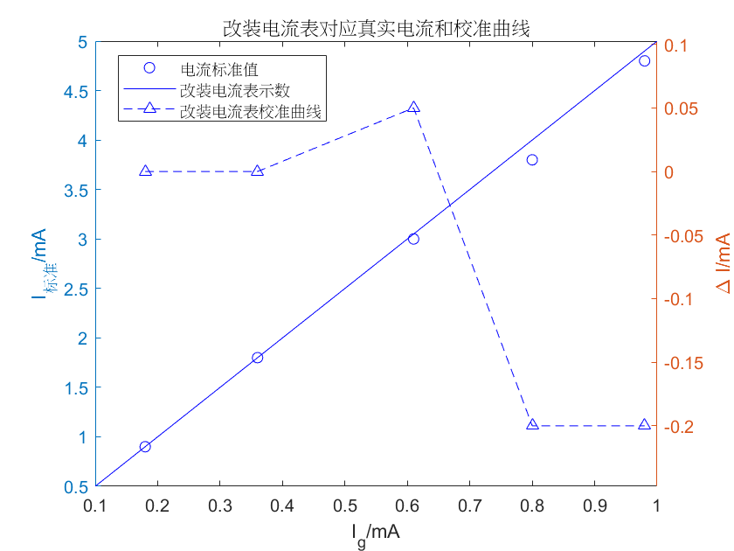

1. 改装5V量程的电流表并校准

|  |  |  |  |  |  |
| --- | --- | --- | --- | --- | --- |
| 实验次数 | 1 | 2 | 3 | 4 | 5 |
| 电流计示数 | 0.16 | 0.38 | 0.58 | 0.84 | 1.00 |
|  | 0.80 | 1.90 | 2.90 | 4.20 | 5.00 |
|  | 0.80 | 1.80 | 2.80 | 3.90 | 4.90 |
|  | 0.00 | -0.10 | -0.10 | -0.30 | -0.10 |

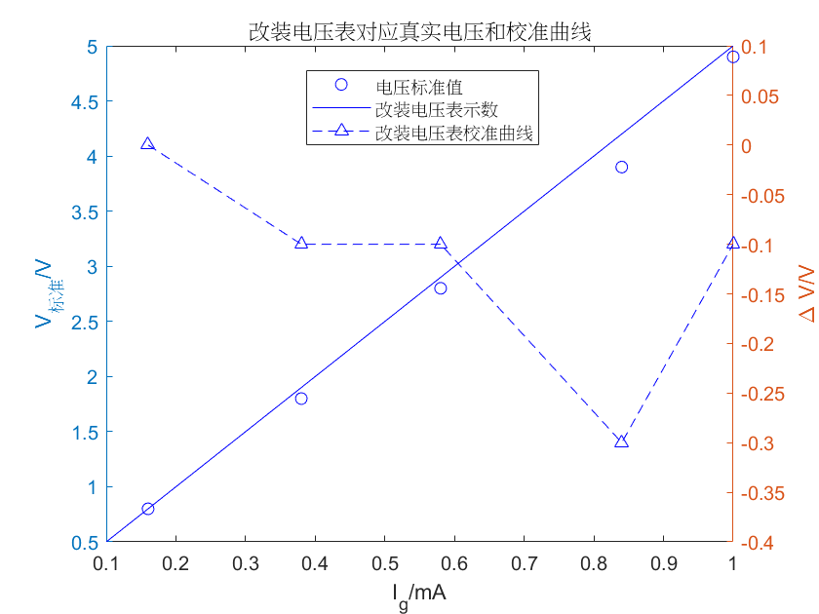

1. 改装欧姆表

|  |  |  |  |  |  |  |  |  |  |  |  |
| --- | --- | --- | --- | --- | --- | --- | --- | --- | --- | --- | --- |
|  | 1.00 | 0.90 | 0.80 | 0.70 | 0.60 | 0.50 | 0.40 | 0.30 | 0.20 | 0.10 | 0.00 |
|  | 0 | 45 | 93 | 152 | 225 | 330 | 490 | 740 | 1250 | 2500 |  |



740

490

330

225

152

93

45

0



2500

1250

0.00

0.10

0.20

0.30

0.40

0.50

0.60

0.70

0.80

0.90

1.00

