实验一 普朗克常数的计算

由【实验原理】部分，，其中

取真空中光速，取基本电荷

|  |  |  |  |  |  |
| --- | --- | --- | --- | --- | --- |
|  | 577 | 546 | 436 | 405 | 365 |
|  | 5.196 | 5.491 | 6.876 | 7.402 | 8.213 |
|  | -0.690 | -0.809 | -1.374 | -1.590 | -1.928 |

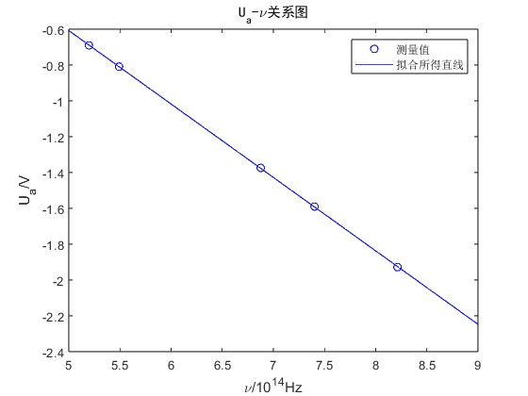MATLAB拟合得直线方程为



可知普朗克常数测量值



理论值为



相对误差为



实验二 图像绘制

光的波长为，原始数据如下表

|  |  |  |  |  |  |  |  |  |
| --- | --- | --- | --- | --- | --- | --- | --- | --- |
|  | -1.37 | 0.00 | 1.00 | 2.00 | 3.00 | 4.00 | 5.00 | 6.00 |
|  | 0 | 26 | 60 | 103 | 152 | 198 | 227 | 251 |
|  | 7.00 | 8.00 | 9.00 | 10.00 | 11.00 | 12.00 | 13.00 | 14.10 |
|  | 278 | 307 | 331 | 351 | 372 | 390 | 410 | 425 |
|  | 15.01 | 16.04 | 16.95 | 18.01 | 19.00 | 20.04 | 21.05 | 22.04 |
|  | 437 | 454 | 461 | 475 | 490 | 503 | 518 | 528 |
|  | 23.04 | 24.00 | 25.01 | 26.08 | 27.08 | 28.04 | 29.36 | 30.63 |
|  | 540 | 549 | 560 | 568 | 579 | 588 | 596 | 604 |

（请翻页）

绘制出图像如下图所示

