表1 反射法测三棱镜顶角

|  |  |  |  |  |  |
| --- | --- | --- | --- | --- | --- |
| 实验次数 | 左 | | 右 | |  |
| I窗 | II窗 | I窗 | II窗 |
|  |  |  |  |  |  |
|  |  |  |  |  |  |
|  |  |  |  |  |  |
|  |  |  |  |  |  |
|  |  |  |  |  |  |
|  |  |  |  |  |  |









表2 三棱镜对波长为汞单色光的最小偏向角

|  |  |  |  |  |  |  |  |
| --- | --- | --- | --- | --- | --- | --- | --- |
| 实验次数 |  |  |  |  |  |  |  |
|  |  |  |  |  |  |  |  |
|  |  |  |  |  |  |
|  |  |  |  |  |  |
|  |  |  |  |  |  |
|  |  |  |  |  |  |
|  |  |  |  |  |  |









表3 三棱镜对汞灯各单色光的最小偏转角与折射率

|  |  |  |  |
| --- | --- | --- | --- |
| 波长 |  |  | 折射率 |
| 404.7（紫） |  |  | 1.7100 |
| 435.8（蓝） |  | 1.6946 |
| 546.0（绿） |  | 1.6770 |
| 577.1（黄） |  | 1.6735 |

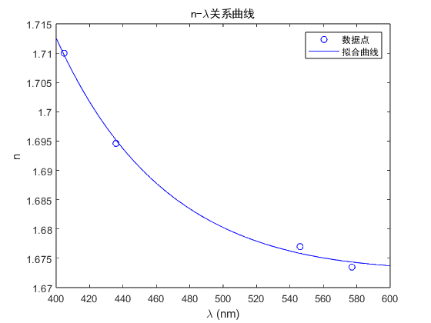根据柯西色散公式使用MATLAB拟合关系曲线

lambda = [404.7 435.8 546.0 577.1];

LambdaSpace = linspace(400,600);

x = lambda.^(-2);

n = [1.7100 1.6946 1.6770 1.6735];

p = polyfit(x,n,2);

c = p(1);

b = p(2);

a = p(3);

nSpace = c*LambdaSpace.^(-4)+b*LambdaSpace.^(-2)+a;

plot(lambda,n,'bo',LambdaSpace,nSpace,'b-')

legend('数据点','拟合曲线',fontname='黑体')

title('n-\lambda关系曲线',FontName='黑体')

xlabel('\lambda (nm)')

ylabel('n')

拟合的曲线方程为



此处的单位为