Document Title

# Young Biz Times

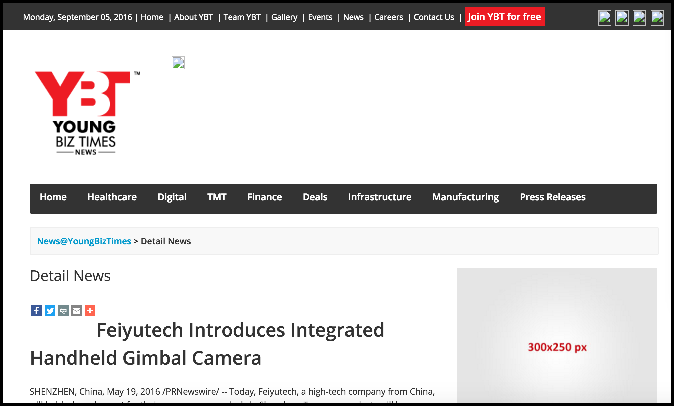

# Yeiki

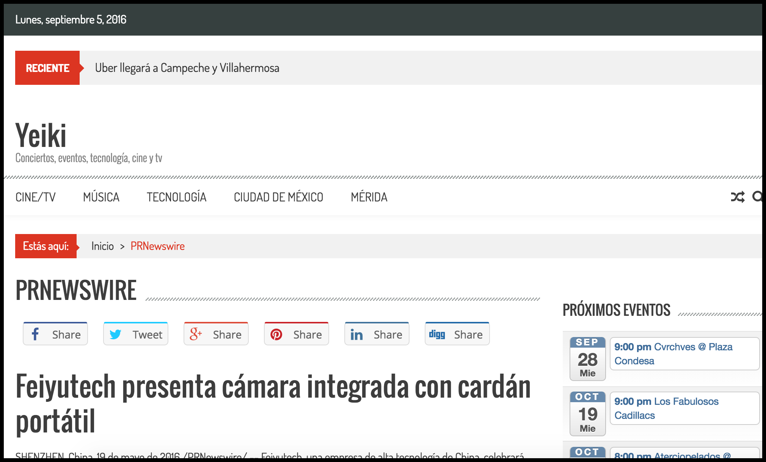

# Yahoo! Singapore

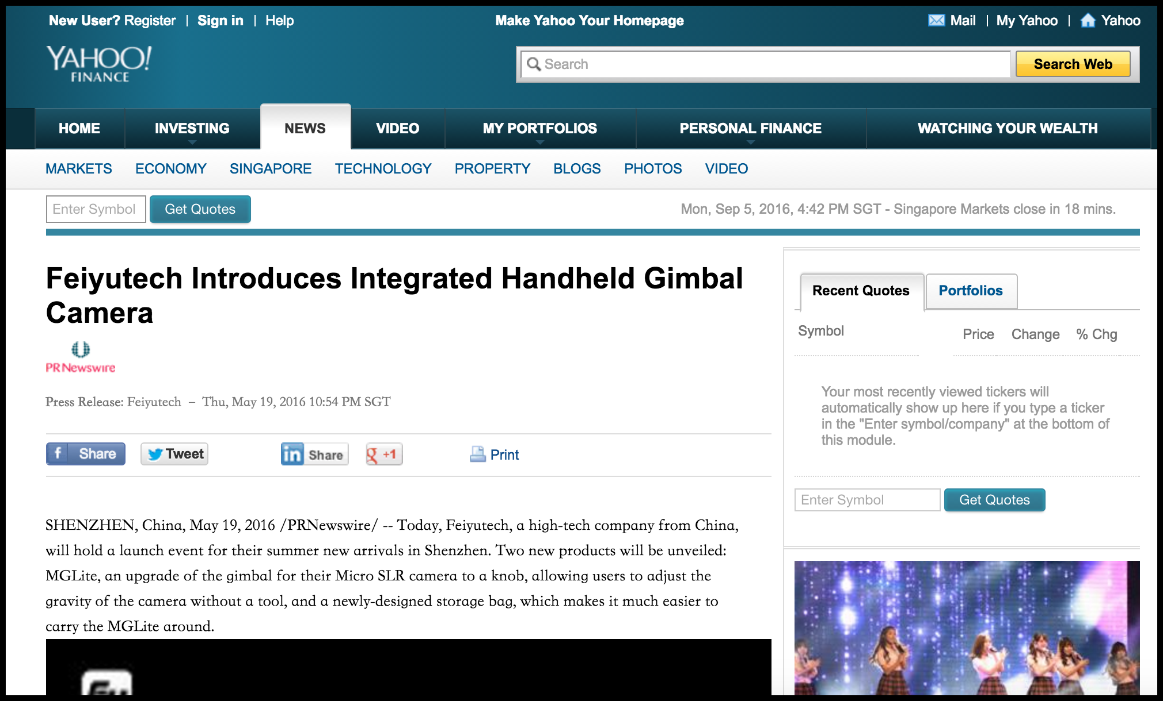

# ('Twitter 账号: ', 'AIPatHome (AIPatHome)')

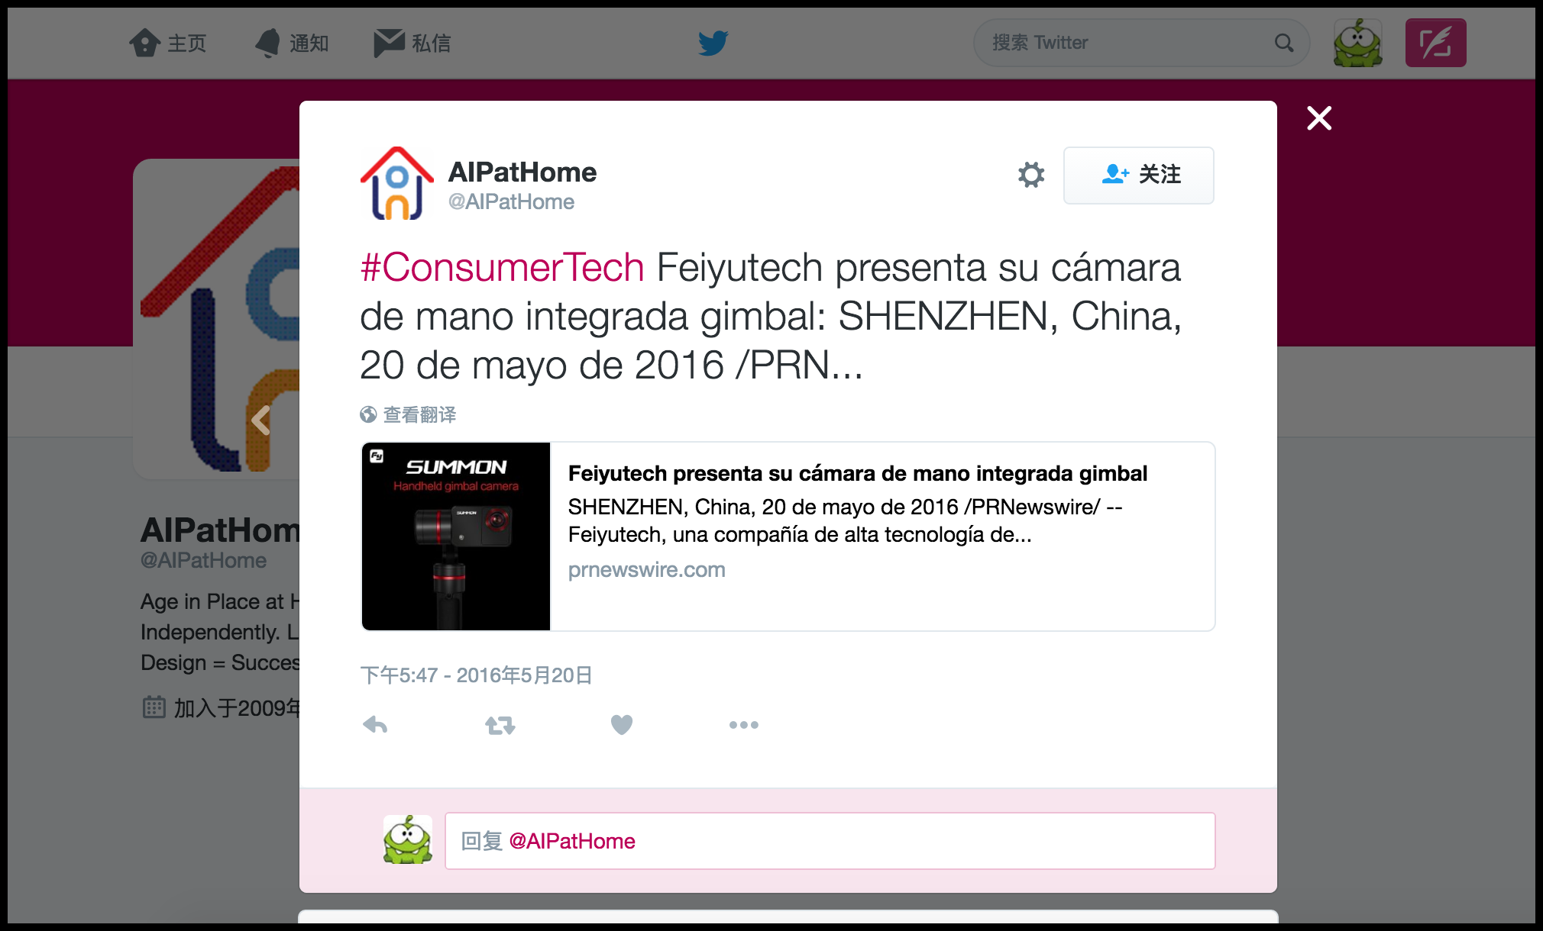

# ('Twitter 账号: ', 'AIPatHome (AIPatHome)')

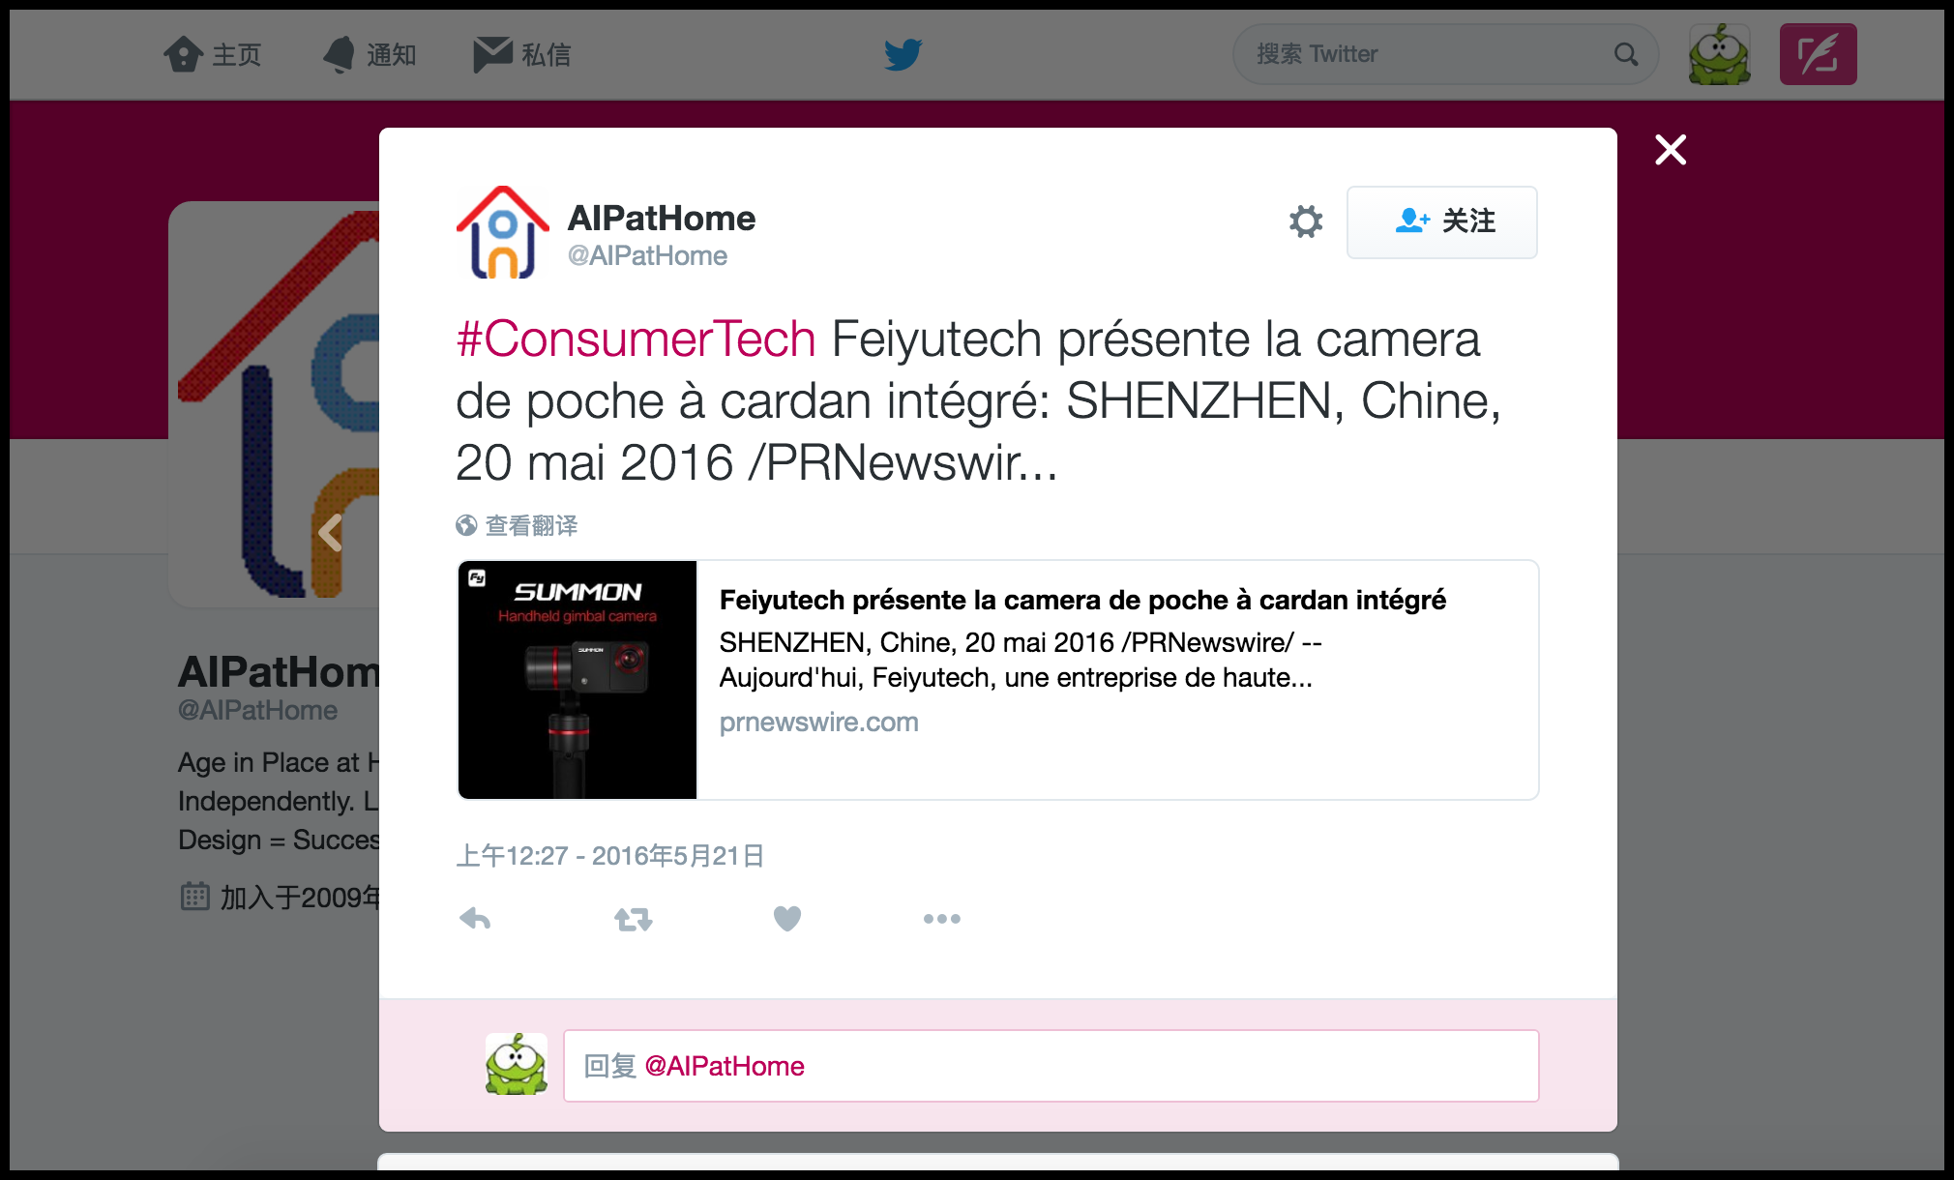

# ('Twitter 账号: ', 'AIPatHome (AIPatHome)')



# ('Twitter 账号: ', 'AIPatHome (AIPatHome)')

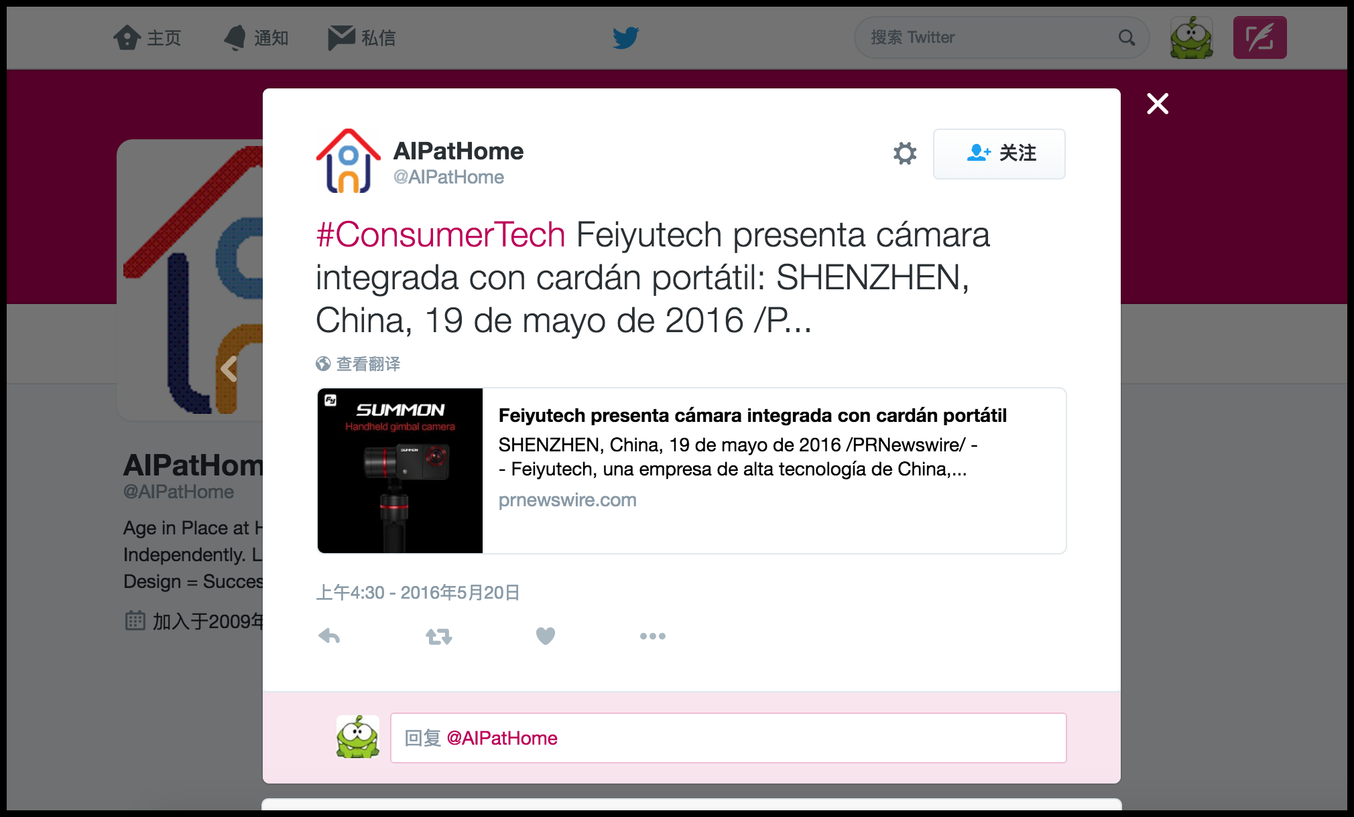

# ('Twitter 账号: ', 'marlene (SavaneWorld)')

