Fault diagnosis with evaluation of fault-relevant variable significance and twofold statistical modelling based on NeLFDA for industrial processes

Chunhui Zhao¹, Wei Wang², Furong Gao³, Jie Zhang⁴
1 State Key Laboratory of Industrial Control Technology, College of Control Science and Engineering, Zhejiang University, Hangzhou, 310027, China
2 China Tobacco Zhejiang Industrial Company Limited, Hangzhou, 310009
3 Department of Chemical and Biomolecular Engineering, The Hong Kong University of Science and Technology, Clear Water Bay, Kowloon, Hong Kong Special Administrative Region
4 School of Chemical Engineering and Advanced Materials, Newcastle University, Newcastle upon Tyne NE1 7RU, UK
Abstract
Discriminant analysis (DA) has been widely applied for fault diagnosis recently, which, however, treats the fault data as a single subject without analyzing the specific effects of different variables. Also, there are some drawbacks for the DA algorithm itself. It thus may not clearly distinguish different fault types from each other. To address this problem, a new fault diagnosis method is proposed which can extract more meaningful discriminant directions and probe into the specific faulty variables. Monte Carlo(MC) is used to judge whether it is suitable to conduct DA on the fault data. By pairwise performing nested-loop Fisher discriminant analysis (NeLFDA) algorithm on normal and fault process data, some projection directions that are useful for classification between normal and fault cases are extracted. Then along these directions, fault-relevant variable significance is measured for iterative faulty variable selection using MC and NeLFDA so that process variables that are significantly fault-relevant are identified and distinguished from those general variables. Based on variable separation results, twofold fault diagnosis models are developed for each fault type. Each fault is marked with variable separation result, twofold fault diagnosis models and their associated statistics. A probability index is calculated using Bayes' rule for each fault sample to quantitatively evaluate the probability it belongs to each fault type. Online fault diagnosis is then performed by dually checking the characteristics of fault samples using two fault diagnosis models. Its performance is illustrated with the real industrial process data from the cut-made process of cigarette.
Keywords: Fault-relevant variable significance; fault diagnosis; Monte Carlo; Bayes' rule; nested-loop Fisher discriminant analysis(NeLFDA).
1 Introduction
In manufacturing industries and chemical processes, online fault detection and diagnosis[1-9] has drawing people’s increasing attentions over the last few decades, which is of importance to ensure safe and efficient operation. As one of the most active research areas in process control,. With large amounts of data being collected in many chemical processes and the development of data-driven methods, multivariate statistical process monitoring (MSPM) has emerged as an important tool for fault detection and diagnosis of industrial processes in order to maximize their productivities and efficiencies. Dimensionality reduction techniques[10-14], such as principal component analysis (PCA)[10,11], Fisher discriminant analysis (FDA)[12,14] and etc., have been widely applied for fault diagnosis. The success may result from one of the main characteristics of these multivariate projection methods, i.e., their ability to handle large numbers of highly correlated variables. In particular, they are able to extract a few latent variables to summarize all the relevant information and thus project the measurement data down into a low-dimensional space, resulting in a refined analysis space.
FDA algorithm[12] is one of the most popular fault diagnosis methods[15-18]. Since the research work by Chiang et al. in 2000[15], the use of FDA for fault diagnosis of chemical process has been explored widely. From another perspective, fault diagnosis can be regarded as one of classification problems, where each class corresponds to data collected during a specific known fault. The classical FDA searches for the projection directions on which the data points of different classes are separated as far as possible while the data points of the same class are kept to be close to each other. Despite of its success in fault diagnosis, recently, people have recognized some problems of classical FDA algorithm which may have limited its effectiveness.
First, for the FDA algorithm itself, there is the singularity problem of within-class scatter matrix. Several variants[19-25] of FDA algorithm, such as regularized LDA[21], pseudoinverse linear discriminant analysis (LDA)[22] and LDA/QR[24], have been developed, which, however, have caused some undesirable new problems. Zhao et al. proposed a nested-loop fisher discriminant analysis(NeLFDA) algorithm[25] to comprehensively handle three important problems of FDA algorithm. It can overcome the singularity problem of within-class scatter matrix for eigenvalue decomposition. Besides, it can extract multiple discriminant components by solving rank deficiency of the between-class scatter matrix, and obtain orthogonal discriminant components. By employing orthogonal transformation, correlations among features are decomposed so that overlapping information between components is avoided. The above problems are addressed in a nested-loop iterative process including inner-loop and outer-loop calculation. The NeLFDA algorithm is reported to be able to better separate different classes with improved discriminant power.
Second, conventional discriminant analysis treats the whole measurement variables as a single subject which does not isolate the specific faulty variables. Some diagnosis methods have focused on analyzing the specific variables. Contribution plots[26-28] are the most popular tool for identifying which variables are pushing the statistics out of their control limits. It is based on the assumption that the out-of-control monitoring statistics are contributed significantly by those faulty variables. Although this approach does not need prior fault information, it, however, may result in confusing results since it is hard to say whether the contribution of one variable is significant or not. Moreover, the contribution values are calculated along the PCA monitoring directions which are extracted based on the distribution variances of normal data and may not be useful to distinguish fault data from normal data. Because discriminant analysis takes both normal and fault data into account and finds the fault directions that optimally separate fault data from normal data, the discriminant projection can thus better explore the fault effects departing from the normal status. Like the contribution plot method based on PCA, Qin et al.[17] identified the major contributing variables to the fault based on FDA directions instead of PCA directions, which, however, does not probe into the relationship of specific variables. Meanwhile, it was limited by the singularity problem of conventional FDA algorithm.
In general, for each fault case, the variables may be influenced differently. Some specific variables will be disturbed significantly while some others may stay similar with those of normal case and thus may not contain meaningful information about the fault effects. Since not all measurement variables are disturbed and they have different correlations, one important issue is to isolate those faulty variables and separate them from the others based on their different relationships with fault effects in order to produce the most discriminative power for fault diagnosis. Besides, distinguishing the significant faulty variables that cover the informative fault effects from those general variables can enhance fault process understanding. To address the above problem, a fault diagnosis method is proposed in this paper with evaluation of fault-relevant variable significance and twofold statistical modelling based on NeLFDA. First, to better separate each fault type from normal data, NeLFDA is pairwise conducted for normal and fault data sets to extract fault directions. Second, measurement variables are evaluated by checking their fault-relevant significance, in which, one significant faulty variable is selected and the left variables are evaluated to see whether they has the similar variation with that of normal data. The above selection action is iteratively implemented which can separate the original measurement variables into two parts, faulty variables and general variables. Third, twofold statistical models are developed, which can evaluate the underlying variable characteristics of two variable subsets. A probability index is defined which can quantify the extent of each sample belongs to one fault type. In this work, it assumes that the fault process shows a deviation departing from the normal status which thus provides a good platform for discriminant analysis.
The major contribution is listed as below:
(1), The difference between normal and fault cases are well probed into by exploring the significant fault directions using NeLFDA algorithm.
(2), A faulty variable selection algorithm is proposed in which faulty variables are isolated and distinguished from general variables, revealing significant fault effects.
(3), Fault cause is double checked by two subsets of variables, which reveal different variable correlations.
The remainder of the paper is organized as follows. First, a simple preparatory theoretical support is framed by a revisit to the conventional FDA and the NeLFDA algorithm. Subsequently, the proposed algorithm is mathematically formulated that includes variable separation, fault diagnosis modeling and online diagnosis. Based on the industrial process data from the cut-made process of cigarette, the proposed method is verified. Discussions are conducted to analyze the illustration results. Finally, conclusions are drawn based on results of this study in the last section.
2 Revisit of FDA and NeLFDA
In this section, two FDA algorithms are revisited, the conventional FDA algorithm[12,16] and the NeLFDA algorithm developed in our previous work[25]. NeLFDA algorithm is the basis of the proposed faulty variable selection based fault diagnosis work.
2.1 The Conventional FDA Algorithm[12,16]
Let 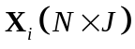 be a data matrix which is composed of the samples from Class i in which the rows are the observations and the columns are process variables. In this work, each class may correspond to historical data collected from a specific fault. N indicates the samples and J indicates the variables. 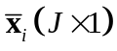 is the J-dimensional sample mean for Class i. Without special statement, a vector is a column vector. The within-class scatter matrix for Class i can be calculated by
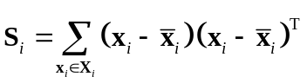 (1)
Then the within-class-scatter matrix for all classes is,
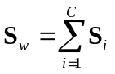 (2)
where, C is the number of classes.
The between-class scatter matrix is calculated as,
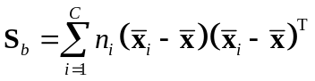 (3)
where, n_{i} is the number of observations in Class i, and is the total mean vector for all samples.
The FDA components are determined by maximizing the Fisher criterion, i.e., the ratio of the between-class scatter to the within-class scatter,
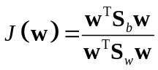 (4)
where the vector w is the Fisher optimal discriminant direction.
It is easy to show that a vector w that maximizes 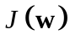 is equal to calculating the generalized eigenvectors of the eigenvalue problem:
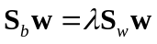 (5)
where the eigenvalue indicates the degree of overall separability among the classes. If 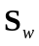 is non-singular, we can obtain a conventional eigenvalue problem by the following expression
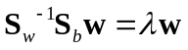 (6)
A set of eigenvectors of 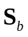 and can be obtained once corresponding to the m largest non-zero generalized eigenvalues. Note that there are at most C-1 non-zero generalized eigenvalues. Therefore, the number of retained discriminant components is subject to the number of classes.
2.2 The NeLFDA Algorithm[25]
As mentioned before, the conventional FDA algorithm has some problems which may limit its success. In order to improve the discriminability, a nested-loop FDA algorithm (NeLFDA) is developed by designing two iterative modelling processes. The theoretical part is presented in our previous work[25]. The basic idea of the proposed NeLFDA is to overcome three important problems of the conventional FDA algorithm as mentioned before. The above problems are addressed in a nested-loop iterative process by constructing two different mathematical optimization problems with different objective functions. First, it designs an inner-loop iterative process, which maximizes the between-class scatter but can prepare as many preliminary components as the rank of the original within-class scatter matrix. The within-matrix scatter in fact converges to a diagonal matrix, which thus provides an analysis platform for further feature compression. Second, it further refines the preliminary components by maximizing the ratio of the between-class scatter to the within-class scatter to extract the final discriminant components which in fact works as a post-processing step on the inner-loop results. An outer-loop iterative process is implemented so that multiple final discriminant components can be obtained to solve the problem of the rank deficiency of the between-class scatter matrix. Besides, class-specific data deflation is performed whenever a final discriminant component is extracted which thus guarantees the orthogonality of discriminant components for each class. For the specific, please refer to our previous work[25].
3 The proposed method
Following the theory part of NeLFDA algorithm[25], it is employed for faulty variable isolation and online fault diagnosis. Two issues are addressed during offline model development and online application, including which variables are significant to fault effects and how to classify the fault cause for both fault-relevant and irrelevant variables. They are solved by three key steps. First, during offline modelling stage, a faulty variable selection strategy is developed which can isolate those fault-relevant significant variables and separate them from the other general variables. Second, different characteristics of the two variable sets are deeply probed into for twofold model development. Third, for online fault diagnosis, the underlying process characteristics of new fault samples will be double checked regarding both variable sets. And the affiliation probability of new samples is calculated which can assign each sample to the most possible fault type.
3.1 Faulty variable selection based on Monte Carlo and NeLFDA
Here, an iterative faulty variable selection strategy is developed based on the principle of Monte Carlo (MC)[29] and NeLFDA. Two data sets are prepared, 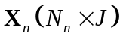 and 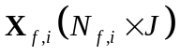, each being composed of the same number of variables indicated by J and maybe different number of samples indicated by 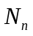 and 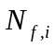 respectively. 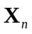 denote the normal data where subscript n denotes normal data and 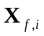 denote one data set collected under one fault status i where subscript f denotes fault data and i denotes the fault class index.
The Monte Carlo method, or called as the random imitative method, is a powerful and widely used stochastic technique, which is based on the use of random numbers and probability statistics to investigate problems. In this work, MC method is used in the procedure of acquiring faulty variable for two aspects.
First, Monte Carlo based fault center evaluation is performed to judge whether discriminant analysis can be conducted. A certain amount of normal samples 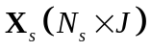 are randomly selected from as the normal subsets (where the number of samples in subset counts for 2/3 of the total number of normal samples 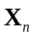 here), and the center of each normal subset is calculated. The random selection procedure is repeated M times(here M is set with 200) and a matrix of the centers are obtained, 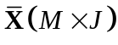 where each row vector is the center from subset . Then the final center and the variance can be calculated from from which, a confidence region is defined as 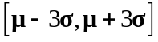 which can tell the variation of normal data center. It will be used to check whether the fault variation can be explored by discriminant analysis. If the fault data center is beyond the confidence region for any variable, disciminant analysis can then be performed on and 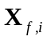 for fault variable selection.
Second, Monte Carlo based faulty variable evaluation index is defined to reduce dependence on modelling samples and to judge the selection of them. M normal subsets are randomly selected by MC and pairwise analyzed with fault data to extract the discriminant-based fault directions. Along the fault directions, the fault effects of different variables are evaluated in which a large number of ratio values are calculated at each time for each variable with randomly selected normal subsets, and then each variable is evaluated with a stability of the corresponding ratios. Variables with good stability are known as faulty variables for the current time. Along time direction, the changes of stability is checked and the faulty variables should have the highest frequency to be chosen. The evaluation index is described as below.
(1). Monte Carlo technique is used to randomly select a certain amount of normal samples from and M normal subsets are obtained. By pairwise implementing NeLFDA algorithm[25] on one normal subset that is randomly selected by MC and fault data , the weights 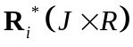(The italic letter R denotes the number of retained discriminant components, which is different from the bold letter R) are obtained corresponding to the normal class when it is associated with fault class i. The weights for each fault class can also be obtained, 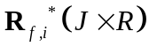. It is noted that for the normal class, when it is associated with different classes of fault data, the extracted 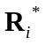 are different which are used as projection directions to discriminate normal and fault classes. are used as the monitoring directions and along the extracted directions, multiple discriminant components can be extracted for each fault class which reveal the major information to separate each specific fault class from the normal status, revealing the responsible fault effects,
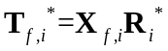 (7)
Also, for the normal class, the corresponding discriminant components can be calculated, revealing the normal version of 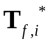,
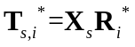 (8)
Here, the class-specific final discriminant components and 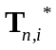 can be used to replace the original fault class data and normal class data. For simplicity, the superscript * is omitted in the following description.
(2). The Mahalanobis distance[30] of each sample m in the normal class can be calculated to provide a useful measure of similarity between this sample to the normal class center,
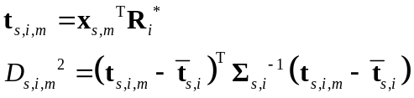 (9)
where, 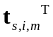 is the discriminant components of some specific normal sample 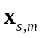 calculated by associating the normal subset to fault class i. 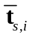 is the mean value of 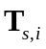 calculated from training data subset. 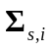 denotes a diagonal matrix where the diagonal elements are the variances of components along directions . It is noted that if some of the variance values are close to zero, they will be set to be one to avoid ill-condition problem. The statistic D² in fact summarizes the variations at the normal status along different fault directions attached with different weights which make the variations have the same scale and thus reasonable to be added up.
For the fault class, the corresponding D² for each fault sample which summarizes the variations at fault status along the extracted fault directions can also be calculated as,
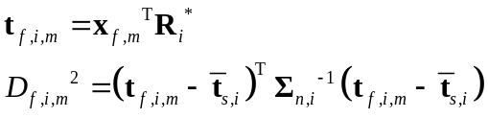 (10)
where, 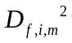 in fact reveals the fault version of 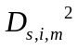 that counts the integrated fault information.
(3). By comparing against , it reveals the difference of variations between normal and fault cases. The purpose of faulty variable selection is to find those informative ones in fault data that have significantly contributed to discrimination between normal and fault and are thus useful for fault classification. Therefore, we can calculate the contribution of each variable in one sample m to D² statistic defined for the normal data and the fault class i,
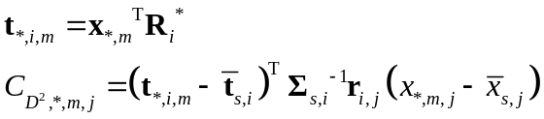 (11)
where, the normal data and fault data are distinguished by the subscript * in which subscript * can be n which denotes the normal class or f which denotes the fault class. 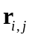 are the jth row vector of which are the weight coefficients associated with the jth variable along different fault directions. 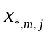 is the jth variable in the sample m. 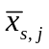 is the mean value of the jth variable of training data in normal subset. The contribution of each variable in the sample m to the concerned D² statistic is then defined by 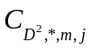. It is clear that 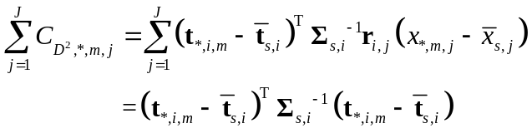.
(4). For each normal subset, a vector 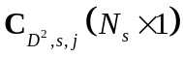 can be obtained corresponding to each variable. Considering that the normal data may also have a certain contribution, the contribution ratio between normal and faulty variables should be used which can reveal how significantly each variable’s contribution to D² monitoring statistic is changing from normal to fault. The ratio of variable contribution in one fault sample m is calculated as,
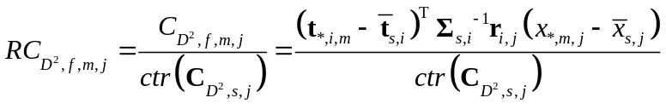 (12)
where, 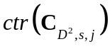 denotes the control limit of 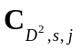 defined for normal training subset. The density distribution of is estimated using kernel density estimation[31] and the point, occupying the 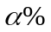 area of density distribution, can be calculated as the control limit with 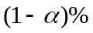 confidence level. The limit is used as the reference for each variable where singular points are excluded to avoid their influences on the reference. In this way, the relative contribution of each variable in fault data is calculated at each time in comparison with each variable in normal subset. A larger value 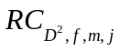 means the variable of fault data has a larger contribution to fault variations in comparison with the other variables. For M normal subsets that are randomly selected by MC, a vector 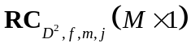 is obtained, which can quantitatively measure the fault-relevant significance of each variable j by defining the significance index as below:
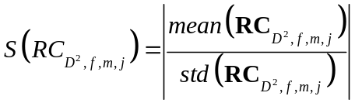 (13)
where, 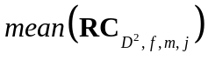 calculates the mean of the column vector 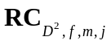 and 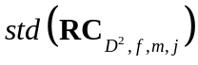 calculates the standard deviation of . The absolute value of ratio between and is used to indicate the significance of each variable to fault effects. The highest value of 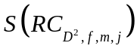 indicates that the concerned variable has the largest relative contribution with the smallest variability among randomly selected subsets which thus reveals the most significant fault-relevant variable. Besides, for all fault samples, the values can be organized as an N_{f}-dimensional vector 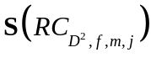 for each variable. Here mean value of along time direction (i.e., the average level) can be calculated as 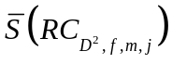 to reflect the fault influences of multiple samples. The most significant faulty variable thus can be indicated based on the largest mean value . In contrast, the left variables do not contribute to the discrimination between normal and fault, which are thus termed general variables here.
The specific faulty variable selection procedure is described as follows.
Step (1). Monte Carlo based fault center evaluation
Monte Carlo technique is used to randomly select a certain amount of normal samples from and M normal subsets are obtained. Then the confidence region of normal data center is defined as 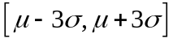 to judge whether the fault variation can be explored by discriminant analysis. If the fault data center is beyond the confidence region, stop the procedure. Otherwise, go to Step (2).
Step (2). NeLFDA based fault direction extraction
For each normal data subset (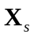) and each class of fault data set (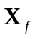), the fault directions () are extracted by pairwisely performing NeLFDA algorithm[25]. Using the extracted fault directions () as the monitoring model, the corresponding class-specific components (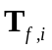 and ) are then extracted for each fault class and the normal subset using Eqs. (7) and (8) respectively.
Step (3). Fault data monitoring
Calculate the statistical index D² using class-specific components for the normal and fault classes using Eqs. (9) and (10) respectively. Then compare the values of monitoring statistic from fault samples against the confidence limit defined for normal data subset. If no enough alarm is issued where the threshold of number of alarm signals is indicated by ß, the fault class is regarded to have the similar variation with that of normal data subset. Stop the procedure. Otherwise, go to Step (3) to continue the modeling procedure.
Step (4). Variable contribution evaluation
Calculate the variable contribution for both normal subsets and fault data using Eq. (11). Set the reference contribution for each variable based on normal data subset and calculate the ratio of variable contribution () for each variable in the fault class as shown in Eq. (12). Go back to Step (2) to calculate for next normal subset and fault samples until all normal subsets have been used.
Step (5). Calculation of variable significance
The significance index is calculated as shown in Eq. (13) for each variable as well as the mean value for fault samples, which is used to indicate the significance of each variable in distinguishing normal and fault data.
Step (6). Faulty variable selection
Sort the process variables based on the values of . The variable with the largest is determined to be the most informative and contributive. Archive this variable (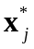) into the faulty variable library.
Step (7). Model updating
Remove the selected faulty variable () from both normal data and fault data and the updated data are denoted as 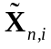 and 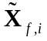.Go back to Step (1) to conduct selection of next faulty variable based on the updated normal and fault data ( and ).
Iteratively repeat the above steps until all faulty variables are selected. They cover the least number of faulty variables that have contributed to the discrimination between normal and fault data and have caused monitoring alarms. During the faulty variable selection process, two conditions are used to determine whether the iterative process should stop as described in Step (1) and Step (3). For the stop condition shown in Step (1), it is used to judge whether it is necessary to perform discriminant analysis since the deviation of data center is a necessity. For the stop condition shown in Step (3), it is used to check whether the left variables can be accommodated by the model defined for normal data. If this condition is met, it means that the left variables after removing the faulty variables are correlated similar with those in normal case. Therefore, there is no need to implement the following selection action and the iterative procedure can stop. Otherwise, there are still some variables different from those in normal case, which should be selected as faulty variables. If all modeling variables have been disturbed by the process fault, all variables have to be selected since the fault effects have propagated from the root variables to others. It will converge to the case that all variables are used for discriminant analysis, which can be regarded as one extreme case of the proposed strategy. In general, two variable sets can be separated from each other, revealing different variable correlations.
(Insert Figure 1 here)
A flowchart is shown in Fig. 1 to explain the faulty variable selection procedure. The output is variable separation results for both normal and fault samples. For each fault class, the faulty variables 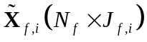 which cover 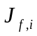 significant faulty variables that are relevant with the fault effects reveal significant difference between normal and fault statuses. The left general variables 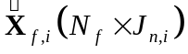 are not disturbed and can be accommodated into the confidence region of normal data. That is, the variables in each fault class are separated into two parts (faulty variables and general variables) based on their relationship with those in normal class. Some are related with discrimination between normal and fault data and the others do not contribute to the fault effects.
3.2 Development of fault diagnosis models
After the variable selection, those significant faulty variables are marked and separated from the other general variables for each fault class. However, only the faulty variable separation results may not well distinguish different fault types since even the same set of process variables are disturbed, they may correlated in a different way. Here, two fault diagnosis models are extracted for two parts of variables in each fault type based on variable separation results. They are used to reveal the fault effects for each fault type and then used to calculate the fault evaluation statistics for fault diagnosis. It can help further fault process understanding since the fault effects are captured variable-wise. On the one hand, the selection of faulty variables can improve the parsimony of diagnosis model which can thus focus on the key information and more clearly separate the normal and fault cases by excluding those uninformative variables. On the other hand, more information is provided based on the two separated variable subsets which are explored differently. To achieve this purpose, the variables in the normal status are also separated into two parts corresponding to the variable separation in each fault type, which are denoted as 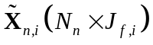 and 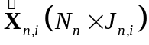 here. It is noted that when the normal data are associated with different fault types for pairwise discriminant analysis, the separation of variables at the normal status can be different which is indicated by subscript i. For the two separated variable subsets, the modeling procedure is described as below.
(1), For the faulty variables in normal and fault samples:
Data normalization is performed for and the normalization information is used to process fault samples . Here for simplicity, the preprocessed data are still denoted as and .
Pairwise NeLFDA is performed on and to extract fault directions to explain the major abnormal changes from normal to fault. The fault directions are extracted as 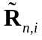 for the normal data and 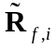 for the fault data regarding the faulty variables. The fault directions extracted in this way can focus on the significant discriminant information between the normal and fault classes. Here the number of retained fault directions is determined by using the idea of fault reconstruction where the least number of directions are kept in which the monitoring statistics of the corrected data after removing the variations along the concerned directions can be brought back to the normal region defined for normal data ,
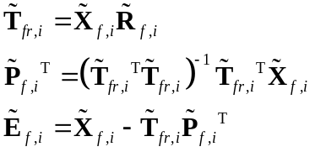 (13)
where, 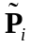 denotes loading matrix for 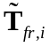 to explain 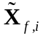 and 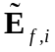 denotes the left variation after the explanation.
The left variation are projected onto the PCA model () defined for , where it is noted that all monitoring directions are kept which is equal to the rank of ,
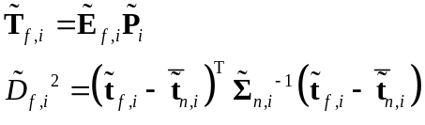 (14)
where, 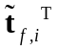 is one row vector in 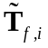, the components extracted from the faulty variables ; 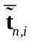 denotes the mean of components 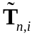 extracted from by 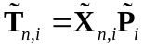 which is in fact zero vector because of the data normalization; 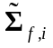 is the variance-covariance matrix of . This statistic 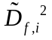 summarizes the fault variations along PCA directions .
A confidence limit should be derived for the statistic in each fault class. Assume that the process data follow a multivariate Gaussian distribution, and the sample number is large enough so that the  distribution[32] instead of F-distribution[33] can be adopted for computation of confidence limit,
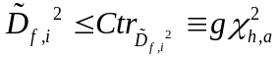 (15)
where, 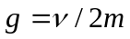 and 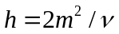, in which, is the average of all the values calculated for training data of each fault class using Eq. (14). is the corresponding variance. If there is not any knowledge of fault data distribution, kernel density estimation[31], as a non-parametric way to estimate the probability density function of a random variable, can be used to define the confidence limit of .
(2), For the general variables in normal and fault samples:
Since the general variables are uninformative to discriminate from normal to fault samples, the variations are similar which can be accommodated by a unified model. Here, the super data 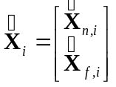 are constructed where data preprocessing is conducted to make each variable to be of zero mean and unit standard deviation. PCA is then performed on 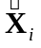 to extract monitoring directions to explain the process variations. Here, all directions are kept in which the maximal number of components is limited to the rank of . The monitoring directions are extracted as 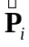 regarding the part of general variables, which is then used for calculation of fault evaluation statistics,
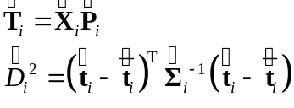 (16)
where, 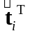 is one row vector in 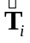, the principal components extracted from data ; denotes the mean of principal components which in fact is zero due to data preprocessing; 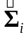 is the variance-covariance matrix of . This statistic 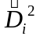 summarizes the general variations in each fault class along monitoring directions that are not significant to discriminate normal and fault classes.
A confidence limit is derived for the statistic of each fault class using the similar principle for statistic.
Based on the above analysis, each fault class is marked with two parts of variables, their respective diagnosis models and the associated confidence limits. Different faults are distinguished from each other by both faulty variables and general variables as well as their different variable correlations. All the fault information is archived in the fault library. Then for online fault diagnosis, the fault information of each candidate fault class obtained during offline modelling stage will be tried to identify the affiliation of each new fault sample.
3.3 Online fault diagnosis
Whenever a new observation at the kth time interval, 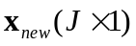, is available, fault detection is firstly implemented to find whether some abnormal behavior is happening. Here, the focus is for online fault diagnosis. Therefore, we assume that the fault is detected by some method and the current sample is deemed to be abnormal. Based on the models developed based on faulty variable separation, the fault diagnosis is implemented for each fault sample by determining its affiliation to one of candidate fault classes in fault library. That is, the fault information from each candidate fault class will be alternatively tried to find which one can well accommodate the current fault sample.
Assume the fault sample belongs to some candidate fault class. Correspondingly, according to the faulty variable separation information from this candidate fault class, the current sample is directly separated into two parts, the faulty variable part and the general variable part, 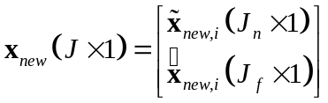. Then the similarity of this new fault sample with each candidate fault class will be alternatively evaluated for the two separated variable subsets.
(1). The corresponding faulty variables are evaluated by adopting the corresponding fault diagnosis model developed for faulty variables of the candidate fault i,
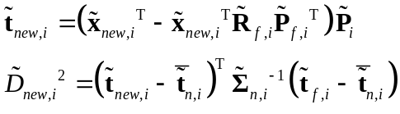 (17)
where, 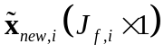 are the selected faulty variables in the fault sample 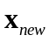 which are reconstructed by the specific fault diagnosis models (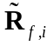 and 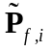) to calculate the components 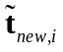. The corresponding statistic 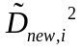 is then calculated to reveal the left variations along the concerned monitoring directions .
(2). Those general variables are evaluated by adopting the corresponding fault diagnosis model of the candidate fault,
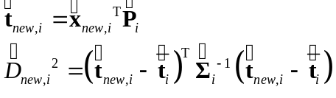 (18)
where, 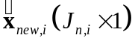 are the left general variables in the fault sample and 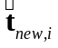 are the components. The statistic 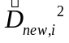 is calculated to reveal the variations along the concerned monitoring directions 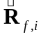.
The two statistics evaluate different variations in the current fault sample. 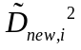 summarizes the corrected variations after the explanation of fault directions and summarizes the left general variation information which is not significantly different from that of normal status. Then compare the values of two new fault evaluation statistics with the predefined control limits for the corresponding parts of normal samples respectively. If both monitoring statistics stay well within the predefined confidence regions of one specific fault class, it means that both the fault effects and general variations of the new sample are similar with those of the concerned fault class. Thus the current sample can be deemed to be operating according to the concerned fault class. On the contrary, if alarm signals are issued for any statistic, it reveals that the current fault sample is not consistent with the candidate fault type. Based on the above calculation, fault cause is judged by finding which candidate fault class can well accommodate the current fault sample.
However, the above rule can only tell whether the new samples belong to one fault type or not which can not tell how much the samples is associated with the concerned fault type. Therefore, a probability index is also defined here to evaluate whether the fault cause can be correctly identified which can tell the possibility of the current fault samples belong to each fault type.
Using Bayes' rule[34], for each measurement sample,
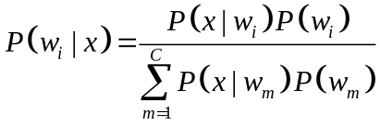 (19)
where, 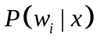 is the a posteriori probability of x belonging to class 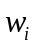. 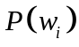 is the a priori probability for fault class . C is the number of fault classes which are considered in fault library. 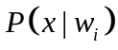 is the probability density function for x conditioned on where x can be represented by one of the monitoring statistics defined in Eqs. (14) and (15). Without any knowledge of fault data distribution, kernel density estimation[31] is used as a non-parametric way to estimate their probability density functions respectively. Assume that is the same for different fault classes, Eq. (19) can be replaced by 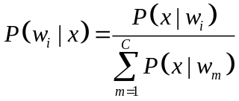. Since the denominator is the same, can thus be replaced by .
Therefore, for each sample, a posteriori probability of x belonging to class can be calculated based on two statistics, 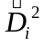 and 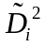.
4 Illustrations and Discussions
In this subsection, the proposed fault diagnosis method with variable separation is tested by the real industrial process data from the cut-made process of cigarette. The proposed method is also compared with the conventional discriminant analysis based fault diagnosis method.
(Insert Table 1 here)
As one of the most important procedures in the cigarette manufacturing, cut-made process determines the flavor and style characteristic of cigarette. It is composed of three operation sections, leaf processing, silk processing, and Blending and spicing. The silk processing transfers the leaves into leaf-silk which is critical to cigarette quality. It includes two major operation machines, SIROX warming and humidification machine and cylinder drier (KLD). The first machines inflates and dampens the leaf-silk before the later machines dries the moisture content of leaf-silk from 20% to 12% using the heated barrel with saturated steam. For the process, twenty-three measurement variables are collected with interval of 10 seconds, which are described in Table 1. In this study, all variables are used for modeling. Three fault cases are considered and the fault description is shown in Table 2(a).
First, during offline modelling stage, faulty variable separation is performed for different faults. Here, 595 normal samples are used as reference. Two different number of fault samples (50 and 100 fault samples respectively) are compared. For the two cases, the identified faulty variables are comparatively shown in Table 2(b). The variable selection ratio (VSR) is calculated as the ratio between the number of selected faulty variables and the number of modelling variables. It is clear that when more fault samples are used for analysis, more faulty variables are selected as indicated by the increase of VSR index. It means that with time evolving, the fault effects will propagate and more variables will be disturbed.
(Insert Table 2 here)
In the following, fifty fault samples are used which represent a short fault process time so that we can assume that the fault characteristics have not changed significantly. For each fault case, the result of faulty variable selection is explained as below.
For Fault #1, a step change happens for Region-1 vapour pressure by adjusting the vapour pressure valve in which, the valve open is increased by 25%. The change of Region-1 vapour pressure will result in changes of other variables because of their close relationship. First, faulty variables are selected using the proposed algorithm. Fifty fault samples are used which represent a short fault process time so that we can assume that the fault characteristics have not changed significantly. Using the proposed faulty variable selection algorithm, seven faulty variables are selected, including Variables #11, 12, 15, 20, 21, 22 and 23. This agrees well with the real case. Following the adjustment of pressure valve, the Region-1 vapour pressure (Variable #11) will response directly. When the valve opening is increased, the Region-1 vapour pressure will be increased, which will result in more vapour projected onto the wall and thus the wall temperature (Variable #12) will be increased. The condensed water temperature (Variable #15) is thus increased since there is more heat to be condensed for the same amount of cooling water. Variable #20(KLD dried moisture content) and Variable #21(KLD dried temperature) are measured at the output of KLD machine. Variable #22 (Cooling moisture content) and Variable #23 (Cooling temperature) are measured at the output of winnowing cooling machine that locates after KLD machine. With the increase of wall temperature, more water is evaporated from the tobacco so that the KLD dried moisture content (Variable #20) is thus reduced as well as the cooling moisture content (Variable #22). Besides, the KLD dried temperature (Variable #21) is increased as well as the cooling temperature (Variable #23) due to the increase of wall temperature.
For Fault #2, the set point of KLD hot wind speed is increased which will result in the increase of KLD hot wind speed and the changes of other variables because of their relationship. Using the proposed faulty variable selection algorithm, six faulty variables are selected, including Variables #18, 19, 20, 21, 22 and 23, which is reasonable in response to the disturbance. Following the increase of KLD hot wind speed (Variable #18), the leaf-silk will go through the KLD faster. Thus, less water is evaporated from the leaf-silk and the moisture content can not be dried to the expected value, resulting in smaller KLD water removal mass (Variable #19). In contrast, more moisture content will be left so that the KLD dried moisture content (Variable #20) will be larger than the normal value. Resulting from a shorter stay during the KLD, the KLD dried temperature (Variable #21) will be lower than the reference value. Then the output of KLD is fed into winnowing cooling machine in which the cooling temperature (Variable #23) will be larger and the cooling moisture content (Variable #22) will be smaller than the normal values. It is noted that because the disturbance happens in KLD machine, which is located after SIROX warming and humidification processing unit, which, thus, will not influence the SIROX process unit before KLD.
For Fault #3, the fault cause is unknown in advance in which the operation process is stopped resulting from the fact that Region-2 wall temperature is going beyond the normal region. The faulty variable selection is directly performed on the fault data where eleven variables are selected as faulty ones. Based on the selected faulty variables, the fault cause is analyzed as below. First, all the variables measured for Region-1 and Region-2 are selected, including Variables #11 through 16. It reveals that the fault may happen in this part which locates in the front of KLD machine. Besides, the change of wall temperature may result from the change of vapour pressure. Moreover, Variables #10, 20, 17 and 21 reveal the operation status of back KLD machine, which may result from the changes in Region-1 and Region-2. Besides, Variable #22 (Cooling moisture content) is also selected since it may go beyond the expected value because of all disturbances happened before. From the selected faulty variables, the fault cause may be analyzed. The vapour pressure leads to some failure in vapour pressure valve, which thus results in changes of wall temperature and condensed water temperature. Based on the faulty variable separation result, the engineers checked the pressure values and confirmed the reliability of fault cause.
(Insert Figure 2 here)
Since the main contribution of the current work is faulty variable separation before embarking modeling, comparison with the fault evaluation models developed with all variables retained are conducted. In Fig. 2, the first two discriminant components extracted by NeLFDA with and without variable selection are compared for Fault #1. Without faulty variable selection, the fault data and normal data can not be clearly separated from each other with some overlapping to a certain extent as shown in Fig. 2 (a). In contrast, for the selected faulty variables, the two components are separated better between fault and normal data than that shown in Fig. 2(b). The general variables of the fault data are more similar with those of the normal data after excluding the faulty variables, which are overlapped significantly as shown in Fig. 2 (b). Therefore, the faulty variable selection can identify the significant fault effects and improve the classification performance between normal and fault data.
Based on faulty variable separation results, different models are developed based on the selected faulty variables and the general variables respectively for each fault. Another fifty fault samples are used for online testing. After the fault is detected, online fault diagnosis is performed. For each fault sample, twofold models developed for faulty variables and general variables are checked to see whether the current fault sample can be well described and explained.
(Insert Figure 3 here)
(Insert Figure 4 here)
For samples from Fault Case #1, they are evaluated by two-fold models developed from Fault #1 as shown in Fig. 3(a). For general variables, the statistics stay well below the region, revealing similar characteristics with those of training case. For faulty variables, the statistics are out of control before reconstruction; they will be corrected by the model developed by NeLFDA and the reconstructed statistics go back to the normal region as shown in Fig. 3(b). The fault cause is correctly identified by double checking the characteristics of general variables and faulty variables. For comparison, if the fault samples are evaluated by models developed from Fault #2, as shown in Fig. 4, both general variables and faulty variables can not stay within the confidence region even after reconstruction.
(Insert Figure 5 here)
Besides, the probability of each fault sample belonging to each fault type is shown in Fig. 5 for Fault #1 and Fault #2. Clearly, the probability to Fault #1 is significantly higher than that to Fault #2, which also indicates the correct fault cause. For Faults #2 and #3, the similar conclusion is drawn (the results are not presented here for simplicity) where the general variables tell the operation status similar to normal case and the faulty variables tell whether the variables are departing from the normal case along discriminant directions. Besides, with the separation of faulty variables, these fault types can be better separated from each other since they may have different faulty variables with different variable correlations.
From subsection 3.3, the candidate fault models are tried alternatively to identify the fault cause. The fault class that can best accommodate the current fault samples is judged to be the fault cause. Therefore, to evaluate whether the fault cause can be identified correctly using the proposed method, the fault types should be well separated from each other. Therefore, for fault samples from Fault #i, if they can also be well explained by fault models from other faults, they may cause wrong fault diagnosis results. Two indices are calculated to evaluate the fault diagnosis performance, correct classification rate (CCR) and false classification rate (FCR),
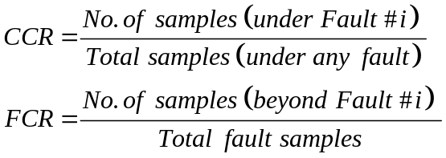 (20)
where, the CCR index is defined as the rate between the number of samples that are under the confidence region of Fault #i and the sum of samples that are under the confidence region of any fault. The FCR index is defined as the rate between the number of samples that are out of the confidence region of Fault #i and the number of fault samples. A largest CCR indicates that the models from Fault #i can best accommodate the fault samples in comparison with the other faults. FCR can quantify how much fault samples stay well within the confidence region of Fault #i.
(Insert Table 3 here)
As summarized in Table 3, the fault diagnosis performance is compared between three methods for three faults and 50 testing samples to demonstrate the idea of faulty variable selection as well as improved discriminant power of NeLFDA in comparison with conventional FDA algorithm. For each fault case, the values of CCR and FCR are presented for three different methods. In comparison, both CCR and FCR indices of the proposed method are statistically better than those of the conventional FDA method based on a paired t-test (α=0.05)[35]. Besides, the proposed method presents a significantly larger CCR index than that of the NeLFDA algorithm with no faulty variable separation, revealing that faulty variable separation has a significant effect on diagnosis accuracy. Besides, the NeLFDA algorithm with no faulty variable separation presents significantly better diagnosis performance than the conventional FDA algorithm based on a paired t-test (α=0.05)[35], revealing improved discriminant power of NeLFDA in comparison with conventional FDA algorithm. Therefore, the proposed algorithm shows the best diagnosis performance. In contrast, the conventional FDA algorithm presents the worst fault diagnosis performance. It may result from the following reasons. First, it can only extract single discriminant component for pairwise analysis of normal and fault data sets which thus may not be sufficient to explore the critical difference among multiple fault types. Second, with no faulty variable selection, the fault effects covered in faulty variables are mixed up with general variables.
5 Conclusion
In the present work, a new fault diagnosis method is proposed which can extract more meaningful discriminant directions and probe into the specific faulty variables. The significant faulty variables are separated from the other general variables so that the specific variables in a particular section of the plant can be focused on, thereby making it much easier for operators to assign possible causes. Also, by separation of variables for each fault class, different underlying characteristics of two variable subsets are explored respectively and then double evaluated for fault diagnosis. The feasibility of the proposed algorithm has been verified using the industrial process data from the cut-made process of cigarette.
Acknowledgments
This work is supported by the National Natural Science Foundation of China (Nos. 61422306, 61273166 and 61433005), the Fundamental Research Funds for the Central Universities, Zhejiang University K.P. Chao’s High Technology Development Foundation and the Open Research Project of the State Key Laboratory of Industrial Control Technology, Zhejiang University ,China (No. ICT1600198).
Reference
- Chang CC, Yu CC. On-line fault diagnosis using the signed directed graph. Ind. Eng. Chem. Res. 1990;29: 1290–1299.
- Zhao CH, Sun YX, Gao FR. A Multiple-Time-Region (MTR)-Based Fault Subspace Decomposition and Reconstruction Modeling Strategy for Online Fault Diagnosis. Ind. Eng. Chem. Res. 2012;51: 11207-11217.
- V. Kariwala, P.E. Odiowei, Y. Cao, T. Chen, A branch and bound method for isolation of faulty variables through missing variable analysis, J. Proc. Cont. 2010;20: 1198-1206
- P. V. den Kerkhof, J. Vanlaer, G. Gins, J. F. M. V. Impe, Analysis of smearing-out in contribution plot based fault isolation for statistical process control, Chemical Engineering Science, 104, 285–293, 2013.
- Zhao CH, Yao Y, Gao FR, Wang FL. Statistical Analysis and Online Monitoring for Multimode Processes with Between-mode Transitions. Chemical Engineering Science, 2010, 65(22): 5961-5975.
- Yu J, Rashid MM, A novel dynamic bayesian network-based networked process monitoring approach for fault detection, propagation identification, and root cause diagnosis. AIChE J. 2013; 59 (7): 2348-2365.
- Zhao CH, Sun YX. Comprehensive subspace decomposition and isolation of principal reconstruction directions for online fault diagnosis. J. Process Control. 2013,23: 1515-1527.
- Zhao CH, Gao FR. Online Fault Prognosis with Relative Deviation Analysis and Vector Autoregressive Modeling. Chemical Engineering Science. 2015, 138(22): 531–543.
- Tong C, El-Farra NH, Palazoglu A, Yan X. Fault detection and isolation in hybrid process systems using a combined data-driven and observer-design methodology. AIChE J. 2014; 60 (8): 2805-2814.
- Wold S, Esbensen K, Geladi P. Principal component analysis. Chemom. Intell. Lab. Syst. 1987;2: 37-52.
- Jackson JE. A user’s guide to principal components. John Wiley & Sons Canada, Ltd., 2005
- Duda RO, Hart PE. Pattern classification and scene analysis. New York: Wiley, 1973.
- Burnham AJ, Viveros R, MacGregor JF. Frameworks for latent variable multivariate regression. J. Chem. 1996;10: 31-45.
- Martínez AM, Kak AC. PCA versus LDA. IEEE Trans. Pattern Anal. Mach. Intell. 2001;23: 228-233.
- Chiang LH, Kotanchek ME, Kordon AK. Fault diagnosis based on Fisher discriminant analysis and support vector machines. Comput. Chem. Eng. 2004;28: 1389-1401.
- Chiang LH, Russell EL, Braatz RD. Fault diagnosis in chemical processes using Fisher discriminant analysis, discriminant partial least squares, and principal component analysis. Chemometr. Intell. Lab. 2000;50: 243-252.
- He QP, Qin SJ, Wang J. A new fault diagnosis method using fault directions in Fisher discriminant analysis. AIChE J. 2005;51: 555–571.
- Du Z, Jin X. Multiple faults diagnosis for sensors in air handling unit using fisher discrimminant analysis. Energ. Convers. Manage. 2008;49: 3654-3665.
- Chakrabarti S, Roy S, Soundalgekar MV. Fast and accurate text classification via multiple linear discriminant projections. VLDB J. 2003;12: 170-185.
- Ye J, Janardan R, Park CH, Park H. An optimization criterion for generalized discriminant analysis on undersampled problems. IEEE Trans. Pattern Anal. Mach. Intell. 2004;26: 982-994.
- Friedman JH. Regularized discriminant analysis. J. Am. Stat. Assoc. 1989;84: 165-175.
- Raudys S, Duin RPW. Expected classification error of the fisher linear classifier with pseudoinverse convariance matrix. Pattern Recogn. Lett. 1998;19: 385-392.
- Peter NB, Joao PH, David JK. Eigenfaces vs fisherfaces: recognition using class specific linear projection. IEEE Trans. Pattern Anal. Mach. Intell. 2005;27: 929-941.
- Ye JP, Li Q. A two-stage linear discriminant analysis via QR-decomposition. IEEE Trans. Pattern Anal. Mach. Intell. 2005;27: 929-941.
- Zhao CH, Gao FR. A nested-loop Fisher discriminant analysis algorithm. Chemometr. Intell. Lab. Syst. 2015, 146: 396–406.
- Gertler J, Li W, Huang Y, McAvoy T, Isolation enhanced principal component analysis, AIChE J, 1999, 45: 323-334.
- Westerhuis JA, Gurden SP, Smilde AK. Generalized contribution plots in multivariate statistical process monitoring, Chemometr. Intell. Lab. Syst. 2000, 51: 95-114.
- Liu JL, Chen DS. Fault isolation using modified contribution plots, Comput. Chem. Eng. vol. 61, pp. 9-19, 2014.
- Owen AB. Monte Carlo theory, methods and examples, 2013.
- Mahalanobis PC. On the generalized distance in statistics. Proceedings of the National Institute of Sciences (Calcutta). 1936; 2: 49-55.
- Silverman BW. Density Estimation for Statistics and Data Analysis (Chapman & Hall/CRC Monographs on Statistics & Applied Probability), Chapman and Hall/CRC, 1986.
- Nomikos P, MacGregor JF. Multivariate SPC charts for monitoring batch processes. Technometrics. 1995;37: 41-59.
- Lowry CA, Montgomery DC. A review of multivariate control charts. IIE Trans. 1995;27: 800-810.
- Chiang LH, Russell EL, Braatz RD. Fault detection and diagnosis in industrial systems. Springer-Verlag London Ltd, 2001.
- Montgomery DC, Runger GC. Applied statistics and probability for engineers. 4th ed. New York: Wiley, 2006.
List of Figure Captions
Figure 1 Illustration of the proposed faulty variable selection procedure
Figure 2 The first two components extracted from fault data and normal data using (a) the proposed algorithm with faulty variable separation and (b) NeLFDA without faulty variable separation
Figure 3 Online fault diagnosis results using (a) general variables and (b) faulty variables for Fault #1 using the proposed method(dotted line: monitoring statistics; red dashed line: 99% monitoring confidence limit)
Figure 4 Online fault diagnosis results for Fault #1 using fault models developed from Fault #2 (dotted line: monitoring statistics; red dashed line: 99% monitoring confidence limit)
Figure 5 Online probability values for fault diagnosis of Fault #1 using fault models with faulty variable separation developed from (a) Fault #1 and (b) Fault #2
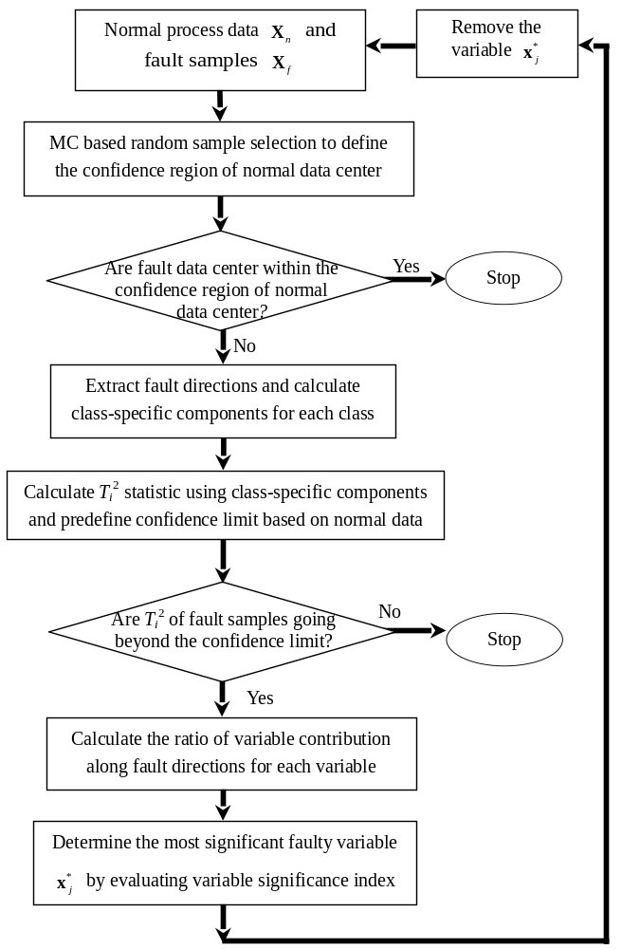
Figure 1 Illustration of the proposed faulty variable selection procedure
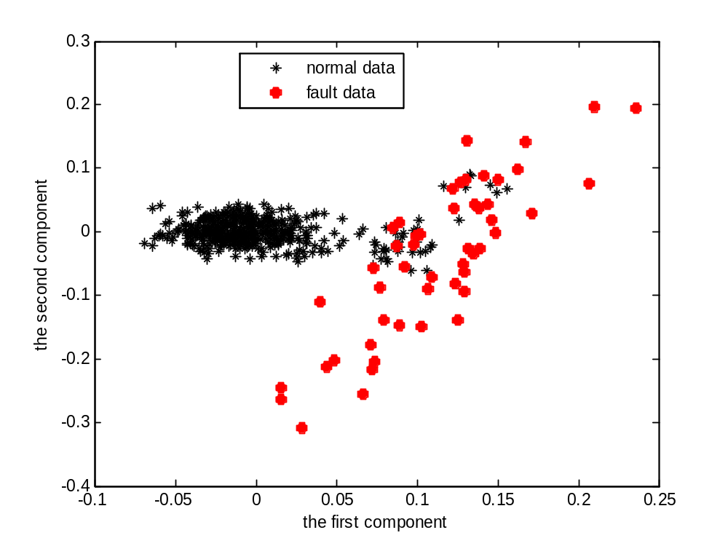
(a)

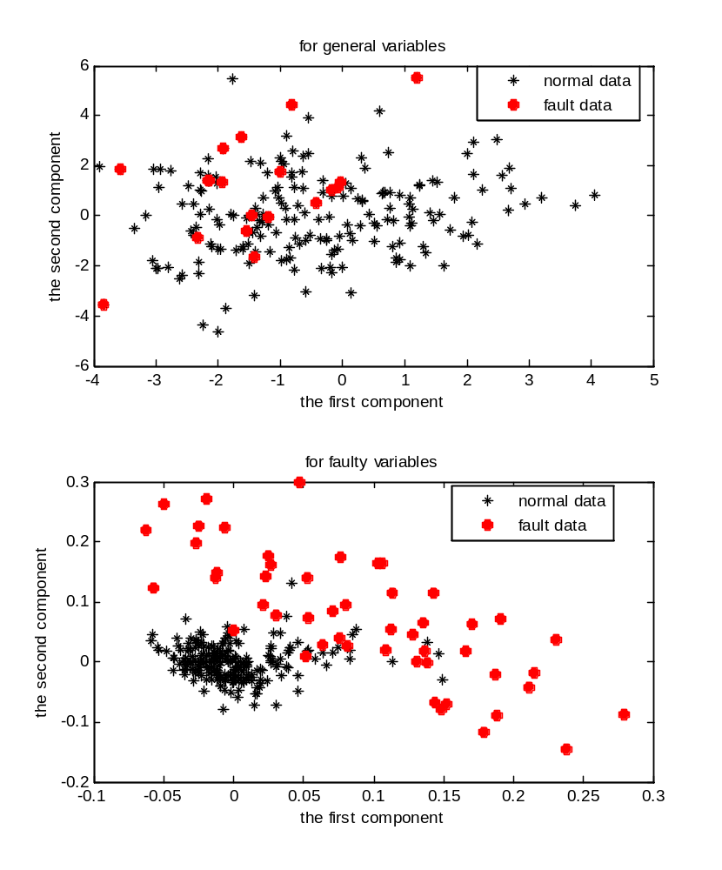
(b)
Figure 2 The first two components extracted from fault data and normal data using (a) the proposed algorithm with faulty variable separation and (b) NeLFDA without faulty variable separation

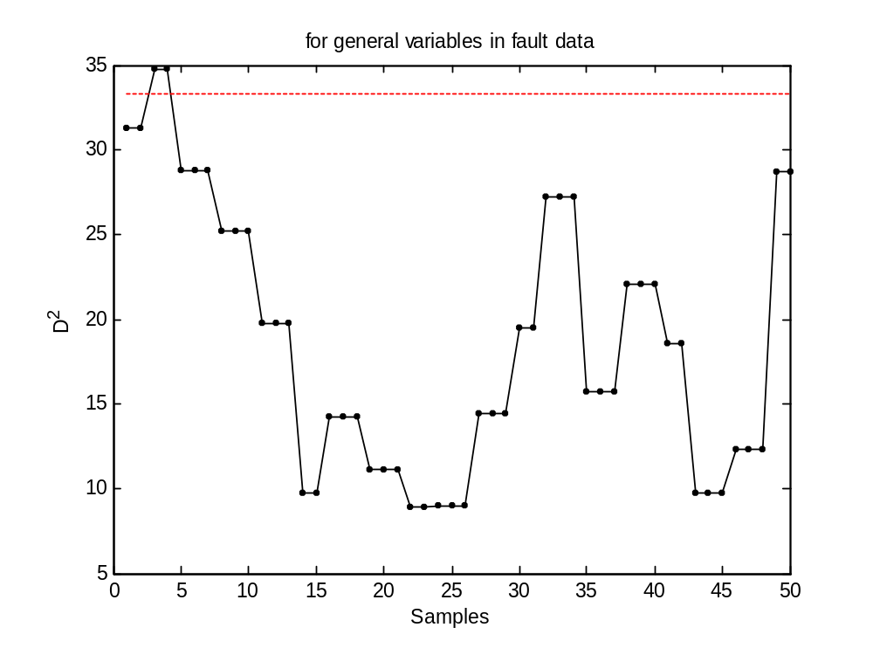
(a)
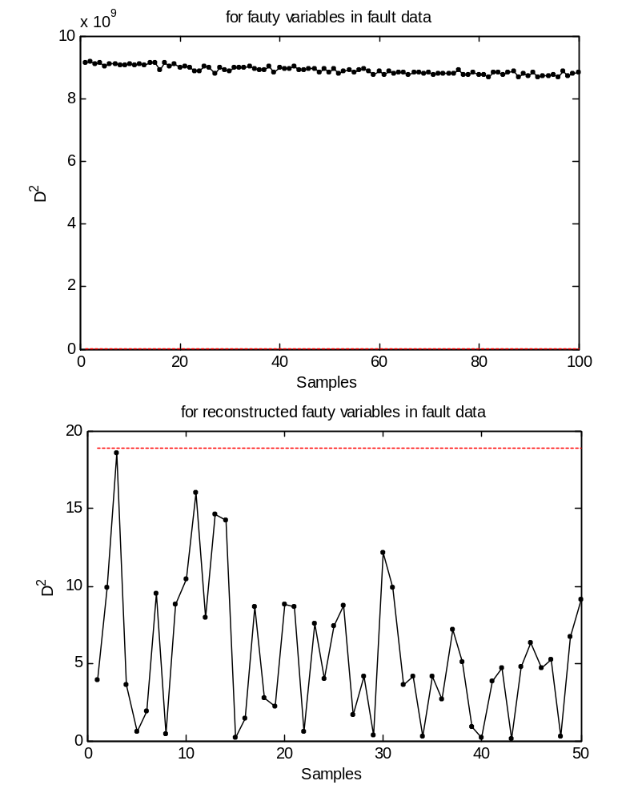
(b)
Figure 3 Online fault diagnosis results using (a) general variables and (b) faulty variables for Fault #1 using the proposed method(dotted line: monitoring statistics; red dashed line: 99% monitoring confidence limit)
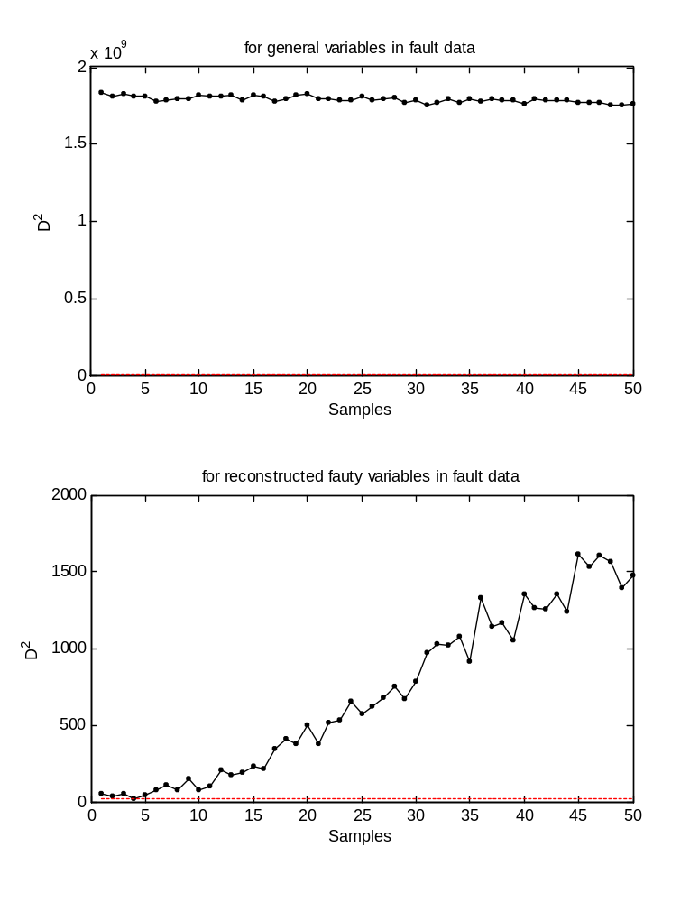
Figure 4 Online fault diagnosis results for Fault #1 using fault models developed from Fault #2 (dotted line: monitoring statistics; red dashed line: 99% monitoring confidence limit)
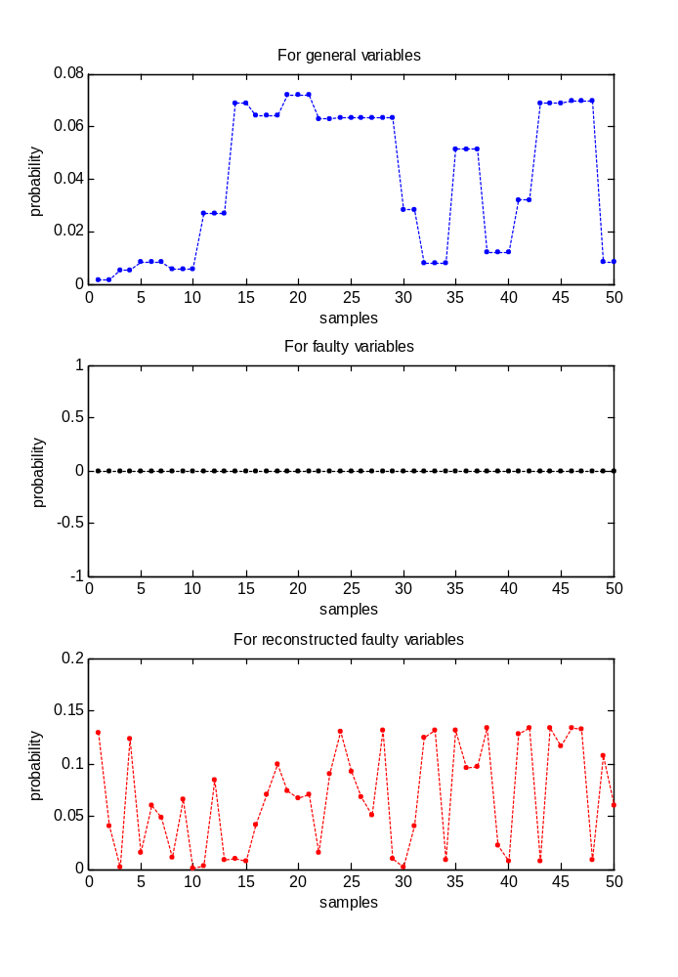
(a)
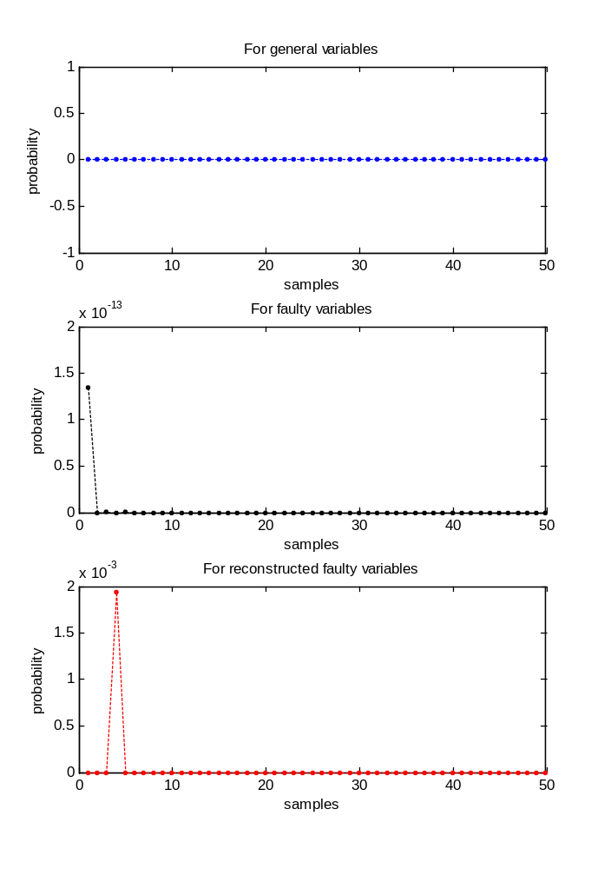
(b)
Figure 5 Online probability values for fault diagnosis of Fault #1 using fault models with faulty variable separation developed from (a) Fault #1 and (b) Fault #2
Table 1 Variables in cut-made process of cigarette used for modeling
Variable No. | Variable Description | Variable No. | Variable Description | Variable No. | Variable Description
1 | Initial cut tobacco flow rate (kg/h) | 9 | KLD moisture exhaust damper opening (%) | 17 | KLD hot wind temperature (℃)
2 | Initial moisture content (%) | 10 | KLD vapour pressure (bar) | 18 | KLD hot wind speed (m/s)
3 | SIROX vapour pressure (bar) | 11 | Region-1 vapour pressure (bar) | 19 | KLD water removal mass (l/h)
4 | SIROX temperature (℃) | 12 | Region-1 wall temperature | 20 | KLD dried moisture content (%)
5 | SIROX vapour volume flow rate (m3/h) | 13 | Region-2 vapour pressure (bar) | 21 | KLD dried temperature (℃)
6 | SIROX vapour mass flow rate (kg/h) | 14 | Region-2 wall temperature (℃) | 22 | Cooling moisture content (%)
7 | SIROX vapour diaphragm valve opening (%) | 15 | Region-1 condensed water temperature (℃) | 23 | Cooling temperature (℃)
8 | KLD moisture exhaust negative pressure (ubar) | 16 | Region-2 condensed water temperature (℃)

Table 2 (a) Fault description and (b) faulty variable selection results in cut-made process of cigarette
(a)
Fault No. | Fault description
1 | The vapour pressure valve open is increased by 25%
2 | Step change is imposed in the set point of KLD hot wind speed
3 | Unknown fault

(b)
Fault No. | The variable selection ratio (VSR%)
Fault No. | 50 fault samples | 100 fault samples
1 | 7/23 | 9/23
2 | 6/23 | 11/23
3 | 11/23 | 13/23

Table 3 Fault diagnosis performance for three different methods evaluated by CCR and FCR (%)
Fault # | Method
Fault # | The conventional  FDA algorithm |  | The NeLFDA  algorithm with  no faulty variable separation |  | The NeLFDA  algorithm with  faulty variable separation
Fault # | CCR | FCR | CCR | FCR | CCR | FCR
1 | 66.78 | 19.00 | 79.05 | 14.00 | 96.08 | 2.00
2 | 72.84 | 24.00 | 78.96 | 15.00 | 88.70 | 6.00
3 | 71.33 | 20.00 | 77.43 | 15.00 | 87.60 | 6.00

Corresponding author: Tel: 86-571-87951879, Fax: 86-571-87951879, E-mail address: chhzhao@zju.edu.cn

